

Master thesis submitted in partial fulfillment of the requirements
for the diploma Master of Science in Toegepaste Economische
Wetenschappen

The European football landscape: An
analysis of the performance of
Belgian, German and English football
Teams

Louis VAN LOOY
0529077
Academic year 2019-2020

Promotor: Stijn VAN PUYVELDE

Social Sciences & Solvay Business School
Abstract

Being a soccer fan, the growth of European football in terms of businesses in the last 25 years motivated me to investigate this particular evolution. The analysis in this thesis focuses on three competitions in Europe: Premier League (UK), Bundesliga (GE) and the Jupiler Pro League (BE) for a period of ten years. This thesis investigates the relationship between sporting, financial and business performance on the level of clubs (n=36). We start with an overview of soccer economics and the most important events in European football the last decades, followed by a description of performance and the specific competitions under study. Next, we jump into a two-stage method which ranks clubs via a Multicriteria Analysis (PROMETHEE II) and assess the relationships between sporting, financial and business performance with a Partial Least Squares Structural Equation Modeling (PLS-SEM).
After running the first analysis, the model of Galariotis et al. (2018) is challenged and refined by introducing a factor analysis on the financial performance. The factor analysis revealed that financial performance consists of three underlying constructs: size, debt and profitability. With the obtained factor scores we run a general linear model examining the same relationships. In addition, the path-analysis of the redefined constructs are investigated through partial correlation. In the end the PLS-SEM is implemented again with the redefined constructs. For Belgian and English football clubs similar patterns become visible: business performance affects sports performance positively and vice versa, while the relationship with profitability is absent (not significant). For German clubs we do find a positive relationship between profitability and sportive performance, irrespective of business performance. A final, fixed effects model, reveals considerable heterogeneity between clubs; it also signals that profitability is eventually related to sporting performance on the club level. However, for most clubs in Belgium and the UK, this positive relationship boils down to minimizing losses. The findings in this work indicates that the Bundesliga is the only league which seems, on average, economically sustainable during the last ten years.

Keywords: Economics of Sports, Soccer, Football club performance, Partial Least Squares, Structural Equation Modeling, PROMETHEE II, Factor-analysis, GLM, time-lags, partial correlation, fixed effects
Table of Contents

1. Foreword 6
2. Introduction 7
3. Problem definition 8
4. Literature review 11
4.1. Economics of sports 11
4.2. Economics of soccer 13
4.3. Specific characteristics of soccer 14
4.4. Difference between sports models in the United States and Europe 14
4.5. Major events in European soccer 15
4.5.1. The birth of UEFA and the Champions League 16
4.5.2 Reinvention of the Premier League 17
4.5.2. Bosman Ruling 18
4.5.3. Financial Fair Play 19
4.6. Competitive balance 21
4.6.1. The Idealized Standard Deviation 23
4.6.2. The Herfindahl Index 23
4.7. Performance 24
4.7.1. Financial performance 26
4.7.2. Sports performance 26
4.7.3. Business performance 27
4.8. European football 28
4.8.1 England and Germany 28
4.8.2 Belgium 31
4.9. Conclusions in literature 33
5. Research framework 35
6. Data collection 36
7. Methodolgy 38
8. Results 43
8.1. Descriptives and trends in European Soccer 43
8.2. PLS-SEM results 48
8.2.1. Premier League 48
8.2.2. Bundesliga 50
8.2.3. Jupiler Pro League 50
8.3. Factor analysis 52
8.4. Correlation over time 55
8.5. Regression – GLM 56
8.5.1 Regression diagnostics 56
8.5.2 General Linear model 57
8.6. Partial Correlation 59
8.7 Redefined PLS-SEM results 62
8.7.1 Premier League (2) 63
8.7.2 Bundesliga (2) 64
8.7.3 Jupiler Pro League (2) 65
8.8 Fixed Effects 65
9. Limitations and further research 67
10. Conclusion 68
11. References 70
12. Appendix 75
Appendix I 75
Appendix II 76
Appendix IV – Assumptions for each country 81
Appendix V 86

Foreword

Writing this thesis has been an enlightening experience that has enabled me to link the concepts used in my studies to a subject that interests me greatly as a person. This work was a long and intensive process, but also led to valuable results.
First of all, I want to thank my supervisor Professor Stijn van Puyvelde, for his guidance and constructive feedback to help me during this year. A word of thanks to my dad Bart Van Looy for the statistical recommendations, feedback and for improving this thesis. Also, a word of thanks to my mother Nicole Jacques who was always there to support me during my studies. In addition a word for Edwin Zimmermann for having a critical read of the final version of this thesis. Last but not least I would like to thank my friends, brother and cat for the support during the whole process of writing this work.

Introduction

Football or soccer is the most widespread of all sports worldwide (Giulianotti, 2012). The importance is only increasing according to a Bloomberg article of Boudway (2018) with data provided from Nielsen Sports DNA surveys, which indicates that soccer is the most widespread sports in the world and occupies an important position in everyday society.
This popularity transformed football clubs into money making machines. Is this actually the case or are they rather money consuming machines? The evolution of football clubs, since the creation of the Champions League in 1992 and the implementation of the Bosman Ruling in 1995, is remarkable and led to an increase in the payments to the professional players and challenged the borders of European Football (Galariotis et al., 2018). Nevertheless there is a big difference between regular companies and football clubs. Dejonghe & Vanderweghe (2006) are stating that companies are looking for profit and the football clubs are striving for both financial and sporting successes, which make it atypical, but also a very interesting topic to investigate.
Dobson & Goddard (2001) formulate that the interest from the academic world appeared around the mid-1950s and that interest keeps growing. This work investigates the link between sports and economics within European football. This work specifically looks at the relationships between different constructs in football, more specifically financial, sporting and business performance and whether or not there exists a reinforcing or conflicting relationship between these dimensions. The financial, sporting and business performance are brought together in order to arrive at insights for 36 clubs, situated in three European competitions (UK, GE and BE).

Problem definition

In this work European football is analyzed, including an evaluation of the financial and sporting performance of football clubs. Furthermore the relationship between these two has been investigated over time and so we could look more into the long-term sustainability of football clubs. According to an article of Sports Talk Florida (2019) the gap between the Big 5 and the next 50 competitions is only getting bigger, due to their ability to attract more revenue. The following statement from Sports Talk Florida (2019) is strong proof of their dominance: "The Big 5 leagues banked 97 percent of the €2.4 billion euros ($2.6 billion) generated in non-domestic broadcast revenue by all European leagues in the 2017-18 season.".
Joos (2019) is a Belgian sports journalist who works for Sporza. He wrote an article in December which got my attention and provides an interesting starting point for this work. He sees an increasing dominance of the five major leagues. In the 2019/2020 season, in the final phase of the Champions League, there are only teams from the Big 5 leagues left, the first time ever in the history of the tournament. He sees a trend where money dominates football. A quote of Joos (2019) defines this well: “But hasn't it all become too predictable? It has. It is predictable, no matter if Ajax was still in there. Ajax is not like PSV or Club Brugge. Ajax is also a football club with money. Occasionally it is been exciting, we've had great football evenings, but in the end money wins."
On the other hand, there are also recent examples that show that it is not only the financial performance that counts. Leicester City became the champion in the 2015-2016 season in England. In advancece this was considered impossible. To give an idea Eden Hazard, the top player of the English reigning champion in 2015, had a market value of £32 million when he was bought from Lille. The whole Leicester team had an estimated player value £22 million. A remarkable figure. This shows that the interrelationship between financial and sporting performance in reality is not so clear-cut. Furthermore, Ajax, the top club from the Netherlands, reached the semi-finals of the Champions League last year against all odds after eliminating the absolute top clubs Juventus and Real Madrid.
Finally, it is also remarkable that, for the first time since the 2002-2003 season, two Belgian clubs have managed to qualify for the group stage of the Champions League. Belgium's UEFA ranking was at its highest in the 80s and 90s with peaks in 1979 and 1980 with a third place in the ranking. Around the turn of the century, Belgium bottomed out in 1998 with a 20th place. In recent years, Belgian football has had a revival with an 8th place in 2019 (Kassies, 2020).
A way to get a first impression of how Belgium is performing compared to the Big 5 is by the UEFA country coefficient. The country coefficient of a country is based on the results of the sports performance of each country in European tournaments during the five last years (UEFA, 2020). On figure 2 the evolution of the absolute differences between the UEFA country coefficients of the G5 countries and Belgium is shown. A first observation is the increase in the absolute difference between Spain and Belgium and we can also see a slightly decreasing trend between Belgium and France. The difference with the other 3 fluctuates.

Figure 2.
Evolution of UEFA Country Ranking from Belgium compared to the G5 from 2005-2020.
Source. “UEFA European Cup Coefficients Database” Kassies, B. (2020)
More specifically this work investigates the difference in sporting, financial and business performance between the football leagues in England, Germany and Belgium during the last 10 years. Sporting performance refers to the number of points obtained the national and European competitions and the points from domestic cups. Financial performance can be expressed based on the financial results of a football club and ultimately business performance gives an indication of the size of a football club and their ability to generate revenue from different sources. Business performance refers to revenue-generating activities such as match attendance, merchandise and sponsorships. This will be dealt in more detail further in this work. The question is what pattern do we see in the European football landscape between these dimensions of performance? Does financial or business performance leads to sportive success and vice versa? And if so, is this relationship economically sustainable?

Literature review

In this literature review I give an overview and clarification of the concepts and phenomena that are of relevant for this research. Firstly the terms ‘sports economics’ and ‘soccer economics’ are defined. Next, the difference between US and European sports models is briefly discussed. Subsequently, three major events that have shaped the current football landscape in Europe are highlighted. After that the competitive balance and the different ways in the existing literature to analyze this are given. Afterwards the ways to measure financial, sports and business performance are addressed. In the end the specific characteristics of the different leagues are briefly discussed.

Economics of sports

It is clear that sports economics obviously can be situated within the domain of economics. First, a definition of this concept is needed. One important term to have in mind is introduced by Kahane & Shmanske (2012). They introduce the term ‘professional sports’ which shows that professional sports is a complex combination of both sporting and financial competition. This combination has led to a specific form of organization. Additionally sport economics should be defined. Sports economics is a discipline of economics focused on its relationship to sports. Mondal (2019, p1.) defines sports economics as such: “Sports economics is a discipline of economics focused on its relationship to sports. In this field economists are able to analyze many topics, including discrimination and antitrust law.”
Neale (1964) describes the peculiar economics of professional team sports. For a team it is not possible to produce any output without the existence of other producers, better known as teams. Mutual interdependence is crucial for the success of sports. The product that is been sold to the public is a joint game. El-Hodiri and Quirck (1971) created one of the first formal micro-economic models of a sports league. Over the years, it is clear that Noll (1974) plays an important role in the creation of relevant literature within the sports economy. His work consists mostly of antitrust analysis, but he also opened the door for new studies like demand for sports, sports broadcasting and sponsorship, stadium attendance, etc.
Andreff & Szymanski (2006) are showing the application of economic concepts within the landscape of sports. Furthermore, the terminology ‘Economics of sports’ is getting more and more attention in the mid-20th century. Simon Rottenberg and Walter Neale are pioneers in the field of sport economics, being among the first academics to map the link between sport and economics. Rottenberg (1956) investigated the labor market of baseball players in the United States. He immediately ran into market problems and the atypical characteristics of sport. In a business situation a desired market form is a monopoly, but in sports this is quite different. The competition has to be of an equivalent form in order to be considered a successful competition. Neale (1964) goes further in his work and analyses the different market forms within sport and he comes to the conclusion that a monopoly form is a major financial disaster. The more economic collusion and sports competition, the higher the profits will be.
Afterwards, in the mid-1990s there has been a boom in the literature in this domain, as well in the amount of publications as in the number of various authors. The increased scientific recognition can be seen by can be witnessed by a few occurrences (Andreff & Szymanski, 2006):
- There is now an International Association of Sport Economists, launched in 1999, which holds an annual conference.
- There is a field journal, the Journal of Sports Economics, started in 2000.
- There is an increasing number of papers on sports economics that are published in generalist economic journals including the American Economic Review, the Journal of Political Economy, the Journal of Economic Perspectives, the Review of Economics and Statistics, the European Economic Review, Applied Economics, the Economic Journal, Economic Policy, Economic Inquiry, and Contemporary Economic Policy
- Since 2000 several textbooks about Soccer Economics have been published.
Furthermore there was an increase in interest by the public sector. Europe and its member countries conducted several studies on their sports associations. Due to this augmented interest from several fields, sports economics can be seen as a discipline on its own (Andreff & Szymanski, 2006).

Economics of soccer

As just mentioned, today’s football clubs have turned into companies. Football it is not just about sports anymore. It has become a financial game where football clubs evolve into businesses. The term ‘economics of soccer’ emerged. The academic papers of Sloane (1969, 1971) can be seen as the first contributions that are really focusing on the economics of soccer. Sloane (1969) analyzed the soccer players’ labor market in England, where he described the strict limitations on the employment mobility of soccer players. Furthermore Sloane (1971) was the first to develop an economic model to describe the specific characteristics of soccer, he based his model on the ‘classic’ economic theory of the firm, where firms, here soccer clubs, make specific decisions to maximize their profits.
Dietl et al. (2008) are describing the characteristics of football competition as a competition where football clubs can only improve their ranking when they worsen the position of the other clubs. They state that sporting and economic successes are correlated. They also talk about ‘overinvestment’ in soccer. Overinvestment in playing talent is a clear consequence of the ruinous competitive interaction between clubs. In Europe there exists a system of promotion and relegation which means that the worst performing club will be relegated and replaced by the best performing club from the next lower division. This specific rule plays a vital role in the overinvestment in soccer. Clubs are afraid of relegation because of the financial and sporting consequences and therefore tend to overinvest in players. In their conclusion they find some incentives which increase the reasons to overinvest:
- A strong correlation between talent investment and league performance
- Existence of an unequal distribution of the league’s revenue
- An additional exogenous price (participation in European competition (cfr. Champions League or Europa League)
- The European system of promotion and relegation
- An increased inequality between the first and the second division of a domestic league

Specific characteristics of soccer

Haan et al. (2002) are describing some of the specific characteristics of soccer. Firstly, the soccer competition is their own product. Teams need to produce ‘competitive excitement’ to stay alive. If this didn’t exist soccer wouldn’t be that attractive. Another unique characteristic is that the creation of competitive excitement is unlikely to be a sustainable activity without the existence of any cartel-like arrangements. This is where conflict arises. Politicians allow cartel practices within football while these are strictly outlawed in other industries. An example of such an arrangement is the sharing of the revenue of the television rights between soccer clubs.
Furthermore soccer is a team sport with an uncertain outcome. The nature of demand by the spectators is quite different than those of individual sports. Fans tend to support a team mostly on the basis of geographic proximity, and to stay supporter regardless of the performance of their team. Further is it also clear that teams which achieve better results during a long period are more likely to have more support (Szymanski, 2003a).

Difference between sports models in the United States and Europe

Goddard & Sloane (2005) are showing that team sports are being a laboratory for economists since they are showing cartel and anti-competitive behavior, compared to the conventional industries. Mainly, it is important to demonstrate that the sports competitions in North America and Europe have differed to such a level that these competitions need to be analyzed in a separate manner. One major difference is the construction of the labor market. In North America they make use of drafts, where teams negotiate the contract with the young players in reverse order of their finishing position in the previous season. Furthermore they exist clear salary caps, restrictions on player trading and the habit to sell broadcasting rights in a collective manner.
In Europe these practices are rather unknown. Revenue sharing is less common and salary caps have only been introduced recently. The organization of the labor market is also very different. In Europe it is normal to trade players for cash but in North America it is rather an exception. This difference is leading to greater imbalances in Europe where a few teams are dominating their domestic leagues. The system of promotion and relegation is absent in North America. The European Commission states that this forms the cornerstone of the European model of sports.
Szymanski (2006) describes the characteristics of the European Football Model as the following, the model based on a report from the European Commission (1998, pp 2-5.):
- Sport is organized and governed at regional, national and international level by federations that wield supreme authority over the management of sport
- Amateurs play alongside professionals, with the former often taking leading roles within the hierarchy. As a result commercial motivations are less important and even frowned upon
- There is a strong emphasis on the role of nationality in competition and the state itself is closely involved in the organization and funding of sport
- Within the hierarchy, sports teams are both upwardly and downwardly mobile thanks to the institution of promotion and relegation
Not only the organization and the rules are different. US and European economists have also addressed some differences between the objectives which owners of football clubs are trying to achieve. The idea of profit maximization is more present in North America whereas in Europe maximization of games won, subject to a profit constraint is more common. Goddard & Sloane (2005) state that the increased income from broadcasting rights and the upcoming ‘hype’ to be listed on the stock company may have recently led to a more commercial approach in Europe.

Major events in European soccer

After studying the literature, three major events often recurred that have shaped the European football landscape nowadays. Firstly, the emergence of the UEFA and the creation of the tournament with the most public interest, the Champions League. Secondly the rebuilding and reinvention of the Premier League has also played an important role in the formation of the European football landscape. This is followed by a discussion of Bosman Ruling, which radically reformed the labor market for football players. Finally, Financial Fair Play will be discussed, a regulation, imposed by UEFA in 2010, to ensure that clubs are financially 'healthy' and to avoid financial doping as much as possible.

The birth of UEFA and the Champions League

Vonnard & Quin (2017) are sketching the history of UEFA. UEFA is the abbreviation for Union of European Football Associations. The organization was founded in 1954 by 28 national football associations across Europe as a reaction on the changes of the Fédération Internationale de Football Association (FIFA) in 1953 which forced them to form a European organization. From 1955 UEFA created new competition format and started to control the broadcasting of European football. The UEFA can also be considered as an initiative of the European integration after the Second World War. In this period a lot of political, scientific and cultural organizations and initiatives were formed. However, the establishment of UEFA is slightly different. It surpassed the existing borders, created by the Cold War, countries from Eastern Europe were also allowed. As mentioned before UEFA forms one of the six continental confederations of world football’s governing body FIFA. On figure 3 you can see a representation of the organizational structure of the FIFA and its continental members. In this work we will focus on the European soccer and the UEFA.
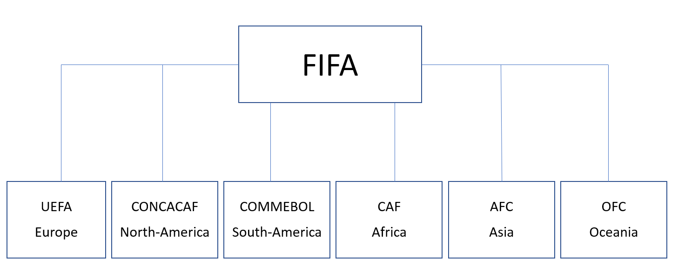
Figure 3.
Structure of the FIFA and the six continental confederations.
Source. “The Interdisciplinary Electronic Journal of African Sports” Cooper, E. A. (2011, P1.).

In 1955 they organized the first European competition, named the Europa Cup I. The UEFA only possessed a sole decision-making authority but over time the management of the different aspects of soccer became more and more complex so there arose also additional expert committees. UEFA was not only active in the organization of soccer. After the Heysel stadium disaster in 1985 they created stringent security requirements for the soccer stadiums which impacted the way people watch football nowadays.
UEFA always tried to reinvent itself. First, the Europa Cup I was only for the champions of the national competitions. But in the 90’s the format of the competition changed, not only the champions were allowed to participate in the tournament, from now on also teams which weren’t champion were allowed to participate. This was mainly to expand the number of played games to increase the revenues. The modern format of the European competition, called the Champions League, was organized for the first time in the season 1992-1993. The shape of the tournament and the participating countries are parameters that have evolved slightly over time. Recently, in order to fully exploit the commercial potential of the Champions League, UEFA has been increasingly opting for more teams from the Big 5 competitions to participate in the main tournaments. It is clear that UEFA took an important role in the development of European football (UEFA, 2019).

4.5.2 Reinvention of the Premier League

Back in 1992, English football was stuck in the dark ages, emerging from a five-year ban from European competition. The Premier League in its current form was established in 1992 to face their former problems. One of the biggest changes was that from now on money would not be shared with the clubs from all divisions, but only with the ones that are active in that competition. As a result of this breakdown, the amounts for the TV deal of the highest division rose sky-high. This TV-money flowing led to attracting top players like: Thierry Henry, Ruud van Nistelrooy and Dennis Bergkamp. The amounts of these transfers continued to increase and led to an increase in money flows to other football leagues, they sold their best players to the English teams. They were the first European league to commercialize football on that scale, very similar to the model of the NBA. With this, they stimulated the rest of Europe to follow their example and formed one of the main foundations of modern European football (Conn, 2017).

Bosman Ruling

Another event at the basis of the present structure of the European football landscape was the implementation of the Bosman Ruling on 15 December 1995. Binder and Findlay (2012) are discussing the effect of the Bosman ruling in the English Premier League. One of the main points was the elimination of payments when players were out of contract. Another important measure of this ruling was the undoing of any restrictions on the number of foreign players. They show the impact of the ruling by numbers: in the 1994/1995 season 28.9% of the players who started a game were non-English, compared to 45.8% during the 1998/1999 season and 57.6% in 2003/2004.
Samagaio et al. (2009) indicate that the Bosman ruling drastically changed the formation of the labor market of players, this became an international market of buy and sell the rights of players. Galariotis et al. (2018) highlight this financial boom. The increased remuneration of football players, augmentation of the clubs’ budgets and the formation of elite clubs in European football are some of the most prominent consequences of the ruling. New streams of revenues had to be invented to stay competitive. Football clubs found new revenues in merchandising, sponsorships, licenses and the selling of TV-rights. The race for money had begun. This had led to financial instability within the landscape of European football. The Bosman ruling definitely changed European football.
Binder and Findlay (2012) indicate that it is generally claimed that the Bosman Ruling created more stratification between the clubs as within each EU country as well across the different clubs in Europe. On the other hand, Vrooman (2007) investigated this and found that the introduction of the Bosman ruling had only a negligible impact on the competitive balance.

Financial Fair Play

Peeters & Szymanski (2014) show that the development of the broadcasting technologies increased the income of European soccer clubs significantly, but still the financial performance of most of the clubs is alarming. As a result, UEFA introduced the rules of ‘Financial Fair play’ (FFP) in 2010 to establish some boundaries here. Preuss et al. (2014) show that only those clubs that qualify for UEFA club competitions (Champions League or Europa League) are subject to the rules of the Financial Fair Play. The club-monitoring is conducted by the UEFA itself, this body is called the UEFA Club Financial Control Body (CFCB).
Another interesting point is the research conducted by Szymanski (2003,b) who makes use of a simple linear regression model to show the correlation between sporting success and the clubs’ expenses for player wages. This shows that clubs are not managing their financial resources properly and that is an important reason why the UEFA had to implement the Financial Fair Play rules to limit this problem. Another concept that is appearing more frequently is the term 'financial doping'. Müller et al. (2012) were the first to define this concept: ‘financial means not earned by a club directly or indirectly through its Sporting operations or supporter reputation, but rather provided by an external investor, benefactor or creditor detached from Sporting merit and supporter reputation as well as from sustainable investment motivations.’ (pp. 123–124).
One of the first and most commonly known examples of financial doping was the arrival of the Russian oligarch Roman Abramovich at Chelsea FC in 2003. He took the English Premier League club over and invested more than a billion euros in the period between 2003 and 2012. Since his takeover, the list of clubs with the same events has only been increasing. Some examples are: Liverpool FC, Manchester City, Manchester United, AC Milan and Paris Saint German. To correspond with the legal structure, most of the financial doping is provided by direct ‘injections’ or soft loans (Schubert & Könecke, 2015). Müller et al. (2012) show that the raising number of external investors in football is harming the sport-ethical standards within soccer because funding can be done independently from previous sporting success and the tradition of the club. The principle of ‘one’s own merit’, which is commonly accepted within sports, is no longer a reality.
The regulations concerning the FFP are quite extended. The most significant is that clubs are only allowed to spend €5 million ($5.6 million) more than they earn per assessment period — which lasts three years. The limit can be lifted up till €30 million if these losses can be covered by the owners of the club. However since 2015, investments in stadiums, training facilities, youth development and women's football are not included in the break-even calculations. Football-related expenditures, such as transfers and wages, must be balanced with TV and match day revenue and any money raised from their commercial activities. Clubs must, under all circumstances, meet their transfer and employee salary commitments. The body that enforces the rules of the FFP does not stand still. They can impose fines, deduct points or exclude a club from European competitions. Recently Paris Saint Germain and Manchester City were accused of breaking the FFP rules in 2014. Ultimately they received a fine from €60 million, which in the end was reduced till €20 million (Da Silva, 2019).
More recently Chelsea was fined with a transfer ban for two transfer windows and a financial fine by the FIFA. They were punished because of breaching the regulations regarding international transfers and the signing of players under the age of 18. It is not clear which players are involved. In addition also the English soccer governing body, also known as Football Association (FA), was punished by the UEFA (Kelly, 2019). In February 2020 the UEFA announced that Manchester City has been banned from European competition for two years (2020/2021 and 2021/2022) and with a fine of €30 million. The main reason why this sentence was imposed is because of the practices of the Abu Dhabi United Group, owned by Skeikh Mansour bin Zayed al Nahyan, a billionaire brother of the ruler of the United Arab Emirates, funneled money to several sponsors of Manchester City based in Abu Dhabi which then brought the money back to Manchester City in the form of a sponsorship. In the end they were accused of two things: falsely inflating sponsorship revenues and breaching the regulations by not willing to cooperate in the investigation imposed by the CFCB (Mcmahon, 2020).

Competitive balance

An interesting measure to analyze is the competitive balance. This metric has already been analyzed intensively in the literature devoted to sports economics. Szymanski (2010, p.183) shows that the definition of competitive balance within soccer is not always very unambiguous. In one of his works he defines competitive balance as: “The competitive balance refers to the rational expectations of fans about who will be the winners. In a perfectly balanced contest, each participant starts with an equal chance of winning, so that the outcome will be completely uncertain. If there is no competitive balance then the exact outcome can be predicted with probability one.” Without the existence of competitive balance fans would lose interest in sports. On the other hand it is not proven that a decrease in competitive balance will definitely lead to less interest from fans (Szymanski, 2001).

Another theoretical concept which is closely related to competitive balance is the “uncertainty of outcome hypothesis”. This can be stated as set of three assumptions made by Szymanski (2003a):
- An unequal distribution of resources will lead to unequal competition
- Fan interest declines when outcomes become less uncertain
- Specific redistribution mechanisms are suited to produce more outcome uncertainty

Brandes & Frank (2007) indicate that these assumptions make sense at an intuitive level, but are quite different in reality. The competitive balance hasn't changed significantly during the last two decades, but fan attendance did increase. In their work they give the example of the Bundesliga, the German football competition. In this league Bayern München has been showing resistance against the equal distributions mechanisms which are imposed by the German Football Association. They are stuck in the middle of two competitions: on one hand they are a member of the Bundesliga in Germany where they play 34 games each season. On the other hand they participate in the UEFA Champions League, which transcends the national character of the Bundesliga, on a European scale. The directors from Bayern München wanted to receive a larger share of the TV broadcasting revenues. Bayern München argues that it will need this extra money to be able to compete with big clubs from other countries in Europe like Real Madrid, Barcelona, Juventus, Chelsea, etc.
It is clear the management of Bayern München values a triumph in the Champions League way higher than the potential cost from a loss in fan interest by becoming the biggest and most dominant club in Germany, otherwise it would prefer to maintain the equal distribution of the TV broadcasting revenues. Conversely we see that the critics of Bayern München hide behind the fact that unequal distribution would lead to lower competitive balance and hence lead to reduced fan interest which ultimately would harm Bayern München itself. Brandes & Frank (2007) are analyzing this relationship between competitive balance and fan attendance. Their paper will be used as the basis for the analysis of the competitive balance. Another important reason why competitive balance is part of the analysis is based on the paper by Hoehn & Szymanski (1999). They argue that the revenue, which is part of the financial performance, is determined by the competitive balance between the competitors.

Brandes & Frank (2007) analyze the competitive balance by making use of the average fan attendance. They make use from the measures given by Cain & Haddock (2006). They find a relationship between competitive balance and match attendance across countries and there exists a difference between different divisions within the same country. They also show, that in the literature measures for competitive balance mostly have been used as exogenous variables in regression models, which are variables within the model that are assumed to be given. They demonstrate in their work were competitive balance comes from. They conclude that, indirectly, the distribution of fan attendance decides the league’s degree of competitive balance. It seems reasonable that differences in payrolls across soccer clubs cause also differences in performance. It is important to know where these differences in wages comes from. The revenue of a football clubs plays a key role when they construct their budget for the next year. In European soccer there are some sources of team revenues: tickets sales, advertising, merchandise, transfers and TV revenues. It is clear that the revenue from ticketing relies directly on the number of supporters. In the end most sport leagues are run as cartels, this means that the members of the league appoint a committee which organizes and controls the competition. In this work I will use competitive balance to look at and compare the evolution of this measure in different countries. Several measures have been used in literature to measure competitive balance. Hereby, in the next section, the metrics used by Brandes & Frank (2007) will be addressed.

The Idealized Standard Deviation

Brandes & Frank (2007) are stating that the idealized standard deviation (ISD) forms a measure to analyze the competitive balance. The measurement of competitive balance by the idealized standard deviation of winning percentages has been the most used approach by researchers in the past. Mainly because it is a very simple and easy to use measure. The big problem with this measure is the existence of draws between contenders. In Europe it is normal to end up your football season with several draws. Cain & Haddock (2006, p.331) cite that: “0.5 is a conditional probability: it is the probability that, were the contest to continue resolution, the probability of each team winning in overtime is 0.5. The Fort-Quick ISD does not take into account the probability that, before the fact, one of the competition is a tie.” They derived the empirical distribution of wins, ties and losses in the German Bundesliga during the 1963-2005 period. They found relative frequencies of 37%, 26% and 37% respectively.
- The standard deviation is given by: $\sqrt{1.71N}$, with N the number of games
- The values for the ISD for season t are given by: $\frac{σ_{t}(PW)}{\sqrt{1.71N}}$, where $σ_{t}(PW)$ stand for the standard deviation of point won by each team at the end of the season t.

The Herfindahl Index
This index was originally developed to analyze inequalities between all firms in an industry. We will use this concept in the industry of soccer. To make use of this measure we need the market share of each football club. The Herfindahl Index is calculated as the following:
$H_{t }$= $\sum_{i=1}^{N}{s_{it}^{2}}$
N denotes the number of soccer clubs and $s_{it}$ stands for the share of points of each football club i in season t. As we can see from the equation the Herfindahl Index is strongly dependent on the number of teams in the league. Michie and Oughton (2004) provide a solution to circumvent this problem by multiplying $H_{t }$by 100/(1/N). If the competition is perfectly balanced, the value would exhibit 100. A larger non-balance in the competition is associated with an increase in the value of the Herfindahl index.

Performance

Galariotis et al. (2018) show that there are two major streams within performance analysis to analyze the sporting and financial aspects of football clubs. The first consists of a method making use of Data Envelopment Analysis, or better known as DEA. (Haas 2003; Haas et al. 2004; Lee, 2009; Kounetas, 2014; Yang et al., 2014) This technique makes use of the construction of the efficient frontier, this frontier is formed by the soccer clubs who are the most efficient in transforming inputs into outputs. Inputs can refer to the wages and the salaries of players and coaches, the number of players or stadium facilities expenditures. The output can be seen as: the points won during that season, stadium attendance or the turnover. In this form of analysis the individual objectives of soccer clubs are not taken in consideration. It is difficult to identify whether soccer clubs are striving for sporting or financial performance. The second method works differently and gathers research that separates financial and sports performance variables in order to analyze their interrelationship (Szymanski, 1998; Dobson & Goddard, 1998; Rossi et al., 2013; Dima, 2015).

Galariotis et al. (2018) demonstrate that an important way to analyze European soccer is through financial and sports performance. Lago et al. (2004) created a theoretical model to describe the relationship between the key dimensions of the performance of football clubs. Sports performance has an impact on the revenue, also known as business performance, which in turn impacts financial performance that then once again affects sports performance. This interrelationship can be seen in figure 4.
Figure 4.

The virtuous circle of football clubs’ performance

Source. Lago et al. (2004)

On the other hand, there is no consensus in the literature regarding which method is most appropriate. Galariotis et al. (2018) give several approaches regarding the incentives of soccer clubs. One part tries to maximize profit as common firms another part can be seen a utility maximizers, where sporting results are a priority, or a third option is that they aim to maximize both. In another study, Dobson and Goddard (2001) argue that the English clubs, in a context of financial constraints, seek primarily to maximize revenue and wins rather than maximizing profit. In the same line of research is the work of Dobson and Goddard (2001).
Analysis of financial performance in the past has mainly been done by just looking at the revenue of a soccer club. This has been a limitation in the research that has been performed so far. In this work financial, business and sports performance will be measured through several observable variables. I will also take in consideration the results in national and in European competitions. Galariotis et al. (2018) created an overview of the different forms of performance and their corresponding parameters (See figure 5). For the financial performance it is clear that there is a need of data from the financial statements of football clubs. Business performance and sports performance are more accessible through several database from the UEFA and the official websites of national soccer leagues.
Performance | Parameters
Financial Performance | - Profitability: Operating Margin (Operating Income/Sales), Return on sales (Net Income/Sales) , Return on Equity (Net Income/Equity), Return on Assets (Net Income/Total Assets)  - Liquidity: Net Working Capital (Total Equity - Fixed Assets)  - Financial Indebtness: Debt-to-Equity-Ratio (Total Debt/Equity)  - Financial autonomy: Ratio Equity/Total Assets  - Financial independence: Equity/(Equity + Long-Term Debts + Long Term Provisions)  - Net transfer fees, based on the work of Samagaio et al. (2009)
Business Performance | - Revenue from: match attendance, merchandising and sponsorship
Sports Performance | - Points in domestic league  - Ranking in domestic cup competitions  - Points in European competition
Figure 5. Measurement of financial, business and sports performance. Source. A combined methodology for the concurrent evaluation of the business, financial and sports performance of football clubs: the case of France, Galariotis et al. (2018).

4.7.1. Financial performance

Galariotis et al. (2018) indicate that the financial performance of a soccer club can be analyzed in terms of their ability to obtain a strong level of profitability, combined liquidity, financial indebtedness, financial autonomy and financial independence. These can be captured by several measures which can be seen in figure 5. All these metrics are based on the work of Penman (2001). Samagaio et al. (2009) are also making use of the Net transfer Fees as a financial performance indicator. The data to analyze the financial performance can be retrieved from the yearly published financial statements in every country. As an example, Deloitte publishes every a yearly report called ‘Deloitte Football Money League’ which analyses the financial performance of the top 20 European football clubs.

4.7.2. Sports performance

Galariotis et al. (2018) show that the standing of each soccer club at the end of the season represents their sporting performance. This makes a comparison with the existing literature possible. In this work also the points that are gathered throughout European campaigns (Champions League, Europa League) and national cups will be taken in consideration. Samagaio et al. (2009) are making use of the average score obtained by a club in all official competitions in which it has participated. A win gives a team 3 points and a draw 1 point. Another study by Barros & Leach (2006) is making use of the total points scored in the competition to measure the sporting performance. Nonetheless, I will make use of the average score because in some countries the competition format and the number of teams are slightly different. In addition Samagaio et al. (2009) took also into account the importance of the competition in which the points were gained. Based on the ranking of clubs by the International Federation of Football History & Statistics, they gave a weight of 33.3% for games in the national competition and 85% in the international tournaments.
Another important way to measure the sports performance in the European competitions is with the association club coefficients. They are based on the results of all the teams of one country that played in the Champions League or Europa League during the past five seasons. These coefficients determines the number of places allocated to a country in the next year.
The points system works as the following:
- Each team gets two points for a win and one point for a draw (points are halved for matches in the qualifying and play-off rounds).
- Clubs that reach the round of 16, quarter-finals, semi-finals or final of the Champions League, or the quarter-finals, semi-finals or final of the Europa League, are awarded an extra point for each round.
- In addition, four points are awarded for participation in the group stage of the Champions League and four points for qualifying for the round of 16.
The coefficient is calculated by working out an average score: dividing the number of points obtained, by the total number of clubs representing a country in that season’s two club competitions. The resulting figure is then tallied with the results of the previous four seasons to calculate the coefficient (UEFA, 2020).
Last but not least Samagaio et al. (2009) do not only make use of the points earned in the games. They introduced a point bonus, which is similar to the one that the UEFA made in its ranking clubs. It values also the classification obtained by the club in the different competitions. The system functions as follows: In the national league, 3 points for winning the title, 2 points for the second place and 1 point for the third place. In the other tournaments like the national cup and the European tournaments, 3 points for reaching the final, 2 points to reach the semi-finals and 1 point for reaching the quarter finals. However, it should be noted that this system needs to be adapted for a smaller competition such as the one in Belgium in order to make a comparison possible.

4.7.3. Business performance

Galariotis et al. (2018) are showing that only taking the financial performance into account is not enough to describe the performance of the clubs as economic entities. Business performance is a dimension that is added in their analysis. It is the ability to generate healthy revenue from their operations. This aspects does not only focus on the pure financial part, but also tries to capture more a strategic viewpoint of a football club. They give three criteria to measure this, revenue from: match attendance, merchandising and sponsorships. In addition the annual growth rates of each of these revenue sources from one year to another can be taken into account, based on the works of Gerrard (2005) & Pinnuck and Potter (2006).

European football

In this section we will briefly discuss the history and the state of the competitions that will be addressed in this work. Furthermore, I will discuss how the competitions are organized and which characteristics are specific to the particular competition. Syzmanski (1998) discusses the state and the future of European football in his paper. As also mentioned before, one of the major events that led to the transformation of modern football is the television. Just to show the increase in value, in 1985 the combined value of the broadcast rights of the Big 5 competitions was estimated around €30 million, in 2005 this value increased almost a hundredfold to €2500 million.
Szymanski (2006) indicates, as mentioned before, the growing dominance of the big clubs in the Champions League. He shows that European football has always been highly unbalanced. On the other hand the demand for football is only increasing, which shows that the competitive imbalance is not driving away football fans. The European elite has also been talking for years about a European Super League in which the participating clubs would divide the revenues among themselves, similar to the sports models in the US. As far as the big clubs are concerned they do not destroy football as a whole only the national competitions are harmed, the European level is the most important for all of them.

4.8.1 England and Germany

English football can be seen as the birthplace of football. In 1992 the Premier league and, the current format of English football, was created to give the clubs some protection since neo-liberal thinking dominated English football. The premier league can, within the Big 5 leagues be seen as an example of a very liberal market compared to very strong regulated market like the Bundesliga in Germany. All clubs in the Premier League are investor-owned corporate entities unlike the clubs in Germany where the (50+1) rule applies. This major difference in legal forms indicates that effective and intensive regulation plays a more important and central role in German soccer (Bachmaier, 2018). The following paragraphs go more into detail about the characteristics of German and English football.

4.8.1.1 Germany

In recent years revenues in German football exploded. Dietl & Frank (2007) indicate that the revenue of the Bundesliga evolved from €818 million in 1999-2000 to more than €1.5 billion in 2004-2005. To this day, the total turnover of the Bundesliga is around €4 billion, with 14 clubs that have a revenue of more than €100 million (DFL, 2018). German clubs suffer from the same disease as most of the other competitions in Europe: a declining financial performance despite increasing revenues.
Another specific character of German football is that the power is in the hands of its members, usually the fans of the clubs. It looks, on the surface, that priority is given to the fans over other stakeholders. But when we look deeper into the reality, it is not always the case. All these fans have heterogenous interests like; how the club is run, the prices of tickets, the acquisition of new players, etc. It is clear that there is no efficient way to gather all these voices and translate their preferences and ideas into concrete actions. Thereby football clubs in Germany suffer from significant transaction costs in order to maintain this governance structure (Dietl & Frank, 2007).
To avoid financial instability in the German football they introduced the system of licensing. However this system does not work because of two reasons. The first reason is obvious, the licensing procedure is executed by the clubs’ own association, the DFL. This organization has no more power than granted by its members. Dietl & Frank (2007) show that the DFL is not even allowed to interpret the data provided by the clubs. If we look to other European countries, like France, we see the use of an independent authority with the power to sanction each team, which clearly is a better situation. The second reason is that the external standards imposed by the government are very low. Most of the football clubs are eingetragener Verein in Germany. The eingetragener Verein indicates a nonprofit member organization, which means that they are not even obligated to publish their annual accounts (Dietl & Frank, 2007).

4.8.1.2.England

The Premier League can be seen as the birthplace of modern football. During the 1980’s several financial crises occurred in European football. England answered these crises with the adoption of a more commercial approach where pay-tv operators, and not only state owned national broadcasters, were allowed to enter the market. The crisis in 1982 also led to the decision that directors of soccer clubs were from now on allowed to receive a monthly salary, to accept shirt sponsorship and to enter the stock market. England has taken on a leading role in this transformation and has been the financial competition in which the most money is involved for several years (Szymanski, 2006).
A review of Deloitte found that Premier League club revenues rose to £4.8 billion in 2019, an increase of 6% from the season before. The premier League is still topping the Big 5, with a revenue that is 72% higher than its nearest competitor, Germany. However, in terms of stadium attendance Germany is staying at the top for several years, with an average attendance of 43.000 people for a Bundesliga game. From a sporting point of view English clubs also dominated Europe during the season 2018/19. The two European competition finals both consisted of only English teams. Tottenham faced Liverpool for the Champions League final in Madrid, while Chelsea played their London rival Arsenal in the Europa League final (Reed, 2019).
In terms of governance the most used corporate structure is the one of the limited liability. In the 90’s a lot of football clubs became listed on the stock exchange, but in 2013 we see that only a handful of clubs is still active on the stock exchange. Nowadays most of the English clubs are ruled by one individual or family. The most know examples are Roman Abramovitsj (Chelsea), Sheikh Mansour (Manchester City), Stan Kroenke (Arsenal), and Malcolm Irving Glazer (Manchester United). A concentration of ownership can lead more long-term stability of football clubs because there are less conflicts of interest (Hughson et al. (2017). These owners invested a lot of money in their clubs, this reflection can be seen in the analysis of the financial performance of the Premier League.

4.8.2 Belgium

Belgium is considered as a second ‘grade’ competition in Europe. Dejonghe & Vandeweghe (2006) are describing the state of the Belgian football. In 1984 the clubs in Belgium were mostly dependent on gate receipts, commercial receipts from bars, bank loans, direct subsidies provided by national or local governments , indirect subsidies by letting clubs making free use of community stadiums, public workers of the local government, or specific social security and tax laws. Furthermore since 1984 only four teams (Anderlecht, Club Brugge and Standard Luik and KRC Genk) constitute 50% of the total budget. This clearly shows the imbalance in the Belgian competition. Within the Jupiler Pro League there is a gap between the G5 and K11 clubs. The G5 clubs are the five teams that achieved the best sporting results during the last five years. These are RSC Anderlecht, Club Brugge, KAA Gent, KRC Genk and Standard de Liège. The other eleven clubs in the 1A league are classified as the K11 (Deloitte, 2019). This distribution is crucial for determining who gets what share of the TV contract. In 2020, there was some commotion about the distribution key for the 2020-2025 campaigns. After a some sporting successes in recent years, Antwerp FC wanted to knock on the door of the G5 and protested against the existing distribution key. Following a period of negotiation it was possible to find reconciliation. Belonging to the G5 or not has a clear consequence on the financial income of a club (Sporza, 2020).
More recently a study carried out by Deloitte (2019) gives a better picture of the current situation of Belgian football. An important difference is the organization of the Belgian football, which clearly differs from the other leagues in Europe. As can be seen on the figure 6 Belgium makes since the season 2009/10 use of a Play-offs system, similar to the one of the American basketball competition (NBA). After 30 matches in the regular season the points achieved by the top-6 teams get halved to make it more exciting. The next ten games the top-6 teams are playing twice against each other to determine the champion and the other European competitions tickets. Play-off 2 works different, there are two groups created, both winners of that group play against each other and the winner of that game has to play against the fourth place of PO1 to determine who gets the last European ticket. The cup winner is also assured of a ticket for the Europa League. Another interesting point in the work of Deloitte (2019) is the increase of the wages of soccer players. In the season 15/16 the ratio wage cost/revenue was 51.2% this increased in the season 17/18 till 56%. Wage cost has an significant impact on the financial performance of football clubs.
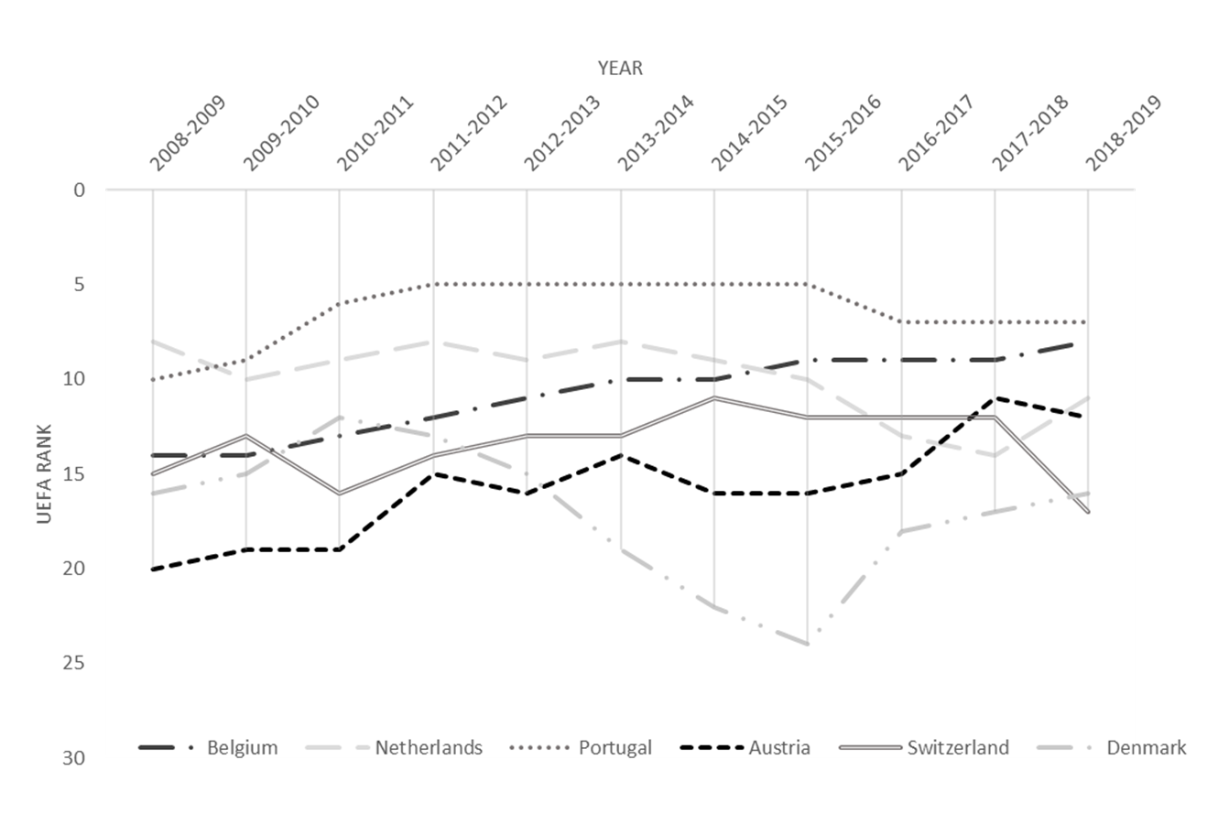
In terms of sports performance Belgium finished 9th place for the third year in a row in the season 17/18 on the UEFA rankings. This places Belgium among other European sub toppers, like Portugal and Russia, and just after the Big 5 competitions. In 18/19 Belgium succeeded even to rise one place. On figure 6 you get an overview of the UEFA ranking for countries with a similar population and GDP as Belgium. You can clearly see that Belgium did a consistent job in terms of sports performance during the years.

Figure 6.
Evolution of UEFA country coefficient.
Source. UEFA European Cup Coefficients Database, Kassies, B. (2020).

Conclusions in literature

Previous empirical studies analyzing the relationship between sports, financial and business performance as summarized below.
Authors | Conclusions
Dobson & Goddard (1998) | Indicate that different types of club in England have had markedly different experiences with regard to performance and revenue. The ‘bigger’ clubs enjoyed a larger share in their percentage share of revenues, but not followed by corresponding increase in sporting performance. Still they find evidence that chances of success are more favorable for more wealthy clubs. They point out the danger of this increasing gap and advice the football authorities to create a system of redistribution to keep the competitive balance.
Syzmanski (1998) | He investigated the relationship between league position and revenue of football clubs in England. He came to the conclusion that better sporting performance leads to higher revenue.
Gerrard (2005) | Gerrard used several variables like sports performance, profitability, team playing quality, wage costs, revenues, team fan base and team ownership status to perform a multiple regression analysis. He found that financial performance is negatively related to sporting performance in the English Premier League.
Brandes & Frank (2007) | Their work analyzed the relationship between competitive balance and fan attendance in professional European Soccer. They found a heterogenous relationship in the relationship between these two. In Germany and England they found an influence of fan attendance on competitive balance, but not vice versa.
Samagaio et al. (2009) | By making use of SEM they analyzed the influence of sporting performance and financial performance on the stock market performance. Most sports clubs seek to achieve a minimum level of profit and maximize sporting performance. They found moderate correlations between stock market returns, financial performance and sporting performance.
Rossi et al. (2013) | Rossi et al. (2013) investigated Italian football and the participation in European competitions. They show that participation and the European ranking, which depends on sporting performance, is very important in achieving financial success.
Kounetas (2014) | Examined the performance and technical efficiency of Greek football clubs after their national team won the Euro tournament in 2004. He found out that technical efficiency of Greek clubs appears to be specific to the resources of each club in terms of financial, individual and sport characteristics.
Galariotis et al. (2018) | Made use of two-stage approach by PROMETHEE II and PLS to investigate the relationship between different variables of soccer clubs in France. They found that the virtuous circle (Lago et al., 2004) is broken. Financial performance influences sports performance in a negative way. Football clubs in general seem to have a tendency to sacrifice financial health and sustainable growth over short-term sports objectives such as winning the championship. They indicate the crucial role of the FFP in the future of European football.

It is certain that the results of the above-mentioned summary are not all the identical and depend on the used methodology and the investigated countries. However, it is clear that there is a link between financial and sports performance. Dobson & Goddard (1998), Syzmanski (1998), Samagaio et al. (2009) and Rossi et al. (2013) found a rather positive relationship between sports and financial performance. On the other hand we have Gerrard (2005) and Galariotis et al. (2018) who observe a negative relationship between these two.

Research framework

Regarding the relevance of soccer and the increasing attention of the public, a study about the evolution in financial, sports and business performance between Belgium and two other major competitions in Europe is an interesting choice. To conduct this research I will use this main research question:
- Is a stable financial/business policy a propeller of successful sports performance within European soccer? Or is it the other way around?
- Do the same dynamics appear in the top competitions as well in the Belgian football competition?

Data collection

The data required for the mapping of performance was collected from various sources. For the financial performance the accounts of the various football clubs had to be consulted. The data for the Spanish and Italian competitions could not be retrieved due to paid-only access for these databases and are therefore not included in this work. The data from France was not complete to map the entire financial performance. The three analyzed competitions are: Belgium, England and Germany. This comes down to two leagues from the Big 5 competitions and one smaller league. To evaluate the business performance data the revenue of the soccer clubs was enlisted. Points in the domestic league and the ranking in the domestic cup competitions can be found on the websites of the national football associations. For European competitions the results are published on the website of the UEFA. On figure 7 you get an overview the sources of these parameters.
Performance | Parameters
Financial Performance | - Jupiler Pro League, Belgium: Nationale Bank van België (2020)  - Bundesliga, Germany: Unternehmensregister (2020)  - Premier League, England: Companies House (2020)  - Net transfer fees: Transfermarkt (2020)
Business Performance | - Revenue: NBB, Unternehmensregister (2020) and Companies House (2020)  - Match attendance: Transfermarkt (2020)
Sporting Performance | - Points in domestic league: countries’ national association website  - Ranking in domestic cup competitions: countries’ national association website  - Points in European competition: UEFA
Figure 7.
Overview of data sources of financial, business and sporting performance.
The data is collected for a period of ten years, from the season 2008/09 till 2017/18, for Belgium and Germany. The English competition was not complete and ranges between 2008/09 and 2016/17. Each league contains a selection of 12 teams that have played in the highest division for most seasons, following the work of Galariotis et al. (2018) and Barros & Leach (2006). It was not entirely possible to follow the rule of teams who only played in the highest division because of data limitations. In Germany two teams who consistently performed in the highest division were not possible to obtain because their financial statements are incorporated in the one of their mother company, this concerns Bayer Leverkusen and VFL Wolfsburg, the first belongs to the pharmaceutical giant Bayer and the other to Volkswagen group. For Belgium and England all expected clubs are included in the analysis. On figure 8 you have an overview of the 36 examined clubs. The number in brackets indicates how many seasons the team performed in the highest division in the period between 2008 and 2018.

Jupiler Pro League (BE) |  | Bundesliga (GE) |  | Premier League (UK)
KRC Genk (10) |  | Borussia Dortmund (10) |  | Manchester United (10) | 
KAA Gent (10) |  | Bayern München (10) |      | Arsenal (10) | 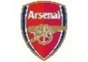
Standard Liège (10) |  | FC Schalke 04 (10) |  | Chelsea (10) | 
RSC Anderlecht (10) |  | Werder Bremen (10) |  | Liverpool (10) | 
Club Brugge (10) |  | B. Mönchengladbach (10) |  | Manchester City (10) | 
KSC Lokeren (10) |  | TSG 1899 Hoffenheim (10) |    | Tottenham Hotspur (10) | 
SV Zulte Waregem (10) |  | Hamburger SV (10) |  | Everton (10) | 
KV Kortrijk (10) |    | Eintracht Frankfurt (9) |  | Stoke City (10) | 
RSC Charleroi (9) |  | Hannover 96 (9) |  | West Ham United (9) | 
KV Mechelen (9) |    | Herta BSC (8) |  | Newcastle United (8) | 
Cercle Brugge (7) |  | FC Köln (8) | 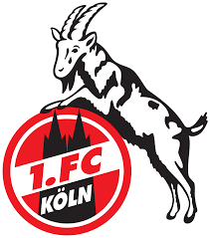 | Aston Villa (8) | 
STVV (6) |  | FC Augsburg (7) |  | Fulham (6) | 
Figure 8.
Overview of the 36 analyzed clubs.

Methodolgy

The methods used for the analysis in this work can be subdivided into three main parts. First of all, the data is presented and summarized with some descriptive statistics, complemented by the evolution of some important variables. Secondly, a PROMETHEE II ranking, also known as a method to make multicriteria decisions, is used to rank the financial performance of the football clubs, this is done to be able to make use of a Partial Least Squares Structural Equation Modeling Approach (PLS-SEM). This last step is based on the work of Galariotis et al. (2018), they introduce this new method and try to challenge the classical method, DEA. With this form of analysis it is possible to investigate the relationship between the different measures of performance, as well as the strength, the sign, and the direction of this relationship. In the last step the model of Galariotis et al. (2018) is challenged to see whether another model could lead to new insights. A factor analysis is used to analyze the financial construct from the first model, followed by looking at the correlation over time. Further on, a regression model and partial correlation analysis has been performed to look into the relationship of these new constructs. In the end the PLS-SEM is executed again with the redefined model.
The two stage-approach from Galariotis et al. (2018) starts with ranking the football clubs based on their business and financial performance by means of PROMETHEE II. This work didn’t perform this for the business performance because only revenue was used to measure this, and so no trade-off had to be made here. The calculation of the sporting index followed the work of Samagaio et al. (2009). This measure consists of the sum of four components: the average points per game, reaching the quarter final for national cup tournaments and/or European tournaments and ultimately a bonus is added for every team that ends in the top 3 of the national competition. As mentioned before this system is slightly adapted for the Belgian competitions as they have less access to enter the European competitions. Surviving the group stage of the Europa League or Champions League is already a huge achievement for a Belgian soccer club. They got one point for surviving the group stage, two for reaching the next round and three if they make it to the quarter-final or further, still all the other components are handled in the same way as the other two competitions. But this may of measuring has implications for the creation of general models because the sportive index is not measured in same for the three competitions.
The concept of PROMETHEE II will first be explained in more detail. PROMETHEE (Preference Ranking Organization Method of Enrichment Evaluations) II is a multicriteria method which can be used to evaluate certain entities when multiple evaluation criteria are involved. This measure is known for its efficiency and simplicity and has applications in different fields like: economics, agriculture and the industrial field (Goletsis et al. 2003; Duvivier et al. 2007; Corrente et al. 2014a; Caballero et al. 2016). This method allows a to create a preference among pairs {a, b}, in which a and b represent football clubs. The PROMETHEE II method includes the evaluation of the different football clubs based on n criteria. Each criterion receive a certain weight, depending on its importance. The higher the weight the more important it becomes in the evaluation. Ultimately the preference index π(a, b), based on the preference between a and b, ranges between 0 and 1 (Galariotis et al., 2018).

π(a, b) = $\sum_{j=1}^{n}{p_{j}} H_{j }$($d_{ab}^{j}$) (1)

The overall performance of an alternative a, compared to all the other m alternatives, is captured through the net-flow index, this measure aggregates all the strengths and weaknesses of each alternative compared to its pears. This measure is defined as the following:
ϕ(a) = $\frac{1}{m-1}$ $\sum_{∀b}{[π(a, b) - π(b, a)]}$ (2)

This indicator contains values between -1 and 1. A value close to one indicates that a is strongly preferred over all other alternatives. If the value reaches -1 shows that the competing alternatives are strongly preferred over a (Galariotis et al., 2018).

In this work the following 9 criteria are used for the PROMETHEE II method: Operating Margin (+), Return On Sales (+), Return on Equity (+), Return on assets (+), Liquidity (+), Financial Indebtness (-), Financial Autonomy (+), Financial Independence (+) and Net Transfer Value (+) A ‘+’ indicates that having the highest value is preferred whereas ‘-‘ shows that the lowest value is preferred. To perform this method the program ‘Visual PROMETHEE Academic’, which provides a preference index and a visual representation, is utilized. This program has been developed in a joint venture between the ULB and the Canadian company Visual Decision (Mareschal, n.d.).

In the second step the analysis looks further into the possible relationships of the different forms of performance, based on the rankings made in the first step, by using the PLS-SEM approach. This method is a second-generation method that is able to handle the limitations of regression based approaches (Haenlein & Kaplan, 2004; Galariotis et al., 2018). This method allows to discover the direction, causality, significance and their sign. This method assumes no distributional assumptions for the data and is particularly suitable for handling very small data sets (n = 12), this technique maximizes power and creates the possibility to estimate the path coefficients (Galariotis et al., 2018). Galariotis et al. (2018, p. 599) quote the following: “Another advantage of PLS is that it allows the construction of latent variables that are combinations of the original variables. This construction allows testing the financial, business and sports components and related constructs in all their possible combinations.” This is the perfect tool to analyze the relationships between the different components of performance.
For the construction of the PLS model the work of Galariotis et al. (2018) is fully pursued and can be captured by the following three equations:
x = $∀_{x}$ ξ + δ (3)
y = $∀_{y}$η + ε (4)
η = Bη + $∂$ξ + ζ (5)

where
- x: independent (exogenous) variable that is observed (manifest)
- ξ: independent (exogenous) variable that is unobserved (latent)
- $∀_{x}$: coefficients relating unmeasured independent variables to measured independent variables
- δ: error in observed independent variable
- y: dependent (endogenous) variable that is observed (manifest)
- η: dependent (endogenous) variable that is unobserved (latent)
- $∀_{y}$: coefficients relating unmeasured dependent variables to measured dependent variables
- ε: error in observed dependent variable
- ζ: sources of variance in η not included in ξ
- B: coefficients interrelating unmeasured dependent variables
- ∂: coefficients relating unmeasured independent variables to unmeasured dependent variables
Galariotis et al. (2018) are describing the PLS-SEM in a very clear way. In this work the latent variables are financial, business and sports performance, which are all related in a reflexive way to 10 measurement observed variables for each country. The PLS model follows a logic of three steps. First the weights relations for the indicators which are linked to the unobservable variables are estimated. In the second step case values for each unobservable variable are calculated, using the weight relationship from step one as an input. Finally these values are used in a set of regression equations to determine the parameters for these structural relationships. This model is clearly based on the estimation of the weight relationship. 1000 iterations were executed with the SmartPLS program. The PLS-SEM makes use of a two-step estimation process to estimate the weights (Cassel et al., 1999; Galariotis et al., 2018):
- In the first step an outside approximation is performed, in this step case values for each latent variable are estimated. This estimation of weights is comparable with principal-component analysis (Cassel et al., 1999).
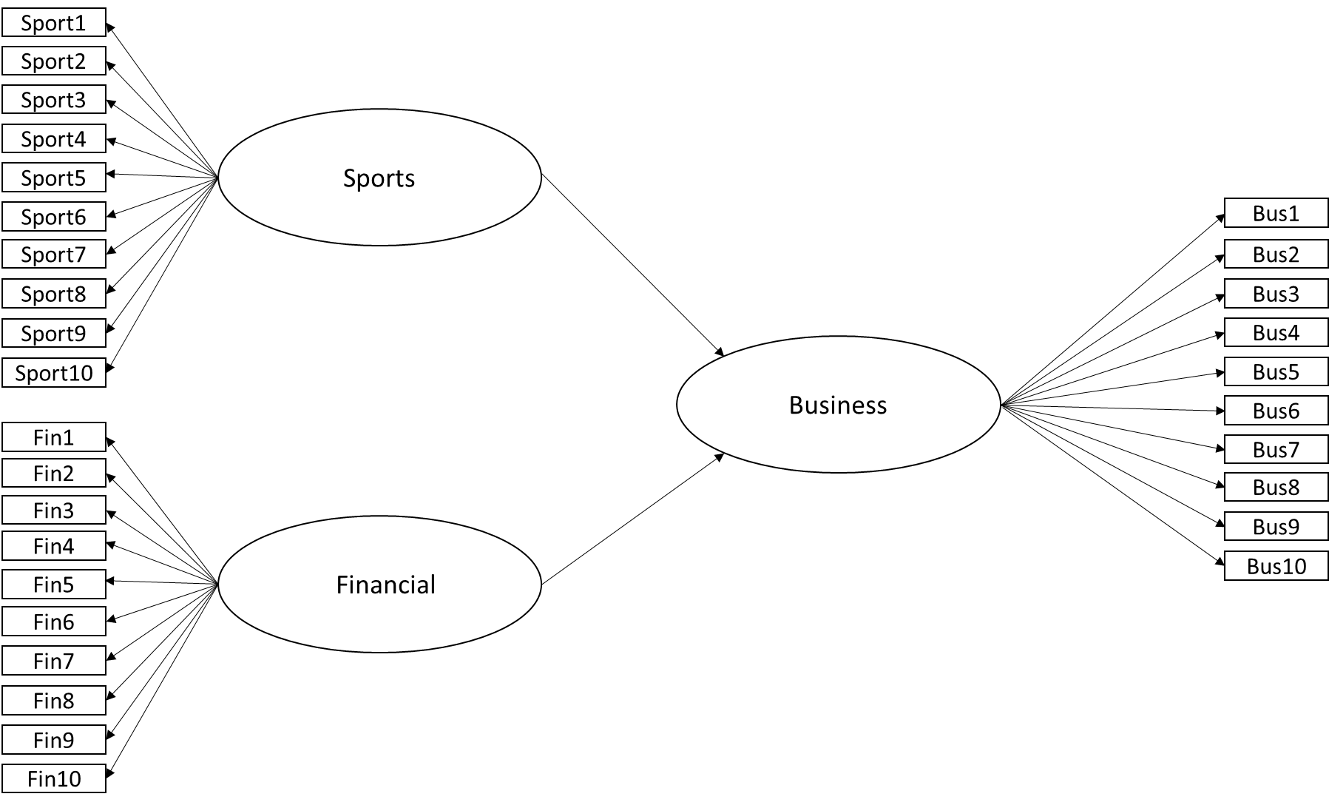
- Secondly an inside approximation is executed in which improved the previous estimated case values. They are now defined as a weighted average of neighboring latent variables. Using this second estimate of the case values, the weight relations are modified and the process of estimation is repeated until convergence of the case values is achieved and a fixed estimation is made (Cassel et al., 1999).

Figure 9. Representation of PLS Model with the significant path coefficients. this model consists of two components: the structural model (the rounded shapes), which shows the relationship of the endogenous independent variables (here sports and financial performance) and the exogenous variable (here business performance). Different specifications can be made, depending on the significance. These three variables are defined by the observable data that can be found in the small windows (Galariotis et al., 2018).

Finally to test the quality and reliability of the model the measures used by Galariotis et al. (2018) are followed, they make use of the construct reliability and convergent validity. The construct reliability is tested by the internal composite reliability (ICR), this measure is based on Jöreskog’s ρ (Jöreskog, 1971) and should contain a value above 0.70. Secondly, the convergent validity is evaluated as the average of the squared factor loadings of the measures of their respective construct, this value has to be above 0.50 and is based on the work of Fornell and Larcker (1981). In the end the overall explicative power, R², is checked and the corresponding relationships and strengths of the different dimensions of performance as well.

The computer program used to perform this PLS-SEM analysis is called ‘SmartPLS’. It is a program which allows researchers to create powerful models and execute multivariate analysis in a very understandable way and provides many ways to validate the created models (Ringle et al., 2015).

Results

The analysis follows the guidelines explained in the methodology and will focus on the description of some of the major criteria.

Descriptives and trends in European Soccer

First of all the financial performance of the different countries has been reviewed. To begin with, the indicators: revenue, operating income and net income are discussed. There is a clear positive evolution in the sum and the mean of the revenue in all the three competitions. Belgium scored the highest during the ten year time span, with an increase 155% in terms of revenue, followed by the Premier League with 136% and finally the Bundesliga with 122%. figure 10 shows this increase in mean revenue.
Figure 10. Evolution of mean revenue.
The variables operating income and net income show the same trend, the operating income extremes shows more outliers. These two variables fluctuate each year for every competition. Although, it is interesting to look more into detail to the evolution of net income. Belgium shows a slight downward trend over the years, while Germany shows a slightly positive trend and England fluctuates more, but in a rather positive way, as can be seen on Figure 11.
Figure 11. Evolution of mean net income.
The mean total and fixed assets per competition increased strongly over the years. However, in Germany there is a remarkable decrease from 2009/10 until about three seasons later. This is also reflected in the percentage increase in assets over the years. Germany scores the lowest for the evolution of the total assets and fixed assets, with an increase of 77% and 90% respectively. If this number is compared with Belgium, respectively a growth of 133% and 247%, and England with respectively 181% and 143%, there exist differences to note here.

Figure 12. Evolution of mean total assets (left) and mean fixed assets (right).

Another clear difference between Belgium and the other two can be seen when the net transfer fees are being analyzed. Belgium is the only competition that manages to present both an average positive transfer balance and a positive sum of net transfers over the last 10 years. In the Premier league we find a clear declining trend. On the other hand the Belgian competition is not able to maintain a mean positive net income during the years.

Figure 13. Evolution of the net transfer sum (left) and mean net transfers (right).
Another measure to investigate is the evolution of the mean total debt in the three competitions. The Premier League is showing a clear increase in the creation of debt, compared to the Jupiler Pro League and the Bundesliga who are able to maintain a stable level of mean debts during the years as can be seen on figure 14.

Figure 14. Evolution of the mean total debt (left) and mean total debt (right).

The buffers and financial reserves built in by the clubs are briefly discussed here on figure 15. The mean provisions are increasing greatly for German soccer clubs and doubled in the investigated period. In the Premier League the same thing happened but with only half of the absolute numbers, compared to Germany. In terms of equity, the English competition shows the highest increase mean equity, by a factor of 2.5. Maria (2008) indicates that the increase of foreign investment in the Premier League is leading to more ‘fresh’ money and forms an explanation for the increase in mean equity. Belgium shows a slight decrease in terms of mean provisions and a slight increase mean equity.

Figure 15. Evolution of the mean provisions (left) and mean equity (right).

In this part the attendance is briefly discussed. When the average attendance of the football clubs is mapped, there is a clear difference between the Belgian league and the two Big 5 leagues. On figure 16 the average attendance over the ten years stays is displayed and shows a rather stable trend. Belgian clubs manage to only fill its stadia for an average of around 70%, while in England and Germany this figure lays around 90%. If we look at the boxplots on figure 16 we also see that the data shows much more outliers in the two directions for Belgium than for Germany and England.

Figure 16. Evolution and distribution of the average attendance.
Subsequently, the measure of competitive balance was also surveyed. The used microeconomic measure is the Herfindahl Index. This measure is calculated twice, once based on the market share and one time on the sporting results. All the percentage market shares were calculated and multiplied by 100 and then the market shares were quadrated and accumulated. The higher the value the lower the competitive balance in a competition (Brandes & Frank, 2007). The calculated Herfindahl Index can be seen on figure 17. The Belgian competition shows the highest value for competitive balance, based on the revenues of the different clubs, but if we look at the the Herfindahl index, based on sporting results, Belgium shows mainly the lowest value for the competitive balance.
Figure 17. Evolution of the Herfindahl index, based on revenue (left) and sports performance results (right).

Secondly the situation of Germany is adressed. The Bundesliga finds itself between the Jupiler Pro League and the Premier Leauge based on financial results, but based on sports results we see that the value of the Herfindahl index is clearly higher in the period from 2011 till 2016 then the other two competitions. This is striking, but somewhere also understandable since 2 subtoppers (Wolfsburg and Bayer Leverkussen) have been left out of the analysis. Ultimately, the Premier League shows the lowest value if we look at the market shares of revenue, but if we look to the sports distribution, a similar value to the Belgian competitions is retrieved. It is clear that Belgium has the lowest competitive balance when the revenues are used. On the other hand, the sportive Herfindahl index shows that Germany has a lower competitive balance than the two other competitions. To conclude the English competition can be seen as the competition with the highest competitive balance when the two figures are combined.

PLS-SEM results

In the next section the PLS-SEM results are discussed, starting with the Premier League, followed by the Bundesliga and as last on the Jupiler Pro League is discussed. These models have been tested, following the statistical measures from Galariotis et al. (2018). All the statistical output for these three models can be found in appendix I.

Premier League

As can be seen in Table 1 the model for the Premier League is decent, only the financial performance dimension is not showing preferable results. The Convergent Validity (AVE) should be above 0.5 according to the work of Fornell and Larcker (1981). This is the case for the business and sports dimension, but not for financial with only reaching a value of 0.347. The Reliability (ICR) is showing the same trend, the business and sporting performance attain a value of 0.985 and 0.940 respectively, whereas financial performance just has a value of 0.683 and falls beneath the threshold of 0.70, following the work of Nunnally & Bernstein (1994).
Latent Variables | Convergent Validity (AVE) | Reliability (ICR)
Business | 0.881 | 0.985
Financial | 0.347° | 0.683°
Sports | 0.616 | 0.940
°: below minimum value
Table 1. Convergent and reliability measures for the Premier League
Further on, the upper representation from figure 18 indicates a high value of 0.874 for R². The bootstrapped path coefficients only show significant value of 0.912 (p-value: 0.000) for sporting and business performance. The financial performance has no significant impact on business performance (p-value: 0.869). Business performance has a significant impact on sports performance of 0.798 (p-value: 0.000) with a R² value of 0.917. Once again the financial dimension has no significant impact on the sports performance (p-value: 0.385).
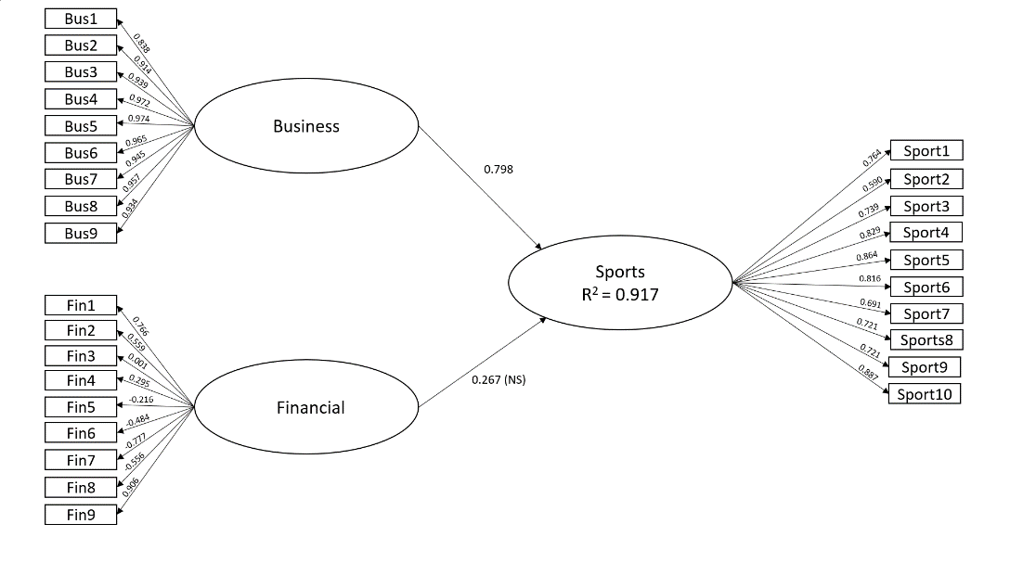
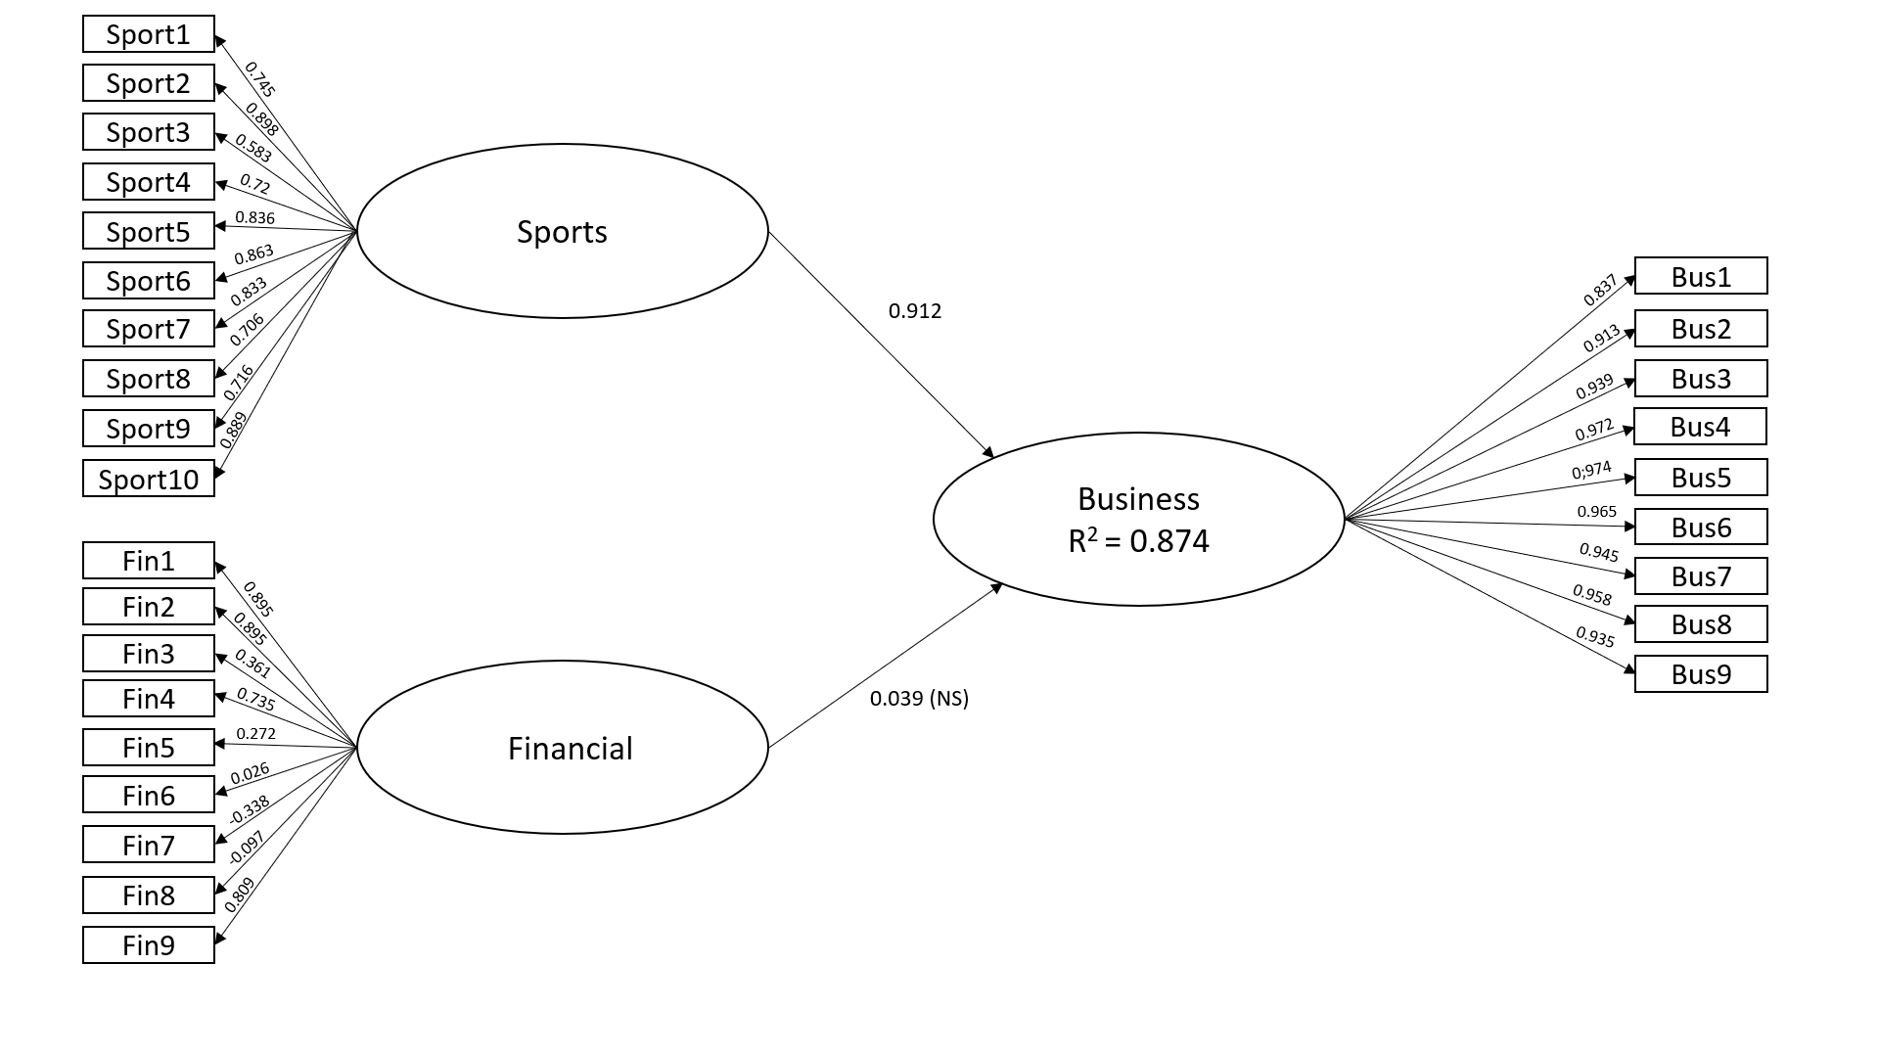
Figure 18. Graphical presentation of the PLS-SEM model – Premier League
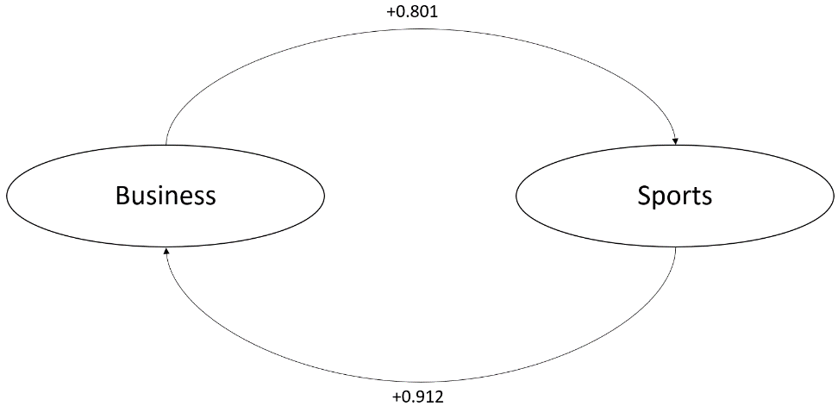
The analysis of the PLS-models clearly shows a significant relationship between the sport performance and business performance in both directions and looks like shown on figure 19.

Figure 19. Presentation of the significant relationship between business and sports performance in the PL.

Bundesliga

The second discussed competition is the Bundesliga. After following the same procedure and criteria as in England there is no significant relationship between any of the three measures of performance. The p-value and t-statistics for this model can be found in Appendix I. The Sports performance is the only dimension with high validity and reliability, as can be seen on table 2, but has no significant relationships with the two other measures of performance.
Latent Variables | Convergent Validity (AVE) | Reliability (ICR)
Business | 0.231° | 0.527°
Financial | 0.307° | 0.763
Sports | 0.718 | 0.959
°: below minimum value
Table 2. Convergent and reliability measures for the Bundesliga

Jupiler Pro League

Last but not least the Belgian competition is analyzed. The Belgian competitions shows a similar relationship as the Premier League. Once again, the financial dimension is showing no high values for validity and reliability. The business dimension do contain high values, as shown in table 3. The sports performance falls just below the limit of 0.5 and is therefore a doubtful case but is reinforced by a reliability of 0.904 and should be considered useful.
Latent Variables | Convergent Validity (AVE) | Reliability (ICR)
Business | 0.848 | 0.982
Financial | 0.180° | 0.420°
Sports | 0.491° | 0.904
°: below minimum value
Table 3. Convergent and reliability measures for the Jupiler Pro League.
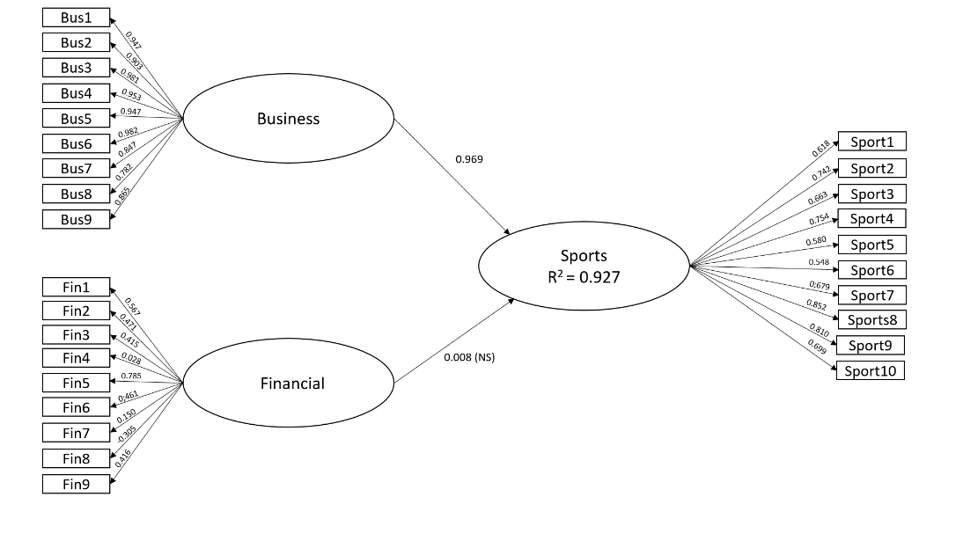
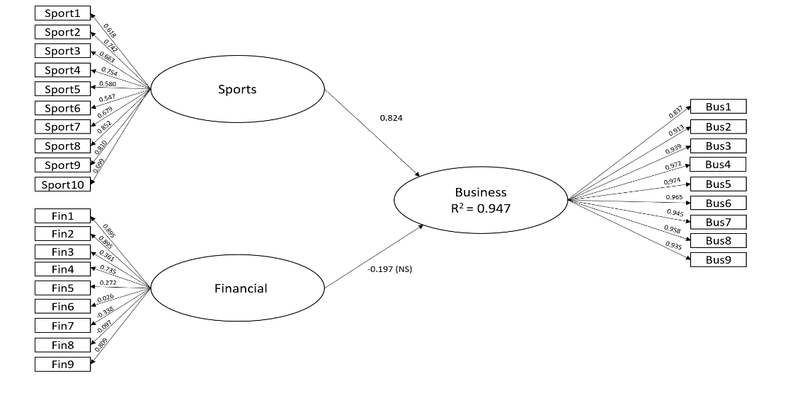
Once again the financial dimension does not establish significant path coefficients, the according t-statistics and p-value for the three latent variables can be found in Appendix I. In the PLS-SEM model, sporting performance has a positive impact of 0.824 (p-value: 0.000) on business performance with an R² value of 0.947 and vice versa business performance has a positive impact of 0.969 (p-value: 0.000) on sporting performance with an R² of 0.927, as can be seen on figure 19.

Figure 19. Graphical presentation of the PLS-SEM model – Jupiler Pro League
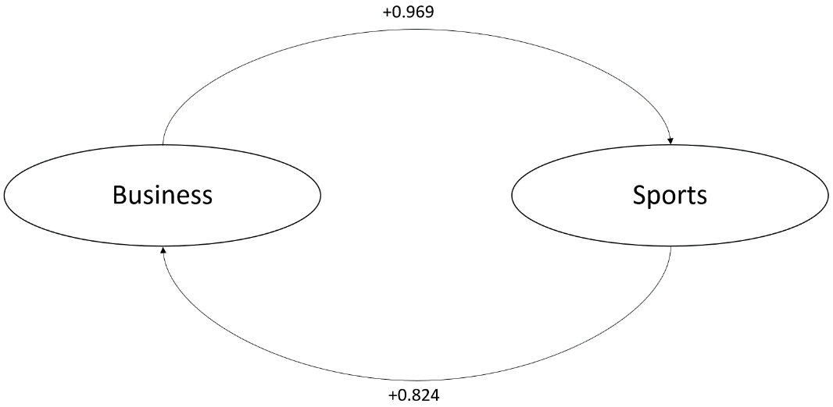
The analysis of the models clearly shows a significant relationship between the sport performance and business performance in both directions and looks like shown on figure 20, also here the financial dimension is not significant and therefore could not be used.
Figure 20. Presentation of the significant relationship between business and sports performance in the JPL.
These results clearly differ from that relationship that Galariotis et al. (2018) found in their work. In the three countries the dimension of financial performance is never significant and should maybe be reconsidered because this measure is captured by 9 underlying variables. Therefore the dimensions of financial performance are reconsidered by executing a factor analysis in the next part, to see whether the correct classification has been made or if there is maybe another division more suitable.

Factor analysis

A factor analysis has been performed to see if the financial component is well captured. The method and knowledge of the factor analysis is based on the course ‘Market research’, instructed by professor Malaika Brengmann (VUB), and makes use of the work of De Pelsmacker & Van Kenhove (2019). The dataset for the three countries has been combined. To be able to perform a factor analysis a KMO and Bartlett’s-Test needs to be executed to see if factor analysis is useful. The KMO-value should contain a value above 0.5, in this analysis this value reaches 0.750. The Bartlett’s test also shows significance (value 0.000). This output is retrieved in appendix II. It is notable that three underlying components explain 85.77% of the variance, as shown on table 4. The according scree plot can be found in Appendix II.

Component | Total | % of Variance | Cumulative %
1 | 4,614 | 51,267 | 51,267
2 | 2,027 | 22,524 | 73,790
3 | 1,078 | 11,980 | 85,770
4 | 0,509 | 5,650 | 91,421
5 | 0,285 | 3,166 | 94,587
6 | 0,169 | 1,881 | 96,468
7 | 0,149 | 1,658 | 98,126
8 | 0,125 | 1,391 | 99,517
9 | 0,043 | 0,483 | 100,000

Table 4. Principal component analysis output
 | Component
 | 1 | 2 | 3
Total Assets | .942 | .035 | .245
Total Equity | .889 | -.061 | .101
Fixed Assets | .872 | -.130 | .335
Revenue | .853 | .219 | .279
Net Transfer Fees | -.659 | .437 | -.019
Net Income | -.006 | .944 | -.072
Operating Income | -.021 | .916 | -.204
LT-Debt | .162 | -.103 | .938
Total Debt | .398 | -.225 | .833
Extraction Method: Principal Component Analysis.
Rotation Method: Varimax with Kaiser Normalization.
a. Rotation converged in 4 iterations.
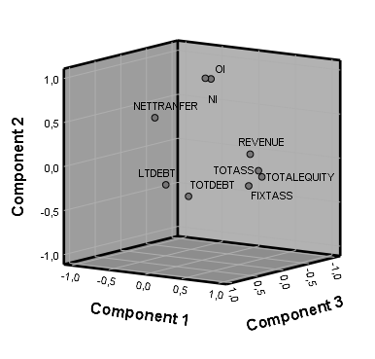
When looked deeper into these three components by making use of the component matrix and a varimax rotation, following the work of De Pelsmacker & Van Kenhove (2019). This is done to make the factors orthogonal and eliminate the correlation between the estimated factors (IBM, 2020). On figure 21 the rotated components are calibrated and are given in a numeric way and on a three-dimensional axis. The first one refers to the total assets, fixed assets, total equity and revenue and are now identified as ‘size’ (green circle). The second component exist of net income, operating income and net transfer and is from now on defined as ‘profitability’ (blue circle). The last one consist of total and long-term debt and is combined into ‘debt’ (red circle). The values for this new variables is equal to the scores obtained from the factor analysis. This score is based on the Regression Method. These estimated scores have a mean of 0 and a variance equal to the squared multiple correlation between the estimated factor scores and the true factor values. These factors are rotated to make the correlation 0 between the three constructs (IBM, 2020).

Figure 21. Numerical (right) and graphical (left) representation of coherent constructs.
The conclusion that can be drawn from this factor analysis is that the financial component consists of three separate constructs.
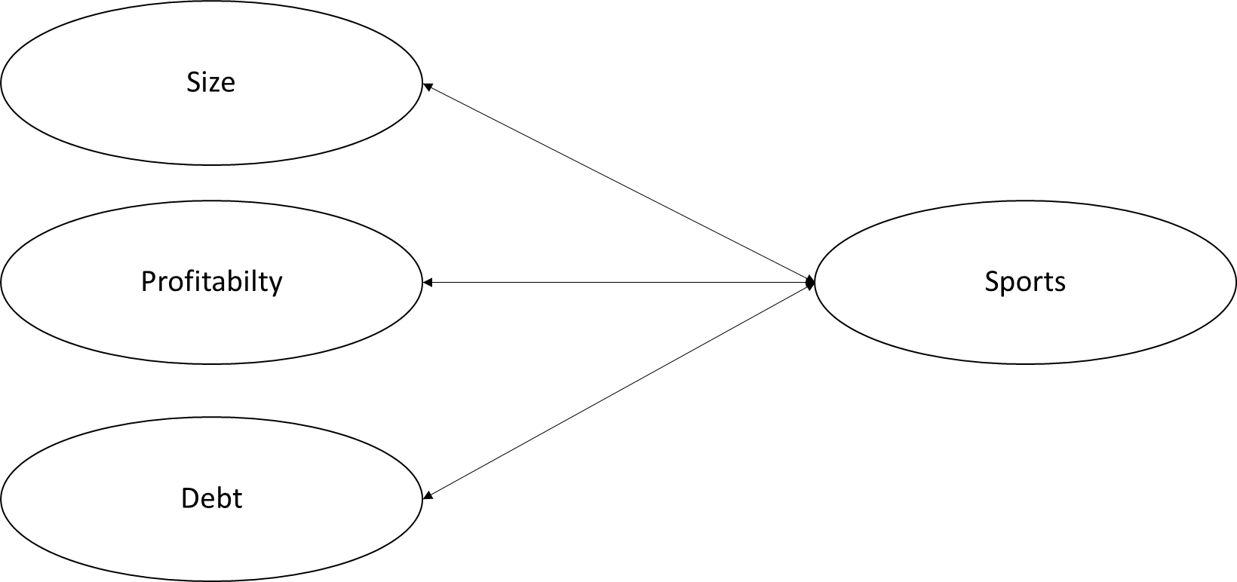
These ensure that the PLS-SEM can be redefined, as shown on figure 22, with three very clear and understandable components. The previous PLS-SEM identified business performance through the variable revenue, this measure is now incorporated in ‘size’. The objective is to use the previously used PLS-SEM method again in the final step to see if this leads to new insights.

Figure 22. Graphical presentation of redefined PLS-SEM.

Correlation over time

One of the shortcomings in the work of Galariotis et al. (2018) is the absence of the variable time, which is mapped out in a rather limited way. The time span of the data over 10 years gives possibilities to take a look at time lags. This could lead to new insights and possibly a reorientation of the model (Boudt, 2018). To investigate the effects over time the sporting results for the three competitions are correlated with the three redefined variable, based on the scores from the factor analysis. The difference is considered two years in the back and two years in the front: sports_{t-2}, sports_{t-1}, sports_{t}, sports_{t+1} and sports_{t+2}. The Pearson correlation is used here. This gives the following correlation matrix.
sports | Size_{t} | Profitability_{t} | Debt_{t}
sports_{t-2} | 0.418** | 0.113 (NS) | 0.194**
sports_{t-1}, | 0.422** | 0.158** | 0.169**
sports_{t} | 0.447** | 0.151** | 0.182**
sports_{t+1} | 0.394** | 0.047 (NS) | 0.152**
Sports_{t+2} | 0.437** | -0.016 (NS) | 0.117*

**. Correlation is significant at the 0.01 level (2-tailed).
*. Correlation is significant at the 0.05 level (2-tailed).

It is remarkable that size and debt show a fairly consistent and significant correlation with sports performance during the time shifts. Profitability only shows a significant relationship with sports performance in the same year and the sporting achievements from the year before. This gives an indication that it is rather sporting results gained in the previous year that will lead to profitability in the next year and not vice versa.

Regression – GLM

8.5.1 Regression diagnostics

To perform a regression analysis several assumptions are made and have to be validated, especially for the error terms. Based on the work of Neels (2017) and Boudt (2018) six assumptions are tested:
- Linearity: The relationship between the dependent variable and the independent is linear. As can be seen on the figures in appendix IV (figure 1), a linear relationship is present.
- Multicollinearity: This indicates an excessive consistency of the independent variables. This can be checked on the basis of the correlation of the different variables. This could ensure that these variables explain the same variance, this is not desired in the model. This can be tested through the VIF (Variance Inflation Factor)(Neels, 2017).
- Autocorrelation: The absence of autocorrelation refers to the fact that there exists no autocorrelation between the residuals of the different independent variables, Cov(ε_{i},ε_{j}) = 0. This is tested with the Durbin-Watson statistic, the measure ranges between 0 and 4. A value of 2 indicates no autocorrelation (Neels, 2017).
- Homoscedasticity: The assumption of homoscedasticity states that the error term ε_{i} got the same variance for every combination of independent variables, Var(ε_{i}) = σ² (Neels, 2017). This can be investigated by drawing a scatter plot of the actual error terms and the predicted error terms.
- Values of the residuals are normally distributed: This is investigated through a normal probability plot. If this criteria is not met, a transformation of the variables could be to done in order to resolve this.
- Outliers: No influential cases are influencing your models. This is tested through the Cook’s distance. All values should be under 1 to not have a major influence on the model.

After checking these assumptions for the general model (all three competitions, n=346) and the separate countries (BE, n=120, GE, n=120, UK, n=108) it is clear that most of the assumptions are clearly met. The output for the general model can be found in appendix III and for the countries separately in appendix VI. Linearity is fulfilled. The multicollinearity is checked by VIF and indicates for all the four models a favorable value. Next, the autocorrelation is checked through the Durbin-Watson statistic and the models are all indicating values around 2, which indicate an absence of autocorrelation. Subsequently, homoscedasticity is checked by investigating the scatter plot. This plot show two values exceeding the range between –3 and +3, the model for the UK shows no value exceeding this range, Germany one and Belgium two. The normality of the residuals can also be found in appendix VI and does not show full normal distribution, the variables could be transformed to improve this. Last but not least the outliers are checked through the Cook’s distance. These values all remain well below 1 and this part poses no concern .

8.5.2 General Linear model

The next step is to perform the linear regression, based on the work of Kris Boudt (2018). After checking the correlation in section 8.4 a model is created where sportive forms the dependent variable. Scale, profitability and debt are the independent variables and are based on the factor scores from 7.4. A linear regression model will be implemented for the three countries collectively and then a model for the three countries separately will be carried out.
On table 5 a summary of the model for the three countries can be retrieved (n=346). The three components are all significant, according to the t-statistics and p-value (below 0.05). This combined model has a rather low R²-value of 0.256.
Model | Beta | t-statistic | Sig. (p-score)
(Intercept) | 3.047 | 27.624 | 0.000
Size | 1.060 | 9.6 | 0.000
Profitability | 0.358 | 3.241 | 0.000
Debt | 0.430 | 3.897 | 0.000

Table 5. GLM-output of general model.

The next step is to look into the model for each separate country. This analysis is ran and combined into the following output in table 6. Is it remarkable that in each competition one of the three is not significant. In Belgium and the UK this one is profitability (0.132 and 0.911 p-values, respectively), in Germany this is debt (p-value: 0.605). This leads to different regression models for the three countries, as can be seen on table 6.
Country | Model |  | Unstandardized Coefficients |  | Standardized Coefficients | t | Sig.
Country |  |  | Beta | Std. Error | Beta | t | Sig.
BE |  | (Constant) | 9.012 | .934 |  | 9.644 | .000
BE |  | Size | 6.960 | 1.506 | .370 | 4.622 | .000
BE |  | Profitability | 1.198 | .790 | .136 | 1.516 | .132
BE |  | Debt | 5.510 | 1.651 | .297 | 3.337 | .001
GE |  | (Constant) | 2.336 | .226 |  | 10.358 | .000
GE |  | Size | 2.244 | .219 | .715 | 10.235 | .000
GE |  | Profitability | .678 | .311 | .154 | 2.179 | .031
GE |  | Debt | -.289 | .557 | -.030 | -.519 | .605
UK |  | (Constant) | 2.257 | .215 |  | 10.504 | .000
UK |  | Size | .900 | .140 | .519 | 6.445 | .000
UK |  | Profitability | -.013 | .113 | -.009 | -.112 | .911
UK |  | Debt | .668 | .116 | .465 | 5.777 | .000

Table 6. GLM-output of model for each competition.

What immediately stands out on table 7 is that in Germany a large part of the variance (R² = 0.670) can be explained by the three variables of the regression model. Whereas if the other countries have been assessed we see a lower explanatory score for Belgium (R² = 0.428) and England (R² = 0.369).

Country | R² | Adjusted R² | N | F | Durbin-Watson
BE | .428 | .413 | 120 | 28.9 | 2.323
GE | .670 | .661 | 120 | 77.693 | 1.910
UK | .369 | .351 | 108 | 20.275 | 1.964

Table 7. R², R² adjusted, F-statistic, Durbin Watson for each competition.

On top of that an regression analysis has also been performed with some other variables that had the highest explanatory power, as discussed in section 7.4. The used variables for the regression are total assets, net income and long-term debt. These showed slightly lower values than the one with the factor scores and are not shown here.

Partial Correlation

Partial Correlation | All
Sports - Size | 0.460**
Sports - Profitability | 0.172**
Sports - Debt | 0.206**
Debt - Size  Debt - Profitability  Size - Profitability | -0.095 (NS)  -0.035 (NS)  -0.079 (NS)
Another way to investigate the relationship between the different constructs and to be able to perform a path-analysis is through the partial correlation (Tacq, 1997). Partial correlation allows to outline the correlation of two variables of rational scale after checking for one or more control variables. This is mainly done to avoid misinterpretation if another variable is numerically related to the other two variables of interest. In this case there are two control variables and is therefore called a partial correlation of the second order (Blalock, 1979). Statistically, the partial correlation between X and Y, given a set of n controlling variables Z = {Z₁, Z₂, ..., Z_{n}}, written ρ_{XY}·Z_{n}, is the correlation between the residuals from X (e_{X}) and Y (e_{Y}) resulting from the linear regression of X with Z and of Y with Z, respectively (Guilford & Fruchter, 1973). Below the table and the according representation of the relationships is displayed in numbers on table 8 and visually on figure 23. The partial correlation between the two variables is always controlled by the other two. This global model is only created to give an indication of the partial correlation and path-coefficients of the different constructs.

**. Correlation is significant at the 0.01 level (2-tailed).
*. Correlation is significant at the 0.05 level (2-tailed).

Table 8. Partial correlation-output of model for all competitions combined.
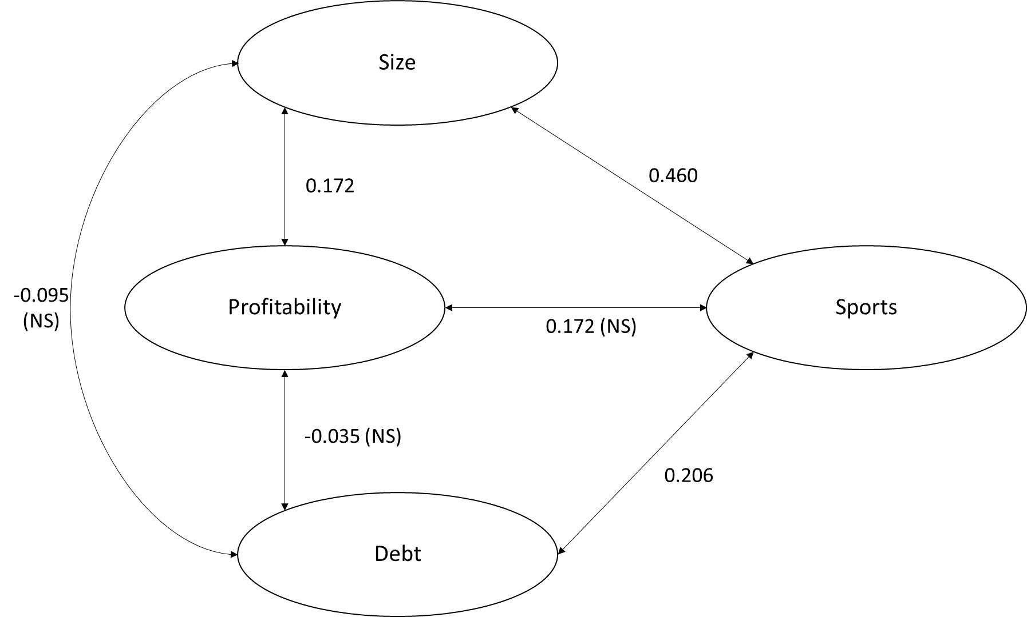
Figure 23. Graphical presentation of partial correlation paths (ALL).
This process is repeated for each individual competition and gives the following output. The partial correlation differ in all the three leagues, only sporting and size are showing a rather high and significant relationship in all three competitions, as can be seen on table 9.

Partial Correlation | Jupiler Pro League |  | Bundesliga | Premier League
Sports - Size | 0.394** |  | 0.690** | 0.534**
Sports - Profitability | 0.139 (NS) |  | 0.199* | -0.011 (NS)
Sports - Debt | 0.296** |  | -0.048 (NS) | 0.493**
Debt - Size  Debt - Profitability  Size - Profitability | 0.088 (NS)  0.426**  0.173 (NS) |  | -0.178 (NS)  0.337**  0.313** | -0.436**  0.072 (NS)  -0.060 (NS)
**. Correlation is significant at the 0.01 level (2-tailed).
*. Correlation is significant at the 0.05 level (2-tailed).

Table 9. Partial correlation-output of model for all competitions combined

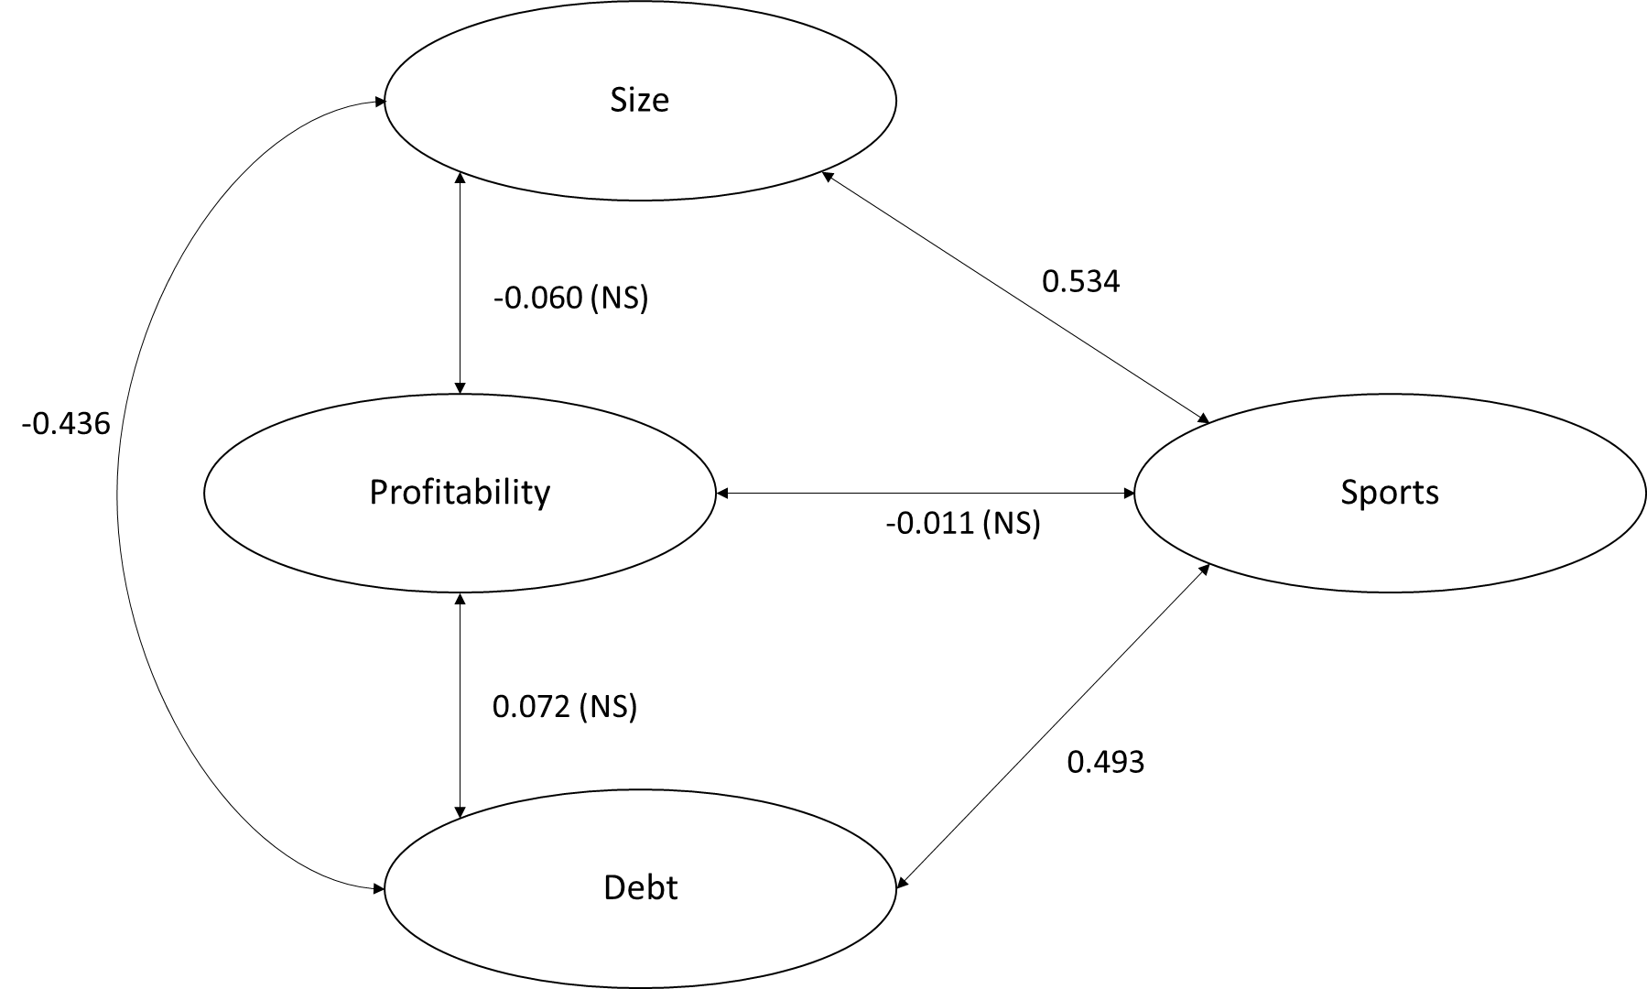
Firstly the English competition is addressed. Sports performance and size are showing a positive correlation of 0.534. Sporting success goes also hand in hand with debt. An interesting relationship in the Premier League is the one of -0.436 between size and debt, which indicates that size and debts are showing a high correlation. These relationships can be seen on figure 24.
Figure 24. Graphical presentation of partial correlation paths (UK).
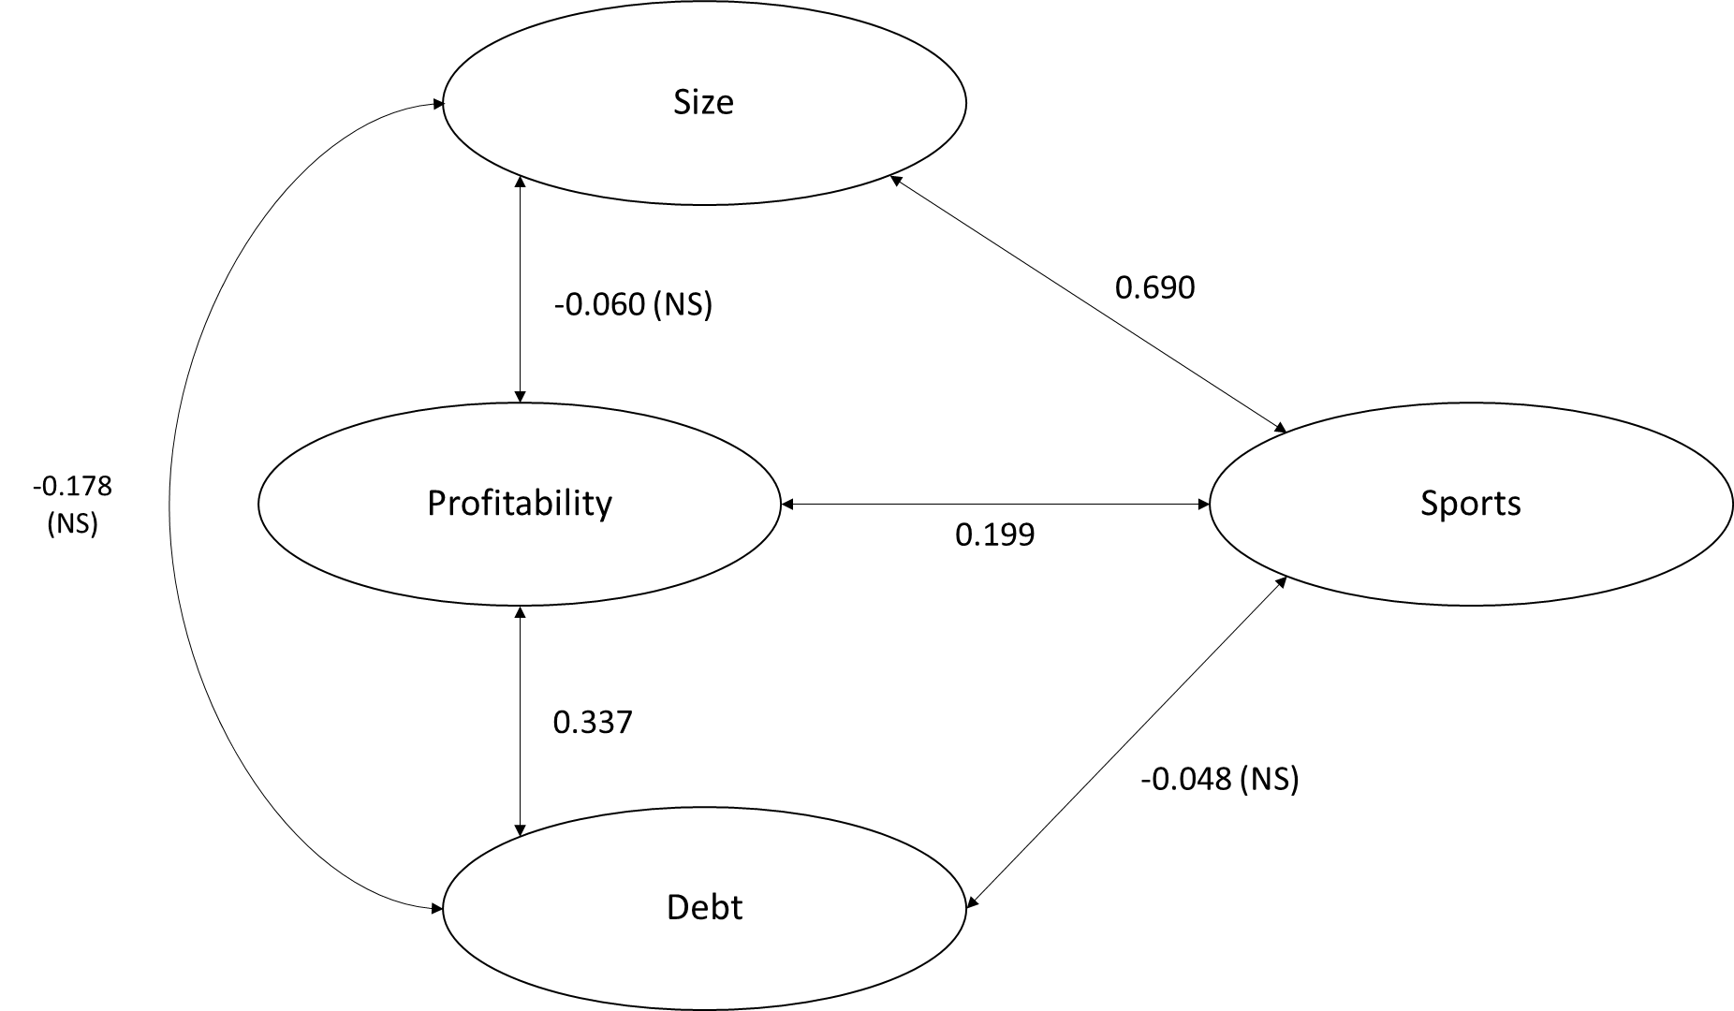
The next partial path model is the one of the Bundesliga, displayed on figure 25. From all the models the Bundesliga shows the highest partial correlation between size and sports, a value of 0.690. It is also interesting to see that this is the only competition which shows a significant partial correlation of 0.199 between profitability and sporting performance. Finally, there is positive relationship of 0.337 between debt and profitability which indicates that making profit goes hand in hand with creating debt and vice versa.

Figure 25. Graphical presentation of partial correlation paths (GE).
Thirdly, the path-model for the Belgian competition is discussed on figure 26. Size has a significant and positive partial correlation with sporting performance. Another interesting fact is the positive relationship between profitability and debt, like in Germany. Finally, debt also interacts positively with sporting performance with a factor of 0.296.
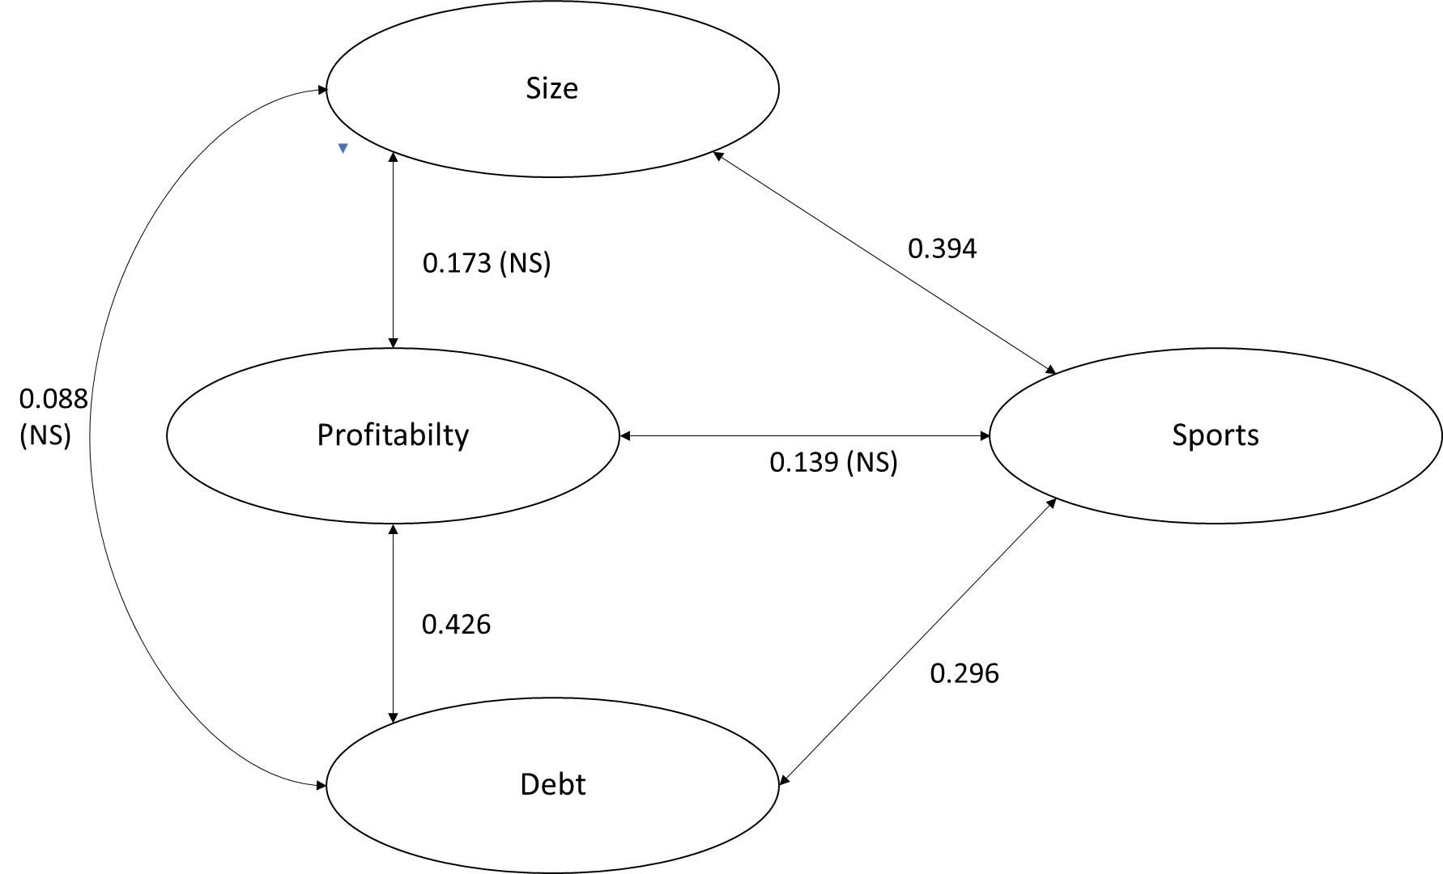

Figure 26. Graphical presentation of partial correlation paths (BE).

This parts shows again some similarities between the three competitions Belgium has on the one hand two similar significant paths as Germany and on the other hand also two in common with the English competition.

8.7 Redefined PLS-SEM results

In this step it is interesting to see if the redefined model has led to any new results. To summarize and discuss the results of the redefined model the same structure as in 8.2 is followed. One thing that has been added is the analysis of all the three competitions. All the t-statistics and p-values for the three competitions can be retrieved in appendix V.
On table 10 we see the results for the combined model. We see that 3 of the 4 are scoring above the thresholds of 0.5 for the validity and 0.7 for the reliability. Only profitability has a low score of 0.292 in terms of validity, but a good value for reliability of 0.706. The value for R² is 0.557
Latent Variables | Convergent Validity (AVE) | Reliability (ICR)
Size | 0.787 | 0.971
Profitability | 0.292° | 0.706
Debt  Sports | 0.681  0.596 | 0.920  0.917
°: below minimum value
Table 10. Convergent and reliability measures for all the competitions.

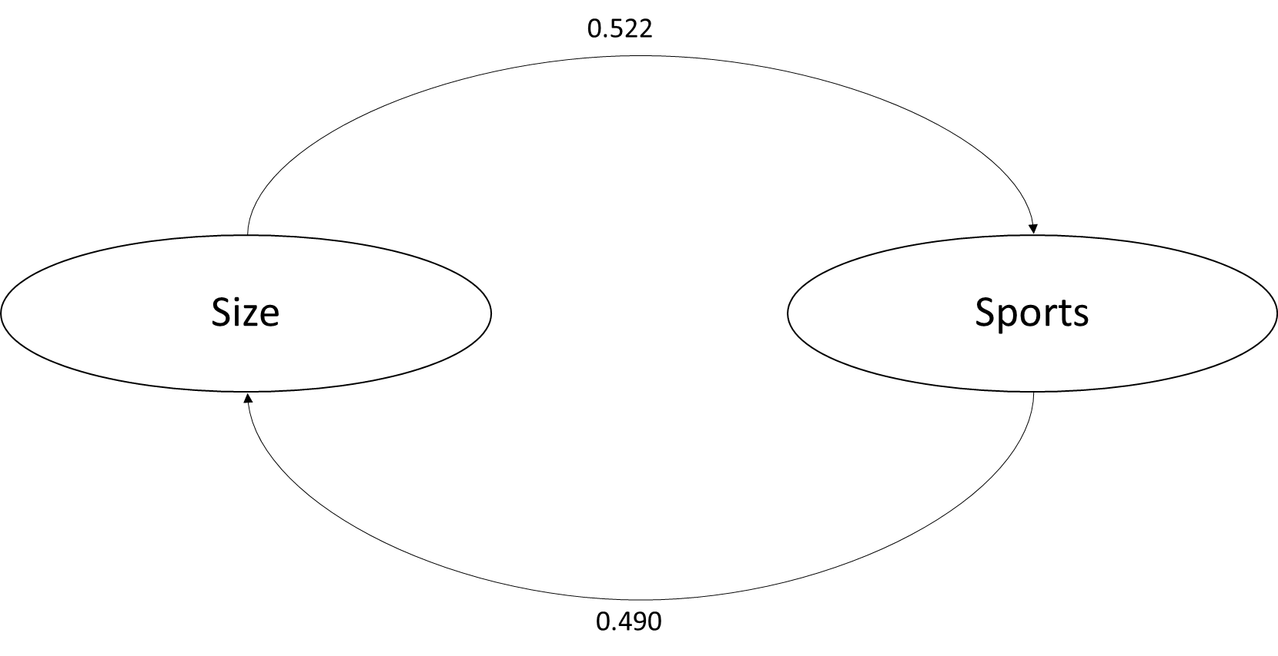
Out of the t-statistics and the p-value a significant relationship can be found between size and sports performance, with the according values shown on figure 27. These two constructs reinforce each other.
Figure 27. Presentation of the significant relationship between size and sports performance in all competitions.

8.7.1 Premier League (2)

The validity and reliability measures of this model are scoring very good, as can be seen on table 11, with no value below the borderline. This model has an R² of 0.693.
Latent Variables | Convergent Validity (AVE) | Reliability (ICR)
Size | 0.927 | 0.991
Profitability | 0.506 | 0.873
Debt  Sports | 0.912  0.583 | 0.989  0.925

Table 11. Convergent and reliability measures for the Premier League.
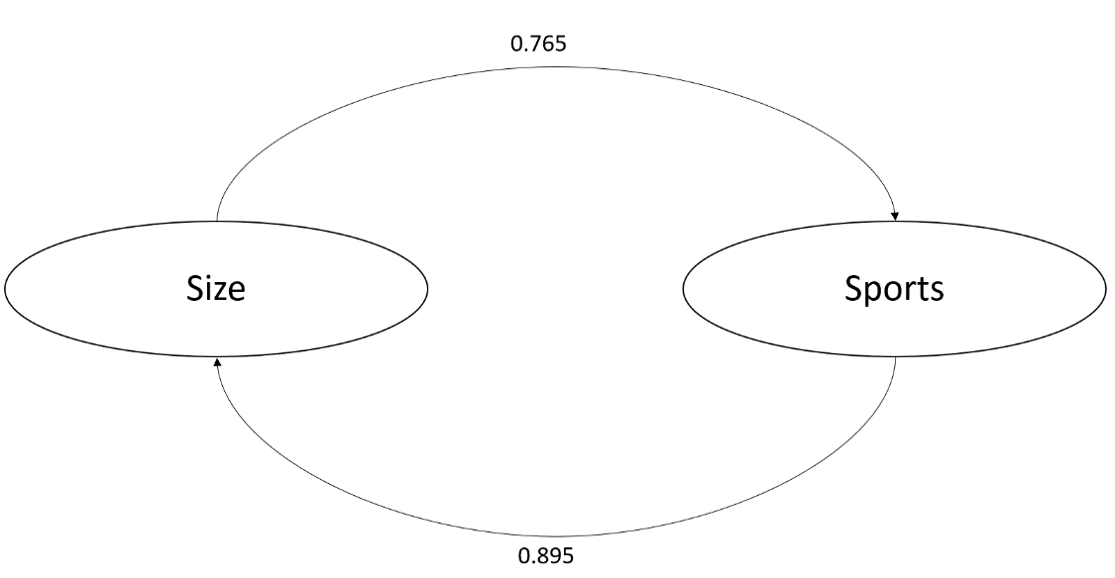
The Premier League follows the results from the general model and indicates a significant relationship between the constructs, size and sports. This relationship is higher than in the general model and show a strong positive relationship as can be seen on figure 28.
Figure 28. Presentation of the significant relationship between size and sports performance in Premier League.

8.7.2 Bundesliga (2)

The German football competitions is not showing any significant relationships, the same as in the results from 8.2.2. Also the measure of validity is scoring very low, as displayed on table 12, three values score below 0.5 and therefore these results should be handled with care.
Latent Variables | Convergent Validity (AVE) | Reliability (ICR)
Size | 0.932 | 0.992
Profitability | 0.479° | 0.863
Debt  Sports | 0.202°  0.424° | 0.025°  0.805

°: below minimum value
Table 12. Convergent and reliability measures for the Bundesliga.

8.7.3 Jupiler Pro League (2)

The Jupiler Pro League shows the same pattern as the German football league and no significant relationships can be found between the different constructs, as can be seen in on table 13 and in appendix V. The validity is once again scoring rather low with two values below 0.5 and two close to that value.
Latent Variables | Convergent Validity (AVE) | Reliability (ICR)
Size | 0.623 | 0.942
Profitability | 0.326° | 0.641°
Debt  Sports | 0.568  0.490° | 0.926  0.904

°: below minimum value
Table 13. Convergent and reliability measures for the Jupiler Pro League.

8.8 Fixed Effects

Country | R² |  | Adjusted R²
BE | .573 | .516
GE | .763 | .731
UK | .602 | .542
Although this work focuses on a comparison across and between the leagues, it is also interesting to take into account the individual clubs more formally. Imai & Kim (2019) indicate that making use of fixed effects in a statistical regression model allows to vary freely across individuals, or here football clubs. It is mostly used in social sciences to control for any case-specific (time-invariant) attributes. Panel data is a requirement to perform a fixed effects regression. The model follows the same setup as the GLM in 8.5, the only difference is the fixed factors are the clubs now. This model indicates now R²-values higher than 0.5 for all three competitions, as can be seen on table 13.

Table 13. R² and Adjusted R² for the three countries

The most striking observation is that profitability now shows a significant influence on the dependent variable sporting performance for all three competitions, as can be seen on table 14. Germany is the only country where debt also has a significant and negative relationship with sporting performance. This once again shows the sustainable way in which the Bundesliga operates.
Country | Variable | β-Value
BE  GE  UK | Profit  Profit  Debt  Profit | 2.23**  0.940**  -2.022*  0.313*

**. Correlation is significant at the 0.01 level (2-tailed).
*. Correlation is significant at the 0.05 level (2-tailed).

Table 14. General Linear Model with fixed effects – significant results.

This relationship was also found in the 8.6. The complete output can be found in appendix VI. At the same time, the positive effect of sportive and size disappears, as this now is being captured by ‘club’ fixed effects. Not only do these findings reveal that there are considerable differences between clubs; ‘within’ clubs, sporting success and profitability do go hand in hand (which seems to boil down for UK and BE clubs as a ‘loss’ minimizing strategy).

Limitations and further research

Like all literature this research was subject to some limitations. Firstly, the data is limited to three competitions. Future research might benefit from including data on clubs in the Spanish, Italian and French competitions. It could also be very interesting to add another competition, comparable to the Belgian one, to analyze the difference between top competitions and lower ranked competitions. The effect of the implemented Financial Fair play rules can also be of interest for future research (see in this respect the recent evolution of net income in the Premier League towards more profitability).
Another limitation relates to the absence of two top teams in the Bundesliga (Bayer Leverkussen and Wolfsburg), this could lead to biased results for this competition. For the execution of the PROMETHEE II several German clubs did not have any equity indication in their financial statements which led to a financial ranking with only 5 variables instead of 9. Another aspect relates to the Belgian competition which is not completely the same as the other two. As Belgian clubs perform on average less well within European tournaments (compared to England and Germany), this might influence the interpretation of the overall models, but still makes a comparison between (and within) countries possible.
Future research could definitely be performed to investigate the clubs individually to make more comparisons between clubs and eventually divide them into clusters or groups. This could be interesting to define the different business models in European soccer and is definitely an intriguing path to explore in future research. The last part, concerning the fixed effects signals the relevance of such an approach.

Conclusion

The performance of the competitions in England, Germany and Belgium have been analyzed in several ways in this research and have also led to various results. First of all, the descriptives give an indication of the trends in the three competitions. Revenue increased in all three competitions, but is accompanied with higher total and long-term debt, only the Bundesliga is able to maintain a steady level of debt. If we look into the mean net income we see that this mean is overall positive in Germany, whereas in the Premier League this swings from year to year with several years indicating significant losses and in Belgium this number oscillates around 0. In terms of net transfers, Belgium is the only competition which is able to maintain a mean positive net transfer balance. In the Premier League this number is getting more and more downhill every year. If we look at the implementation of PROMETHEE II and the PLS-SEM, based on the work of Galariotis et al. (2018), a clear positive relationship between sportive and business performance for the English and Belgian competition is found, they reinforce each other. After questioning the used financial dimension of performance, this dimension has been redefined by means of a factor analysis. This led to three new constructs: size, profitability and debt. In the next step the correlation over time was investigated. The sportive performance in year_{t} and in year_{t-1} had a positive correlation with profitability. The General Regression Model showed similarities between England and Belgium, where size and debt form the significant variables, whereas in Germany these are size and profitability. The investigation through partial correlation brought up that size and sports are partially correlated in all three competitions. Belgium had two out of its three significant partial path coefficients in common with the two other competitions. Next, the redefined PLS-SEM showed only a significant relationship between size and sports performance and vice versa in the Premier League and none for the other two.
In the last step the clubs in particular are investigated through a linear regression with fixed effects to look deeper into the heterogeneity of the individual clubs. There we do find out that if we investigate the clubs individually, that profitability is the only significant variable to explain sporting performance for all three competitions.

In this work the negative financial input on the reinforcing relationship between sporting and business performance, as found in the work of Galariotis et al. (2018), is not obtained. This analysis do show very similar relationships for England and Belgium, where business and sportive performance do form a reinforcing relationship, but after redefining, only the Premier League shows the same dynamics between size and sporting performance, this is a very similar result to the work of Syzmanski (1998). Germany, on the other hand is completely different and never shows this particular phenomenon, but indicates a significant relationship between profitability and sporting performance. This thesis also shows that the link between financial and sporting results in European football is practically non-existent. This says something about the financial vision of football clubs. These clubs in general indeed appear to have a tendency to create debt and sacrifice financial health to obtain sporting success. Football clubs in England and Belgium are rather money consuming machines than money making machines whereas we can conclude that the ‘average’ business model of the Bundesliga shows more sustainability over the long term.

References

- Andreff, W., & Szymanski, S. (2006). Handbook on the Economics of Sport. Edward Elgar Publishing.
- Bachmaier, B., Lammert, J., Plumley, D., Wilson, R., & Hovemann, G. (2018). Regulatory intensity in English and German professional football. Sport, Business and Management: An International Journal.
- Barros, C. P., & Leach, S. (2006). Performance evaluation of the English Premier Football League with data envelopment analysis. Applied Economics, 38(12), 1449-1458.
- Binder, J. J., & Findlay, M. (2012). The effects of the Bosman ruling on national and club teams in Europe. Journal of Sports Economics, 13(2), 107-129.
- Blalock, H. M. (1979). Social Statistics. Revised. New York, NY: McGraw-Hill. Box, GEP, & Cox, DR (1964). An analysis of transformations. Journal of the Royal Statistical Society, Series B (Methodology), 26(2), 211-252.
- Boudt, K. (2018). Econometrie. Brussel, België: VUB.
- Boudway, I. (2018, 12 juni). Soccer Is the World’s Most Popular Sport and Still Growing. Consulted on 13 December 2019, from https://www.bloomberg.com/tosv2.html?vid=&uuid=3df57010-1db6-11ea-bde7-43b929379f43&url=L25ld3MvYXJ0aWNsZXMvMjAxOC0wNi0xMi9zb2NjZXItaXMtdGhlLXdvcmxkLXMtbW9zdC1wb3B1bGFyLXNwb3J0LWFuZC1zdGlsbC1ncm93aW5n
- Brandes, L., & Franck, E. (2007). Who made who? An empirical analysis of competitive balance in European soccer leagues. Eastern Economic Journal, 33(3), 379-403.
- Bundesanzeiger. (2020). Unternehmenregister [Dataset]. consulted from https://www.bundesanzeiger.de/ebanzwww/wexsservlet?page.navid=to_start&global_data.designmode=eb&global_data.language=de
- Caballero, R., Romero, C., & Ruiz, F. (2016). Multiple criteria decision making and economics: An introduction. Annals of Operations Research, 245(1–2), 1–5.
- Cain, L. P., & Haddock, D. D. (2006). Measuring parity: Tying into the idealized standard deviation. Journal of Sports Economics, 7(3), 330-338.
- Cassel, C. M., Hackl, P., & Westlund, A. H. (1999). Robustness of partial least-squares method for estimating latent variable quality structures. Journal of Applied Statistics, 26, 435–446.
- Companies House. (2020, 21 mei). UK Governement. Consulted from https://www.gov.uk/government/organisations/companies-house
- Conn, D. (2017, 20 February). How the FA betrayed their own game. consulted from https://www.theguardian.com/football/2004/nov/14/sport.comment
- Cooper, E. A. (2011). Impumelelo - The Interdisciplinary Electronic Journal of African Sports. Consulted on 12 February 2020, from: https://www.ohio.edu/sportsafrica/journal/Volume7/cooper.html
- Corrente, S., Figueira, J. R., & Greco, S. (2014). Dealing with interaction between bipolar multiple criteria preferences in PROMETHEE methods. Annals of Operations Research, 217(1), 137–164.
- Da Silva, M. (2019, 21 mei). UEFA’s financial fair play rules: 7 things you need to know. Consulted on 1 March 2020, from https://www.dw.com/en/uefas-financial-fair-play-rules-7-things-you-need-to-know/a-48804148.
- Dejonghe, T., & Vandeweghe, H. (2006). Belgian football. Journal of sports economics, 7(1), 105-113.
- Deloitte. (2019). Socio-economische impact studie van de Pro League op de Belgische economie. Consulted from https://www2.deloitte.com/content/dam/Deloitte/be/Documents/technology-media-telecommunications/DeloittePro%20League%20brochure_NL.pdf
- DFL. (2018, 19 November). Report 2018: German professional football generates revenue in excess of €4 billion for the first time – 14 Bundesliga clubs with revenue over €100 million. Consulted on 11 April 2020, from https://www.dfl.de/en/news/2018-dfl-report-german-professional-football-generates-revenue-in-excess-of-4-billion-euros-for-the-first-time/
- Dietl, H. M., & Franck, E. (2007). Governance failure and financial crisis in German football. Journal of sports economics, 8(6), 662-669.
- Dietl, H. M., Franck, E., & Lang, M. (2008). Overinvestment in team sports leagues: A contest theory model. Scottish Journal of Political Economy, 55(3), 353-368.
- Dima, T. (2015). The Economics Of “Big Five” European Football Leagues. CES Working Papers, 7(2A), 434-442.
- Dobson, S. M., & Goddard, J. A. (1998). Performance and revenue in professional league football: Evidence from Granger causality tests. Applied Economics, 30(12), 1641–1651.
- Dobson, S. & Goddard, J. A. (2001). The economics of football (pp. 106-130). Cambridge: Cambridge University Press.
- Duvivier, D., Roux, O., Dhaevers, V., Meskens, N., & Artiba, A. (2007). Multicriteria optimisation and simulation: An industrial application. Annals of Operations Research, 156(1), 45–60.
- El-Hodiri, M., & Quirk, J. (1971). An economic model of a professional sports league. Journal of political economy, 79(6), 1302-1319.
- European Commission. (1998). The European Model of Sport. consultation paper of DGX.
- Fornell, C., & Larcker, D. F. (1981). Evaluating structural equation models with unobservable variables and measurement error. Journal of Marketing Research, 18(1), 39–50.
- Galariotis, E., Germain, C., & Zopounidis, C. (2018). A combined methodology for the concurrent evaluation of the business, financial and sports performance of football clubs: the case of France. Annals of Operations Research, 266(1-2), 589-612.
- Giulianotti, R. (2012). Football. The Wiley‐Blackwell Encyclopedia of Globalization.
- Goddard, J., & Sloane, P. J. (2005). 12 Economics of sport. Economics uncut: a complete guide to life, death and misadventure, 345.
- Gerrard, B. (2005). A resource-utilization model of organizational efficiency in professional sports team. Journal of Sport Management, 19(2), 143–169.
- Goletsis, Y., Psarras, J., & Samouilidis, J. E. (2003). Project ranking in the Armenian energy sector using a multicriteria method for groups. Annals of Operations Research, 120(1–4), 135–157.
- Guilford J. P., Fruchter B. (1973). Fundamental statistics in psychology and education. Tokyo: McGraw-Hill Kogakusha, LTD.
- Haan, Marco, Koning, Ruud H., & Van Witteloostuijn, A. (2002). Market forces in European soccer (Vol. 22). University of Groningen.
- Haas, D. J. (2003). Productive efficiency of English football teams—A data envelopment analysis approach. Managerial and Decision Economics, 24(5), 403–410.
- Haas, D. J., Kocher, M. G., & Sutter, M. (2004). Measuring efficiency of German football teams by data envelopment analysis. Central European Journal of Operations Research, 12(3), 251–268.
- Haenlein, M., & Kaplan, A. M. (2004). A beginner’s guide to partial least squares analysis. Understanding Statistics, 3(4), 283–297.
- Hoehn, T., & Szymanski, S. (1999). European football: the structure of leagues and revenue sharing. Economic Policy, 14(28), 204-240.
- Hughson, J., Moore, K., Spaaij, R. F. J., & Maguire, J. A. (Eds.). (2017). Routledge handbook of football studies. Routledge, Taylor & Francis Group.
- IBM. (2020). IBM Knowledge Center. Consulted from https://www.ibm.com/support/knowledgecenter/SSLVMB_24.0.0/spss/base/idh_fact_sco.html
- Imai, K., & Kim, I. S. (2019). When should we use unit fixed effects regression models for causal inference with longitudinal data?. American Journal of Political Science, 63(2), 467-490.
- Joos, F. (2019, 12 december). “Het is een race tussen een Arabische volbloed en een pony, dan is dit logisch”. Consulted on 10 November 2020, from https://sporza.be/nl/2019/12/12/filip-joos-over-de-g5-in-de-champions-league/
- Jöreskog, K. G. (1971). Statistical analysis of sets of congeneric tests. Psychometrica, 36(2), 109–133
- Kahane, L. H., & Shmanske, S. (Eds.). (2012). The Oxford Handbook of Sports Economics: Volume 1: The Economics of Sports. Oxford University Press.
- Kassies, B. (2020). UEFA European Cup Coefficients Database. Consulted on 12 February 2020, from https://kassiesa.net/uefa/data/
- Kelly, R. (2019). Chelsea transfer ban: Why FIFA sanctioned Blues & what is the appeal process? | Goal.com. Consulted on 6 March 2020, from https://www.goal.com/en-gb/news/chelsea-transfer-ban-why-fifa-sanctioned-blues-what-appeal/tt4ejezxvltd1k8r5symf4rkn
- Kounetas, K. (2014).Greek football clubs’ efficiency before and after Euro 2004 Victory: A bootstrap approach. Central European Journal of Operations Research, 22(4), 623–645..
- Lago, U., Baroncelli, A., & Szymanski, S. (2004). Il business del Calcio. Milano: Egea.
- Lee, Y. H. (2009). Evaluating Management Efficiency of Korean Pro-Soccer Teams Using DEA Analysis. International Journal of Applied Sports Sciences, 21(2), 93-112.
- Mareschal, B. (n.d.). PROMETHEE & GAIA Software. Consulted on 6 May 2020, from http://www.promethee-gaia.net/software.html
- Maria, A. (2008, 1 september). Takeovers & Foreign Investment: Is It Damaging The Premier League? Consulted from https://bleacherreport.com/articles/53131-takeovers-foreign-investment-is-it-damaging-the-premier-league
- McMahon, B. (2020, 17 februari). UEFA Bans Manchester City For 2 Years: Separating Facts From Fiction. Consulted on 6 March 2020, from https://www.forbes.com/sites/bobbymcmahon/2020/02/16/uefa-ban-manchester-city-for-2-years-separating-the-facts-from-fiction/#35669e37204f
- Mondal, M. (2019). Economic Impact of Sports on Society. Indian Journal of Research - Paripex, 8(3), 2250–1991.
- Michie, J., & Oughton, C. (2004). Competitive balance in football: Trends and effects (pp. 1-38). London: The sportsnexus.
- Müller, J. C., Lammert, J., & Hovemann, G. (2012). The financial fair play regulations of UEFA: an adequate concept to ensure the long-term viability and sustainability of European club football?. International journal of sport finance, 7(2).
- Nationale Bank from België. (2020). Balanscentrale. Consulted on 10 February 2020, from https://www.nbb.be/nl/balanscentrale.
- Neale, W. C. (1964). The peculiar economics of professional sports. The quarterly journal of economics, 78(1), 1-14.
- Neels, K. (2017). Multivariate Analyse (1ste editie). Leuven, Belgium: Uitgeverij Acco.
- Noll, R. G. (Ed.). (1974). Government and the sports business: Papers prepared for a conference of experts, with an introduction and summary (No. 8). Brookings institution.
- Nunnally, J. C., & Bernstein, I. H. (1994). Psychometric theory (3rd ed.). New York: McGraw-Hill.
- Peeters, T., & Szymanski, S. (2014). Financial fair play in European football. Economic Policy, 29(78), 343-390.
- De Pelsmacker, P., & Van Kenhove, P. (2019). Marktonderzoek, 5/e. Pearson Education.
- Penman, S. H. (2001). Financial statement analysis and security valuation. New York: The McGraw-Hill Companies.
- Pinnuck, M., & Potter, B. (2006). Impact of on-field football success on the off-field financial performance of AFL football clubs. Accounting and Finance, 46(3), 499–517.
- Preuss, H., Haugen, K., & Schubert, M. (2014). UEFA financial fair play: the curse of regulation. European Journal of Sport Studies, 2(1), 33-51.
- Reed, A. (2019, 30 mei). European soccer posts record revenues with the English Premier League leading the way. Consulted on 29 December 2019, from https://www.cnbc.com/2019/05/30/european-soccer-posts-record-revenues-as-epl-dominates-deloitte.html
- Ringle, C. M., Wende, S., and Becker, J.-M. (2015). "SmartPLS 3." Boenningstedt: SmartPLS GmbH, http://www.smartpls.com.
- Rossi, M., Thrassou, A., & Vrontis, D. (2013). Football performance and strategic choices in Italy and beyond. International Journal of Organizational Analysis.
- Rottenberg, S. (1956). The baseball players' labor market. Journal of political economy, 64(3), 242-258.
- Samagaio, A., Couto, E., & Caiado, J. (2009). Sporting, financial and stock market performance in English football: an empirical analysis of structural relationships. Centre for Applied Mathematics and Economics (CEMAPRE) working papers, 1-41.
- Schubert, M., & Könecke, T. (2015). ‘Classical’doping, financial doping and beyond: UEFA’s financial fair play as a policy of anti-doping. International Journal of Sport Policy and Politics, 7(1), 63-86.
- Sloane, P. (1969), ‘The labour market in professional football’, British Journal of Industrial Relations, 7, 181–99.
- Sloane, P. (1971), ‘The economics of professional football: the football club as utility maximiser’, Scottis Journal of Political Economy, 17, 121–46.
- Sports talk Florida. (2019, 8 september). Study finds huge wealth gap in European soccer - Sports Talk Florida - N. Consulted on 25 October 2019, from http://sportstalkflorida.com/featured/study-finds-huge-wealth-gap-in-european-soccer/
- Sporza. (2020, 18 March). Witte rook: Antwerp gaat akkoord met de deal over het voetbalcontract. Consulted from https://sporza.be/nl/2020/03/18/antwerp-gaat-akkoord-met-voetbalcontract/
- Szymanski, S. (1998). Why is Manchester United so successful?. Business Strategy Review, 9(4), 47-54.
- Szymanski, S. (2001). Income inequality, competitive balance and the attractiveness of team sports: Some evidence and a natural experiment from English soccer. The Economic Journal, 111(469), F69-F84.
- Szymanski, S. (2003a). The assessment: the economics of sport. Oxford Review of Economic Policy, 19(4), 467-477.
- Szymanski, S. (2003b). The Economic Design of Sporting Contests, in Journal of Economic Literature, vol. 41, n. 4, pp. 1137–1187.
- Szymanski, S. (2006). The future of football in Europe. Sports Economics After Fifty Years: Essays in Honour of Simon Rottenberg, Oviedo, Spain: University of Oviedo.
- Szymanski, S. (2010). Football economics and policy. Springer.
- Tacq, J. (1997). Multivariate analysis techniques in social science research: From problem to analysis. Sage.
- Transfermarkt. (2020). Voetbaltransfers, transfergeruchten, marktwaarden & nieuws [Dataset]. Consulted from https://www.transfermarkt.nl/
- UEFA. (2019, 23 januari). The history of UEFA. Consulted on 12 February 2020, from https://www.uefa.com/insideuefa/about-uefa/history/#:~:text=The%20Union%20des%20Associations%20Europ%C3%A9ennes,football%20administrators%20of%20the%20time.
- UEFA. (2020) How association club coefficients are calculated. Consulted on 24 February 2020, from https://www.uefa.com/memberassociations/uefarankings/country/about/
- Vonnard, P., & Quin, G. (2017). Did South America foster European football?: transnational influences on the continentalization of FIFA and the creation of UEFA, 1926–1959. Sport in society, 20(10), 1424-1439.
- Vrooman, J. (2007). Theory of the beautiful game: The unification of European football. Scottish Journal of Political Economy, 54, 314-354.
- Yang, C. H., Lin, H. Y., & Chen, C. P. (2014). Measuring the efficiency of NBA teams: additive efficiency decomposition in two-stage DEA. Annals of Operations Research, 217(1), 565-589.

Appendix

Appendix I
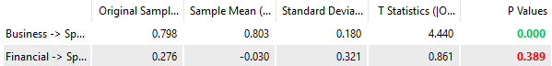


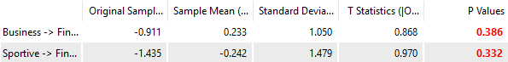

Figure 1. P-values and T-statistics for Path Coefficients - UK - PLS-SEM model.
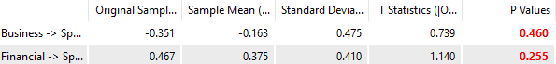

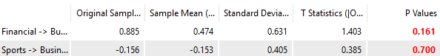

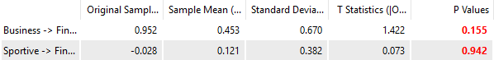

Figure 2. P-values and T-statistics for Path Coefficients -Germany - PLS-SEM model.

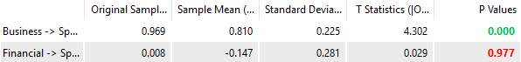



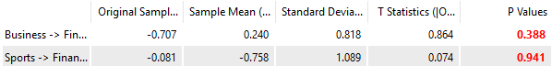

Figure 3. P-values and T-statistics for path coefficients Belgium - PLS-SEM model.

Appendix II

KMO and Bartlett's Test
Kaiser-Meyer-Olkin Measure of Sampling Adequacy. |  | ,750
Bartlett's Test of Sphericity | Approx. Chi-Square | 2912,716
Bartlett's Test of Sphericity | df | 36
Bartlett's Test of Sphericity | Sig. | ,000

Figure 4. Output KMO and Bartlett’s Test – Factor Analysis

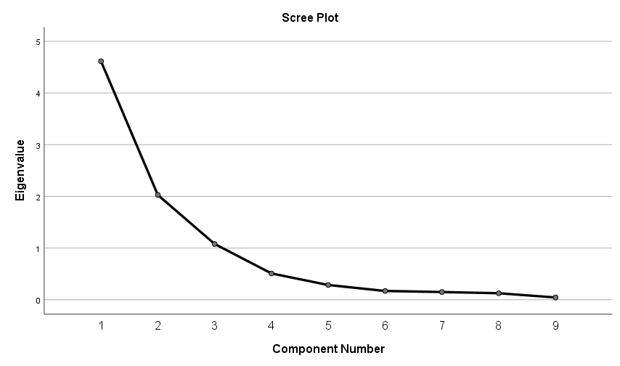
Figure 5. Scree Plot principal components analysis.

Component Matrixª |  |  |  |  |  | Rotated Component Matrixª
 | Component |  |  |  |  |  | Component
 | 1 | 2 | 3 |  |  |  | 1 | 2 | 3
REVENUE | 0,813 | 0,438 | -0,019 |  |  | REVENUE | 0,853 | 0,219 | 0,279
OI | -0,313 | 0,876 | 0,127 |  |  | OI | -0,021 | 0,916 | -0,204
NI | -0,246 | 0,882 | 0,243 |  |  | NI | -0,006 | 0,944 | -0,072
TOTASS | 0,914 | 0,305 | -0,142 |  |  | TOTASS | 0,942 | 0,035 | 0,245
TOTDEBT | 0,779 | -0,232 | 0,492 |  |  | TOTDEBT | 0,398 | -0,225 | 0,833
TOTALEQUITY | 0,823 | 0,226 | -0,277 |  |  | TOTALEQUITY | 0,889 | -0,061 | 0,101
FIXTASS | 0,932 | 0,112 | -0,091 |  |  | FIXTASS | 0,872 | -0,130 | 0,335
LTDEBT | 0,599 | -0,219 | 0,715 |  |  | LTDEBT | 0,162 | -0,103 | 0,938
NETTRANFER | -0,669 | 0,183 | 0,380 |  |  | NETTRANFER | -0,659 | 0,437 | -0,019
Figure 6. Output component matrix (left) and rotated component matrix (right).

Appendix III - Assumptions of General model
Appendix 1
Linearity (1)
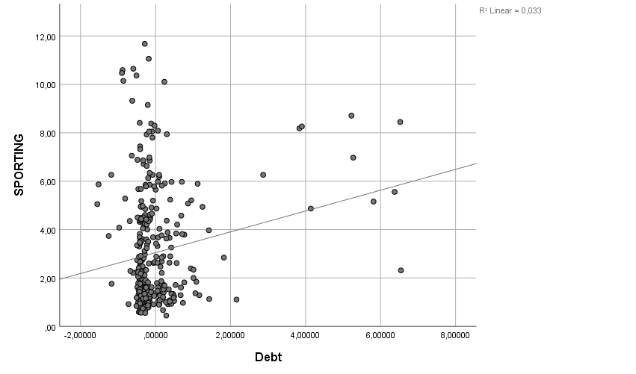
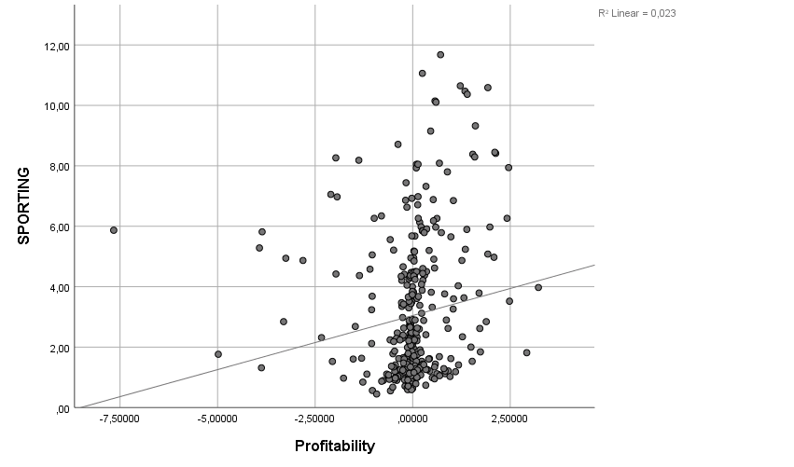
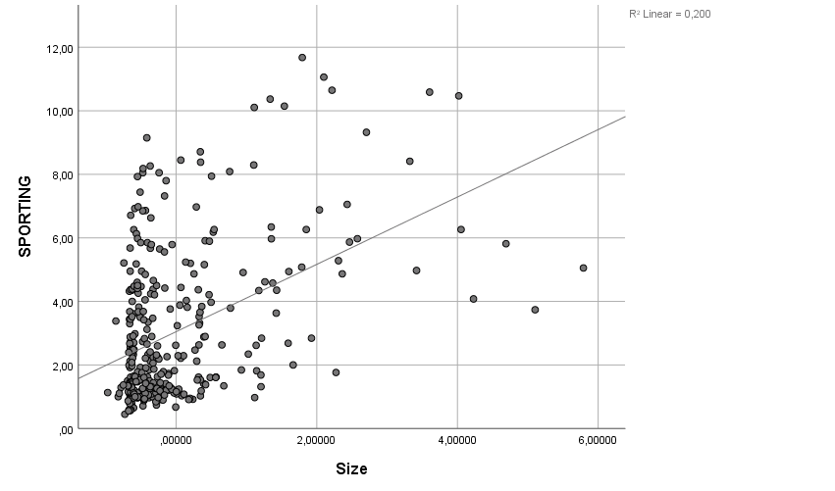

Multicollinearity (2)

Correlations
 |  | Sporting | Size | Profitabilty | Debt
Pearson Correlation | Sporting | 1.000 | .447 | .151 | .182
Pearson Correlation | Size | .447 | 1.000 | .000 | .000
Pearson Correlation | Profitabilty | .151 | .000 | 1.000 | .000
Pearson Correlation | Debt | .182 | .000 | .000 | 1.000
Sig. (1-tailed) | Sporting | . | .000 | .002 | .000
Sig. (1-tailed) | Size | .000 | . | .500 | .500
Sig. (1-tailed) | Profitabilty | .002 | .500 | . | .500
Sig. (1-tailed) | Debt | .000 | .500 | .500 | .
N | Sporting | 347 | 347 | 347 | 347
N | Size | 347 | 347 | 347 | 347
N | Profitabilty | 347 | 347 | 347 | 347
N | Debt | 347 | 347 | 347 | 347

 |  | VIF
 | Size | 1,000
 | Profitabilty | 1,000
 | Debt | 1,000

Autocorrelation (3)
Country | Durbin Watson
All | 1.805

Homoscedasticity (4)
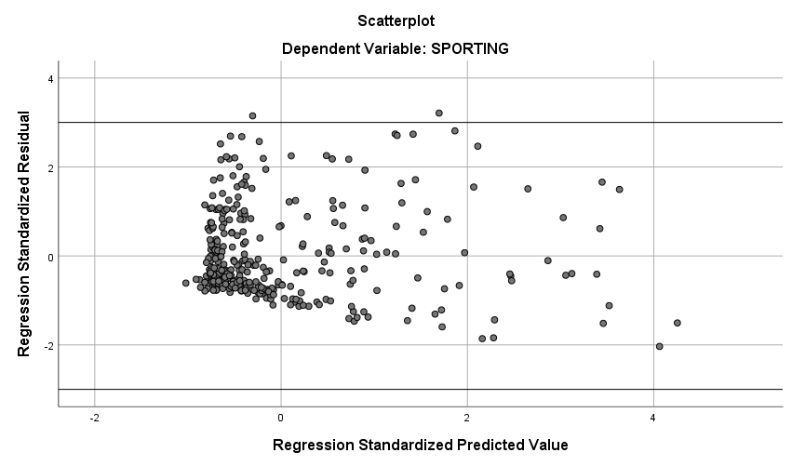

Normal distribution of residuals (5)

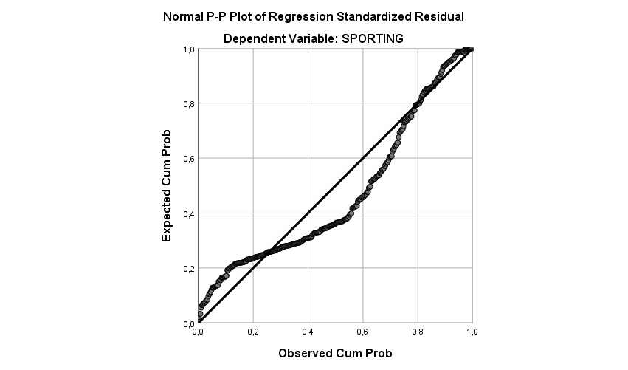

Outliers (6)
 | Minimum | Maximum | Mean | Std. Deviation | N
Cook's Distance | .000 | .235 | .005 | .017 | 347

Appendix IV – Assumptions for each country
Linearity (1)

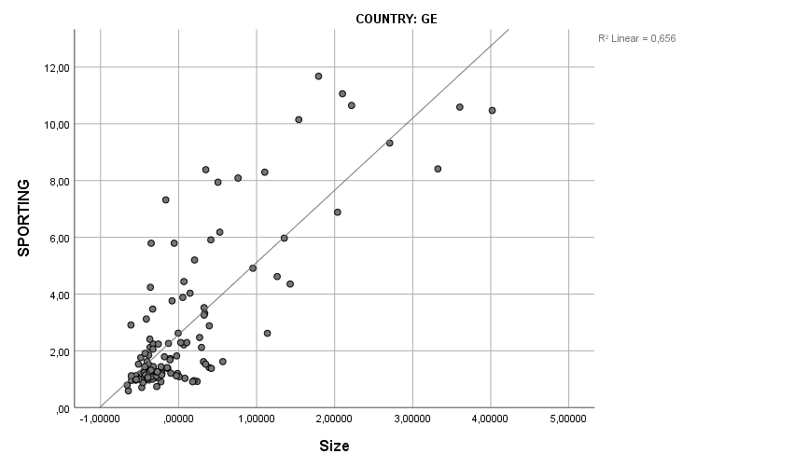
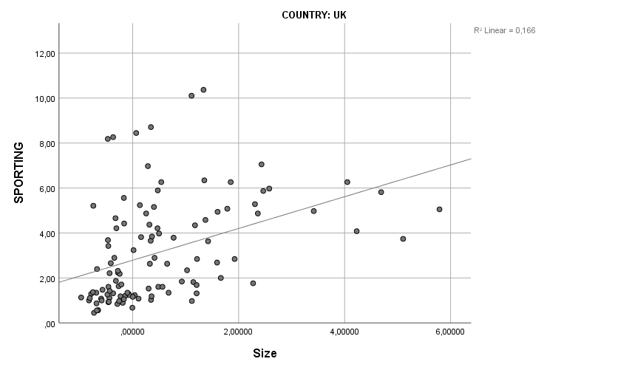
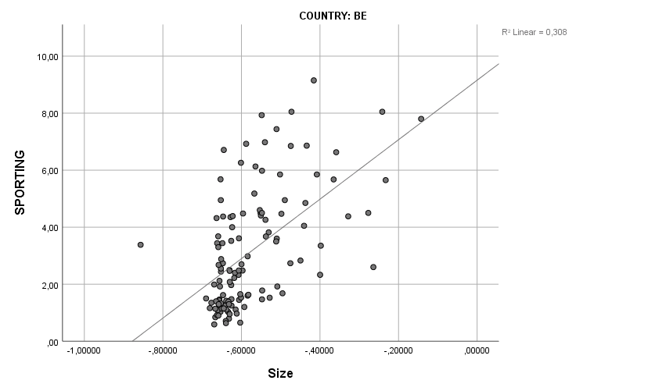
Multicollinearity (2)

Correlations
Country |  |  | Sporting | Size | Profitabilty | Debt
BE | Pearson Correlation | Sporting | 1.000 | .555 | .470 | .534
BE | Pearson Correlation | Size | .555 | 1.000 | .432 | .423
BE | Pearson Correlation | Profitability | .470 | .432 | 1.000 | .586
BE | Pearson Correlation | Debt | .534 | .423 | .586 | 1.000
BE | Sig. (1-tailed) | Sporting | . | .000 | .000 | .000
BE | Sig. (1-tailed) | Size | .000 | . | .000 | .000
BE | Sig. (1-tailed) | Profitability | .000 | .000 | . | .000
BE | Sig. (1-tailed) | Debt | .000 | .000 | .000 | .
BE | N | Sporting | 120 | 120 | 120 | 120
BE | N | Size | 120 | 120 | 120 | 120
BE | N | Profitability | 120 | 120 | 120 | 120
BE | N | Debt | 120 | 120 | 120 | 120
GE | Pearson Correlation | Sporting | 1.000 | .810 | .574 | -.077
GE | Pearson Correlation | Size | .810 | 1.000 | .596 | -.110
GE | Pearson Correlation | Profitability | .574 | .596 | 1.000 | .202
GE | Pearson Correlation | Debt | -.077 | -.110 | .202 | 1.000
GE | Sig. (1-tailed) | Sporting | . | .000 | .000 | .202
GE | Sig. (1-tailed) | Size | .000 | . | .000 | .117
GE | Sig. (1-tailed) | Profitability | .000 | .000 | . | .014
GE | Sig. (1-tailed) | Debt | .202 | .117 | .014 | .
GE | N | Sporting | 119 | 119 | 119 | 119
GE | N | Size | 119 | 119 | 119 | 119
GE | N | Profitability | 119 | 119 | 119 | 119
GE | N | Debt | 119 | 119 | 119 | 119
UK | Pearson Correlation | Sporting | 1.000 | .407 | -.014 | .339
UK | Pearson Correlation | Size | .407 | 1.000 | -.098 | -.242
UK | Pearson Correlation | Profitability | -.014 | -.098 | 1.000 | .098
UK | Pearson Correlation | Debt | .339 | -.242 | .098 | 1.000
UK | Sig. (1-tailed) | Sporting | . | .000 | .442 | .000
UK | Sig. (1-tailed) | Size | .000 | . | .156 | .006
UK | Sig. (1-tailed) | Profitability | .442 | .156 | . | .157
UK | Sig. (1-tailed) | Debt | .000 | .006 | .157 | .
UK | N | Sporting | 108 | 108 | 108 | 108
UK | N | Size | 108 | 108 | 108 | 108
UK | N | Profitability | 108 | 108 | 108 | 108
UK | N | Debt | 108 | 108 | 108 | 108

COUNTRY
COUNTRY | VIF
BE | (Constant)
BE | Size | 1,299
BE | Profit | 1,625
BE | Debt | 1,611
GE | (Constant)
GE | Size | 1,697
GE | Profit | 1,747
GE | Debt | 1,140
UK | (Constant)
UK | Size | 1,068
UK | Profit | 1,016
UK | Debt | 1,068

Country | Durbin Watson
BE  GE  UK | 2.323  1.910  1.964
Autocorrelation (3)

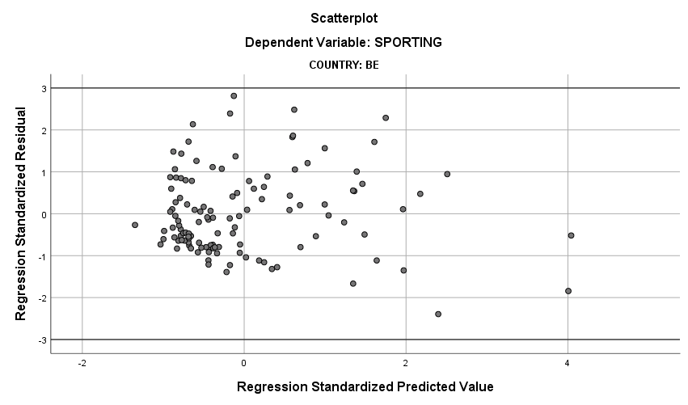
Homoscedasticity (4)
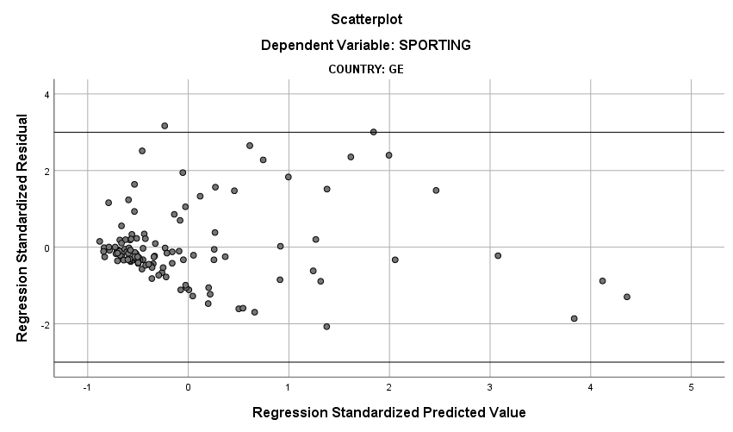
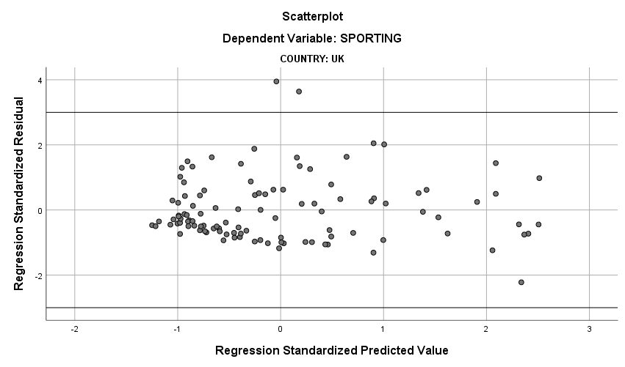
Values of the residuals are normally distributed (5)
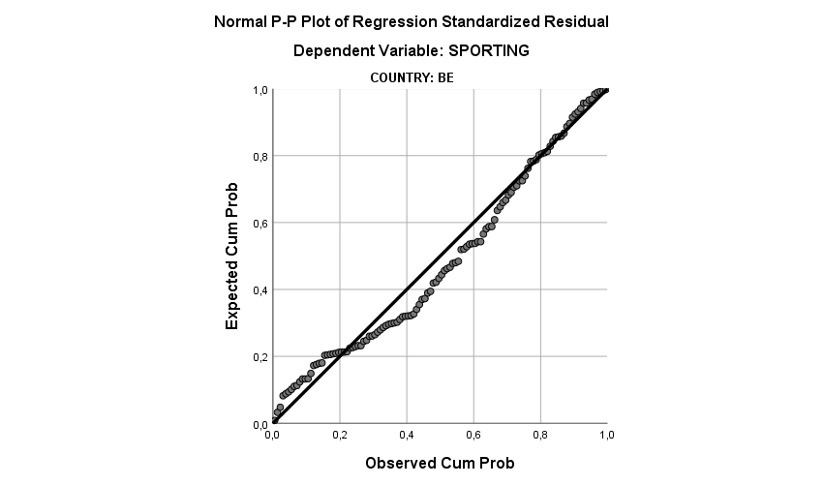
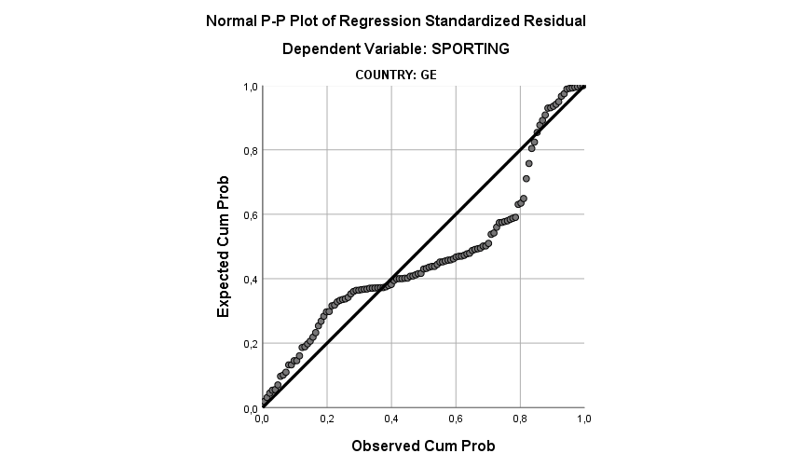

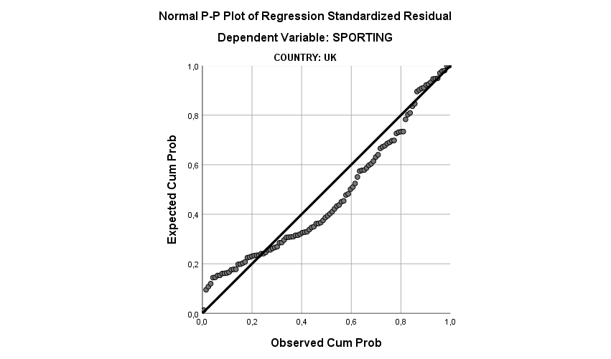

Outliers (6)

 |  | Minimum | Maximum | Mean | Std. Deviation | N
Cook's Distance | BE  GE  UK | 0.000  0.000  0.000 | 0.210  0.176  0.287 | 0.011  0.015  0.013 | 0.028  0.036  0.035 | 120  120  108

Appendix V
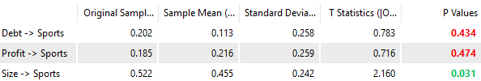
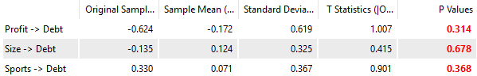
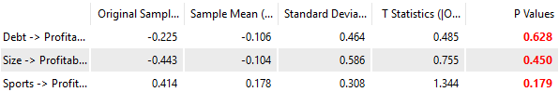
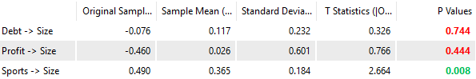

Figure 1. P-values and T-statistics for Path Coefficients -All competitions - PLS-SEM model (2).

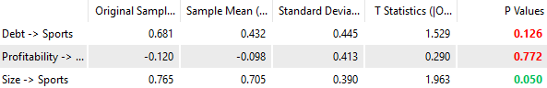
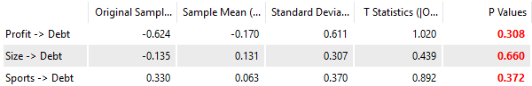
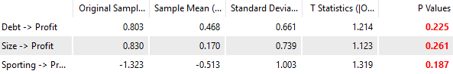
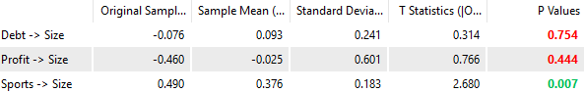
Figure 2. P-values and T-statistics for Path Coefficients - UK - PLS-SEM model (2).

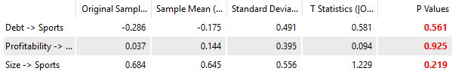
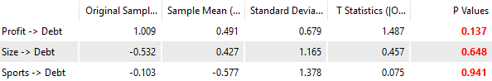
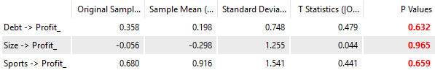
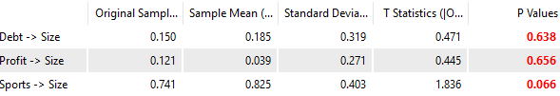
Figure 3. P-values and T-statistics for Path Coefficients - GE - PLS-SEM model (2).

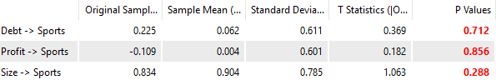
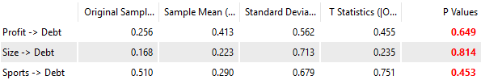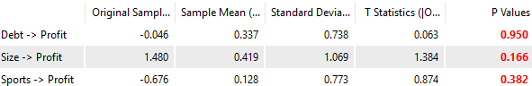
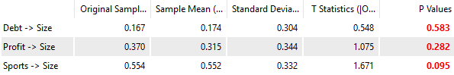

Figure 4. P-values and T-statistics for Path Coefficients - BE - PLS-SEM model (2).

Appendix VI
Output GLM with fixed factor.
Tests of Between-Subjects Effects
Dependent Variable: SPORTING
COUNTRY | Source | Type III Sum of Squares | df | Mean Square | F | Sig. | Partial Eta Squared | Noncent. Parameter | Observed Power^{b}
BE | Corrected Model | 292.335ª | 14 | 20.881 | 10.064 | .000 | .573 | 140.900 | 1.000
BE | Intercept | 28.034 | 1 | 28.034 | 13.512 | .000 | .114 | 13.512 | .954
BE | SIZE | 3.494 | 1 | 3.494 | 1.684 | .197 | .016 | 1.684 | .251
BE | PROFIT | 15.379 | 1 | 15.379 | 7.412 | .008 | .066 | 7.412 | .770
BE | DEBT | .810 | 1 | .810 | .390 | .533 | .004 | .390 | .095
BE | CLUB | 74.117 | 11 | 6.738 | 3.248 | .001 | .254 | 35.723 | .988
BE | Error | 217.850 | 105 | 2.075
BE | Total | 1702.128 | 120
BE | Corrected Total | 510.186 | 119
GE | Corrected Model | 662.967^{c} | 14 | 47.355 | 23.904 | .000 | .763 | 334.652 | 1.000
GE | Intercept | 124.112 | 1 | 124.112 | 62.649 | .000 | .376 | 62.649 | 1.000
GE | SIZE | .466 | 1 | .466 | .235 | .629 | .002 | .235 | .077
GE | PROFIT | 18.849 | 1 | 18.849 | 9.515 | .003 | .084 | 9.515 | .863
GE | DEBT | 10.515 | 1 | 10.515 | 5.308 | .023 | .049 | 5.308 | .626
GE | CLUB | 81.072 | 11 | 7.370 | 3.720 | .000 | .282 | 40.924 | .996
GE | Error | 206.031 | 104 | 1.981
GE | Total | 1827.561 | 119
GE | Corrected Total | 868.997 | 118
UK | Corrected Model | 335.973^{d} | 14 | 23.998 | 10.038 | .000 | .602 | 140.537 | 1.000
UK | Intercept | 347.849 | 1 | 347.849 | 145.504 | .000 | .610 | 145.504 | 1.000
UK | SIZE | .113 | 1 | .113 | .047 | .828 | .001 | .047 | .055
UK | PROFIT | 13.440 | 1 | 13.440 | 5.622 | .020 | .057 | 5.622 | .650
UK | DEBT | 4.053 | 1 | 4.053 | 1.695 | .196 | .018 | 1.695 | .252
UK | CLUB | 129.943 | 11 | 11.813 | 4.941 | .000 | .369 | 54.355 | 1.000
UK | Error | 222.330 | 93 | 2.391
UK | Total | 1636.902 | 108
UK | Corrected Total | 558.303 | 107
a. R Squared = .573 (Adjusted R Squared = .516)
b. Computed using alpha = .05
c. R Squared = .763 (Adjusted R Squared = .731)
d. R Squared = .602 (Adjusted R Squared = .542)

Parameter Estimates
Dependent Variable: SPORTING
COUNTRY | Parameter | B | Std. Error | t | Sig.
BE | Intercept | 4.539 | 1.503 | 3.021 | .003
BE | SIZE | 2.330 | 1.796 | 1.298 | .197
BE | PROFIT | 2.233 | .820 | 2.723 | .008
BE | DEBT | 1.308 | 2.094 | .625 | .533
BE | [CLUB=Cercle Brugge] | .130 | .654 | .199 | .842
BE | [CLUB=Charleroi] | -1.054 | .645 | -1.634 | .105
BE | [CLUB=Club Brugge KV] | 1.777 | .689 | 2.577 | .011
BE | [CLUB=KAA Gent] | .909 | .717 | 1.268 | .208
BE | [CLUB=Koninklijke Racing Club Genk] | .862 | .696 | 1.239 | .218
BE | [CLUB=KV Kortrijk] | .030 | .649 | .046 | .964
BE | [CLUB=KV Mechelen] | -.391 | .645 | -.607 | .545
BE | [CLUB=Lokeren] | -.549 | .645 | -.852 | .396
BE | [CLUB=RSCA] | 2.544 | .789 | 3.226 | .002
BE | [CLUB=Standard] | 1.093 | .756 | 1.446 | .151
BE | [CLUB=STVV] | -.992 | .648 | -1.532 | .128
BE | [CLUB=Zulte Waregem] | 0ª | . | . | .
GE | Intercept | 1.097 | .587 | 1.871 | .064
GE | SIZE | .221 | .455 | .485 | .629
GE | PROFIT | .940 | .305 | 3.085 | .003
GE | DEBT | -2.022 | .877 | -2.304 | .023
GE | [CLUB=Augsburg] | -.704 | .662 | -1.064 | .290
GE | [CLUB=Borussia Mönchengladbach] | .721 | .770 | .936 | .352
GE | [CLUB=Borussia Dormtund] | 3.384 | .840 | 4.029 | .000
GE | [CLUB=Eintracht Frankfurt] | .040 | .643 | .062 | .951
GE | [CLUB=FC Bayern München] | 5.786 | 1.147 | 5.046 | .000
GE | [CLUB=FC Köln] | -.590 | .643 | -.917 | .361
GE | [CLUB=FC Schalke 04] | 2.016 | .886 | 2.277 | .025
GE | [CLUB=Hamburg HSV] | .682 | .694 | .983 | .328
GE | [CLUB=Hannover 96] | -.625 | .652 | -.960 | .339
GE | [CLUB=Herta BSC] | .056 | .644 | .087 | .930
GE | [CLUB=SV Werder Bremen] | .768 | .640 | 1.201 | .232
GE | [CLUB=TSG 1899 Hoffenheim] | 0ª | . | . | .
UK | Intercept | 1.632 | .524 | 3.114 | .002
UK | SIZE | .049 | .226 | .217 | .828
UK | PROFIT | .313 | .132 | 2.371 | .020
UK | DEBT | -.355 | .273 | -1.302 | .196
UK | [CLUB=Arsenal] | 2.283 | .850 | 2.684 | .009
UK | [CLUB=Aston Villa] | .354 | .738 | .480 | .632
UK | [CLUB=Chelsea] | 7.067 | 1.575 | 4.486 | .000
UK | [CLUB=Everton] | .926 | .737 | 1.258 | .212
UK | [CLUB=Fulham] | .320 | .738 | .434 | .666
UK | [CLUB=Liverpool] | 2.137 | .768 | 2.781 | .007
UK | [CLUB=Manchester City] | 3.173 | 1.177 | 2.695 | .008
UK | [CLUB=Manchester United] | 4.535 | .864 | 5.250 | .000
UK | [CLUB=Newcastle United] | -.347 | .731 | -.474 | .636
UK | [CLUB=Stoke City] | .238 | .736 | .324 | .747
UK | [CLUB=Tottenham Hotspur] | 1.347 | .790 | 1.705 | .092
UK | [CLUB=West Ham United] | 0ª | . | . | .
a. This parameter is set to zero because it is redundant.
b. Computed using alpha = .05

