Does working from home lead to improved performance of employees?
The effect of maturity, concentration, and satisfaction of the need for relatedness on homeworkers’ performance

Jonas De Kerf
Academic Year 2019-2020
Promoter: Prof. dr. Rein De Cooman
R0675696
Master's thesis submitted to
obtain the degree of

MASTER OF BUSINESS ADMINISTRATION

Faculty of Economics and Business

Contents
Abstract A
1 Introduction 1
2 Literature review 3
2.1 The impact of homeworking on concentration 3
2.2 The impact of homeworking on the satisfaction of the need for relatedness 4
2.3 Homeworking and performance 5
2.4 The impact of job experience on homeworkers’ performance 6
3 Method 9
3.1 Data collection 9
3.2 Population, sample and participants 9
3.3 Measures 9
3.4 Analyses 10
4 Results 11
4.1 Descriptives 11
4.2 Regression analyses 13
5 Discussion 17
5.1 Conclusion 17
5.2 Limitations and suggestions for further research 18
6 Practical implementations 20
Appendix 1: Histograms of the residuals i
Appendix 2: Regressions with ‘Gender’ iii
Press release iv

Abstract
Despite the fact that working from home is gaining tremendous popularity, previous findings are not consistent in the current literature. Therefore, this study investigates relationships between the intensity of homeworking and its outcomes, by looking at both positive and negative effects that might affect homeworkers’ performance. Homeworkers’ concentration, satisfaction of the need for relatedness and experience in their current job are suggested as elements to influence this relationship. In total, 3188 respondents participated in a two-wave study, in order to clarify several outcomes concerning the variables mentioned above. The results indicate that increased homeworking intensity, between two periods, leads to better performance. This increase however cannot be dedicated to an effect on homeworkers’ concentration or satisfaction of the need for relatedness, because increased homeworking intensity did not have a significant impact on these variables. Furthermore, there is no significant difference in performance between less experienced and experienced homeworkers.

Acknowledgements
I would like to take the opportunity to thank a few people in this section. First, I would like to thank the management of the organization and its employees for helping in this research and I sincerely hope they will benefit from the results. I addition, I would like to express my gratitude to some of my fellow students for their help and feedback. My parents should not be left out of these acknowledgements, as their support has been of enormous value. Finally, I would like to thank my promoter, Prof. De Cooman, for her feedback and advice throughout this study. Thank you, everyone!

Introduction
Because of the increasing need of employees to improve their work-life balance, employers are allowing them to switch workplaces to other locations instead of working at the main office, also defined as teleworking (Allen, Golden & Shockley, 2015; Sullivan, 2003; Tietze, Musson & Scurry, 2009). Typically, teleworkers work from home, with remote offices or telework centrals as the main other option (Gajendran & Harrison, 2007; Sullivan, 2003). This relatively new way of working is part of a wider category of flexible work arrangements, which were not only introduced to support employees in their work-life scheduling, but also to improve the performance of organizations in general (Bailey & Kurland, 2002; Groen, van Triest, Coers & Wtenweerde, 2018). In the last decade, the percentage of homeworkers in Flanders rose from 12,9% in 1999 to 23% in 2018 (Flemish Government, 2019). However, the percentage of homeworkers has drastically increased since March 12 in Belgium (University of Antwerp, 2020), as a result of new government measures to prevent further spread of the coronavirus. Whether this high amount of employees will remain working from home is still unclear. The increase in the number of homeworkers between 1999 and 2018 does already indicate its relevance before the pandemic, since almost one out of four employees worked from home now and then (Flemish Government, 2019). Alongside work-life balance, the reduction in commuting costs and increased work autonomy are other reasons why teleworking became more popular for employees (Gajendran & Harrison, 2007). Not only individuals can benefit from working outside the office. Teleworking was first introduced by organizations because of several anticipated positive effects on their results, such as reduced real estate, labour and other fixed costs (Bailey & Kurland, 2002; Biron & Van Veldhoven, 2016; Gajendran & Harrison, 2007; Richardson & McKenna, 2014).

Based on above-mentioned reasons, organizations are increasingly introducing homeworking to provide their employees more flexibility, in exchange for both an anticipated increase in their functioning directly, and anticipated improvements of their wellbeing indirectly. Indeed, previous studies indicated that working from home leads to an increase in performance and productivity of employees due to fewer interruptions and more efficient use of hours (Hill, Ferris & Märtinson, 2003; Neufeld & Fang, 2005; Vega, Anderson & Kaplan, 2015). Contrary to these positive effects on performance, mixed or negative effects are also found (Bailey & Kurland, 2002; Gajendran & Harrison, 2007; Hill et al., 2003). Therefore, this study will look at mechanisms that might explain positive effects as well as mechanisms that might explain negative effects of homeworking on performance. Most studies did not take homeworking intensity into account while examining homeworkers’ performance (Biron & Van Veldhoven, 2016; Gajendran & Harrison, 2007; Vega et al., 2015). The aim of this study is therefore to investigate performance levels between low-intensive and intensive homeworkers, measured as the difference in the amount of home-based work between two measuring moments.

Two major factors that are considered to explain this relationship are homeworkers’ ability to concentrate and the quality of homeworkers’ relationships with others (Demerouti, Taris & Bakker, 2007; Van den Broeck, Ferris, Chang & Rosen, 2016). Concentration can, according to previous findings, motivate employees to work outside the main office because by doing so they avoid disruptions from colleagues and supervisors (Bailey & Kurland, 2002). Even though there are probably also home-related factors (e.g. children, spouses) that might decrease homeworkers’ concentration (Biron & Van Veldhoven, 2016), we will examine whether homeworking leads to more concentration as previously suggested in the HRM literature. Since performance is impacted by an employee’s ability to concentrate (Biron & Van Veldhoven, 2016; Demerouti et al., 2007), we will thus verify whether the relationship between homeworking and performance is mediated by concentration (i.e. a mechanism explaining positive effects). Furthermore, literature indicates that working from home is often at the expense of relationships with colleagues (Arling, 2004; Gajendran & Harrison, 2007; Lal & Dwivedi, 2009; Richardson & McKenna, 2014; Tavares, 2017). Considering the reduction in social contact, homeworking might lead to less informal learning and fewer cooperation between colleagues and could therefore negatively impact performance (Hill et al., 2003). In our study, homeworkers’ relationships with their peers refers to the satisfaction of their need for relatedness according to the Self-Determination Theory (Deci & Ryan, 2000). Since homeworkers’ performance might be impacted by a reduction in the satisfaction of their need for relatedness (Van den Broeck et al., 2016), we will thus verify whether the relationship between homeworking and performance is mediated by the satisfaction of this need (i.e. a mechanism explaining negative effects).

The maturity level of employees will be used in the current study to further understand the relationship between homeworking and performance. Some authors indicated that whether effort translates into performance is dependent on the maturity level of employees, linked to high abilities and willingness to perform (Blank, Weitzel, Blau & Green, 1988; Hersey, Blanchard & Natemeyer, 1979). Homeworking however often implies reduced control of managers over their employees and homeworkers are therefore faced with more responsibilities and autonomy (Dambrin, 2004). Homeworkers’ performance might therefore be influenced by their maturity level, since more mature employees are more likely to deal with these responsibilities, taking their abilities and willingness to perform into account (Blank et al., 1988; Hersey et al., 1979). For these reasons, we will verify whether the relationship between homeworking and performance is moderated by experience of employees, defined as the amount of years employees work in their current job.

Considering the inconsistency of the effects of homeworking on homeworkers’ concentration and interpersonal relationships, and therefore the impact on performance, this thesis will contribute to the current literature by providing empirical evidence on whether (often and/or more often) working from home does lead to increased performance. In order to clarify the impact of working from home, a survey was conducted in which 3188 employees participated in a two-wave study. All respondents worked in the same company with several work venues in Belgium where a new and uniform policy concerning teleworking was implemented.
.

Literature review

Homeworkers’ performance explained by the impact of homeworking on concentration
To establish the main relationship between homeworking and performance, the influence of homeworking on concentration and the satisfaction of the need for relatedness amongst homeworkers will first be discussed. In this section, we will determine whether increased homeworking leads to an increase in homeworkers’ ability to concentrate, and we propose concentration as a mediator in the relationship between homeworking and performance. Perceived overall concentration will be investigated, meaning concentration in the office as well as concentration while working from home, since this research will determine whether increased homeworking intensity of employees between periods leads to an overall better functioning in terms of work-related concentration at the second period.
One of the reasons employees chose to work from home is to avoid interruptions and therefore, increase their ability to concentrate on their tasks (Bailey & Kurland, 2002). For employees to be concentrated, it is required to actively prevent environmental factors from causing distractions (Biron & Van Veldhoven, 2016). Literature shows that physical factors in the main office negatively impact performance due to their influence on concentration (Ashkanasy, Ayoko & Jehn, 2014; Fonner & Roloff, 2010). Examples are non-relevant but clearly audible conversations amongst colleagues, noise, interruptions and small interactional distance and personal space. Homeworkers tend to feel more productive since they can work (more often) without these office-related disruptions (Richardson & McKenna, 2014).
Furthermore, there are two theoretical assumptions that are supporting the fact that concentration is influenced by the intensity of homeworking, namely the Job Demands-Resources model and Boundary Theory. The Job Demands-Resources model suggests that several job demands, such as work pressure and work-home conflict, are likely to increase the need for recovery of employees, caused by the additional mental efforts to reduce fatigue and maintain current performance levels (Bakker, Van Emmerik & Van Riet, 2008). The need for recovery increases fatigue or exhaustion over the long term, due to the lack of opportunities to deal with work demands (Sardeshmukh, Sharma & Golden, 2012). Therefore, more effort is required to concentrate on certain tasks in times of fatigue because employees have a more difficult time avoiding distracting thoughts (Demerouti et al., 2007). However, the negative effect of these demands on the need for recovery can be compensated by the presence of job resources, such as autonomy and social support (Bakker & Demerouti, 2014). In the next paragraph, we will discuss that homeworkers tend to experience a lower need for recovery, due to reduced job demands and a lower depletion of job resources (Biron & Van Veldhoven, 2016), for which we expect their concentration to increase over time.
Homeworkers commute less and therefore experience less stress regarding the transport from and to the workplace, which indicates that homeworking is negatively related to time pressure (Biron & Van Veldhoven, 2016; Sardeshmukh et al., 2012). Furthermore, homeworkers feel less obligated to interact with colleagues, which often takes a lot of time and effort (Biron & Van Veldhoven, 2016). Homeworkers have more control over their worktime because they can choose when to take breaks and when to start or end working (Biron & Van Veldhoven, 2016; Dambrin, 2004; Gajendran & Harrison, 2007). More flexibility and autonomy enhance homeworkers’ control over their daily schedule and priorities, for which they experience less need for recovery (Sardeshmukh et al., 2012). In line with the Job Demands-Resources model and above-mentioned arguments, Biron and Van Veldhoven (2016) indicated that homeworkers feel less need for recovery on the days working from home, compared to those working at the office. Thus, we expect that the more frequently employees work from home, the lower their need for recovery will be, therefore leading to an increase in concentration.
A second theory that helps us understand the link between increased homeworking and concentration is Boundary Theory, which focuses on transitions between work and home roles (Ashforth, Kreiner & Fugate, 2000). According to this theory, homeworkers have the opportunity to integrate or segment both roles. Findings from the study of Fonner and Stache (2012) indicate that working from home is more likely to increase concentration when employees distinguish work and home roles. When homeworkers’ roles are clearly separated, the possible interruption from a home interference is less likely while working from home (Ashforth et al., 2000). Moreover, Kossek, Lautsch and Eaton (2006) indicated that integrating both roles is positively related to higher family-to-work conflicts, which might lead to more interruptions and lost productivity while working from home (Golden, Veiga & Simsek, 2006). Homeworking intensity is considered to impact the strategy in which homeworkers tend to manage control over work and home boundaries (Fonner & Stache, 2012). More frequent homeworkers use their working location more regularly, compared to less intensive homeworkers, as a boundary between their work and home roles. The most common example is having an office at home specially designed for work. Since intensive homeworkers prefer to segment work and home roles, we predict homeworkers’ concentration to increase along with the amount of days they work from home.
Considering above-mentioned arguments, intensive homeworkers develop methods that benefit their personal and working performances, resulting in higher effectiveness of homeworking (Biron & Van Veldhoven, 2016; Fonner & Stache, 2012). In addition, employees working from home several days a week might be able to concentrate better during working hours because of their experience in dealing with household distractions. Considering these arguments, we follow the positive path and suggest that:
Hypothesis 1: Increased homeworking leads to better concentration over time.
Psychological literature already indicated that improved concentration leads to better performance (Biron & Van Veldhoven, 2016; Demerouti et al., 2007). Based on the Job Demands-Resources model, several job demands provoke exhaustion and more need for recovery, causing employees to have more problems with putting energy into their tasks (Bakker, Demerouti & Verbeke, 2004; Bakker et al., 2008). Because it is more difficult for less concentrated employees to process information, and they prefer effort-saving working methods, a decrease in an employee’s concentration decreases performance (Demerouti et al., 2007). Homeworkers report less experience of the need for recovery, for which we assume homeworkers to perform better because of more concentration (Biron & Van Veldhoven, 2016; Sardeshmukh et al., 2012). For these reasons, we will examine whether concentration mediates the relationship between increased homeworking and increased performance. Thus, we suggest the following:
Hypothesis 2: The relationship between increased homeworking and increased performance is partially mediated by concentration.

Homeworkers’ performance explained by the impact of homeworking on the satisfaction of the psychological need for relatedness
Compared to other forms of teleworking, employees working from home are more likely to feel socially isolated (Kurland & Cooper, 2002). However, current literature does not give a specific answer to whether homeworkers feel less related with others from their organization. For this reason, the satisfaction of the need for relatedness will be examined amongst homeworkers. We will provide several arguments for which we expect an increase in homeworking intensity between two periods would lead to a lower satisfaction of this need. Furthermore, we propose the satisfaction of the need for relatedness as a mediator in the relationship between homeworking and performance.
The need for relatedness is, based on the Self-Determination Theory, a fundamental human need and refers to the desire to love or be loved, care and be cared for and to feel connected with others (Deci & Ryan, 2000). When people feel part of a group, forge relationships and connections with others, this desire for relatedness is satisfied (Van den Broeck et al., 2016). In a working context, the satisfaction of the need for relatedness of employees relies on relationships with colleagues and supervisors and the feeling that they care about them (Van den Broeck, Vansteenkiste, De Witte, Soenens & Lens, 2010). According to the Social Presence Theory and the Media Richness Theory, face-to-face interaction is the most stimulating form of communication benefiting the quality of relationships amongst individuals (Gajendran & Harrison, 2007). Several authors already indicated the negative impact homeworking has on the relationships between homeworkers and their colleagues. Homeworking for example decreases face-to-face communication and physical presence (Arling, 2004; Lal & Dwivedi, 2009; Richardson & McKenna, 2014), and therefore, fewer possibilities for building relationships and connect with others through communication occur (Fonner & Roloff, 2010; Lal & Dwivedi, 2009). Social isolation, also described as loneliness, is an often-indicated outcome of telework (Kurland & Cooper, 2002). Workplace exclusion, a similar concept that refers to the fact that employees do not feel like they are part of the organization, is also more common amongst homeworkers (Morganson, Major, Oborn, Verive & Heelan, 2010).
However, we expect that intensive homeworkers have a higher chance of experiencing the negative effect of homeworking on the satisfaction of the need for relatedness compared to less intensive homeworkers (Biron & Van Veldhoven, 2016; Golden, 2006). Homeworkers who are working outside the main offices less often have the possibility to compensate the feeling of isolation when they are working in the office in order to maintain work-related relationships. Even though the outcomes of isolation are not consistent in homeworking literature, Bailey and Kurland (2002) stated that the negative effect of isolation on performance was insignificant when teleworking was less frequent. Although many researchers identified social isolation as a negative consequence of working from home (Kurland & Cooper, 2002), no specific tests have yet been carried out as to whether homeworking can also be considered to satisfy the need for relatedness to a lesser extent amongst homeworkers. Because the satisfaction of the need for relatedness requires frequent interaction with other colleagues (Van den Broeck et al., 2010), we expect that increased home-based work will have a negative influence on the satisfaction of the need for relatedness. Thus, we will examine the following hypothesis:
Hypothesis 3: Increased homeworking leads to less satisfaction of the need for relatedness.
Since perceived social isolation reduces overall cognitive performance (Cacioppo & Hawkley, 2009), we suggest the satisfaction of the need for relatedness to mediate the relationship between homeworking and performance. Less communication with others can impact performance of individuals, due to not receiving important information (Arling, 2004). Additionally, Richardson and McKenna (2014) reported in their qualitative study that most of the homeworkers they interviewed felt that they were missing out on important conversations which could help them perform better. In line with the Self-Determination Theory, the satisfaction of the need for relatedness leads to an overall increase in well-being and functioning and is therefore positively related to performance (Van den Broeck et al., 2016). Therefore, we expect homeworkers’ performance to decrease when the need for relatedness is less satisfied. These arguments lead to the following hypothesis:
Hypothesis 4: The relationship between increased homeworking and increased performance is partially mediated by the (dis)satisfaction of the need for relatedness.

Homeworking and performance
As said earlier, researchers mainly reported that working outside the main office, mostly at home, has a positive impact on the performance and/or productivity of employees (Dubrin, 1991; Hill et al., 2003; Neufeld & Fang, 2005). However, previous mentioned studies examined a positive impact on performance between homeworkers and non-homeworkers, without taking the intensity of homeworking into account. It is therefore that this study will examine several aspects for which we expect an increase in homeworking intensity to lead to increased performance in a linear fashion.
Several authors already indicated mixed results considering the relationship between homeworking, or teleworking, and performance. Gajendran and Harrison (2007) reported in their meta-analysis no significant impact of teleworking on performance of teleworkers compared to non-teleworkers. Similar results were found by Hill et al. (2003). These authors indicated that homeworking did not predict performance significantly, while it did lead to a positive effect on perceived productivity. Bailey and Kurland (2002) also reported in their review of teleworking research that teleworking enhances productivity. Finally, Kossek et al. (2006) also found supporting evidence for their hypothesis that homeworking leads to increased performance. Different results might occur in teleworking and/or homeworking research, depending on whether researchers use a within-person perspective or a between-person perspective (Vega et al., 2015). Multiple studies compared between-persons effects of teleworking between teleworkers and non-teleworkers or highly intensive teleworkers versus low intensive teleworkers (Biron & Van Veldhoven, 2016; Gajendran & Harrison, 2007; Vega et al., 2015). For example, several studies already indicated that teleworkers perform better compared to non-teleworkers, because of their increase in autonomy and motivation (Tavares, 2017; Vega et al., 2015). However, this argumentation does not automatically imply that increased homeworking leads to increased performance due to increased autonomy and/or motivation. Gajendran and Harrison (2007) for example already indicated that increased homeworking does not lead to increased autonomy.
The above-mentioned arguments suggest that homeworking intensity should be taken into account in the discussion of its outcomes. Vega et al. (2015) for example, indicated that homeworkers reported higher performance on the days working from home, compared to the days worked in the main office. For that reason, this study aims to examine differences in performance levels, depending on within-persons differences in homeworking intensity between two periods. More specifically, our study will test whether increased home-based work, measured as the difference between the first and second measurement wave, leads to increased performance. Considering the importance of intensity in the discussion of the effect of homeworking on performance, we investigated this relationship through the impact of increased homeworking on concentration and satisfaction of the need for relatedness.
The positive effect increased homeworking has on concentration is expected to compensate its negative effect on the satisfaction of the need for relatedness, because homeworkers are actively taking initiatives in order to reduce this negative effect (Lal & Dwivedi, 2009). Additionally, the negative effect working from home might have on the satisfaction of the need for relatedness might be compensated by increased quality of the relationships between homeworkers and their family members, due to increased face-to-face interactions and presence of these employees at home (Golden, 2006). Taking these arguments into account, we expect that the negative impact of increased homeworking on the satisfaction of the need for relatedness, and therefore on performance, will not be as significant compared to the increase in concentration. Considering the negative arguments, we still suggest increased homeworking to be positively related to performance, since that is the overall tendency in empirical findings as well as the business case of homeworking. We will therefore examine the following hypothesis:
Hypothesis 5: Increased homeworking leads to increased performance.

The impact of job experience on homeworkers’ performance
Supervisors’ biggest concern considering the flexible arrangement of homeworking is the reduced possibility to control or interact with their employees (Gajendran & Harrison, 2007; Groen et al., 2018). In this study, we link the need for control with employees’ job experience. To date, no study has indicated whether the job experience of homeworkers (i.e. tenure in a specific job) affects their performance or not. Therefore, this section aims to investigate the relationship between increased homeworking and increased performance as moderated by job experience.
Homeworking has an impact on both the communication between homeworker and manager and the working methods of the employee (Dambrin, 2004). Based on both elements, we suggest that (intensively) working from home is more recommendable for experienced employees, since they indicate the need for autonomous workers who should be working from home. Authors have indicated that homeworking leads to less formal and informal communication between employees and their supervisors (Dambrin, 2004). Feedback from managers or other communications are more difficult to interpret for homeworkers, due to the lack of face-to-face exchanges (again) according to the Media Richness Theory (Dambrin, 2004; Golden, 2006; Suh, 1999). As homeworking reduces the opportunity for informal learning (Biron & Van Veldhoven, 2016; Kurland & Cooper, 2002), homeworkers are demanded to work more independently (Dambrin, 2004). Another form of autonomy that homeworkers experience is the freedom of choice in scheduling their work and working hours (Dambrin, 2004; Gajendran & Harrison, 2007). Homeworking raises the importance of priority setting for homeworkers, since homeworkers often receive tasks that they must complete within a certain period. Although homeworkers have more freedom in choosing how to work, more accountability is placed on their performance (Dambrin, 2004; Kurland & Cooper, 2002). An additional form of pressure is perceived because homeworkers’ supervisors and/or organizations trust them with more autonomy and accountability.
The above-mentioned arguments suggest that homeworkers must be able to work independently and take responsibility, which are both factors that are considered to go along with growing maturity of employees according to the Situational Leadership Theory (Hersey & Blanchard, 1969). These authors suggest that leaders should adapt their behavior, whether it is directive and/or supportive, depending on the level of development of employees (Blanchard, Zigarmi & Nelson, 1993). Recently hired employees (i.e. low in maturity) are perceived as committed but not competent, meaning that managers should behave more directive by for example explaining how several tasks should be performed and providing feedback on employees’ performance. When a certain maturity or development level is reached, effective leaders will delegate and show less supportive and directive behavior because employees became more competent (Blanchard et al., 1993; Hersey et al., 1979). Employees can establish their working methods while being more mature, meaning that they can choose how, when and where their work should be performed. They have less need for directive behavior from their supervisors, in terms of communication for example, for them to work longer without supervision. Compared to recently hired employees, more mature employees are more independent and willing to perform better, for which we assume their performance to increase and therefore, leadership to be less necessary (Blank et al., 1988).
Because competences are increasing along with maturity and development (Blank et al., 1988; Graeff, 1983), we suggest that the performance of homeworkers with less job experience will degrade. As mentioned earlier, homeworking is associated with more responsibilities and less communication (Dambrin, 2004). We therefore assume that less mature or developed employees are less likely to perform better in this flexible working method. Compared to less mature homeworkers, we suggest performance to increase simultaneously along with homeworking intensity amongst mature homeworkers. In summary, we expect that when a certain experience level is reached, increased experience positively impacts homeworkers’ performance, compared to unexperienced employees. Thus, we suggest the following:
Hypothesis 6: Job experience moderates the relationship between increased homeworking and increased performance, reducing performance improvements amongst less experienced employees and increasing performance improvements amongst experienced homeworkers.

To conclude, all assumed relations are summarized in Figure 1.
Figure 1: Conceptual framework
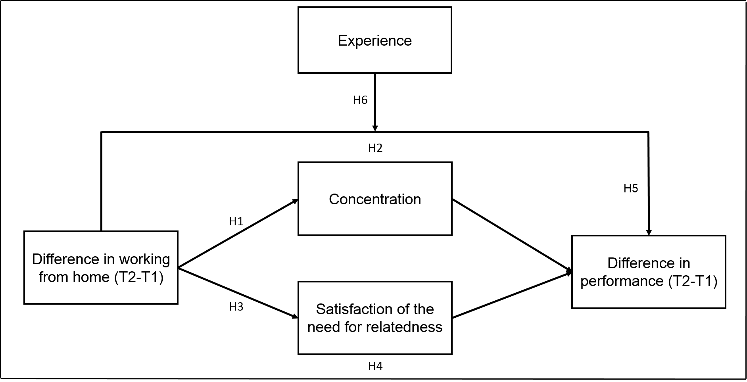

Method

Data collection
We will test the assumed hypotheses using a quantitative study, based on two surveys conducted in a Flemish company that mainly focuses on job placement. More specifically, both surveys were conducted within the same organization with a period of three months between them, in order to examine the difference in the amount of homeworking between both periods and its outcomes. The survey was sent by e-mail to all the employees of the organization and they were strongly motivated to fill it in, explaining the high response rate of 80,1% in the first measurement wave and 77% in the second one. In total, the organization employs 5119 workers and supervisors and allowed all its employees to work from home. The first survey was conducted several weeks after teleworking was introduced by the management. We therefore assume that it was about a baseline measurement, which makes the difference between the first and second measurement wave relevant and little influenced by previous experiences of employees with homeworking (Hill et al., 2003). The sequence of the variables differed between employees and items were mixed up, so that the respondents could not figure out which concept was measured in order to avoid socially desirable answers.

Population, sample and participants
The population on which this research focuses are all employees or supervisors of a Flemish organization that mainly provides employment services. It was not necessary to draw a random sample of homeworkers and employees, since the survey was conducted amongst all the organization’s employees. Such research is also defined as a census, because all the members of our population were questioned (Saunders, Lewis & Thornhill, 2015). Not all the respondents were used in this study, since several employees did not fill in both surveys and/or did not answer all the questions. In total, 3188 employees and/or supervisors did fill in all the items that were used to measure the concepts for this research and therefore the sample we used, consists of these respondents.
The average age of the employees who filled in the questionnaire in the first wave, is 47 years. The majority (71,2%) of the respondents are women (N=2947). Most of the employees were highly educated, having a bachelor or master’s degree (N=2877, 70%), full-time employed (N=2399, 58%) and professional employees, e.g. mediator, staff department, expert role, etc. (N=2470, 60%). In the first period, the respondents’ attitudes towards teleworking was mostly positive, as more than 70% indicated that they expected teleworking would lead to several positive outcomes. Examples are working more flexible and without interruptions and less work-related traffic. In the first period, the majority of the employees reported that they (on average in the last 3 months) already worked at least 1 day a week from home (N=2305, 56%). This number increased with 8% in the second period (N=2498, 64%).

Measures
Performance. In order to measure performance, the in-role performance scale of Williams and Anderson (1991) was used, which contains 7 items. These authors used the in-role performance scale of O’Reilly and Chatman (1986) but added several items since this scale only contained 3 items. The added items were based upon behaviors as described in job descriptions or by several rewards systems, underlying the definition of in-role behavior. An example item is “I fulfil the responsibilities mentioned in my job description”.
Concentration. An employee’s ability to concentrate was measured, using a scale of Demerouti et al. (2007), which was used to assess whether employees were able to focus completely on their job. The scale contains 5 items of which one extra was added to the original scale of Jackson and Marsh (1996), namely “Over the past 3 months, my thoughts have drifted to other things during work.”, which is reverse-coded. An example of an item of the original scale is “Over the past 3 months, my attention has been focused on the task I was performing during my work”.
Satisfaction of the need for relatedness. Van den Broeck et al. (2010) published an article in which they constructed and validated a scale that included all the basic need satisfactions in a work-related context. Three of these items were used to measure the satisfaction of the need for relatedness, namely “I feel like part of a group at work”, “I can talk to others at work about what I really think is important” and “Some of the people I work with are real friends”.
In addition, all items were questioned, using a 7-point Likert scale, going from 1=”strongly disagree” to 7=”strongly agree”. A framing period of 3 months was added to the items, since the deadline to fill in the survey was 3 months after teleworking was introduced by the organization. The Cronbach’s alphas of all the concepts were always between 0.73 and 0.86, indicating that the scales are sufficiently reliable. Furthermore, several demographic variables were included in the survey. Examples are gender, educational degree, age, contract, location, marital status, whether the employees have children and how many.
Experience. Job experience was measured by one item, namely “How many years do you work in your current position?”.
Difference in homeworking intensity. Several steps were taken in order to calculate the difference in days worked from home between the first and second period. First, respondents were asked in both measuring moments how many days a week they worked from home during the last 3 months, on a scale from 0 to 4 (4 being at least 4 days a week). This categoric variable was named ‘Homeworking frequency’. However, a considerable amount of employees did not work full-time in the organization. So, employees who only work 3 days a week, but then also work those full 3 days from home for example, need to have the same weight than those who work 5 days out of 5 (full-time) from home. Therefore, the variable ‘Working regime’, was used in order to correct the amount of homeworking days. ‘Working regime’ represents the amount of days a week an employee works for the organization compared to a full working week. The variable is categorized as follows: 1: 0%-24, 2: 25%-59%, 3: 60%-79%, 4: >= 80%. Then, in order to calculate ‘Homeworking intensity’, the variable ‘Homeworking frequency’ was divided by ‘Working regime’. Finally, the difference between ‘Homeworking intensity’ from the second and first period was calculated and added to our analyses. It is important to note that ‘Homeworking intensity’ might have a negative sign in our data, due to the fact that the amount of days employees worked from home between the two periods could have decreased.

Analyses

All hypotheses of our conceptual framework will be tested, using the regression estimation technique called Ordinary Least Squares (OLS). Our results will be controlled, using the PROCESSv3.4 Macro from Hayes (2013), installed in SPSS. This software enables us to test multiple direct and indirect effects in one model, also using OLS. A new variable (X), was calculated, which measures the difference in homeworking intensity between T2 and T1. The factor scores of the concepts concentration (T2) and satisfaction of the need for relatedness (T2) will be calculated and added to the analyses as mediators M1 and M2, respectively. Furthermore, the variable job experience (T2) will be added as moderator on the relationship between X (difference in homeworking intensity) and the dependent variable, difference in performance (T2-T1). Furthermore, in line with the Job Demands-Resources model, autonomy, social support and work engagement will be added as control variables to the analyses, since previous studies indicated their impact on performance (Bakker & Demerouti, 2014; Bakker et al., 2004).

Results

Descriptives
Table 1 provides the means, standard deviations and correlations between the variables examined in the analyses. First, it is important to note that, in general, the correlations between the dependent variable (∆performance), the mediators and the independent variable (∆homeworking intensity) are relatively low, indicating that little can be explained based on these variables. Furthermore, most employees in our study believe that their performance has hardly decreased between the first and second period, since the average difference in performance is close to zero. The average difference in homeworking intensity also indicates that the amount of homeworking between the first and second period remains almost unchanged.
∆Homeworking intensity is positively correlated to the satisfaction of the need for relatedness and ∆performance, but not to concentration. Surprisingly, both mediators, namely concentration and satisfaction of the need for relatedness, are positively related to each other. The satisfaction of the need for relatedness is positively related to motivation and performance (Van den Broeck et al., 2016), which might imply that employees who experience a satisfaction of this basic need are more determined to perform, by means of focusing more on their tasks. The satisfaction of this need might also imply that employees experience increased well-being in general and therefore, their efforts require less energy for which their focus improves. In accordance with our expectations, both performance and ∆performance are positively related to concentration and satisfaction of the need for relatedness. Only concentration is positively related to job experience, which might imply that more experienced employees are more determined or able to focus better on their tasks. Finally, it is noteworthy that no correlation was found between experience and ∆performance, since we expected performance improvements to be different between less experienced and experienced employees.

Table 1: Means, standard deviations and correlations
Variable | Mean | Standard Deviation | 1 | 2 | 3 | 4 | 5 | 6 | 7
1. ∆ Homeworking intensity | 0.03 | 0.14 | 1
2. Homeworking intensity (T2) | 0.21 | 0.19 | 0.396** | 1
3. Concentration | 5.33 | 0.88 | -0.001 | -0.008 | 1
4. Satisfaction of relatedness | 5.27 | 1.08 | 0.039* | 0.015 | 0.331** | 1
5. Performance | 5.90 | 0.69 | 0.011 | 0.065** | 0.437** | 0.251** | 1
6. ∆ Performance | -0.03 | 0.65 | 0.053** | 0.036* | 0.120** | 0.079** | 0.488** | 1
7. Job experience | 9.30 | 9.20 | -0.009 | -0.167** | 0.038* | 0.012 | -0.001 | -0.011 | 1
Note: Correlations are provided between the means of concentration, satisfaction of the need for relatedness, performance and ∆performance. Further analyses will be done with the factor scores of these variables.
**. Correlation is significant at the 0.01 level (2-tailed).
*. Correlation is significant at the 0.05 level (2-tailed).

Regression analyses
All hypotheses were examined, using OLS regressions. The analyses were examined and controlled, using the PROCESSv3.4 Macro from Hayes (2013) and similar results were found. In the first models, the assumption of normality for OLS was not fulfilled and several outliers were present. After several attempts to improve and correct the models, results remained almost unchanged, but we managed to delete several outliers. The fact that the error terms in all the regressions are not normally distributed, will be addressed in the discussion. The factor scores of the variables autonomy, social support and work engagement were added to the analyses.

The effect of the difference in homeworking intensity on both mediators (H1 – H2)
In our first hypothesis, we assumed that an increase in the intensity employees worked from home between the first and second period would lead to an increase in concentration. In the second one, an increase in homeworking intensity was assumed to lead to a decrease in the satisfaction of the need for relatedness. Contrary to our expectations, our analyses did not support these hypotheses. The results from both regressions are presented in Table 2. The control variables were included in these models, but their coefficients are presented in Table 3.
Table 2: OLS with ∆homeworking intensity as independent variable
Dependent variable | β | Sig. | F | ANOVA sig. | R²
Concentration | -0.016 | 0.255 | 389.776 | 0.000 | 0.318
Satisfaction of the need for relatedness | 0.019 | 0.196 | 376.232 | 0.000 | 0.317
Note: Sig. refers to the p-values of the standardized coefficients. ANOVA sig. refers to the p-values of the ANOVA-table.
Both the OLS regressions and the Macro from Hayes (2013) found no significant impact of an increase in homeworking intensity on employees’ concentration in the second period (β= -0.016, ρ= 0.225). The same result applies to the hypothesis that an increase in homeworking intensity would lead to a lower satisfaction of the need for relatedness (β= 0.019, ρ= 0.196). Considering the low correlations between these variables and the relatively low R² of the models, these results are not surprising.

The mediating and direct effects on performance (H3 – H5)
Hypotheses 3, 4 and 5 were tested, using the same method as mentioned above. Hypothesis 3 assumed that the relationship between increased homeworking intensity and increased performance would be mediated by concentration and Hypothesis 4 assumed that this relationship would be mediated by the satisfaction of the need for relatedness. Several regressions were carried out, using the method of Baron and Kenny (1986). Its results were also controlled, using the PROCESSv3.4 Macro. First, both mediators were the dependent variables in the first two regressions and ∆homeworking intensity the independent variable. Second, ∆homeworking intensity was the independent variable and ∆performance the dependent variable. A third type of regression was then carried out, in which both mediators and ∆homeworking intensity were used as the independent variables and ∆performance as the dependent again. Our analyses, that are provided in Table 3, found no support for both hypotheses.
Table 3: Summary of regression analyses
 | Dependent Variables
 | Concentration |  | Satisfaction of the need for relatedness |  | ∆ Performance
Independent variables | β | Sig. | β | Sig. | β | Sig.
∆ Homeworking intensity | -0.016 | 0.255 | 0.019 | 0.196 | 0.050 | 0.049
Autonomy | 0.088 | 0.000 | 0.113 | 0.000 | -0.003 | 0.859
Social support | 0.019 | 0.203 | 0.269 | 0.000 | 0.022 | 0.247
Work engagement | 0.518 | 0.000 | 0.365 | 0.000 | 0.121 | 0.000
Concentration |  |  |  |  | 0.088 | 0.000
Satisfaction of the need for relatedness |  |  |  |  | -0.018 | 0.387
Model | F(4, 3341) = 389.8, ρ=0.000, R² = 0.318 |  | F(4, 3243)= 376.2, ρ=0.000, R²= 0.317 |  | F(8, 3063)= 14.1, ρ=0.000, R²= 0.035
Note: Sig. refers to the p-values of the standardized coefficients.
Hypothesis 3 and Hypothesis 4 are not supported, since ∆homeworking intensity has no significant impact on concentration (β= -0.016, ρ= 0.255) and on the satisfaction of the need for relatedness (β= 0.019, ρ= 0.196). The latter was already discussed in 4.2.1. The relationship between increased homeworking intensity and increased performance cannot be mediated by both variables, since the first condition of mediation, according to Baron and Kenny (1986), is that the independent variable must have a significant impact on the mediator(s).
Hypothesis 5 assumed that increased homeworking intensity would lead to an increase in performance. Our analyses found support for this hypothesis (β= 0.050, ρ= 0.049). However, this increase in performance is relatively small, compared to the other significant effects. Moreover, the model has a significantly low R² (0.035), indicating that it has no or little explanatory effect. To conclude, an increase in the intensity of homeworking between the first and second period does lead to an increase in performance between both periods. However, concentration and the satisfaction of the need for relatedness at the second period are not affected by an increase (or decrease) in homeworking intensity.

The moderating effect of job experience (H6)
The sixth and final hypothesis proposed that the relationship between increased homeworking intensity and performance would be moderated by the amount of experience employees have in their job. Baron and Kenny (1986) their method was used and controlled by the PROCESSv3.4 Macro. Contrary to our expectations, we found no support for Hypothesis 6. The results of this analysis are provided in Table 4.

Table 4: OLS regression with job experience as moderator
 | ∆ Performance
Independent variables | β | Sig.
∆Homeworking intensity | 0.050 | 0.049
Job experience | -0.010 | 0.602
Interaction effect | 0.011 | 0.661
Model | F(8, 3063) = 14.1, ρ= 0.000, R² = 0.035
Note: Sig. refers to the p-values of the standardized coefficients.
First, it is important to note that this model has a low R² (0.035), meaning that it has little explanatory effect. Hypothesis 6 was not supported since the interaction term between job experience and ∆homeworking intensity is nonsignificant (β= 0.011, ρ= 0.661). Surprisingly, job experience has no significant influence on ∆performance (β= -0.010, ρ= 0.602), meaning that an increase or decrease in performance is not affected by the amount of experience employees have in their job. Table 1 in our descriptive analysis already indicated that job experience was not correlated to ∆performance.
Figure 2: Relationship between ∆homeworking intensity and ∆performance, with job experience as moderator
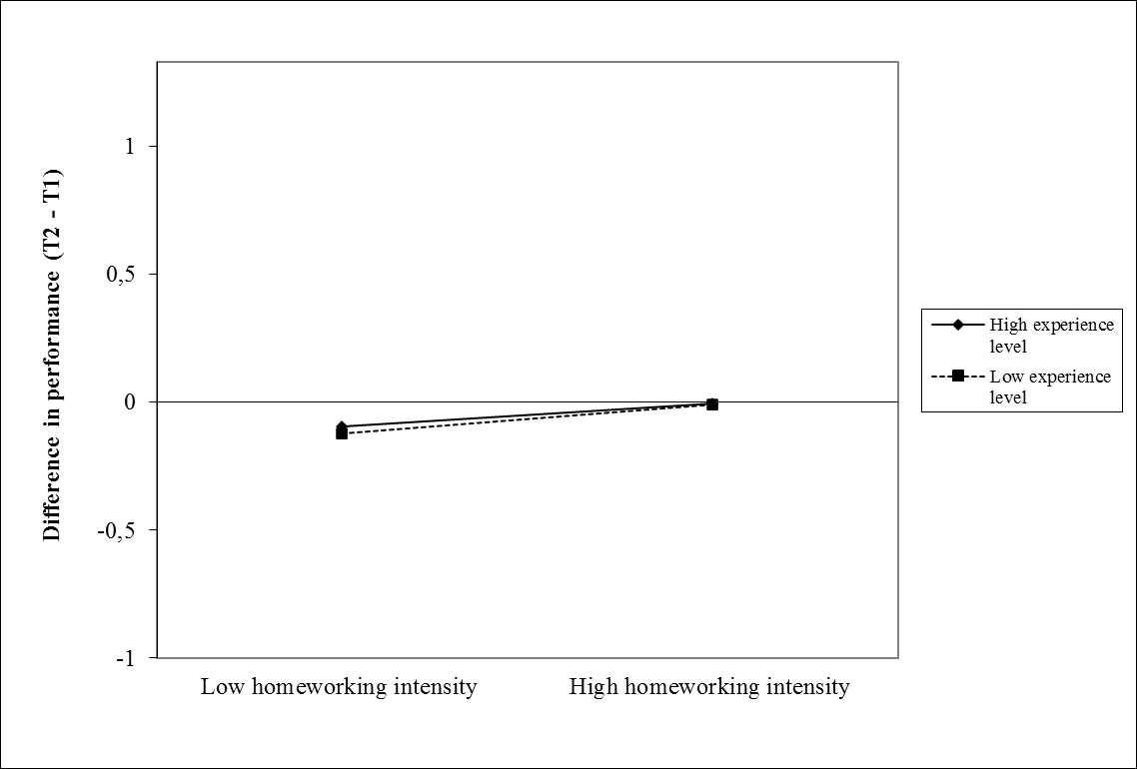
Note: The vertical axis represents the difference between the factor scores of the first and second period of ∆performance. The horizontal axis indicates the difference in homeworking intensity between both periods. The low and high values of the variables were computed by adding one standard deviation to their means and subtracting one standard deviation from their means.

This figure indicates that increased homeworking intensity leads in general to an increase in performance between the two measuring moments, for both less experienced and experienced employees, which confirms Hypothesis 5 again. However, there is no significant difference in performance levels. The fact that the interaction term and job experience were nonsignificant in the regression indicates that we found no support for Hypothesis 6 and that Figure 2 should not be interpreted.

Discussion

Conclusion
This research aimed to explain the relationship between homeworking intensity and performance, taking homeworkers’ concentration, satisfaction of the need for relatedness and job experience into account. Several theories and results from previous research were examined and discussed in order to propose multiple hypotheses concerning the above-mentioned variables. Even though our analyses found no support for most hypotheses, there are still some relevant conclusions associated with this study.
First, we investigated whether increased homeworking intensity between both periods would lead to better overall concentration in the second period. Contrary to our expectations, Hypothesis 1 was not supported, which can be caused by various reasons. Our survey questioned the overall concentration of employees during the last 3 months, without any distinction between days worked from home and days worked in the office. Most employees in our study reported no difference in the amount of homeworking intensity between the first and second period (N= 2676) and only worked 1 day a week from home (N= 2077). This might imply that if employees work less often from home, their overall concentration is less likely to improve. When employees experience better concentration on the days worked from home but a lower concentration while working at the office, as Biron and Van Veldhoven (2016) indicated, their overall concentration might be equal. Furthermore, less intensive homeworkers tend to prefer integrating work and home roles, which negatively influences their concentration. Several home-related factors might negatively impact homeworkers’ concentration, such as increased family interference with work activities (Golden et al., 2006), and therefore compensating the benefits on homeworkers’ overall functioning (Biron & Van Veldhoven, 2016; Fonner & Stache, 2012).
We also found no support for Hypothesis 2, even though we assumed that the need for relatedness would be less satisfied due to an increase in homeworking intensity. As we mentioned above, the difference in homeworking intensity between the first and second period has remained unchanged for most employees, and most employees only worked 1 day a week from home in the second period. The latter might suggest that the (negative) impact of an increase in the amount of homeworking is limited on the satisfaction of this need. Bailey and Kurland (2002) already indicated that the effect of social isolation was insignificant when homeworking is less frequent. Findings from the study from Golden et al. (2006) indicated that homeworking is negatively related to work-to-family conflict, because homeworkers tend to spend more time with their family members. This might compensate the negative effect of homeworking on the relationship with their colleagues and therefore their satisfaction of this need. Furthermore, homeworkers who feel more socially isolated tend to take actions to overcome those feelings, such as having more conversations with colleagues, which is confirmed in the qualitative research of Lal and Dwivedi (2009). Duxbury and Neufeld (1999) indicated in their study that part-time teleworking has no significant impact on communications between homeworkers and their managers or colleagues. As most of our respondents only worked a limited amount of time from home, their communication with others might have hardly decreased.
Our third and fourth hypotheses proposed that the relationship between increased homeworking intensity and increased performance would be mediated by both concentration and the satisfaction of the need for relatedness. Since our independent variable, difference in homeworking intensity, has no significant impact on both mediators, we found no supporting evidence for these hypotheses. Employees’ concentration in the second period did lead to a significant increase in performance between both periods. This indicates the importance of employees’ ability to concentrate on their tasks in order to perform better while working from home, even though working from home does not automatically lead to better concentration. It is noteworthy that the satisfaction of the need for relatedness has no significant impact on the difference in performance, as we suggested in the fourth hypothesis. Employees who feel like they are missing important conversations or social support for example, might provoke actions to reduce these negative effects. For example, they attempt to build smaller networks with colleagues to engage in conversations about work-related matters such as gossip or changes in the organization (Lal & Dwivedi, 2009). Finally, homeworkers tend to compensate their absence during the days working in the office.
Additionally, an increase in homeworking intensity between the first and second period did lead to better performance between both periods, meaning that Hypothesis 5 was supported. Thus, an increase in the amount of homeworking does lead to an increase in homeworkers’ performance, compared to homeworkers of whom the difference between the two periods is smaller. These findings support the results of Vega et al. (2015), who indicated that homeworkers reported higher performance levels on the days working from home, compared to those working at the office. Employees who prefer working from home now have the voluntary choice to do so. Therefore, they are more likely to be motivated to perform and feel more pressure in order to maintain the level of trust their organizations and/or supervisors gave them (Hill et al., 2003; Richardson & McKenna, 2014). However, Kossek et al. (2006) found no evidence that the extent of teleworking was positively related to performance. Furthermore, supporting evidence for this hypothesis should be interpreted carefully, since the impact of increased homeworking intensity on increased performance is relatively small (β= 0.050), compared to the other significant effects on increased performance. Since our survey is about a baseline measurement, homeworkers’ performance improvements might be limited, because they had little or no experience with working from home. The latter might explain the fact that we only found a smaller effect.
Finally, we proposed that the relationship between increased homeworking intensity and increased performance would be moderated by employees’ experience in their job. Contrary to our expectations, we found no support for this hypothesis. Homeworkers’ increase in performance is not significantly influenced by their job experience and there is no interaction effect between job experience and difference in homeworking intensity. As mentioned earlier, managers’ biggest concern is their reduced control over their employees while working from home. The fact that the difference in homeworking intensity was limited in our study might imply that homeworkers’ managers are able to supervise homeworkers during the days they work at the office. Homeworkers are also able to ask feedback or help from their colleagues during these days. Communication patterns might remain unchanged when employees work (part-time) from home, as the findings from Duxbury & Neufeld (1999) indicated. Moreover, managers in the qualitative research of Dambrin (2004) reported that they continuously take actions in order to retain much of the control over their employees, such as regularly organizing virtual meetings. These arguments might explain why we did not find supporting evidence for this hypothesis.

Limitations and suggestions for further research
There are several limitations to this research that are worth discussing. First, it is important to note that both the correlations between the variables and their variations are low and therefore, there is little to explain in general. Furthermore, in trying to fulfill the assumptions of OLS in the regression analyses, we faced several limitations. In the first models, both heteroskedasticity and several outliers were present in the residuals. In order to meet these assumptions, several outliers were deleted but the assumption of normality could be fulfilled, according to the KS-test, which might influence the validity of the results (Studendmund & Johnson, 2017). Taking our large sample and the histograms of the residuals into account, the neglection of this assumption will have little (or zero) effect on the interpretation or validity of our results. The histograms are presented in Appendix 1. However, considering the low R² of the models, omitted variable bias is most likely to occur. The latter was tested, using Ramsey’s Regression Specification Error Test (RESET) and indeed, the tests indicated that there are specification errors in the models, probably because the residuals contain elements that are affecting the dependent variables. Therefore, the results in this study should be interpreted carefully.
Another limitation in the study is that men are underrepresented in our sample (28,8%), which is likely to affect our hypotheses on concentration and the satisfaction of the need for relatedness. However, the sample in our study is large enough to clarify several outcomes of homeworking within that organization. There is limited proof that women are more likely to experience work-family conflict than men, which might negatively influence their concentration (Parasuraman & Greenhaus, 2002). However, Golden et al. (2006) found no support for this relationship. We carried out two extra regressions, of which the results are represented in Appendix 2. Women reported lower concentration levels (β= -0.028, ρ= 0.049), compared to men in our study. Surprisingly, women also reported higher levels of satisfaction of the need for relatedness (β= 0.053, ρ= 0.000). The under-representation of men might therefore affect our results, meaning that if men were more represented in our study, increased homeworking intensity might lead to different concentration and/or satisfaction levels. Further research might examine the underlying reasons for which women (might) report lower concentration levels or increased levels of their satisfaction of the need for relatedness.
As discussed in the conclusion, the results might be affected because the amount of days employees worked from home in our study is limited, compared to the amount of days they worked in the office. For most employees, homeworking intensity between both periods has remained almost unchanged as well. Further research could study effects between groups in which the intensity of homeworking (or the difference between periods) is higher, in order to compare effects between intensive homeworkers and less intensive homeworkers. Moreover, we proposed that the relationship between increased homeworking intensity and the other variables would be linear. The Ramsey RESET tests indicated that specification errors were occurring in the analyses, which can indicate that the relationships between the variables are u-shaped. Scholars might examine whether there is an optimal combination between working days in the office and working days at home, in order to optimize concentration, satisfaction of the need for relatedness and performance. A within-person analysis might be recommended as well, to identify whether homeworkers experience higher concentration or performance levels or a lower satisfaction of the need for relatedness, on the days working from home compared to those working in the office.
Also, it is important to note that our results came from self-reported data and no objective measurements were used in order to examine performance, concentration, and satisfaction of the need for relatedness, which might affect the validity of our results. Even though employees might be better at judging their own performance, performance rated by others is often lower than performance rated by employees themselves (Demerouti et al., 2007). Moreover, the fact that employees in our study had the voluntary choice to work from home might also affect the results on performance. Those who indicated to work from home probably preferred this flexible arrangement, for which they might (unconsciously) report higher performance levels than their actual performance levels. Neufeld and Fang (2005) for example, suggested that employees often tend to claim better outcomes of teleworking because they prefer this way of working. Moreover, positive attitudes towards teleworking are positively rated to performance. Since homeworkers who prefer this flexible working arrangement are allowed to do so, they tend to be more motivated to perform and prove to their supervisors its effectiveness, for which they indicate positive outcomes of homeworking (Tavares, 2017). Considering these arguments, results about performance and the other variables should be interpreted carefully and further research might examine the difference between objective performance ratings and self-rated outcomes of homeworking.
Finally, the increase in performance in our study cannot be attributed to an increase (or decrease) in both mediators, as discussed previously. Therefore, future research might examine variables that affect homeworkers’ well-being as well, instead of work-related outcomes only, in order to investigate this relationship.

Practical implementations
The results of this study may provide several practical implementations. First, it is advisable for organizations to allow, and not obligate, employees to work from home. Those who prefer to work from home (and are now allowed to do so), might experience increased motivation and therefore performance. However, taking the current situation of the pandemic into account, most employees are required to work from home for several months (University of Antwerp, 2020). A survey of 1000 respondents indicated that most of the employees and supervisors prefer to keep working from home between 1 and 3 days a week, after the crisis (HR Square, 2020). Increased productivity was the main reason for which they prefer to proceed this working method. Taking the fact that concentration is an important determinant of productivity into account, supervisors might introduce policies that would encourage concentration both in the office and from home. Results from our study also indicated that concentration is an important determinant for increased performance. Therefore, organizations might examine for which reasons employees’ productivity and/or concentration has improved while working from home and whether a similar environment that stresses these factors in the office can be created as well.
In our study, 783 respondents indicated that their supervisors do not support flexible working arrangements, such as homeworking. This might indicate that employees are not yet motivated to work from home because of the fact that their supervisors show negative attitudes towards or do not support homeworking. Since the results in our study indicated that homeworking does lead to better performance and there is no difference in performance between less experienced and experienced employees, managers and/or supervisors could consider taking a more positive view towards homeworking. The study from Baker, Avery and Crawford (2007) for example indicated that the trust of managers towards homeworkers is positively related to homeworkers’ satisfaction, indicating its importance. However, receiving feedback is an important element for employees to perform better as well. Therefore, it is important that supervisors remain in touch with their employees, without reducing homeworkers’ perceived autonomy, which is considered to be an important factor for homeworking’s positive outcomes.

Appendix 1: Histograms of the residuals
The histograms of the residuals of the models that were used in our analyses are presented below. Our sample sizes in all three regressions are relatively large, between 3000 and 3400 cases, compared to other studies. Moreover, the histograms of the unstandardized residuals also indicate that the distributions are considerably close to being normal. Therefore, as discussed in the limitations of the study, we propose that the neglection of this assumption will have little effect on the validity of our results.
Figure B.1: Histogram of the regression with concentration as dependent variable
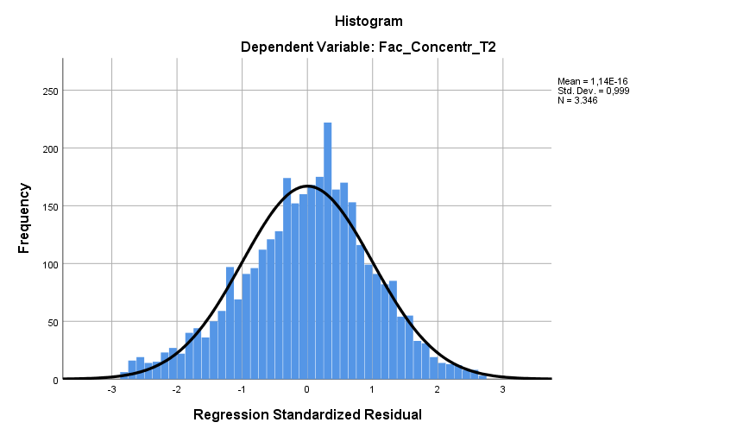
Figure B.2: Histogram of the regression with the satisfaction of the need for relatedness as dependent variable
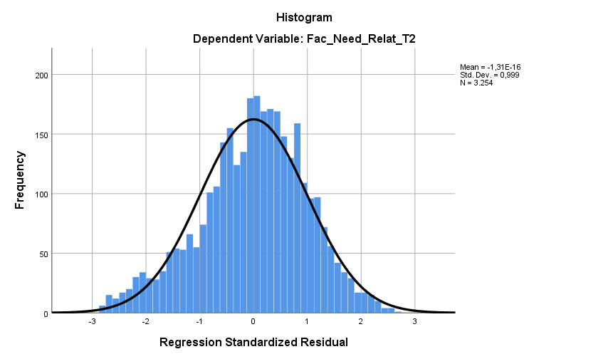
Figure B.3: Histogram of the regression with ∆performance as dependent variable 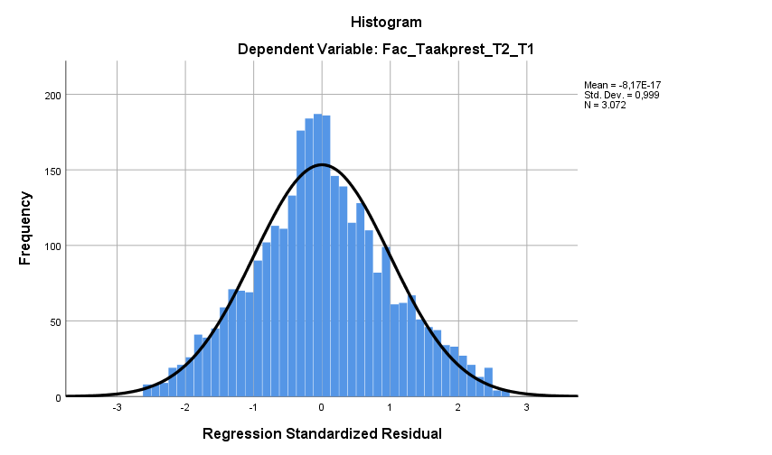

Appendix 2: Regressions with ‘Gender’
Table B.1: OLS with concentration as dependent variable and gender as dummy variable
 | Concentration
Independent variables | β | Sig.
∆Homeworking intensity | -0.016 | 0.276
Autonomy | 0.086 | 0.000
Social support | 0.021 | 0.162
Work engagement | 0.518 | 0.000
Gender | -0.028 | 0.049
Model | F(6, 3338) = 260.8, ρ= 0.000, R² = 0.319
Note: Gender: Male= 0, Female= 1, with Male as reference category. Sig. refers to the p-values of the standardized coefficients.
Table B.2: OLS with satisfaction of the need for relatedness as dependent variable and gender as dummy variable
 | Concentration
Independent variables | β | Sig.
∆Homeworking intensity | 0.017 | 0.247
Autonomy | 0.115 | 0.000
Social support | 0.265 | 0.000
Work engagement | 0.366 | 0.000
Gender | 0.053 | 0.000
Model | F(6, 3240) = 253.9, ρ= 0.000, R² = 0.320
Note: Gender: Male= 0, Female= 1, with Male as reference category. Sig. refers to the p-values of the standardized coefficients.


Press release
02/05/2020
Working from home does have a positive impact on employees' performance
Working from home has become more present than ever in today’s world economy, due the increased use of computers, smartphones, and other digital technologies. Almost one out of four employees works from home now and then. However, due to the coronavirus, more than 70% of employees started working from home. Studies already indicated that this trend is likely to continue after the virus. Results from a Master’s thesis from a student Human Resource Management (HRM) indicate that employees who work from home more often tend to perform better than those who apply this flexible working method less often.
One of many positive outcomes
Working from home is not only introduced by organizations because they expect better performance levels of their employees. Improved work-life balance, enhanced autonomy and motivation and reduced commuting costs are positive effects for homeworkers as well. But performance is one of several positive outcomes of homeworking that improves along with the amount of days employees work from home. The greater extent to which homeworkers work from home neither affect homeworkers’ concentration, nor their relatedness with others from the organization.
Homeworkers remain connected
Contrary to the overall assumption on homeworking, homeworkers do not feel less connected with their organization or their colleagues, regardless of the amount of days they work from home. As mentioned before, digital technologies or mobile phones might play a major role in this relationship. Homeworkers often attempt to build small networks with colleagues to engage in conversations about work-related matters, such as gossip or changes in the organization. Women even tend to be more related with their colleagues than men in this study. Homeworkers do not only remain connected with others of their organizations, their relationships with family members might improve as well, and it is this combination that is likely to enhance homeworkers’ performance.
The importance of the research method
Contrary to most studies on homeworking, this study stressed the importance of homeworking intensity in the discussion of its outcomes. A survey was conducted amongst employees of different functions, ages or locations, within a Flemish organization that is active in the public sector. In total, almost 3200 respondents participated in this study. Because of this large amount of respondents, other organizations could use the results of this study to implement a clear policy on working from home.
--------------------------------------------------- END PRESS RELEASE ---------------------------------------------------
About KU Leuven
KU Leuven is a research and educational institution with almost 59 000 students, 21 500 employees and a well-known international reputation. Educational activities are organized within 15 faculties and research takes mainly place within departments. There are three groups in which faculties are organized, namely Human Sciences, Science & Technology and Biomedical Sciences. In total, the institution has 14 campuses, spread over 10 cities in Flanders. It leads the Reuters ranking of Europe’s most innovative universities for four years in a row. More information can be found on https://www.kuleuven.be/over-kuleuven/
Contact details
If you would like more information about this study, contact:

De Kerf Jonas
jonas.dekerf@student.kuleuven.be

Faculty of Economics and Business
Campus Carolus Antwerp
Korte Nieuwstraat 33
2000 Antwerp
phone. + 32 3 201 18 40
FEB.antwerpen@kuleuven.be

