Is physical activity associated to inflammation, T-cell phenotypes and/or (pre-)frailty in community-dwelling persons aged 80+ years?

Emelyn Mathot

Eindwerk, ingediend voor het behalen van de graad van Master in de Biomedische Wetenschappen

18 en 19 juni 2020

Academiejaar 2019 - 2020

Promotor: Prof. Ivan Bautmans

Begeleider: Prof. Rose Njemini

Naam en adres van de stageplaats
Frailty in Ageing (FRIA) research group
Laarbeeklaan 103
1090 Brussels



Deze masterproef is (ten dele) tot stand gekomen in de periode dat het hoger onderwijs onderhevig was aan een lockdown en beschermende maatregelen ter voorkoming van de verspreiding van het COVID-19 virus. Het proces van opmaak, de verzameling van gegevens, de onderzoeksmethode en/of andere wetenschappelijke werkzaamheden die ermee gepaard gaan, zijn niet altijd op gebruikelijke wijze kunnen verlopen. De lezer dient met deze context rekening te houden bij het lezen van deze masterproef, en eventueel ook indien sommige conclusies zouden worden overgenomen.

This master's thesis came about (in part) during the period in which higher education was subjected to a lockdown and protective measures to prevent the spread of the COVID-19 virus. The process of formatting, data collection, the research method and/or other scientific work the thesis involved could therefore not always be carried out in the usual manner. The reader should bear this context in mind when reading this Master's thesis, and also in the event that some conclusions are taken on board.

Samenvatting

Achtergrond: Frailty kent een hoge mortaliteit en is één van de grootste bedreigingen voor onze vergrijzende bevolking. Frailty, maar ook de daaraan gerelateerde disregulatie van het immuunsysteem, immunosenescentie, en inflammatie staan daarom in de weg van gezond ouder worden. Recent onderzoek duidt lichaamsbeweging aan als mogelijke oplossing om deze leeftijdgebonden veranderingen tegen te gaan, echter vaak door gebruik te maken van specifieke dosis-respons interventies.

Doel: Het doel van deze studie was om na te gaan of fysieke activiteit uitgevoerd tijdens dagdagelijkse activiteiten, zoals wandelen of strijken, ook een rol zou kunnen spelen bij het optreden van (pre-)frailty, immunosenescentie en inflammatie in 80-jarigen.

Resultaten: Driehonderd en negen deelnemers van de BUTTERFLY-studie, een cohort studie in zelfstandige 80+’ers die robuust of pre-frail zijn, werden in de studie geïncludeerd. 144 deelnemers (46.60%) waren pre-frail. Ouder zijn (p<.001) en tot het mannelijke geslacht behoren (p<.001) droegen significant bij tot het pre-frail zijn. Robuust of pre-frail zijn was echter niet geassocieerd met fysieke activiteit in onze populatie. Fysiek actief zijn was geassocieerd met lagere percentages CD8+CD28+CD57- (naïeve) en hogere percentages CD8+CD28-CD57- (memory) cel fenotypes, behalve in mannen. In mannen was actief zijn gecorreleerd met minder CD8-CD28+CD57- (naïeve) T cellen. Tenslotte was actief zijn geassocieerd met lagere levels van inflammatoire merker C-reactive protein (CRP) in vrouwen.

Besluit: Deze studie draagt bij tot de algemeen aanvaarde consensus dat pre-frailty vooral mannen treft en geassocieerd is met veroudering. Dit onderzoek toonde ook aan dat fysieke activiteit geassocieerd is met specifieke T-cel fenotypes en inflammatoire merker CRP in vrouwen.

Abstract

Background: Frailty and its associated mortality risks are one of the major concerns regarding our aging population. Together with immunosenescence, an aging-associated dysfunction of the immune system and inflammation, frailty seriously threatens healthy ageing. Growing evidence indicates that physical exercise may counteract these age-related immune changes. However, this was evidenced in a dose-response using specific interventions.

Aim: The aim of this study was to investigate whether physical activity performed during daily life activities (such as walking, household and/or gardening) could also interfere with (pre-)frailty, immunosenescence and inflammation in people aged 80 and over.

Results: Three hundred and nine participants of the BUTTERFLY-study, a cohort study in well-functioning subjects aged 80+ who are robust or pre-frail, were included in this study. From included participants, 144 (46.60%) were pre-frail. Being older (p<.001) en being a man (p<.001) contributed significantly to pre-frailty. No associations were found between (pre-)frailty and physical activity in our population. Physical activity was associated with a lower percentage of CD8+CD28+CD57- (naïve) and a higher percentage of CD8+CD28-CD57- (memory) immunosenescence phenotypes, except in men. In men, physical activity was correlated with lower counts of CD8-CD28+CD57- (naïve) T-cells. Additionally, a higher physical activity profile was associated with lower C-reactive protein (CRP) levels, an inflammation marker, in women.

Conclusion: Our analysis supports the view that pre-frailty affects more men than women and that pre-frailty is associated with aging. Moreover, our study was able to show associations between physical activity and specific T-cell phenotypes and inflammatory marker CRP, except in men.

Introduction

Over the past decades, the group of people aged 80 and over has emerged as the fastest growing group within our society. The World Health Organization even expects this demographic group to triple to 426 million by 2050 ¹. Unfortunately, becoming older does not necessarily go hand-in-hand with healthy ageing ² as up to 60% of older people is confronted with the consequences of frailty ³. Frailty is a geriatric syndrome that consists of an aging-associated decrease in reserve capacity and a decreased resistance to stressors⁴. The state of increased vulnerability it generates ultimately leads to high risk for poor health outcomes, including disability, falls, hospitalization and even death ⁵.

Although the underlying pathophysiology of frailty is not completely understood yet, there are strong indications for the involvement of immunosenescence, as evidenced by recent research ^{6,7}. Immunosenescence is an aging-associated dysregulation of the immune system that leads to an increased susceptibility to auto-immunity and infections, but also to a reduced vaccination response ⁸. This dysregulation can take place at different levels of the immune system as aging causes alterations in immune cells, but also in lymphoid organs and circulating factors ⁹. Immunosenescence not only affects the innate, but also the more specific adaptive immunity. This is characterized by a shift in T cell phenotypes, namely from naïve - dealing with newly encountered antigens - to memory and senescent T-cells ¹⁰. Senescent T cells are dysfunctional immune cells. Having lost expression of co-stimulatory molecule CD28 and having shortened telomeres, they are unable to divide and are resistant to apoptosis ¹¹. Additionally, their senescence-associated secretory phenotype (SASP) is responsible for the secretion of pro-inflammatory cytokines, contributing to a low-grade pro-inflammatory state referred to as ‘Inflamm-aging’ ¹²⁻¹⁴. Although recent literature suggests that immunosenescence and inflammaging should be considered as two separate states ^{15,16}, it is the combination of these two states that makes aging the most important risk factor for the most common chronic diseases because of their contribution to low-grade inflammation ¹⁷. Moreover, inflammaging has also been reported to be associated to frailty ¹⁵.

With ageing currently being an important demographic challenge, it is crucial to consider the impact of immunosenescence and inflammation on frailty and the associated negative health outcomes on the elderly this may give rise to. Therefore, different approaches have already been proposed to try to tackle immunosenescence, inflammation and frailty; physical exercise being one of them.

In the last years, beneficial effects of physical exercise on immunosenescence ^{18,19}, frailty ²⁰⁻²² and inflammation-status ^{23,24} have already been evidenced. However, this was evidenced in a dose-response using specific interventions. In contrary, evidence regarding the role of physical activity, performed during daily life activities such as household or gardening by the oldest old population is sparse. Peterson et al. showed in 2010 that sedentary elderly had increased odds of developing frailty whereas individuals with an active lifestyle did not ²⁵. More recently, Rogers et al. showed that mild physical activity (including vacuuming and laundry) could not reduce the progression of frailty, while moderate physical activity (including washing the car and gardening) could, but in particular age groups only (65 years and above). Vigorous activity (including running and swimming) could also reduce the progression to frailty in older adults (even in adults aged 80 and over) ²⁶. Although some studies have studied the effect of physical activity on immunosenescence ^{27,28} and inflammation ^{29,30} stating some positive effects of physical exercise, there is a need for studies investigating frailty, immunosenescence and inflammaging in one cohort of older persons. While these mentioned studies suggest that physical activity could play a role in halting the progression of frailty, immunosenesence and inflammation, they also show that collected evidence is still equivocal and highly dependent on the targeted age group. In this study, we therefore aimed to identify whether physical activity performed during daily life activities is associated with pre-frailty, immunosenescence and inflammation, specifically focusing on people aged 80 years and over.

Results

Descriptive statistics
From the 309 included participants, 144 (46.60%) were pre-frail. Pre-frail older adults were significantly older (p<0.001), had a higher body weight (p=.043) and Body Mass Index (BMI) (p=.042) (Table 1A and Supplementary table 1A). Our study included 103 pre-frail men (71.53%) versus 41 women (28.47%). In general, men had higher grip strength compared to women (p<.001). Moreover, men also spent less hours a week performing daily life activities, as depicted by the YPAS Time summary index in hours a week (p<.001). This difference in physical activity level could also be observed in robust elderly (p=.008), but not in pre-frail ones (p=.106). In general, men smoked more than women (p<.001). Women had a lower acetylsalicylic acid intake compared to men (p=.004). This was also seen in the robust elderly (p=.003), but was not observed in the pre-frail group (p=.342) (Table 1B and supplementary table 1B).

Association between frailty-status and physical activity
In order to determine whether physical activity could have an impact on frailty-status, we firstly performed a bivariate correlation (Pearson) to determine whether there was a correlation between these two variables. No correlation was found between frailty-status and total hours performing physical activity, determined by the YPAS total time summary index (p=.062) and the YPAS energy expenditure summary index, an index multiplying the time spent on each activity by an intensity code specific to that activity (p=.269) (Table 2A). Next, we performed a binary logistic regression with frailty-status as dependent variable. Being a men and higher age were the greatest predictors for pre-frailty in our sample and explained 20,5% of the observed variances (Table 3).
When looking at men only, the two physical activity parameters were not correlated to frailty-status (Table 2B). Although age (p=.001) and height (p=.001) were both correlated to frailty-status, inclusion of both variables in our binary regression did not lead to a significant predictive model.
Similar observations were made in women as no correlations between frailty-status and physical activity could be found (p-values of respectively .271, .319) (Table 2C). Age was the only significant predictor for frailty-status in women (p=.002).

Association between T-cell phenotypes and physical activity
Considering the established impact of physical exercise on T-cell phenotypes, we investigated whether physical activity performed during daily life activities was associated to these phenotypes. Firstly, we investigated possible correlations between physical activity and T-cell phenotypes using bivariate correlation (Pearson). There was a negative correlation between YPAS total time summary index and percent CD8+CD28+CD57- (naïve) cells. Additionally, the percentage of CD8+CD28+CD57- (naïve) cells was also negatively correlated to YPAS energy expenditure summary index (Table 2A). When performing a linear regression for this phenotype, no other variables could significantly contribute to a predictive model for percent CD8+CD28+CD57- (naïve) cells. The negative association observed between the CD8+ naïve phenotype and physical activity parameters was also seen in women (Table 2C). In this group, score on the Charlson comorbidity index also contributed significantly to our predictive model (Table 4A). However, in men, no correlation between physical activity and the naïve CD8+ phenotype could be found. Only CRP-levels were significantly negatively correlated to this phenotype in men (Table 2B). In contrast, in a sub study encompassing absolute counts of T-cell phenotypes, no correlations could be found between physical activity parameters and absolute counts of CD8+CD28+CD57- (naïve) cells in our total sample, in women and in men (Table 2D,E and F). In both the total population and women, anti-inflammatory drug intake and having an inflammatory disease were correlated to the absolute counts of naïve CD8+ cells (Table 2D and F) but these two variables could not be combined into a significant predictive model. In men, no significant correlations were found (Table 2F).

Next, we found a positive correlation between YPAS energy expenditure summary index and percent CD8+CD28-CD57- (memory) cells (Table 2A). In the total sample, our predictive model included the YPAS expenditure summary index, but also CRP levels as they contributed significantly to our model for the CD8+ memory phenotype (Table 4B). This positive correlation between the YPAS energy expenditure summary index and percent CD8+ memory was again also observed in women (Table 2B), but not in men (Table 2C). In women, a positive correlation between YPAS energy expenditure summary index and percent CD8+CD28-CD57- (memory) cells was also observed. Furthermore, the Charlson Comorbidity Index was also correlated to this phenotype (Table 2C), but the combination of both variables in one regression did not lead to a significant predictive model for the CD8+ memory phenotype. In men, cardiac impulse and CRP levels, but not physical activity parameters were positively correlated with this phenotype (Table 2B), but their combination was not significant anymore in our linear regression. No correlations could be found between physical activity parameters and absolute counts of CD8+CD28-CD57- (memory) cells. Similar to the CD8+ naïve phenotype, anti-inflammatory drug intake and having an inflammatory disease were correlated to the absolute counts of memory CD8+ cells in both the total population (Table 2D) and women (Table 2F), but these two variables could not be combined into a significant predictive model. In men, no significant correlations were found (Table 2E).

No correlations were found between physical activity and percent CD8+CD28-CD57+ or CD8+CD28+CD57+ senescent-prone phenotypes. Moreover, no predictive equation could be made for the CD8+CD28-CD57+ and CD8+CD28+CD57+ senescent phenotypes as none of the included independent variables were correlated to this phenotypes (Table 2A, B and C). Similarly, no correlations between physical activity and absolute counts of CD8+CD28-CD57+ or CD8+CD28+CD57+ senescent-prone phenotypes were found (Table 2D, E and F). A predictive model for absolute counts of CD8+CD28-CD57+ in our total sample and in men could not be formulated as no significant correlations were found between this senescent phenotype and included variables (Table 2D and E). In women, however, a positive correlation with anti-inflammatory drug intake could be found (Table 2F). Similarly to CD8+CD28-CD57+, no predictive model for absolute counts of CD8+CD28+CD57+ cells could be formulated in men. In women, anti-inflammatory drug intake and presence of an inflammatory disease were positively correlated to absolute counts of CD8+CD28+CD57+ cells (Table 2F). Combination of both variables in a linear regression did not lead to a significant predictive model for this phenotype. In our total sample, anti-inflammatory drug and acetylsalicylic acid intake contributed significantly to our predictive model for the absolute counts of CD8+CD28+CD57+ cells (Table 4C).

Additionally, no correlations were found between percent CD8-CD28+CD57- (naïve) and physical activity parameters (Table 2A). Moreover, no predictive model could be made in women due to the lack of significant associations (Table 2B). However, this phenotype was significantly associated with the Charlson comorbidity index and CRP levels in the total population sample (Table 4D) and in men (Table 4E). In contrast, a negative correlation was found between the absolute counts of CD8-CD28+CD57- (naïve) cells and the YPAS total time summary index in men (Table 2E). This was not the case for the total population (Table 2D), nor for women (Table 2F). While no variables could be significantly correlated to this phenotype in women (Table 2F), levels of CRP were negatively correlated with counts of CD8- memory phenotype in our total sample (Table 2D).

Next, associations between percent CD8-CD28-CD57- (memory) cells and physical activity were investigated. No significant correlations were found (Table 2A, B and C). Percentage of CD8-CD28-CD57- (memory) T-cells was positively correlated to CRP in the total population (Table 2A), in men (Table 2B) and in women (Table 2C). In women, the presence of an inflammatory disease was also significant within our predictive model (Table 4F). Similarly, no correlations were found between absolute counts of CD8-CD28-CD57- (memory) cells and physical activity parameters (Table 2D, E and F). In the total sample, our predictive model for this phenotype consisted of the combination of CRP levels and the presence of an inflammatory disease (Table 4G). No significant predictive model could be made for absolute counts in men and women, although this phenotype was positively correlated with CRP, anti-inflammatory drug intake and the presence of an inflammatory disease in women (Table 2F).

Additionally, percent and absolute counts of CD8-CD28-CD57+ and CD8- CD28+CD57+ senescence-prone cells and physical activity were not correlated with physical activity paramters (Table 2). A positive correlation between the Charlson comorbidity index and percent CD8-CD28-CD57+ cells in both the total sample (Table 2A) and in men (Table 2B) was found. As none of independent variables in our regression were significant, no predictive model could be made for women (Table 2C). Absolute counts of CD8-CD28-CD57+ cells were also associated with the Charlson comorbidity index, but also to anti-inflammatory drug intake in the total sample (Table 2D). No significant variables were found in men (Table 2E) and women (Table 2F). Percent CD8-CD28+CD57+ was only negatively associated with BMI (Table 2A) in the total sample and with bodyweight in women (Table 2C). No predictive equation could be formulated for men as no significant correlations were found (Table 2B). Absolute counts of CD8-CD28+CD57+ cells were negatively correlated to weight in our total sample (Table 2D). No significant correlations were found in men and women (Table 2E and F).

Lastly, no correlations were found between the CD8-/CD8+ ratio and physical activity parameters (Table 2D, E and F). In our total sample (Table 2D) and in men (Table 2E), no predictive model could be formulated due to the lack of significant associations with included variables. However, a negative correlation with the charlson comorbidity index was found in women (Table 2F).

Association between inflammation and physical activity
In order to establish possible correlations between C-reactive protein (CRP), an inflammatory marker, and physical activity, we firstly performed a bivariate correlation analysis (Pearson). No significant correlations were found between CRP levels and YPAS Time Summary Index and YPAS Expenditure Summary Index (Table 2A). Percentages of CD8+CD28-CD57- (memory) and percent CD8-CD28-CD57- were positively correlated to CRP while percent CD8-CD28+CD57- (naïve) was negatively correlated to CRP-levels in our population. Moreover, CRP was also negatively correlated to absolute counts of CD8-CD28+CD57- (naïve) and positively correlated to CD8-CD28-CD57- (memory) cells. (Table 2E).
In men, no correlations between CRP and physical activity parameters were found (Table 2B). However, positive correlations were found between CRP levels and the presence of an inflammatory disease, the intake of inflammatory drugs, CD8+CD28-CD57- (memory) and CD8-CD28-CD57- (memory) cells. Negative correlations were found between percentages of CD8+CD28+CD57- (naïve) , CD8-CD28+CD57- (naïve) cells and CRP (Table 2B). Having an inflammatory disease and higher percentages of CD8- memory cells were significant predictors for CRP (Table 5A).
In contrast to the total sample and men, a negative correlation between CRP levels and YPAS total time summary index and YPAS energy expenditure summary index was found in women (Table 2F). Our predictive model showed that being more physically activity was associated with lower CRP levels and having a higher percent of CD8-CD28-CD57- (memory) cells was significantly associated with higher CRP levels in women (Table 5B). Additionally, CRP levels were also positively correlated to CD8-CD28-CD57- (memory) cells (Table 2F).

Discussion

Recent studies seem to support the view that physical exercise could interfere with incident frailty, immunosenescence and inflammation. However, this was mostly evidenced in young or middle-aged adults in a dose-response using highly specific interventions. One could wonder to what extent the results collected in adults can be extrapolated to the oldest old in our population, who most suffer from these mainly age-related conditions. Although some studies^{25,26} ²⁷⁻³⁰ have described the effects of physical activity in older adults, this is still at an early stage and collected evidence is still sparse and equivocal. Therefore, this study based on baseline data of the BUTTERFLY-cohort was the perfect set-up to shed the light on the effects of physical activity on frailty, immunosenescence and inflammation in people aged 80 and over.

In this study, including 309 community-dwelling persons aged 80 and over, we reported no significant associations between physical activity parameters and frailty, even when stratified by age. However, as suggested by Higueras-Fresnillo et al., physical activity may also benefit older people in other ways, such as by compensating for mortality risks in people who are already frail. ³³ Therefore, other scales assessing the mortality risks, such as the Elixhauser comorbidity index ³⁴ perhaps should be included in this model as an addition to the Charlson comorbidity Index, because it includes several predictors of outcome that are not commonly measured, such as mental disorders and drug and alcohol abuse. Furthermore, different studies assessed the effect of physical activity in halting the progression toward frailty ²⁶, something that could not be investigated based on baseline data solely. As the BUTTERFLY-study includes 5 assessments over a period of two years, follow-up of robust and pre-frail participants will enable us to determine whether physical activity is able to halt the progression to respectively pre-frailty or frailty in the future. Lastly, discrepancies between results of other articles could be related to the definition of frailty and the type of questionnaires that were used or the types of physical activities that were recorded.

Next, our study was able to provide evidence for the effect of physical activity on percentages of CD8+CD28+CD57- (naïve) cells in our total sample and in women. In men, no association with physical activity could be observed. Similar results were also observed in our regression analysis with CD8+CD28-CD57- (memory) phenotype as dependent variable. Again, physical activity was only associated with this immunosenescence marker in our total sample and in women, but not in men. This may be related to the fact that women spent more hours a week performing physical activity compared to men. Indeed, a possible explanation may be that a certain threshold of physical activity has to be reached in order to affect immunosenescence markers, which in this case would be reached by women, but not by men.
Unexpectedly, as physical activity increased, the percentage of CD8+ naïve cells decreased while the percentage of CD8+ memory cells increased. In men, absolute counts of CD8- naïve cells also decreased as physical activity increased. Furthermore, no effects of physical activity on senescent-prone phenotypes could be observed. Following Simpson et al. hypothesis³⁵, we would however have expected an increase in naïve phenotypes and a decrease in more differentiated memory and senescent-prone phenotypes. Indeed, it is assumed that an acute bout of exercise causes a mobilization of highly differentiated and senescent T cells from the peripheral tissues to the bloodstream where after these cells are removed by apoptosis. This may alleviate immunosenescence, and could leave a vacant space, ready to home naïve T cells that react to new antigenic threats³⁵. The physical activity levels performed by the participants included in our study were probably not sufficient to mimic effects triggered by physical exercise. Noteworthy, recent literature suggests that the effects of aging should not only be considered as a deterioration, but rather as adjustment dictated by the changes in an individual’s environment. For example, as most pathogens will be encountered during early life, resources will mainly be invested in protection against those encountered antigens from the local environment rather then in the maintenance of a broad naïve antigen repertoire. Therefore, it may be wrong to solely focus on altering the immune system of the aged towards the system of young adults, as proposed by Pawelec ¹⁵.
Furthermore, our model probably would have benefitted from the inclusion of cells subsets derived from the innate immunity, such as NK-cells given their important role in the initiation of immune responses³⁶, because of the previously observed effect of physical activity on these innate immune system subsets ^{27,28}.
Although obtaining the highest R square to explain observed variances was not the primary goal of our models, we could only observe that in most cases, included variables could not account for high percentages of variances. This indicates that although our study included many pertinent confounding factors, there is still room for improvement and more variables could have been included, such as the presence of cytomegalovirus (CMV)³⁷.

Regarding physical activity and inflammation, our study showed no association between physical activity parameters in our total sample size and in men. However, there was an association between CRP levels and YPAS total time and expenditure summary index in women: performing physical activity had a lowering effect on the levels of CRP. These sex differences may be explained by the fact that women spent more hours a week performing physical activity compared to men in the total participants’ population. Inclusion of more inflammation markers related to inflammaging, such as pro-inflammatory cytokines IL-1, IL-2, IL-6, IL-12, IL-15, IL-18, IL-22, IL-23, TNF-α, IFN-γ ³⁸, may therefore be beneficial. For this master thesis, we did not quantify those cytokines. This will be performed at a later time-point in de BUTTERFLY-study, when serum will have been collected from all of the five assessment periods. This will enable simultaneous determination of cytokines from different samples, reducing intra- and inter-assay variability related to measurement of cytokines from the same participants at different time points, using different stock solutions etc.

Of the 309 participants included in this study, 46.60% were pre-frail. The observation that pre-frailty mostly affected men and was associated with aging, was consistent with literature ³. Age and gender were also the best predictors of frailty in our model and their combination solely could account for 20,5% of the observed variances. Addition of confounding factors such as smoking habit, cardiac impulse, inflammatory disease, anti-inflammatory drugs or comorbidity did not significantly improve our model. Furthermore, CD8+ and CD8- naïve, memory, senescent phenotypes and the ratio of CD8-/CD8+ were also not associated with frailty. This may be due to the fact that immunosenescence is a broad concept and cannot be reduced to a change in phenotype only. Indeed, immunosenescence also has effects on the innate immune system, such as the alterations of Toll-like receptor (TLR) functions, pattern recognition receptors able to upregulate various pro-inflammatory cytokine responses on monocytes and macrophages, but also alteration of function of neutrophils or changes in cytotoxicity of NK-cells ^{17,31}. Therefore, taking changes in the innate immune system into account and including it in our model would possibly lead to a higher predictive value.
In the BUTTERFLY-study, high-functioning persons aged 80+ who were not frail were specifically recruited. Therefore, it is very likely that the recruited pre-frail participants were still at the very early stages of (pre-)frailty; thus blunting the contrast between robust & pre-frail. Additionally, it is important to keep in mind that the definition of frailty is still evolving. Recent studies describe frailty as a multidimensional syndrome, not only encompassing physical, but also psychosocial factors ³. Addition of psychosocial factors such as depressive symptoms, quality of life or resilience ³² to our model could thus potentially increase the predictive value of our model.

The results of this study should be interpreted with regards of it’s limitations. As mentioned before, the BUTTERFLY-study specifically recruited highly functioning older persons, including only robust and pre-frail elderly, presumably at an early stage of pre-frailty. Inclusion of these highly functioning older adults may therefore have masked some relationships in our predictive models. Additionally, pre-frailty was assessed using the Fried frailty index, not taking psychosocial factors into account. Furthermore, immunosenescence was characterized by its change in T-cell phenotypes. Including effects of immunosenescence on the innate immune system would perhaps have offered a broader picture. However, it is also possible that physical activity performed during daily life activities was simply not enough to reach significant effects. As described earlier, inflammation was assessed through C-reactive protein. Addition of more inflammatory factors could be beneficial to investigate the effects of inflammaging in a broader scope. Lastly, this study included mostly (but not intentionally) Caucasian participants, precluding the determination of effects of physical activity in ethnic minorities. However, this study distinguished itself from other studies by investigating the effects of physical activity on pre-frailty, immunosenescence and inflammation in the same cohort of people aged 80+ years. Therefore, this study complements sparse literature in the oldest old group. Moreover, the number of included participants and the multidimensional character of the study, combining medical, biomedical and physical aspects were rare and precious assets within this study.

Conclusion
Our analysis supports the view that pre-frailty affects more men than women and that pre-frailty is associated with aging. Our study showed no associations between physical activity and pre-frailty. Our study did show associations between physical activity and specific T-cell (CD8+CD28+CD56- naïve and CD8+CD28-CD57- memory) phenotypes in women and inflammatory marker CRP in women. As our results demonstrates that physical activity performed during daily life activities is not always sufficient to reach significant effects, the results provide a strong argument to prescribe physical activity at a higher intensity in order to affect frailty level and T-cell senescence.

Methods

Participants and study design
The ‘BrUssels sTudy on The early pRedictors of FraiLtY’ (BUTTERFLY) is an ongoing explorative, observational, longitudinal cohort study –organized by the Vrije Universiteit Brussel, Universitair ziekenhuis Brussel and Universiteit Gent- designed to identify frailty and healthy ageing markers and assess their predictive value for the occurrence of frailty or maintenance of healthy ageing in older adults aged 80 and over. For this purpose, healthy community dwelling octogenarians are invited for assessment every 6 months for a period of over two years regarding medical and physical, but also psychological, social and environmental factors. Recruitment of participants (n=494) started in February 2015 and was completed in June 2019 by advertisement and distribution of flyers through day centers, health insurance companies, seniors associations, municipalities and/or general practitioners. Participants were excluded when they were unable to participate in the assessments due to physical or cognitive impairment (unable to understand instructions and/or scoring >24 on the Mini Mental State Examination (MMSE)³⁹). Participants were also excluded when being diagnosed with cancer and/or having undergone surgery, chemotherapy or radiotherapy within the past 6 months or when scheduled for the near future. Participants who were robust or pre-frail on the adapted version of the Frailty Index of Fried (FFI ⁴) ⁴⁰, and robust on both Rockwood Frailty Index (RFI ⁴¹) and the Groningen Frailty Indicator (GFI ⁴²), were included for further assessments. The study protocol was approved by the local ethics committee in accordance with the Declaration of Helsinki and each participant gave a written informed consent (B.U.N 143201421976) ³⁷.

Frailty indicators
For the assessment of physical frailty, we used a slightly modified construct of the Fried phenotype ⁴, assessing weight loss, weakness, slowness and exhaustion ⁴⁰. Weight loss was assessed by the following question: ‘In the last six months, have you lost more than 4,5kg unintentionally?’, resulting in two possible answers ‘yes’ or ‘no’. Weakness was evaluated by measuring the grip strength of participants using a hand held dynamometer (Martin Vigorimeter ⁴³) with a cut-off of 42kPa for women and 71kPa for men. For the assessment of exhaustion, two statements derived from the CES-D Depression scale were used ⁴⁴. The statements ‘I felt that everything I did was an effort’ and ‘I could net get going’ were rated by the participants with ‘never or rarely’, ‘sometimes or a little of the time’, ‘ a moderate amount of time’ or ‘most of the time’. Finally, slowness was evaluated by measuring the time needed to walk a distance of 4,5m with following cut-offs: ≥ 7 seconds in men ≤ 173 cm and women ≤ 159, and ≥ 6 seconds in men >173 cm and women > 159. Globally, participants obtaining the score of 0/4 on the frailty scale were found robust while participants with a score of 1-2/4 or 3-4/4 were respectively designated as ‘pre-frail’ and ‘frail’. ³⁷

Anthropometric measurements
The weight of participants was determined with a SECA 877 balance, calibrated to the nearest 0,1kg. Height was measured using a SECA measuring rod to the nearest 0,1 cm ³⁷. Body mass index (BMI) was calculated with following formula: (weight (kg) / height² (m²) ³⁷.

Medical background
Smoking habit was evaluated by a medical doctor as packed years of smoking. Heart rate was measured using an electrocardiogram. C-reactive protein (in serum) was measured by immunonephelometry as a marker for inflammation ⁴⁵. A high sensitivity CRP kit obtained from Dade Behring (Marburg GmbH, Germany) with a detection limit of 0.175mg/L, was used. Intra-assay and inter-assay coefficients of variation ranged from 3.1% to 4.4% and from 2.5% to 5.7%, respectively ¹⁸. Anti-inflammatory drug intake was assessed by a medical doctor. Participants who took corticosteroids, plaquenil or ledetrexate but did not suffer from a chronic obstructive pulmonary disease were classified as having an inflammatory disease. Although acetylsalicylic acid intake is usually prescribed for it’s anti-coagulant properties, it can also have an anti-inflammatory effect ⁴⁶ and was therefore also assessed by the medical doctor. The Charlson Comorbidity Index (CCI), used for predicting one-year mortality, was used as a confounding factor. Therefore, presence of myocardial infarct, congestive heart failure, peripheral vascular disease, dementia, chronic pulmonary disease, connective tissue disease, ulcer disease, mild liver disease, diabetes, hemiplegia, moderate or severe renal disease, tumors, leukemia, lymphoma, moderate or severe liver disease and AIDS was assessed by a medical doctor. ⁴⁷

Physical activity measurements
Physical activity was assessed using the Yale Physical Activity Survey (YPAS ⁴⁸) not only encompassing questions regarding participants’ sportive activities, but also regarding physical activity performed during daily activities, such as household or gardening. By adding up the time spent for each activity on the questionnaire, a total time summary index is obtained, expressed as hours per week. Furthermore, an energy expenditure summary index, expressed as kilocalories per week, can be obtained by multiplying the time spent on each activity by an intensity code specific to that activity for each participant.

Flow cytometry analysis
Venous blood specimens were collected in the morning for EDTA anticoagulated blood to recover peripheral blood leucocytes as described earlier ^{37,49}. Briefly, lysis buffer was added to 2 ml of freshly obtained EDTA samples. Blood leucocytes were isolated after being centrifuged at 2800 rpm for 4 minutes. They were then washed twice in PBS containing 1% BSA at 2800 rpm for 3 minutes. Blood leucocytes were then resuspended in 500 µl PBS containing 1% BSA. Next, approximately 5 × 10⁵ cells were stained with 15 μL of an appropriate combination of following antibodies: PE-CY5-labeled anti-CD8 (Becton Dickinson, San Jose, CA, USA), PE-CY7-labeled anti-CD3 (Biolegend, San Diego, CA, USA), FITC-labeled anti-CD28 (Biolegend, San Diego, CA, USA), and PE-labeled anti-CD57 (Biolegend, San Diego, CA, USA). Staring from November 2017, PE/Dazzel-labelled anti-CD4, PerCP/Cy5.5-labelled anti-CD4 and PE/Dazzel-labelled anti-CD45, (Biolegend, San Diego, CA, USA) were also added for this staining. After 20 min incubation in the dark at room temperature, cells were washed with 2ml PBS FACS flow solution (Becton Dickinson, San Jose, CA, USA) and centrifuged at 2800 rpm for 3 min. 500 μL FACS flow solution (Becton Dickinson, San Jose, CA, USA) was then added to the pellet. The Coulter FC 500 flow cytometer (Beckman Coulter, Fullerton, CA, USA) was used to analyze labeled samples. The Coulter CXP software (epics) was used for data acquisition. Firstly, lymphocyte subpopulation was gated according to size and granularity in the forward vs. side scatter gram, excluding dead cells and debris. Expression of a combination of surface markers enabled the clustering of lymphocytes. Because samples were not stained with an anti-CD4 antibody in the early days of the study, CD8- T cells were considered to be largely CD4+ T cells. This was based on the fact that CD3+ T cells almost exclusively express CD4 or CD8 ⁵⁰ and the fact that at least 95% of CD3+ CD8− cells was CD4+ in a previous study ⁴⁹. Therefore, CD8−/CD8+ T-cell ratio was considered as an imperfect but acceptable approximation of CD4+/CD8+ T-cell ratio in our setup until use of anti- CD4 starting from November 2017. Cell-Dyn hematology analyzer was used to count the number of white blood cells in blood. This total count was differentiated into counts of lymphocytes, monocytes, neutrophils, eosinophils and basophils. The results - together with the flow cytometric data - permitted the calculation of the number of lymphocyte subtypes in blood. However, due to a systematic mistake from the beginning of the study until june 2017, data regarding absolute counts of blood cells were missing. Therefore, analyses regarding absolute counts of T-cell phenotypes were performed on 166 and not on 309 participants. ³⁷.

Statistical analyses
Statistical analyses were performed using IBM SPSS statistics version 26.0. Kolmogorov-Smirnov goodness of fit test was used to test for normality. Although most of the data were not normally distributed, parametric tests were used based on the central limit theory, which states that the sum of many independent variables approximately resembles a normal distribution and that normality can be considered ⁵¹. Independent T-tests were performed to assess the significance of differences found between male and female participants, but also between robust and pre-frail participants. Pearson correlations were used to investigate correlations between variables. Binary regression was used to find associations between frailty-status and other variables and confounding factors, such as age, height, bodyweight, body mass index, physical activity parameters, gender, smoking habit, cardiac pulse, C-reactive protein levels, presence of an inflammatory disease anti-inflammatory drug or acetylsalicylic acid intake, score on charlson comorbidity index, percentage and absolute counts of CD8+/- naïve memory and senescent-prone T-cell phenotypes and ratio of CD8-/CD8+ using a dichotomized index for being robust or pre-frail. Linear regressions were used for finding associations between physical activity and immunosenescence phenotypes using age, height, bodyweight, body mass index, physical activity parameters, gender, smoking habit, cardiac pulse, C-reactive protein levels, presence of an inflammatory disease anti-inflammatory drug or acetylsalicylic acid intake, score on charlson comorbidity index and frailty-status as independent variables. Linear regressions were also used for finding associations between physical activity and CRP using age, height, bodyweight, body mass index, physical activity parameters, gender, smoking habit, cardiac pulse, presence of an inflammatory disease anti-inflammatory drug or acetylsalicylic acid intake, score on charlson comorbidity index, percentage and absolute counts of CD8+/- naïve memory and senescent-prone T-cell phenotypes and ratio of CD8-/CD8+as independent variables. Statistical significance was set a priori two-sided p<.05.

Acknowledgements

I would like to thank Prof. Ivan Bautmans, my promoter and Prof. Rose Njemini, for their expertise and help throughout the writing of this master thesis. Furthermore, I would also like to thank the members of the Butterfly team, Veerle Knoop, Axelle Costenoble, Aziz Debain, Kéren Duarte Baltazar and Celeste smeys, and the Frailty In Ageing research team for their help and encouragements during the past year. More than just being supervised, I was welcomed and made part of this research team, for which I will always be beyond grateful.

References
1 United Nations - Department of Economic and Social Affairs - Population Division. World Population Prospects 2019: Highlights., (2019) available at https://population.un.org/wpp/Publications/Files/WPP2019_Highlights.pdf (Accessed: 2nd of December 2019).
2 World Health Organization. World report on Ageing and Health (2015), available at: https://apps.who.int/iris/bitstream/handle/10665/186463/9789240694811_eng.pdf (Accessed: 2nd of December 2019).
3 Hoogendijk, E. O. et al. Frailty: implications for clinical practice and public health. Lancet 394, 1365-1375, doi:10.1016/s0140-6736(19)31786-6 (2019).
4 Fried, L. P. et al. Frailty in older adults: evidence for a phenotype. J Gerontol A Biol Sci Med Sci 56, M146-156, doi:10.1093/gerona/56.3.m146 (2001).
5 Vermeiren, S. et al. Frailty and the Prediction of Negative Health Outcomes: A Meta-Analysis. J Am Med Dir Assoc 17, 1163.e1161-1163.e1117, doi:10.1016/j.jamda.2016.09.010 (2016).
6 Tannou, T., Koeberle, S., Manckoundia, P. & Aubry, R. Multifactorial immunodeficiency in frail elderly patients: Contributing factors and management. Med Mal Infect 49, 167-172, doi:10.1016/j.medmal.2019.01.012 (2019).
7 Fulop, T. et al. Frailty, Inflammation and Immunosenescence. Interdiscip Top Gerontol Geriatr 41, 26-40, doi:10.1159/000381134 (2015).
8 Pawelec, G. in Mech Ageing Dev Vol. 108 1-7 (1999).
9 Nikolich-Zugich, J. The twilight of immunity: emerging concepts in aging of the immune system. Nat Immunol 19, 10-19, doi:10.1038/s41590-017-0006-x (2018).
10 Alves, A. S. & Bueno, V. Immunosenescence: participation of T lymphocytes and myeloid-derived suppressor cells in aging-related immune response changes. Einstein (Sao Paulo) 17, eRB4733, doi:10.31744/einstein_journal/2019RB4733 (2019).
11 Chou, J. P. & Effros, R. B. T cell replicative senescence in human aging. Curr Pharm Des 19, 1680-1698, doi:10.2174/138161213805219711 (2013).
12 Olivieri, F., Prattichizzo, F., Grillari, J. & Balistreri, C. R. Cellular Senescence and Inflammaging in Age-Related Diseases. Mediators Inflamm 2018, 9076485, doi:10.1155/2018/9076485 (2018).
13 Laberge, R. M. et al. MTOR regulates the pro-tumorigenic senescence-associated secretory phenotype by promoting IL1A translation. Nat Cell Biol 17, 1049-1061, doi:10.1038/ncb3195 (2015).
14 van Deursen, J. M. The role of senescent cells in ageing. Nature 509, 439-446, doi:10.1038/nature13193 (2014).
15 Pawelec, G. Age and immunity: What is "immunosenescence"? Exp Gerontol 105, 4-9, doi:10.1016/j.exger.2017.10.024 (2018).
16 Fulop, T. et al. Immunosenescence and Inflamm-Aging As Two Sides of the Same Coin: Friends or Foes? Front Immunol 8, 1960, doi:10.3389/fimmu.2017.01960 (2017).
17 Fulop, T., Dupuis, G., Witkowski, J. M. & Larbi, A. The Role of Immunosenescence in the Development of Age-Related Diseases. Rev Invest Clin 68, 84-91 (2016).
18 Cao Dinh, H. et al. Strength endurance training but not intensive strength training reduces senescence-prone T-cells in peripheral blood in community-dwelling elderly women. J Gerontol A Biol Sci Med Sci, doi:10.1093/gerona/gly229 (2018).
19 Dinh, H. C. et al. Effects of Physical Exercise on Markers of Cellular Immunosenescence: A Systematic Review. Calcified Tissue International 100, 193-215, doi:10.1007/s00223-016-0212-9 (2017).
20 Silva, R. B., Aldoradin-Cabeza, H., Eslick, G. D., Phu, S. & Duque, G. The Effect of Physical Exercise on Frail Older Persons: A Systematic Review. J Frailty Aging 6, 91-96, doi:10.14283/jfa.2017.7 (2017).
21 Apostolo, J. et al. Effectiveness of interventions to prevent pre-frailty and frailty progression in older adults: a systematic review. JBI Database System Rev Implement Rep 16, 140-232, doi:10.11124/jbisrir-2017-003382 (2018).
22 de Labra, C., Guimaraes-Pinheiro, C., Maseda, A., Lorenzo, T. & Millan-Calenti, J. C. Effects of physical exercise interventions in frail older adults: a systematic review of randomized controlled trials. BMC Geriatr 15, 154, doi:10.1186/s12877-015-0155-4 (2015).
23 Liberman, K., Forti, L. N., Beyer, I. & Bautmans, I. The effects of exercise on muscle strength, body composition, physical functioning and the inflammatory profile of older adults: a systematic review. Curr Opin Clin Nutr Metab Care 20, 30-53, doi:10.1097/mco.0000000000000335 (2017).
24 Nilsson, M. I. et al. Lifelong aerobic exercise protects against inflammaging and cancer. Plos One 14, 25, doi:10.1371/journal.pone.0210863 (2019).
25 Peterson, M. J. et al. Physical activity as a preventative factor for frailty: the health, aging, and body composition study. J Gerontol A Biol Sci Med Sci 64, 61-68, doi:10.1093/gerona/gln001 (2009).
26 Rogers, N. T. et al. Physical activity and trajectories of frailty among older adults: Evidence from the English Longitudinal Study of Ageing. PLoS One 12, e0170878, doi:10.1371/journal.pone.0170878 (2017).
27 Jung, Y. S. et al. Physical Inactivity and Unhealthy Metabolic Status Are Associated with Decreased Natural Killer Cell Activity. Yonsei Med J 59, 554-562, doi:10.3349/ymj.2018.59.4.554 (2018).
28 Valdiglesias, V. et al. Immune biomarkers in older adults: Role of physical activity. J Toxicol Environ Health A 80, 605-620, doi:10.1080/15287394.2017.1286898 (2017).
29 Ertek, S. & Cicero, A. Impact of physical activity on inflammation: effects on cardiovascular disease risk and other inflammatory conditions. Arch Med Sci 8, 794-804, doi:10.5114/aoms.2012.31614 (2012).
30 Shih, I. F. et al. The Roles of Physical Activity and Inflammation in Mortality, Cognition, and Depressive Symptoms Among Older Mexican Americans. Am J Epidemiol 188, 1944-1952, doi:10.1093/aje/kwz180 (2019).
31 Panda, A. et al. Human innate immunosenescence: causes and consequences for immunity in old age. Trends Immunol 30, 325-333, doi:10.1016/j.it.2009.05.004 (2009).
32 Freitag, S. & Schmidt, S. Psychosocial Correlates of Frailty in Older Adults. Geriatrics (Basel) 1, doi:10.3390/geriatrics1040026 (2016).
33 Higueras-Fresnillo, S. et al. Physical Activity and Association Between Frailty and All-Cause and Cardiovascular Mortality in Older Adults: Population-Based Prospective Cohort Study. J Am Geriatr Soc 66, 2097-2103, doi:10.1111/jgs.15542 (2018).
34 Elixhauser, A., Steiner, C., Harris, D. R. & Coffey, R. M. Comorbidity measures for use with administrative data. Med Care 36, 8-27, doi:10.1097/00005650-199801000-00004 (1998).
35 Simpson, R. J. Aging, persistent viral infections, and immunosenescence: can exercise "make space"? Exerc Sport Sci Rev 39, 23-33, doi:10.1097/JES.0b013e318201f39d (2011).
36 Solana, R. et al. Innate immunosenescence: effect of aging on cells and receptors of the innate immune system in humans. Semin Immunol 24, 331-341, doi:10.1016/j.smim.2012.04.008 (2012).
37 Cao Dinh, H. et al. Association Between Immunosenescence Phenotypes and Pre-frailty in Older Subjects: Does Cytomegalovirus Play a Role? J Gerontol A Biol Sci Med Sci 74, 480-488, doi:10.1093/gerona/gly135 (2019).
38 Minciullo, P. L. et al. Inflammaging and Anti-Inflammaging: The Role of Cytokines in Extreme Longevity. Arch Immunol Ther Exp (Warsz) 64, 111-126, doi:10.1007/s00005-015-0377-3 (2016).
39 Folstein, M. F., Folstein, S. E. & McHugh, P. R. "Mini-mental state". A practical method for grading the cognitive state of patients for the clinician. J Psychiatr Res 12, 189-198, doi:10.1016/0022-3956(75)90026-6 (1975).
40 Sirola, J., Pitkala, K. H., Tilvis, R. S., Miettinen, T. A. & Strandberg, T. E. Definition of frailty in older men according to questionnaire data (RAND-36/SF-36): The Helsinki Businessmen Study. J Nutr Health Aging 15, 783-787, doi:10.1007/s12603-011-0131-4 (2011).
41 Rockwood, K., Andrew, M. & Mitnitski, A. A comparison of two approaches to measuring frailty in elderly people. J Gerontol A Biol Sci Med Sci 62, 738-743, doi:10.1093/gerona/62.7.738 (2007).
42 Bielderman, A. et al. Multidimensional structure of the Groningen Frailty Indicator in community-dwelling older people. BMC Geriatr 13, 86, doi:10.1186/1471-2318-13-86 (2013).
43 De Dobbeleer, L. et al. Martin Vigorimeter assesses muscle fatigability in older adults better than the Jamar Dynamometer. Exp Gerontol 111, 65-70, doi:10.1016/j.exger.2018.07.004 (2018).
44 Orme, J. G., Reis, J. & Herz, E. J. Factorial and discriminant validity of the Center for Epidemiological Studies Depression (CES-D) scale. J Clin Psychol 42, 28-33, doi:10.1002/1097-4679(198601)42:1<28::aid-jclp2270420104>3.0.co;2-t (1986).
45 Sproston, N. R. & Ashworth, J. J. Role of C-Reactive Protein at Sites of Inflammation and Infection. Front Immunol 9, 754, doi:10.3389/fimmu.2018.00754 (2018).
46 Paez Espinosa, E. V., Murad, J. P. & Khasawneh, F. T. Aspirin: pharmacology and clinical applications. Thrombosis 2012, 173124, doi:10.1155/2012/173124 (2012).
47 Charlson, M. E., Pompei, P., Ales, K. L. & MacKenzie, C. R. A new method of classifying prognostic comorbidity in longitudinal studies: development and validation. J Chronic Dis 40, 373-383, doi:10.1016/0021-9681(87)90171-8 (1987).
48 Dipietro, L., Caspersen, C. J., Ostfeld, A. M. & Nadel, E. R. A survey for assessing physical activity among older adults. Med Sci Sports Exerc 25, 628-642 (1993).
49 Onyema, O. O. et al. Cellular aging and senescence characteristics of human T-lymphocytes. Biogerontology 13, 169-181, doi:10.1007/s10522-011-9366-z (2012).
50 Campbell, J. P., Guy, K., Cosgrove, C., Florida-James, G. D. & Simpson, R. J. Total lymphocyte CD8 expression is not a reliable marker of cytotoxic T-cell populations in human peripheral blood following an acute bout of high-intensity exercise. Brain Behav Immun 22, 375-380, doi:10.1016/j.bbi.2007.09.001 (2008).
51 Bellingsley, P. Probability and Measure (3rd ed.). (1995).

Figure legends
Table 1: Baseline characteristics of participants:
A) Characteristics of included participants: total, robust and pre-frail, at baseline. Presented as mean ± standard deviation. # significant (p<0.05) difference between robust and pre-frail obtained through independent T-tests between robust and pre-frail. BMI= Body Mass Index; YPAS: Yale Physical activity Scale; BPM: Beat Per Minute; CRP= C-Reactive Protein; SPC= senescent-prone cells. B) Characteristics of included participants: total, robust and pre-frail, at baseline stratified by gender presented as mean ± standard deviation (SD). $: significant difference (p<0.05) between men and women within the total group, the robust group or the pre-frail group obtained through independent T-tests; # significant (p<0.05) difference between robust and pre-frail men obtained through independent T-tests; * significant (p<0.05) difference between robust and pre-frail women, obtained through independent T-tests; BMI= Body Mass Index; YPAS: Yale Physical activity Scale; BPM: Beat Per Minute; CRP= C-Reactive Protein; SPC= senescent-prone cells.

Table 2: Correlations between variables included in the study (Pearson bivariate correlation):
A) Correlations between variables included in the analysis regarding the study including percent of T-cell phenotypes in the total sample (n=309) obtained through bivariate correlation (Pearson). B) Correlations between variables included in the analysis regarding the study including percent of T-cell phenotypes in men (n=172) obtained through bivariate correlation (Pearson). C) Correlations between variables included in the analysis regarding the study including percent of T-cell phenotypes in women (n=137) obtained through bivariate correlation (Pearson). D) Correlations between variables included in the analysis regarding the study including absolute counts of T-cell phenotypes in the total sample (n=166) obtained through bivariate correlation (Pearson). E) Correlations between variables included in the analysis regarding the study including absolute counts of T-cell phenotypes in men (n=89) obtained through bivariate correlation (Pearson). F) Correlations between variables included in the analysis regarding the study including absolute counts of T-cell phenotypes in women (n=77) obtained through bivariate correlation (Pearson).
*= Correlation is significant at the 0.05 level (2-tailed);**= Correlation is significant at the 0.01 level (2-tailed). BMI= Body Mass Index; YPAS: Yale Physical activity Scale; BPM: Beat Per Minute; CRP= C-Reactive Protein; SPC= senescent-prone cells.

Table 3: Logistic regression model for predicting frailty-status in the total population (n=309).

Table 4: Linear regression models for the prediction of T-cell phenotypes
A) Linear regression model for predicting percent CD8+CD28+CD57- (naïve) phenotypes in women (n=137); YPAS: Yale Physical activity Scale. B) Linear regression model for predicting percent CD8+CD28-CD57- (memory) phenotype in total sample (n=309); YPAS: Yale Physical activity, CRP: C-reactive protein C) Linear regression model for predicting absolute counts of the CD8+CD28+CD57+ (senescence-prone) phenotype in total sample of sub study encompassing absolute counts (n=166). D) Linear regression model for predicting percent CD8-CD28+CD57- (naïve) phenotype in total sample (n=309); CRP= C-reactive protein. E) Linear regression model for predicting percent CD8-CD28+CD57- (naïve) phenotype in men (n=172); CRP= C-reactive protein. F) Linear regression model for predicting percent CD8-CD28-CD57- (memory) phenotype in women (n=137); CRP= C-reactive protein. G) Linear regression model for predicting absolute counts of CD8-CD28-CD57- (memory) phenotype in total sample of sub study encompassing absolute counts (n=166); CRP= C-reactive protein.

Table 5: Linear regression models for the prediction of C-reactive protein (CRP)
A) Linear regression model for predicting CRP in men (n=172). B) Linear regression model for predicting CRP in women (n=137); YPAS: Yale Physical activity Scale

Figures

Table 1:
A)
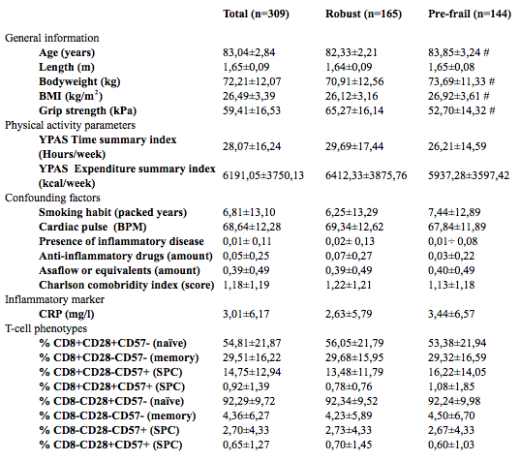

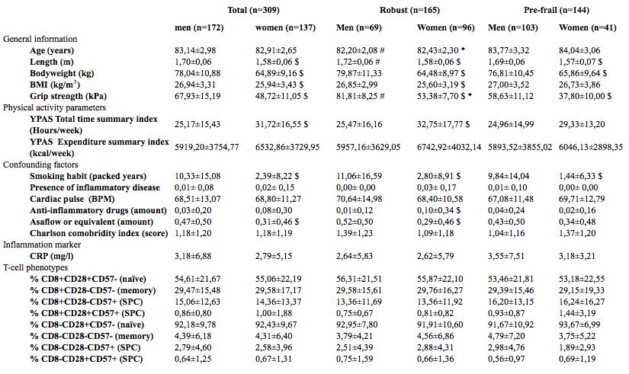
B)

Table 2:
A)

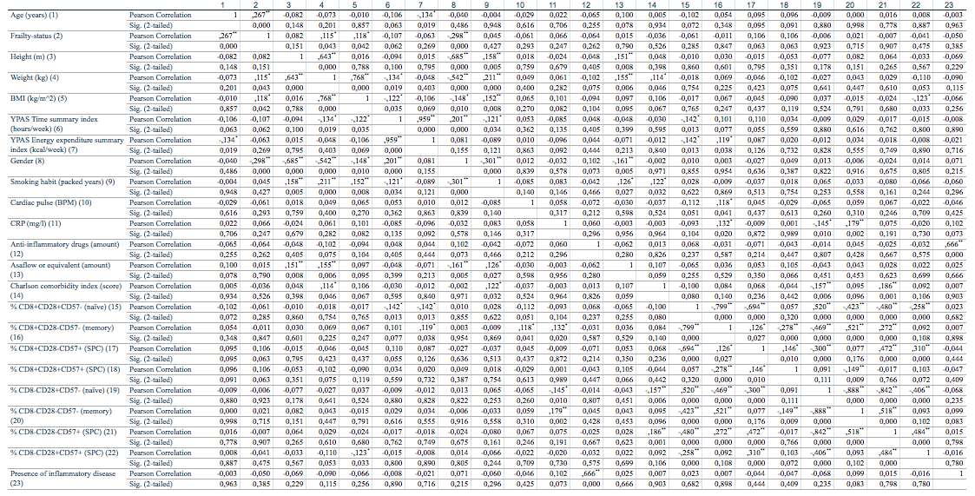

B)

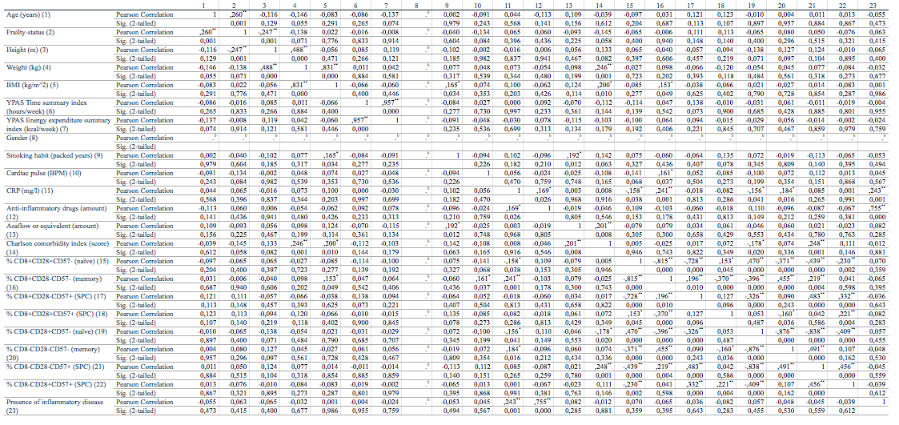
C)

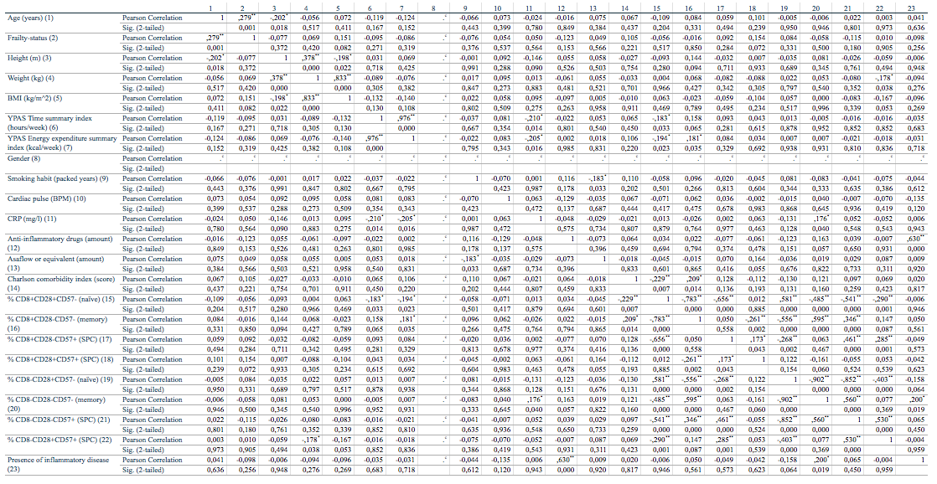
D)

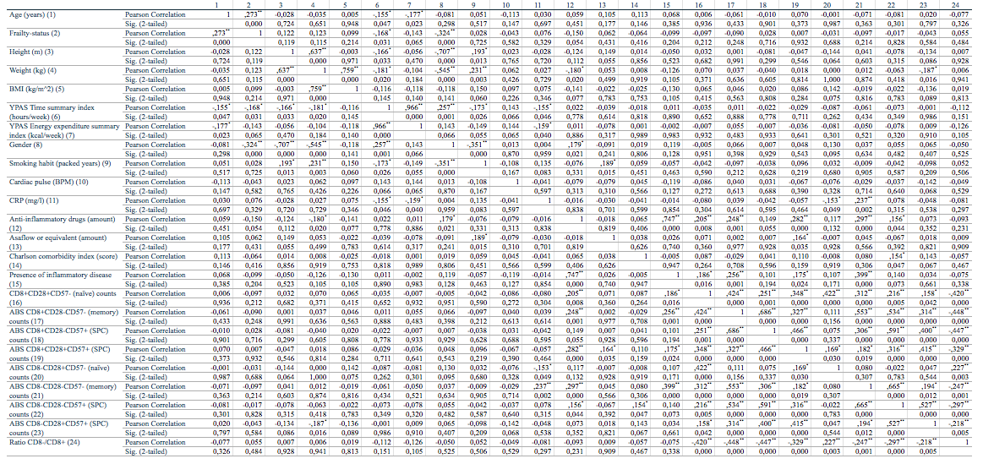
E)

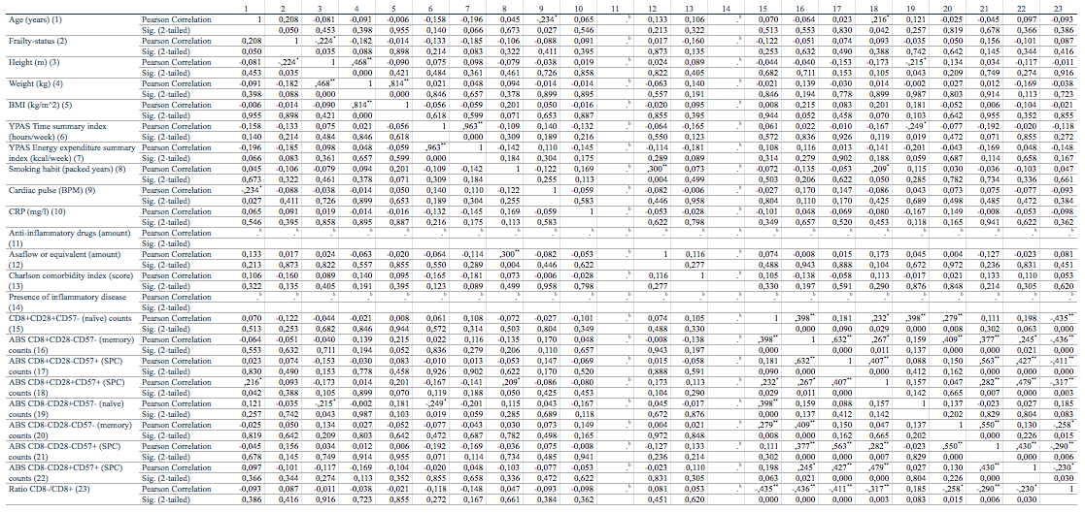
F)

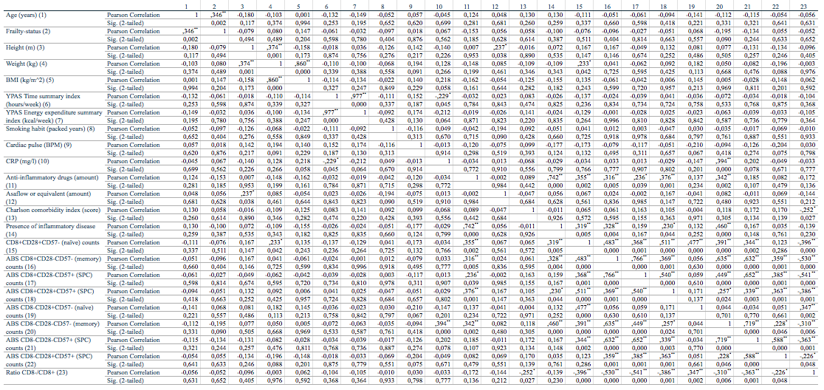
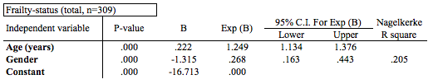
Table 3:

Table 4:
A)
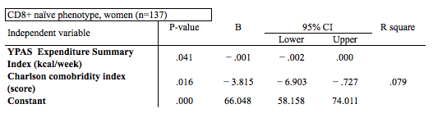
B)
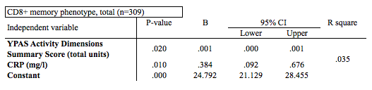
C)
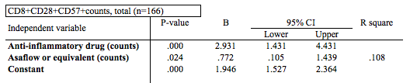
D)
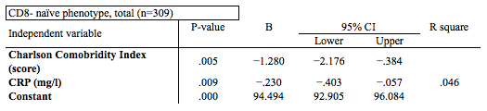

E)
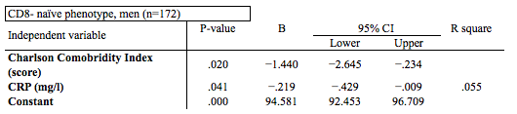F)

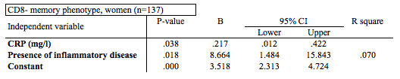
G)

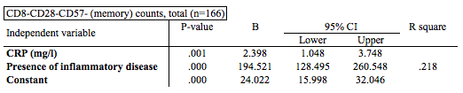

Table 5:
A)
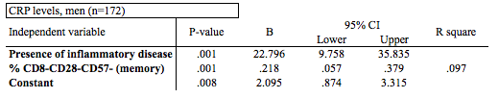
B)
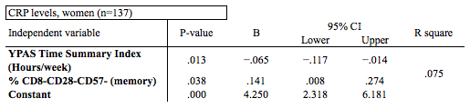
Supplementary information

Impact of COVID-19 pandemic
This master's thesis came about (in part) during the period in which higher education was subjected to a lockdown and protective measures to prevent the spread of the COVID-19 virus. This impacted this master thesis mostly by putting an early end at the collection of flow cytometric data. Although I used baseline data collected from February 2015 to June 2019 in this master thesis, I was finalizing data acquisition with Coulter CXP software (epics) when the lockdown was put in place. This prohibited me from finishing the data acquisition, since the needed software and collected data is only available at the laboratory of the UZ Brussels, where those analyses were performed. Therefore, I could only work on data that I already collected, resulting in the inclusion of 309 instead of 404 participants included at baseline.

Figure legends

Supplementary Table 1: Baseline characteristics of participants (p-values):
A) P-values of characteristics of included participants: total, robust and pre-frail, at baseline (Table 1). Presented as mean ± standard deviation. # significant (p<0.05) difference between robust and pre-frail obtained through independent T-tests between robust and pre-frail. BMI= Body Mass Index; YPAS: Yale Physical activity Scale; BPM: Beat Per Minute; CRP= C-Reactive Protein; SPC= senescent-prone cells. B) P-values of characteristics of included participants: total, robust and pre-frail, at baseline stratified by gender (Table 1B). Presented as mean ± standard deviation (SD). $: significant difference (p<0.05) between men and women within the total group, the robust group or the pre-frail group obtained through independent T-tests; # significant (p<0.05) difference between robust and pre-frail men obtained through independent T-tests; * significant (p<0.05) difference between robust and pre-frail women, obtained through independent T-tests; BMI= Body Mass Index; YPAS: Yale Physical activity Scale; BPM: Beat Per Minute; CRP= C-Reactive Protein; SPC= senescent-prone cells.

Figures:

Supplementary table 1:
A)
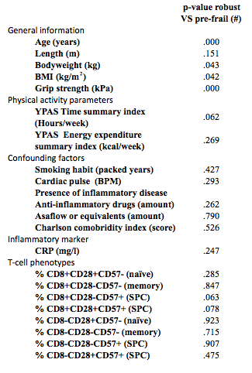

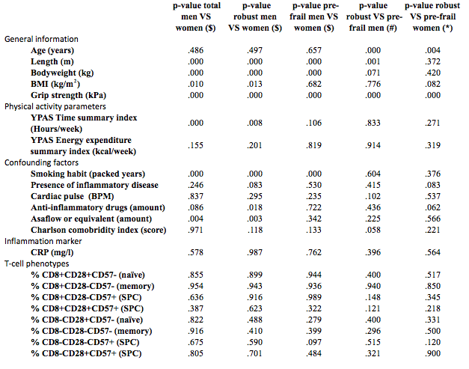
B)

