How can CPR knowledge and practical skills among nurses at Kanifing General Hospital be improved through a context-adapted training program?

Bachelor Thesis submitted by:
Motten Britt
Promotor: Vrancken Jo
Content Expert: Jariatou Drammeh

Academic Year 2025 – 2026 Bachelor Program in Nursing

Table of Content
Inhoud
PROJECT SHEET 1: Project Description 2
PROJECT SHEET 3: Gantt-chart 15
PROJECT SHEET 4: Communication Plan 16
PROJECT SHEET 5: CAT 17
PROJECT SHEET 6: Results 26
PROJECT SHEET 7: Reflection Note 31
PROJECT SHEET 8: Conclusion 32
References 33
Attachments 34

PROJECT SHEET 1: Project Description
Project name: ALS training
Management and Organization: Kanifing General Hospital in The Gambia
Student: Motten Britt
Content Expert: Jariatou Drammeh
Promotor: Vrancken Jo

PROJECT CONTEXT  NURSING CLINICAL PROBLEM/CHALLENGE | This project takes place in Kanifing General Hospital in The Gambia, within the nursing departments across different clinical wards. The hospital operates in a low-resource setting, where there is a significant shortage of medical equipment, materials, and certain medications. These limitations directly influence the organization and execution of cardiopulmonary resuscitation (CPR) and Advanced Life Support (ALS).  The primary target group of this project consists of the nursing staff from various departments and educational levels. Nurses play a key role in the early recognition and management of cardiac arrest situations, especially in settings where immediate access to advanced medical interventions may be limited.  The main objective of these three projects is primarily concerned with the organization of an Advanced Life Support (ALS) training program adapted to the local context and available resources. The training will be directed towards the surgical, medical, and emergency wards, and will be complemented by the development of clear and practical cardiopulmonary resuscitation (CPR) posters for use in these wards. Collaboration with local healthcare professionals and ALS experts is considered essential to ensure that the training is context‑appropriate and, where possible, aligned with international guidelines.  Research by Touray et al. (2018) indicates that in The Gambia there is a shortage of basic equipment, such as monitoring devices and diagnostic resources for critically ill patients. The article also reports that The Gambia lacks adequately trained specialists in CPR. Therefore, there is a clear need to provide healthcare workers with appropriate training in the resuscitation of critically ill patients.  Touray et al. (2019) state that within Kanifing General Hospital, CPR performance among nurses is suboptimal due to insufficient up-to-date knowledge, limited practical training, and a lack of self-confidence. This situation is further compounded by restricted access to educational materials, voluntary participation in BLS training sessions, and high workload, all of which may negatively affect the quality of care in acute situations.  From personal clinical observations in Kanifing Hospital, several important gaps in Advanced Life Support (ALS) resources and training were identified. Essential equipment such as capnography, intraosseous (IO) access devices, and intubation tools were not readily available in routine clinical settings. Although intubation equipment was present in the operating theatre, it was infrequently used, as surgical procedures are often performed under local anesthesia.  In addition, both nurses and physicians reported that they do not receive ongoing ALS refresher training within the hospital. Their exposure to ALS is generally limited to initial training during their formal education, without subsequent reinforcement or continuing professional development.  Furthermore, direct observations of resuscitation attempts in the emergency department revealed suboptimal adherence to ALS protocols. Both nurses and physicians demonstrated uncertainty in their roles and actions during resuscitation, which was reflected in inconsistent technique and coordination. These findings suggest a need for structured, continuous ALS training and improved access to essential equipment to enhance the quality of emergency care.  The identified problem is the provision of suboptimal cardiopulmonary resuscitation (CPR). This issue occurs at Kanifing General Hospital and manifests primarily in acute care situations requiring resuscitation. In these high-pressure clinical settings, effective and timely intervention is crucial for patient survival and neurological outcomes.  Towards our findings in Kanifing General Hospital, the problem is mainly attributed to insufficient knowledge and limited self-confidence among healthcare professionals when performing resuscitation procedures. As a result, both the hospital and its patients are affected, since inadequate CPR performance can negatively influence patient outcomes and overall quality of care.  Several contributing factors have led to this situation. There are limited opportunities for structured training due to high workload, staffing shortages, limited availability of qualified instructors, and insufficient access to up-to-date educational resources such as blended learning and simulation training. Additionally, Advanced Life Support (ALS) training sessions are offered on a voluntary basis, resulting in inconsistent attendance and limited dissemination of essential resuscitation competencies among staff. Nursing students receive only three weeks of CPR training during their education, after which these skills are rarely revised or practiced.
SCOPE | The project covers at minimum 20 nurses will be trained working in the Surgical, Medical and Accident & Emergency (A&E) departments at Kanifing General Hospital in The Gambia. The patient population included in the scope is between 18 and 90 years of age. Outside the scope are nurses from other departments, patients younger than 18 or older than 90, other hospitals, and non-nursing staff. The main deliverables of the project are the preparation of a project plan and scope document, the development of training modules for nurses, the implementation of these trainings in the departments, and the creation of posters.  The project focuses on Advanced Life Support (ALS) at Kanifing General Hospital. We will investigate how the knowledge and self-confidence of nurses evolve after receiving ALS training. Through our observations in the hospital, we have already noticed that the application of ALS is not yet sufficiently known or implemented among the nursing staff. Therefore, this project aims to contribute to better preparation and increased confidence of nurses when dealing with acute and emergency situations.  To ensure a structured approach to the project, the tasks have been divided among the team members. Aude will focus on the methodology, including the materials and resources required to provide effective ALS training. Nomie will compare the guidelines of the European Resuscitation Council with those of the American Heart Association in order to determine which recommendations are the most appropriate to apply within our context. I will conduct a literature review on the most effective methods of delivering ALS training, with the aim of identifying an approach that is both practical and evidence-based.
PROJECT OBJECTIVE | Short-term:  Within 12 weeks of the project start, at least 20 nurses from medical, surgical and A&E will have participated in an Advanced Life Support training session. Their knowledge, awareness and confidence in performing resuscitation will be assessed through pre- and post-tests.  Long-term:  After our project, a guideline poster will be displayed in key hospital areas. There is an improvement in awareness for regular ALS training courses. The aim is that minimum 20 nurses consistently demonstrate correct resuscitation skills and maintain confidence through ongoing awareness and practice.
MAIN RESEARCH QUESTION  PICO | The research question guiding of the general project is: How can CPR knowledge and practical skills among nurses at Kanifing General Hospital be improved through a context-adapted training program?  The target population consists of nurses working in the Surgical, Medical, and Accident & Emergency (A&E) departments of Kanifing General Hospital, providing care to an adult patient population aged 18 to 90 years.  The proposed intervention is a context-adapted CPR/Advanced Life Support (ALS) training program, incorporating both theoretical instruction and practical simulation sessions. In addition, educational posters tailored to the locally available resources and equipment will be developed to support clinical practice.  The comparison condition reflects the current standard practice within the hospital, in which no additional structured CPR training is systematically implemented.  The primary outcomes of this project are improvements in nurses’ CPR-related knowledge, practical resuscitation skills, and self-confidence in performing CPR in acute clinical situations.  The research question on my part of the study is: Which didactic methods are most effective for delivering Advanced Life Support (ALS) training in an African hospital context?  The population consists of nurses and nursing students working in African hospital settings. The intervention focuses on different didactic methods for delivering Advanced Life Support (ALS) training, including simulation-based learning, blended learning, e-learning, scenario-based teaching, peer teaching, and hands-on practical training. These educational methods are compared with traditional lecture-based education or the training methods currently used within the hospital setting. The outcomes include improved ALS knowledge and practical resuscitation skills, increased confidence and competence during resuscitation situations, better retention of knowledge and skills over time, and improved adherence to international resuscitation guidelines.
STAKEHOLDERS | The project on CPR training at Kanifing General Hospital in Gambia is primarily designed for the nurses working in the surgical, medical, and accident & emergency departments. In consultation with local healthcare workers and experienced ALS experts who have encountered these challenges, a context-adapted training program will be developed, supported by educational materials such as posters. Nurses are the key target group, as they play a crucial role in recognizing and managing cardiac arrest in acute situations. They will directly benefit from the training through increased knowledge, practical skills, and self-confidence.  In addition to nurses, patients form another important group. Adult patients between the ages of 18 and 90 will benefit from improved resuscitation care, ensuring more contextually appropriate and optimal treatment. Only minimum 20 professionals will be trained. However, in the long term patients will hopefully benefit. The hospital as a whole will also gain from higher quality CPR/ALS practices and a more standardized approach to resuscitation procedures.  However, not everyone will benefit from this project. Staff members who are not part of the nursing team, such as administrative and logistical personnel, fall outside the scope. Patients younger than 18 or older than 90 are also excluded, as well as nurses from other departments such as pediatrics or maternity. Furthermore, other hospitals outside Kanifing General Hospital are not involved. It is also important to consider the motivation and availability of staff to attend these training sessions, since participation is not mandatory and workload may limit attendance. Finally, a challenge already highlighted by the hospital itself is the shortage of medical equipment and materials, which must be taken into account when designing the training.
POTENTIAL SOLUTIONS | What are potential solutions to the problem?  The potential solutions to our problem are:  - Development of a context-adapted CPR-ALS training program tailored to the available equipment, medication and realistic working conditions within the hospital.  - Regular practical skills training and simulation sessions to strengthen technical competencies, clinical reasoning and teamwork during resuscitation.  - Structured and mandatory ALS training integration within the hospital.  - Implementation of clear visual aids such as the CPR posters that we will hang in the different wards  - Pre- and post-intervention evaluation of knowledge and skills to objectively assess the effectiveness of the training and identify areas for further improvement.
PROJECT PERSONNEL/STAKEHOLDERS | The Advanced Life Support (ALS) training initiative in Kanifing General Hospital will be executed by three nursing students from PXL University of Applied Sciences. All team members have received formal ALS instruction as part of their academic curriculum, with two members having practical experience in emergency care settings where ALS protocols are routinely applied. To ensure the delivery of accurate and contextually appropriate training, the team will engage in further self-directed study and consultation with subject matter experts.  Key academic contacts include Jo Vranken and Jorina Reekmans, both faculty members at PXL, who will provide pedagogical and logistical support. Locally, Jarry Manneh, head nurse at Kanifing General Hospital, will serve as the primary liaison.  Expert guidance will be sought from Stefan Knaepen and Dennis Lenaers, PXL lecturers specializing in emergency and pre-hospital care, as well as from the Red Cross of The Gambia, which plays a central role in BLS and ALS training across the country. Additionally, the hospital’s urologist—trained in China and experienced in ALS—will contribute clinical insights to strengthen the program’s relevance and sustainability.
OBSTACLES | This project presents several important challenges. The primary difficulty lies in improving CPR knowledge and practical skills in a low-resource setting, where limited equipment, high workload and time constraints may hinder effective training implementation. Additional obstacles include potential differences between international guidelines and local practice, cultural and language barriers, and the difficulty of measuring long-term outcomes. We also assume that a gap in knowledge, skills and self-confidence exists among nurses, and that a structured training program will positively influence these competencies. We also assume that nurses and hospital management are willing to engage and support this initiative.  For those directly involved, the problem may be associated with insecurity in acute resuscitation situations and concerns regarding patient safety. Given that CPR is performed in life-threatening emergencies, the issue can be considered highly important. However, in a healthcare system facing multiple structural challenges, competing priorities may influence the perceived urgency of the problem. The level of ownership will largely depend on the degree to which nurses are actively involved in the development and implementation of the training.  The desired outcome is clear: an improvement in nurses’ knowledge, practical skills, and self-confidence when performing CPR, ultimately contributing to better quality of care and patient safety. We are going to do a pre and post questionnaire about the knowledge and self-confidence about ALS. The practical skills can we observe when they exercise on the mannequin. This project is particularly engaging because it combines clinical practice, education, and international collaboration. Its potential to create meaningful impact is highly motivating, although concerns remain regarding sustainability and the limitations imposed by restricted resources.
APPROACH/METHODOLOGY | The project will be developed in close collaboration with both Belgian and local experts. First, an analysis of the current situation at Kanifing General Hospital will be carried out, mapping the existing knowledge, practices and available resources related to CPR and ALS. This will be followed by a comparison between Belgian guidelines and local practices to ensure that the training is scientifically accurate while remaining feasible within the Gambian context.  Next, training modules will be designed, combining theoretical instruction with practical simulation lessons. These will be supported by clear and context-adapted CPR posters to be displayed in the wards. The training will be implemented with the aim of reaching at least 20 nurses in the surgical, medical and accident & emergency departments.  Knowledge, skills, and self-confidence will be measured through pre- and post-tests to measurements to evaluate the effectiveness of the training. Results will be discussed with the local ALS experts and project supervisors.
TIME | The project will be carried out at Kanifing General Hospital in The Gambia within the surgical, medical and accident & emergency departments. The training sessions and poster implementation are planned to take place during the project period of approximately 12 to 17 weeks, starting from the initial preparation phase and continuing through the delivery of the training modules.  The aim is that within 12 weeks at least 20 nurses will have participated in the ALS training, with their knowledge and confidence evaluated through pre- and post-tests.
LOGISTICS | The material requirements for the Advanced Life Support training project remain partially undefined due to limited availability of optimal resources within the local context. Nonetheless, several essential components have been identified to facilitate effective delivery. A spacious and accessible room is required to conduct the training sessions, equipped with a laptop and either a projector or screen to support visual aids and theoretical instruction. Additionally, access to a printing facility will be necessary to reproduce educational posters aimed at reinforcing key ALS concepts and promoting awareness. Further assessment of available equipment and local infrastructure will be conducted to determine the feasibility of incorporating simulation tools or manikins, which are typically used in ALS instruction but may not be readily accessible in the current setting.
Opmerkingen | See appendix 2.4: distribution of tasks

PROJECT SHEET 2: Work Breakdown Structure – Work Packages
Work Package 1: contact with the experts
Work Packages Objective (Related to the project goal): getting insight in ALS course in The Gambia and in Belgium
Description:
- Meeting with ALS experts from both The Gambia and Belgium through an online meeting or a physical meeting. To include both objectives.

Tasks to be performed and timing:
- Contact nursing school in Gambia (3 weeks)
- Contact the ALS expert of Kanifing General hospital (3 weeks)
- Contact Stefan Knaepen and Dennis Lenaers (3 weeks)

Measurable Results:
- The report of the meeting ALS experts Belgium: appendix 1.5
- The report of the meeting ALS experts The Gambia: appendix 1.4

Work Package 2: CAT (literature study)
Work Packages Objective (Related to the project goal): literature study
Description:
- What is the best method to give an ALS training?

Tasks to be performed and timing:
- Finding scientific articles writing about methods to give training

Measurable Results:
- The CAT is finished, and the results are known (see CAT project sheet five)

Work Package 3: comparison from the objective observation between Gambia and Belgium
Work Packages Objective (Related to the project goal): To conduct a comparative analysis of both countries in order to identify the most significant differences in terms of resource availability, organization of ALS training, clinical skill mix, workload, and access to continuing education between Belgium and The Gambia.
Description:
- Gathering insights from nursing students, ward nurses (medical, surgical, and emergency departments), and ALS-related healthcare professionals regarding the healthcare system.

Tasks to be performed and timing:
- Ongoing data collection through clinical observations and informal interviews with nurses and healthcare professionals during the preparation and development phase of the training program.
- To conduct a comparative analysis between Belgium and The Gambia and to determine the context-specific adaptations required for effective implementation.

Measurable Results:
- See project sheet six: results

Work Package 4: making ALS training
Work Packages Objective (Related to the project goal): Providing visual aid for during the ALS course, a conceptual anchor for conducting a scientifically substantiated comparison.

Description:
- With the data collected form the experts and the literature study, we can make a course adapted to the resources in Kanifing General hospital.
- Poster for visual aid
- Feedback from the chosen ALS experts in Belgium and Gambia

Tasks to be performed and timing:
- Making a PowerPoint presentation (1 week)
- Collecting adequate images where the African community is in represented (1 week)
- Providing the experts our presentation to receive professional feedback (2 weeks)

Measurable Results:
- The PowerPoint presentation is finished after professional feedback
- See appendix 2.1

Work package 5: giving the ALS training
Work Packages Objective (Related to the project goal): Delivering Advanced Life Support (ALS) training to a minimum of 10 healthcare professionals from the wards Emergencies, medical, surgical, adapted to their specific clinical context and local needs.
Description: On a designated date, deliver a two-hour training session for staff from the medical, surgical, and A&E wards. To maximize attendance and ensure broader participation, the session will be conducted twice.
Tasks to be performed and timing:
- Giving the ALS course for 2 days (2h per presentation so 4h in total): 2 days
Measurable Results:
- The date set for the course and the verbal feedback from participants.

Work package 6: pre- and post-measurement
Work Packages Objective (Related to the project goal): To evaluate whether this training provides added value within the given context.
Description: Developing a questionnaire for healthcare professionals to be completed before and after the two-day training program.
Tasks to be performed and timing:
- Making a questionnaire that the staff will fill in before and after the training. (1 week)
Measurable Results:
- The results of the questionnaire: project sheet 6
- Questionnaire: see appendix 2.2

Work package 7: making a poster
Work Packages Objective (Related to the project goal): To provide a visual aid and flowchart that reduce cognitive load and support decision-making in high-stress environments, as well as to offer a concise refresher for trained staff.
Description:
- Put the essential guidelines for ALS in a poster to be divided through the wards medical, surgical and A&E.
Tasks to be performed and timing:
- Providing a poster with context- specific adaptations. (2 weeks)
- Placing the poster in the ward medical, surgical and A&E. (1 week)

Measurable Results:
- The poster has been successfully implemented and is displayed across the different wards.
- See appendix 2.3

PROJECT SHEET 3: Gantt-chart
PROJECT SHEET 3: Gantt-chart
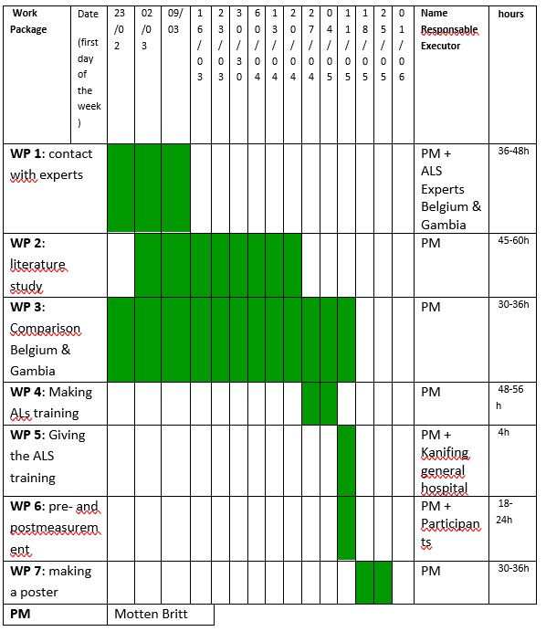

PROJECT SHEET 4: Communication Plan
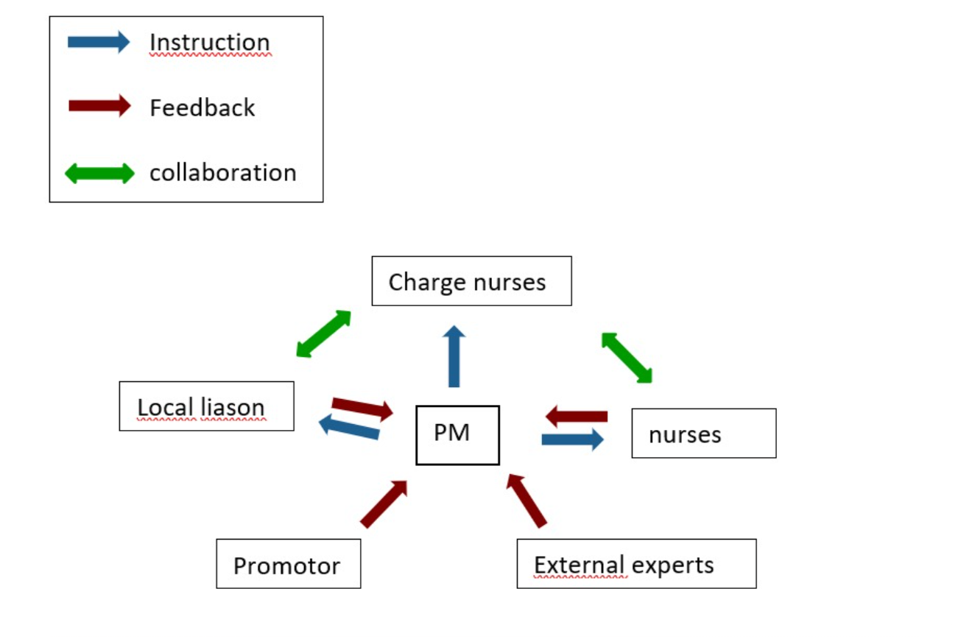
The communication plan of the bachelor’s thesis illustrates the structured flow of information between all stakeholders involved in the project. The Project Manager (PM) acts as the central coordinating figure, ensuring effective communication, alignment, and follow-up throughout the development and implementation of the training program.
Key stakeholders include the charge nurses, ward nurses (medical, surgical, and emergency departments), a local liaison within the hospital, the academic supervisor (promotor), and external experts involved in Advanced Life Support (ALS) training. Each of these actors plays a specific role in the communication process.
The PM provides structured instruction to the different stakeholders, including guidance on the development and implementation of the training program. In return, feedback is collected from nurses, charge nurses, the local liaison, and external experts to ensure continuous adaptation and improvement of the intervention. This feedback loop allows the project to remain contextually relevant and practically feasible.
In addition, collaboration occurs between key clinical stakeholders, particularly between charge nurses and ward nurses, to support the practical execution of the training and its integration into daily clinical practice. The local liaison facilitates communication and coordination within the hospital setting, ensuring smooth implementation and contextual alignment.
Overall, the communication structure is designed as a coordinated and iterative process, in which instruction, feedback, and collaboration are continuously integrated to support the successful development and implementation of the bachelor’s thesis project.

PROJECT SHEET 5: CAT
- Introduction
Nursing clinical problem:
In a hospital setting, acute life‑threatening emergencies such as cardiac arrest can occur unexpectedly. In these critical moments, it is essential that nurses and other healthcare professionals act swiftly and accurately while following Advanced Life Support (ALS) guidelines. Adequate ALS training is therefore indispensable in preparing caregivers for such high‑stakes situations.
However, research by Jang et al. (2021) demonstrates that both knowledge and practical resuscitation skills tend to decline relatively quickly after completing ALS training. Performance levels among healthcare providers begin to drop as early as three to six months post‑training, with further deterioration observed between six and twelve months if no refresher practice or reinforcement takes place.
Moreover, Jang et al. (2021) highlight that the structure and delivery of training play a decisive role in learning outcomes and skill retention. Interactive, practice‑oriented approaches—such as simulation‑based education and case‑based training—have been shown to enhance knowledge acquisition, clinical reasoning, and professional confidence.
Although a variety of teaching methods are currently used in ALS training, there remains ongoing debate about which instructional strategies are most effective for both acquiring and maintaining resuscitation skills. This underscores the importance of further investigation into the most suitable educational approaches for delivering ALS training within the hospital context.

5W and H-method:
In hospital environments, nurses and other healthcare professionals must be prepared to respond effectively when patients experience sudden cardiac arrest and require resuscitation. The effectiveness of the teaching methods used in Advanced Life Support (ALS) training is therefore of critical importance. Within the hospital context, where caregivers must be able to act rapidly in acute resuscitation scenarios, training and retraining in ALS play a decisive role.
Effective instruction is essential not only for acquiring but also for maintaining the knowledge and skills necessary for high-quality patient care and improved survival outcomes. Within Advanced Life Support (ALS) training, different educational approaches can be distinguished. Blended learning refers to a combination of online and face-to-face education, in which participants first acquire theoretical knowledge through e-learning modules (such as videos, quizzes, and guidelines), followed by in-person sessions where this knowledge is applied through simulations and practical skills training. In contrast, traditional training refers to a fully face-to-face approach, where learning takes place in a classroom setting with instructor-led teaching, demonstrations, and immediate hands-on practice without a prior online component.
To achieve optimal outcomes, these educational approaches—such as simulation-based learning, practical exercises, role-play, and blended learning—will be systematically examined and compared based on their effects on skill retention, knowledge acquisition, and confidence among healthcare providers. Therefore we will implement a pre and post questionnaire where we can see the knowledge from de professionals and if they have learned something from the training.
Relevance clinical problem:
From a scientific perspective, there is extensive research showing that the way medical training is organized has a significant impact on the retention of knowledge and skills. Studies by Roh and Kim (2014), Kane et al. (2010), and Roh et al. (2011), for example, demonstrate that simulation-based education and regular practical training often lead to better performance in emergency situations than purely theoretical instruction.
From a societal perspective, this topic is equally relevant. A rapid and correct response to cardiac arrest can mean the difference between life and death. Well-trained healthcare providers not only increase patients’ chances of survival but also improve the overall quality and safety of care. By investigating which teaching methods are most effective, the organization of ALS (Advanced Life Support) training can be optimized, ultimately enhancing patient care.
Research question:
Which didactic methods are most effective for delivering Advanced Life Support (ALS) training in an African hospital context?
- Methodology
This study focuses on nurses and healthcare providers who participate in Advanced Life Support (ALS) training within a hospital setting. The intervention under consideration involves interactive and practice-oriented teaching methods, such as simulation training, scenario-based learning, and blended learning approaches. These methods are compared to more traditional, primarily theoretical forms of instruction, including classroom lectures or purely theoretical education.
The intended outcomes of this comparison are improvements in knowledge of ALS, enhanced practical resuscitation skills, and increased confidence and clinical decision-making during resuscitation scenarios.

Steps taken to select the scientific articles
Database(s)
- PubMed,
- Google Scholar

Search terms and their combination using Boolean operators (AND/NOT/OR)
- Advanced Life Support training
- Resuscitation training
- Simulation-based learning
- Nursing education
- Medical training methods
Search string example: Advanced life support training OR resuscitation training AND simulation OR simulation-based learning OR blended learning AND nurses OR healthcare professionals

Inclusion criteria
- Articles published between 2015 and 2026
- Peer-reviewed scientific articles
- Articles written in English or Dutch
- Studies that focus on ALS, resuscitation or simulation training
- Studies focusing on healthcare workers or nurses

Exclusion criteria
- Articles older then 2015
- Articles who are not included related to training or education
- Studies focusing on patient outcomes without the link to training
- Nonscientific publications such as blogs
- Articles not written in English or Dutch

Screening criteria
- First, the titles and abstracts were screened for relevance to the research question. Next, the full texts of the articles were reviewed to determine whether they met the inclusion criteria. Articles that were not relevant to the didactic methods of ALS training were excluded.

Number of included articles
- ALS training nurses: 67,800 results → limited to the last 15 years: 17,300 → language English or Dutch: 45 → peer-reviewed: 6 articles included.
- ALS training nurses: 67.800 resultaten -> bereik naar max 15 jaar: 17.300 -> taal Engels of Nederlands: 45 resultaten -> peer review: 6

- Results
Across the included studies, a consistent pattern emerges regarding the effectiveness of simulation-based and reinforcement strategies in ALS and clinical nursing education, although differences in context and methodology influence long-term outcomes.
Jang et al. (2021) demonstrated that simulation skills and self-efficacy decline over time after ALS training, but this decline can be mitigated through structured reinforcement. Both intervention and control groups showed reduced knowledge after six months (experimental: 16.68 to 15.32, p = .001; control: 17.19 to 14.67, p < .001), indicating that knowledge retention remains a challenge regardless of intervention. However, differences became more pronounced in self-efficacy and skills performance. While self-efficacy remained relatively stable in the experimental group (50.55 to 47.18), it decreased significantly in the control group (50.67 to 39.00). A similar pattern was observed for skills performance, where the experimental group showed only a slight decline (27.5 to 26.68), compared to a substantial reduction in the control group (27.95 to 16.9). At six-month follow-up, the intervention group consistently outperformed the control group, suggesting that periodic video-based reinforcement helps maintain practical competence and confidence, even though knowledge decay still occurs in both groups.
A broader perspective is provided by Alharbi et al. (2024), who confirm that simulation-based learning (SBL) consistently outperforms traditional teaching methods. Across studies, SBL improved knowledge and skills by approximately 10–35%, with post-test gains ranging from 20–50%. In some cases, knowledge increased from 5.66 to 8.38 and skills from 22.29 to 32.51, representing improvements of up to 45.9%. Additionally, simulation groups consistently scored higher than control groups (p < 0.05), with examples such as 10/10 versus 5/10. Although long-term retention results were mixed, most studies still showed a relative advantage for simulation, with six out of eight reporting around 15% better retention and follow-up scores remaining higher after 2–5 months (e.g., 16.57 vs. 14.76). Beyond cognitive and technical outcomes, SBL also improved self-confidence, clinical reasoning, and teamwork, reinforcing its value as a comprehensive educational approach.
However, contextual limitations are highlighted by Salifu et al. (2022), who emphasize that simulation-based clinical education in low-resource settings remains underdeveloped. Existing frameworks are often designed for high-income contexts and are not fully applicable in settings such as Ghana or Gambia. In response, a newly developed context-specific framework—validated by 20 stakeholders—was considered appropriate and feasible, particularly due to its emphasis on low-fidelity simulation, student-centered learning, and collaboration. Nevertheless, significant barriers persist, including limited resources, insufficient trained facilitators, and large student groups. Traditional teaching methods were also found to be less effective in developing clinical competence. Although simulation shows promise in improving skills and critical thinking, evidence from African contexts remains limited, and long-term effects on patient outcomes are still unclear.
Complementing this, Malya et al. (2025) report that simulation-based education in Tanzanian nursing students significantly enhances confidence, skills, and critical thinking. Students described improved clinical performance through repeated practice in a safe environment, reduced fear of errors, and better mastery of procedures such as neonatal resuscitation. Knowledge and equipment handling also improved, particularly for tools previously unfamiliar to students. Importantly, debriefing sessions strengthened critical thinking and reasoning by helping students integrate theory into practice and understand the rationale behind clinical decisions. Communication and teamwork were also improved, especially in emergency scenarios, reinforcing simulation as an effective method for building clinical competence in low-resource settings.
Finally, the European Resuscitation Council (2023) guideline supports these findings by emphasizing evidence-based ALS training models. It advocates for blended learning approaches, mastery learning with repeated practice and feedback, and frequent refresher training to prevent skill decay. A key principle is that training quality depends more on well-designed simulation scenarios and structured feedback than on high-fidelity equipment alone. This aligns with the broader evidence that sustained competence in ALS requires not only initial training but also ongoing reinforcement and structured educational frameworks.
Overall, the combined evidence indicates that simulation-based education and reinforcement strategies improve short-term knowledge, skills, and confidence, while long-term retention remains vulnerable without continued practice. Structured frameworks, contextual adaptation, and repeated feedback mechanisms appear essential to sustain competence over time.

- Discussion
The methodological quality of the included studies is generally moderate to good, but shows clear variation depending on study design and context. Jang et al. (2021) demonstrates relatively strong methodology through the use of a randomized controlled design with a control group and a six-month follow-up, enhancing internal validity. However, the relatively small sample size limits generalizability.
Alharbi et al. (2024) provides a broader evidence base as a review of multiple studies, but its methodological quality depends on the included studies, which may vary in design and quality. This introduces heterogeneity and potential bias.
Salifu et al. (2022) uses a more exploratory and context-specific design with a small sample (n=20). While appropriate for framework development, it is weaker in terms of external validity and generalizability. Additionally, long-term outcomes and objective clinical endpoints are lacking.
Malya et al. (2025) applies a qualitative design, offering valuable insights into perceptions and experiences, but it is limited in objective measurement and causal inference. The small, context-specific sample further limits transferability.
The European Resuscitation Council (2023) guideline is based on existing evidence and expert consensus, providing high practical relevance, but it is not a primary research study and therefore differs methodologically.
Overall, the studies demonstrate moderate methodological quality, with strengths such as controlled designs and practical relevance, but also limitations including small sample sizes, heterogeneity, limited long-term outcomes, and restricted generalizability, particularly in low-resource settings.
The generalizability and applicability in practice of these studies are moderately strong but highly context-dependent. Studies such as Jang et al. (2021) and Alharbi et al. (2024) provide findings that are well applicable in structured educational environments, such as hospitals and training institutions with sufficient resources. The consistent evidence that simulation-based learning and repeated training improve skills, self-confidence, and performance makes these interventions broadly relevant for ALS education in practice.
However, generalizability is limited by factors such as small sample sizes, differences in educational settings, and variation in training methods. Applicability becomes more challenging in low-resource settings, as highlighted by Salifu et al. (2022) and Malya et al. (2025). In such contexts, constraints like limited equipment, large student groups, and lack of trained facilitators may hinder implementation. At the same time, these studies show that adapted, context-specific approaches (e.g., low-fidelity simulation) can still be feasible and effective.
The European Resuscitation Council (2023) guidelines enhance practical applicability by providing clear recommendations such as blended learning, mastery learning, and frequent refresher training. These principles are broadly transferable but require adaptation to local resources and infrastructure.
In summary, the findings are applicable to clinical education practice, particularly regarding the importance of repetition, feedback, and simulation. However, generalizability is limited by contextual differences, making local adaptation essential for successful implementation.
- Conclusion
The conclusion is that the most effective didactic approach for delivering Advanced Life Support (ALS) training in an African hospital context is a structured, blended training composition combining simulation-based learning, low-dose high-frequency reinforcement, and structured feedback mechanisms. Simulation-based learning forms the core of the training, as it consistently improves clinical skills, self-confidence, and performance in both high- and low-resource settings. However, its effectiveness is maximized when it is not used as a one-time intervention but embedded within a repeated training cycle.
In the short term, simulation-based training leads to clear improvements in knowledge, skills, and self-efficacy. In the long term, however, skills and self-efficacy decline without reinforcement. Evidence therefore shows that regular refresher sessions (e.g. video-based reinforcement, repeated simulation exposure, and mastery learning approaches) are essential components of the training composition to maintain competence over time. Knowledge retention remains a persistent challenge across all methods, indicating that continuous exposure rather than isolated teaching moments is required.
In an African hospital context, the optimal training composition should be adapted to resource constraints by incorporating low-fidelity simulation, structured debriefing, and facilitator-guided learning, while maintaining the core principles of repetition and feedback. This ensures feasibility without compromising educational effectiveness.
At the same time, the studies show that effectiveness and implementation are highly context-dependent. In well-resourced settings, more advanced simulation modalities can be used, whereas in low-resource environments, simplified but well-structured simulation frameworks remain effective when combined with strong pedagogical design.
Overall, it can be concluded that sustainable ALS competence is not achieved through isolated training sessions, but through a continuous, structured training composition consisting of simulation-based education, repeated practice, feedback, and context-adapted reinforcement strategies, which together form the most effective didactic approach for ALS training in African hospital settings.

- Recommendations
Based on the pillars of Evidence-Based Practice (EBP), it is recommended to structurally integrate simulation-based learning into Advanced Life Support (ALS) education, as the evidence consistently demonstrates improvements in clinical skills, self-confidence, and performance. ALS training should not be limited to isolated sessions but embedded within a longitudinal learning strategy that incorporates regular refresher training and reinforcement methods, such as spaced repetition and video-assisted feedback, in order to mitigate the documented decay of knowledge and skills over time.
From the perspective of clinical expertise, educators should design training that incorporates high-fidelity clinical reasoning within realistic, scenario-based simulations, supported by structured debriefing. Such approaches facilitate the development of decision-making, situational awareness, and interprofessional teamwork. Experienced facilitators are essential in adapting instructional strategies to learner needs and in ensuring the progressive development of clinical competence in a controlled environment. Furthermore, patient safety and quality of care should remain central, with simulation providing a protected learning space in which learners can safely engage with error, reflect, and refine their practice.
Finally, educational strategies must be aligned with the local context and available resources. In low-resource settings, low-fidelity simulation combined with context-specific frameworks should be prioritized to ensure feasibility, sustainability, and educational relevance. These frameworks refer to systematically adapted instructional models that account for infrastructural, pedagogical, and workforce constraints. In practice, this may include the use of basic or improvised manikins, scenario-based role-play, and peer-assisted learning strategies, particularly for high-yield emergencies such as cardiac arrest. Moreover, task-shifting approaches, whereby trained nurses or mid-level healthcare providers assume facilitation roles, can strengthen local capacity. Modularized training structures, consisting of short, repeated learning cycles rather than single intensive courses, further support retention and skill maintenance. Importantly, aligning scenarios with locally prevalent clinical conditions and available equipment enhances both authenticity and transferability to real clinical practice.
General recommendation
The general recommendation is to organize ALS education as a continuous and structured learning process, with simulation-based learning at its core, combined with regular repetition, feedback, and evaluation. One-time training is insufficient to ensure long-term competence; therefore, refresher sessions and reinforcement strategies, such as video feedback or spaced practice, should be systematically incorporated. Additionally, education should be adapted to the local context and available resources to ensure both feasibility and effectiveness across different healthcare settings. In this way, not only can healthcare providers’ knowledge and skills be improved, but the overall quality and safety of patient care can also be sustained over time.

PROJECT SHEET 6: Results
Methodology: Development of the PowerPoint and Training Intervention adapted to the Gambian context
For the development of the PowerPoint presentation, a urologist who provides ALS courses in Kanifing was contacted and asked to share his teaching materials. His presentation was based on the guidelines of the American Heart Association (AHA). Although these are largely consistent with the European Resuscitation Council (ERC) guidelines, we chose to primarily follow the ERC guidelines, as they better align with our own clinical practice and are also used by our external experts.
An exception was made for the pharmacological component of resuscitation, specifically the administration of medications such as adrenaline and amiodarone. For this aspect, the AHA guidelines were used, as they provide clearer and more structured guidance regarding the timing and indications for medication administration during resuscitation.
The content was adapted to the local context of Kanifing Hospital. Advanced interventions and equipment such as intraosseous access, capnography, and endotracheal intubation were deliberately excluded, as they are not available in this setting. The presentation was therefore tailored to a low-resource environment, focusing on feasible and applicable interventions.
In addition to the theoretical component, simulation-based training will be provided. The literature review of Britt Motten demonstrated that simulation training significantly improves knowledge retention and skill acquisition among healthcare professionals. To further support knowledge retention, the PowerPoint will be shared with participants afterward, allowing it to serve as a tool for review and reinforcement. Repetition is a key factor in promoting long-term knowledge retention.
To evaluate the effectiveness of the training, a pre- and post-intervention questionnaire was developed. This questionnaire assesses both the self-confidence and the knowledge of the nurses, in line with the evaluation approach recommended by content expert Jarry. This allows us to determine whether the training has had a measurable impact and whether broader implementation within the hospital is warranted.
Finally, a visual poster was developed based on the ERC guidelines, also adapted to the available resources. Elements such as intubation were omitted. The poster will be displayed in the wards and serves as a practical flowchart. The literature of Aude Nuyts gave indication that such visual aids help reduce cognitive load and support decision-making in high-stress situations.
Nomie’s focus was on adaptation of the guidelines.
The training was adapted to the local context of Kanifing General Hospital, taking into account the limited availability of resources and the high workload among nursing staff. Advanced interventions such as capnography, intraosseous access, and endotracheal intubation were excluded from the core training, as these are not routinely available within the clinical setting.
Although intubation is not performed by ward nurses, it is carried out by the operating theatre team when required. This was integrated into the training by emphasizing the availability of the operating theatre for airway management. In addition, an anesthesia nurse demonstrated endotracheal intubation during the session and clarified the procedure for escalation to the anesthesia team.
Monitoring equipment is available in the emergency department but is not consistently present in the medical and surgical wards, which was considered in the design of the training scenarios.
Given the high workload and staffing constraints, short, practical, and repeatable training sessions were prioritized. In collaboration with the head nurse, it was proposed that ALS refresher training combined with simulation-based learning will be implemented on a three-monthly basis to support skill retention and continuity of competence development.

Results of the questionnaire pre and post:
The Advanced Life Support (ALS) training was delivered over the course of two days and was attended by a total of 58 healthcare professionals. To evaluate the impact of the training, pre- and post-training questionnaires were distributed to 18 participants from the primary target departments, namely the Emergency Department, the Surgical Ward, and the Medical Ward. Among the attendees, 20 participants were from the Emergency Department, 9 from the Surgical Ward, and 4 from the Medical Ward. In addition, 25 healthcare professionals from other departments, including the Operating Theatre, Maternity Ward, and Pediatrics, attended the training out of personal interest, as participation was open to all staff members. The bar charts presented below illustrate the mean score for each questionnaire item in both the pre-training and post-training assessments. The mean was used instead of the median because it provides a more accurate representation of the overall change in knowledge and self-confidence among the participants following the ALS training.
By taking all individual scores into account, the mean allows small improvements across the entire group to be reflected in the results. This makes it more suitable for comparing pre-test and post-test outcomes and for evaluating the overall effectiveness of the training. In contrast, the median only represents the middle score and may not adequately capture subtle changes within the group. Therefore, the mean was considered the most appropriate measure for analyzing the results of this study.
In Figure 1, we calculated the average score for each question based on all participants’ responses. For figure 2, the knowledge-related questions, we used a binary scoring system in which 0 represented an incorrect answer and 1 represented a correct answer. We then summed the number of correct responses for each question. Since 18 participants completed the test, the results show how many out of the 18 participants answered each question correctly.
The first four questions of the questionnaire (figure 1) focused on the participants’ self-confidence in recognizing and managing cardiac arrest situations. For the questions about recognizing CPR and starting CPR immediately, only a small difference was observed between the pre-training and post-training responses. Most participants already reported feeling confident in recognizing a cardiac arrest and initiating cardiopulmonary resuscitation (CPR) prior to the training.
In contrast, the question about using the AED demonstrated a significant improvement between the pre- and post-training questionnaires. Many participants initially reported limited confidence in using an automated external defibrillator (AED)/defibrillator, likely due to limited prior exposure and the fact that the use of an AED is not always immediately considered in emergency situations. After the training, participants expressed substantially higher confidence levels in operating an AED correctly.
Similarly, the question about the confidence about ALS at work showed a marked increase in self-confidence regarding the correct application of Advanced Life Support (ALS) protocols within the participants’ clinical work environment. This suggests that the training effectively improved both the participants’ practical understanding and their confidence in performing ALS procedures. See appendix 2.2 for all the fully questions.
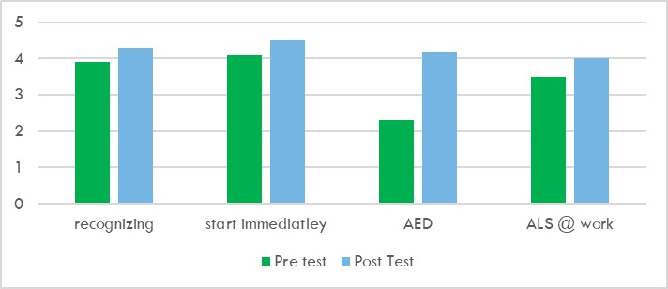
Figure 1: self-confidence

The following questions focus on the knowledge nurses were expected to master. Figure 3 shows the growth achieved, expressed in percentages that represent the proportion of participants who answered each question correctly. Figure 2 presents the number of correct answers per question, illustrating the participants’ knowledge levels. A clear improvement can be observed, with a significant overall increase in knowledge following the training. Together, these results demonstrate the positive impact of the program on the nurses’ knowledge base.
The largest improvement was found in question 14, which addressed the reversible causes. It should be noted that questions 13 and 14 were analyzed together: question 13 assessed knowledge of the reversible causes, while question 14 required listing them. In both the pre‑ and post‑test, partially correct answers were considered correct for the purposes of this analysis. By contrast, no growth was observed in question 9, which concerned the timing of adrenaline administration in a non‑shockable rhythm.
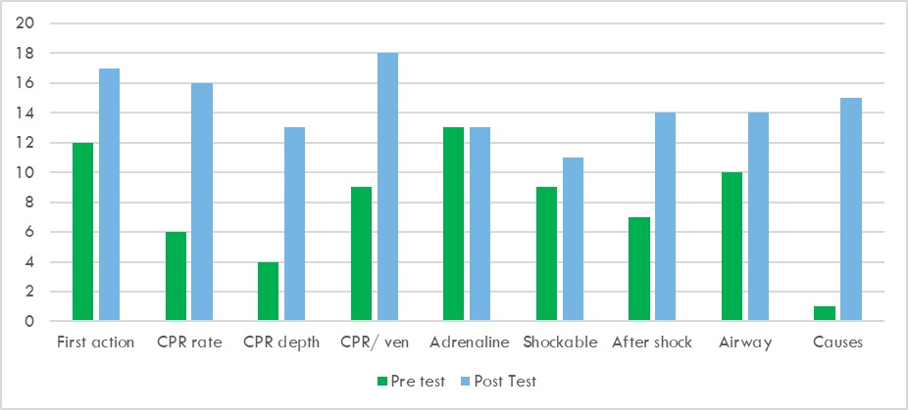
Figure 2: knowledge

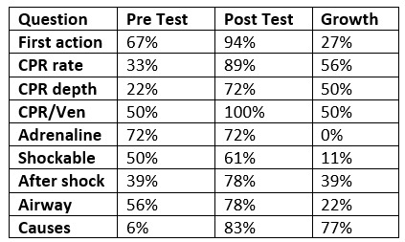
Figure 3: knowledge in %

The final two questions, which were included exclusively in the post-training questionnaire, evaluated the participants’ perceived learning outcomes and preparedness following the ALS training. All participants indicated either “a lot” or “very much” when asked how much they had learned during the training, reflecting a highly positive educational impact. Furthermore, all participants responded affirmatively when asked whether they felt better prepared to perform CPR after completing the training. These findings suggest that the ALS training was effective in enhancing both participants’ knowledge acquisition and their confidence in managing cardiopulmonary resuscitation scenarios.

PROJECT SHEET 7: Reflection Note
- Project Reflection
When considering the concepts of reliability, validity, and generalizability, several important reflections can be made regarding the applicability of ALS training studies across different healthcare contexts.
In terms of reliability, simulation-based ALS training tends to show relatively consistent outcomes across studies, particularly regarding improvements in clinical skills, self-confidence, and short-term performance. However, reliability may be influenced by variations in study design, measurement tools, and follow-up periods. Differences in assessment methods (e.g., objective structured checklists versus self-reported confidence scales) may affect the consistency of results across settings.
Regarding validity, most included studies demonstrate good internal validity, particularly randomized controlled trials and structured simulation interventions that clearly measure pre- and post-training effects. However, external validity is more limited due to contextual factors. Many interventions are developed in controlled educational environments that may not fully reflect real clinical practice, especially in emergency situations with time pressure and resource limitations.
The generalizability of ALS training interventions is moderate but highly context-dependent. While the core educational principles, such as simulation-based learning, repetition, and structured feedback, are transferable across settings, their implementation must be adapted to local resources and healthcare infrastructure. In low-resource or developing country settings, limitations such as lack of ambulances, defibrillators (AEDs), advanced airway equipment, or monitoring tools can significantly influence how ALS training is delivered. In such contexts, low-fidelity simulation, simplified algorithms, and task-shifting approaches are often required to maintain feasibility.
In contrast, high-income settings such as Belgium allow for more advanced ALS training, incorporating technologies such as intraosseous access devices, capnography, mechanical ventilation, and advanced airway management techniques like intubation. This illustrates that while the underlying educational framework remains generalizable, the material implementation and technical complexity vary significantly between healthcare systems.
Overall, ALS training demonstrates acceptable reliability and internal validity within controlled research settings, but its generalizability depends strongly on contextual adaptation. Effective implementation therefore requires balancing evidence-based educational principles with the realities of local resources and clinical infrastructure
- Personal Reflection
- How can I, as a nurse, contribute to promoting health and well-being in vulnerable communities while considering sustainability principles?
During the preparation of this work, ChatGPT was used to support language refinement and improve the clarity of the English text. Following its use, the author critically reviewed, edited, and adapted the content as necessary and retains full responsibility for the final version of the work.

PROJECT SHEET 8: Conclusion
The project concludes that CPR knowledge and practical skills among nurses at Kanifing General Hospital can be effectively improved through a context-adapted training program that combines simulation-based learning, structured repetition, and feedback. The evidence indicates that while initial training leads to short-term improvements in knowledge and skills, long-term retention requires ongoing refresher sessions and reinforcement strategies. Adapting the training to local resource constraints, using simulation based training and realistic, locally relevant scenarios, ensures both feasibility and sustainability. Overall, a structured, continuous, and context-specific training approach is essential to achieve and maintain competence in CPR practice within this setting.

References
In this section include all references according to the APA- guidelines.
Touray, S., Sanyang, B., Zandrows, G., Dibba, F., & Fadera, K. (2018, October). An assessment of critical care capacity in the Gambia. ScienceDirect. https://www.sciencedirect.com/science/article/abs/pii/S0883944118305732
Jang, K., Kim, S. H., Oh, J. Y., & Mun, J. Y. (2021). Effectiveness of self-re-learning using video recordings of advanced life support on nursing students’ knowledge, self-efficacy, and skills performance. BMC Nursing, 20(1), 52. https://doi.org/10.1186/s12912-021-00573-8
Alharbi, A., Nurfianti, A., Mullen, R. F., McClure, J. D., & Miller, W. H. (2024). The effectiveness of simulation-based learning (SBL) on students’ knowledge and skills in nursing programs: a systematic review. BMC Medical Education, 24(1), 1099. https://doi.org/10.1186/s12909-024-06080-z
Salifu, D. A., Heymans, Y., & Christmals, C. D. (2022). A Simulation-Based Clinical Nursing Education Framework for a Low-Resource Setting: A Multimethod Study. Healthcare, 10(9), 1639. https://doi.org/10.3390/healthcare10091639
Malya, R. M., Mahande, M. J., Urstad, K. H., Rogathi, J. J., & Bø, B. (2025). Perception of simulation-based education among nursing and midwifery students in Tanzania: a qualitative study. Advances in Simulation, 10(1), 8. https://doi.org/10.1186/s41077-025-00339-1
European Resuscitation Council. (2023). Guideline 10.2: Advanced life support (ALS) training. European Resuscitation Council. guideline-10-2-advanced-life-support-als-training-231.pdf

Attachments
In this chapter, include all appendices of your bachelor thesis. Each appendix must be numbered and given a title. Begin by including, for example, measurement instruments, questionnaires, the final product, etc.
Appendix 1
- Report of the first meeting with the field supervisor
(The report must include at least the following components: agreements made, feedback on the pitch, …)
During our first meeting, we presented our topic: organizing a CPR training in Gambia, combined with developing clear and practical posters for use in the hospital.
It quickly became clear that there is a shortage of materials in the hospital. This significantly impacts how cardiopulmonary resuscitation (CPR) can be performed. Therefore, we aim not only to focus on theoretical knowledge but also on a realistic and feasible application within the available resources.
The plan is to design posters and provide training to the nurses. We aim to reach at least 50% of the nursing staff, involving nurses from every department and educational level. In this way, knowledge can further spread throughout the hospital.
The training will focus on Advanced Life Support (ALS). Since it is essential that the training is accurate and aligned with guidelines, we will use an e-learning module from Belgium under the guidance of Stefaan Knaepen to refresh our ALS knowledge.
Additionally, we plan to contact ALS experts at Kanifing General Hospital in Gambia. We want to explore what their ALS training entails and whether it aligns with Belgian guidelines. Based on this, we will compare both systems.
It is important that the ALS training we develop is both accurate and feasible within the Gambian context. If certain interventions, such as specific medications or intubation equipment, are not available, we will need to adapt the training content accordingly.
Furthermore, we want to investigate what is taught about resuscitation at the university in Gambia and what resources are available there. We have learned that the United States offers online training to nurses, and we will further explore this as part of our analysis.
As a next step, we will create a synthesis and schedule comparing practices in Europe and in Gambia. Based on this comparison, we will determine whether adjustments are necessary. Each of us will then prepare and present a specific topic.
Finally, we will develop a concrete action plan, including the project objectives and research question. We will contact Stefaan Knaepen as soon as possible to make further arrangements.
Important dates:
- 26/02: submission of the report
- March 13 at 14:00 (in Belgium 15:00): second meeting

- Report of the second meeting with the supervisors of PXL University college
On 13 March 2026, a meeting was held via Microsoft Teams between the project team and the supervisors to reflect on the prior consultations with external experts from PXL University (Dennis Lenaerts and Stefan Knaepen) and the internal expert from Kanifing General Hospital (Dr. Juman Jas). The central outcome of these consultations was that it is not feasible to deliver an official Advanced Life Support (ALS) course within the framework of the project, as such a course requires two full days of training under the supervision of a certified instructor. Nevertheless, it was noted that Dr. Juman Jas could serve as ALS trainer, given his previous experience in conducting ALS courses in collaboration with the Turkish embassy.
During the meeting, consensus was reached on the necessity of refreshing ALS knowledge. In The Gambia, no formal ALS guidelines are currently available, and nurses rely largely on intuition and previously acquired knowledge. Therefore, the project will focus on the development of a shortened four hour ALS course, which will include a brief refresher on Basic Life Support (BLS) and adaptations to the cultural and educational context. For example, since nurses in The Gambia are not trained to interpret electrocardiograms (ECGs), this responsibility will be explicitly assigned to physicians. The course will be delivered to at least ten nurses from the surgical, medical, and emergency wards. To ensure sustainability, participants will be provided with a flowchart and teaching materials, with the expectation that they will continue disseminating the training.
In addition, the practical component of the project will be supported by a literature review. Each team member will prepare an individual project sheet, focusing on a distinct aspect of the shared research question, thereby contributing to a comprehensive and multifaceted analysis.

- Report of the second meeting with the field supervisor
(The report must include at least the following components: agreements made, feedback on the pitch, …)
On April 28, 2026, a meeting took place with Aude Nuyts, Nomie Haazen, Britt Motten, Jo Vrancken, Jorina Reeckmans, and Jarry Manneh. During the meeting, we discussed the progress that has been made since the previous meeting and what still has to happen.
The meeting started with an update from the students. We have been in contact with the Head of A&E regarding the use of two mannequins for the training. An email has also been drafted for the CEO of Kanifing General Hospital to request a room where the course can be conducted.
The training dates were also discussed. The first session will take place on May 12, 2026 (2 hours), and the second on May 13, 2026. The sessions are currently scheduled from 13:00 to 15:00, but this may still be adjusted depending on the availability of the nurses attending the training.
The teaching materials from both ALS experts (Gambia and Belgium) have been obtained and reviewed. A comparison has already been made between the two. From the Gambian ALS expert, we received a PowerPoint, and from the Belgian expert, the course materials.
Emails will be sent to the heads of the surgical, medical, and A&E departments to distribute the training invitation among their colleagues. To give every staff member the opportunity to attend the training, an email will also be sent to all nurses in the hospital. However, only the figures from the three focus departments are essential; the rest is considered a bonus.
We also went into more detail about the completed components and defined the next steps. In Project Sheet 6 (results), we need to include a clear description explaining how the different guidelines were analyzed. How did we decide which parts of the guidelines to use? What was included, what was excluded, and for what reasons?
Once the training has been developed, it must be shared with the Belgian ALS experts (Dennis Lenaerts and Stefan Knaepen), the Gambian ALS expert (Dokter Juman Jas), and the supervisors Jo Vrancken and Jorina Reeckmans. We will then receive feedback to further refine the training. To obtain additional input from Gambia, it is also possible to have the Head of A&E (a physician) review the training.
It was asked whether an ethical committee is required for the pre- and post-training measurements. The answer was no. The survey will be conducted anonymously, and participants will only need to indicate their role and department.
There are two options for the survey:
- Plan A: 15 multiple-choice questions, including 10 knowledge-based questions to assess staff understanding and 5 questions about the training itself (its usefulness, participants’ self-confidence, willingness to repeat it, etc.).
- Plan B: If there is insufficient time for the knowledge assessment, a shorter survey will be used, focusing on self-confidence, knowledge perception, willingness, and repetition of the training. In this case, ALS knowledge will not be assessed before and after the training.
Further discussion focused on recruiting staff for the training. Jarry Manneh will try to gather 15 participants per session from the three focus departments. From the Belgian supervisors’ perspective, it is mainly important to include as many participants as possible, rather than focusing strictly on specific numbers.
A short to-do list was also discussed: create the presentation and request feedback, and develop the pre- and post-training surveys and request feedback. The three students involved will draft a plan and report back to Jo Vrancken and Jorina Reekmans.

- Report of the meeting with the internal expert
Dr. Juman Jas (ALS training done in China and Turkey, specialist in surgery)
On 12 March, we had a meeting with the urologist from Kanifing Hospital in Gambia. He is also the ALS expert in the hospital and holds a certificate in Advanced Life Support (ALS). In the past, he has given one ALS and BLS training at the hospital.
During the conversation, he explained that there are no national guidelines in Gambia based on the ERC guidelines. The hospital does have a modern defibrillator, but the batteries are currently empty and the staff do not know well how to use the device.
It may therefore be possible for us to use the new defibrillator, if this is practically feasible. The AED stickers could potentially be reused. According to the urologist, this is also done in the hospital: the stickers are reused and spare electrodes are inserted.
The urologist will send us the ALS course that they previously gave via email. When we provide the training, he will also be present. Thursdays are usually the most convenient day for him.
For practice, there is a resuscitation manikin available at the hospital in Banjul. If necessary, we may be able to borrow a manikin from there for the training.

- Report of the meeting with the external expert
On Thursday, 12 March 2026, we held a meeting via Microsoft Teams with Dennis Lenaers, one of our ALS experts from Belgium. We briefly discussed which protocols are used in Belgium, namely the ERC (European Resuscitation Council) guidelines.
When asking how one becomes an official ALS expert, what the training entails, and how certification is obtained, we concluded that it is possible to follow an accredited course that leads to an internationally recognized certificate. At PXL Healthcare, shortened ALS training is included within a specific postgraduate program. Although this version is not officially certified, the content is the same. Dennis Lenaers agreed to send us the course materials by email so that we could use them as a reference and make comparisons.
From our own experience, we noticed conflicting messages regarding the importance of chest compressions versus ventilation. We therefore asked where the emphasis lies within ALS. Mr. Lenaers clarified that in BLS (Basic Life Support), the priority is chest compressions, whereas in ALS both compressions and ventilation are essential.
We also discussed how we could implement the training at Kanifing General Hospital. The idea of recording a training video was briefly considered, but this seemed unfeasible due to poor Wi-Fi and the uncertainty that the video would actually be viewed. Our training will be based on the ERC guidelines, which are derived from the global ILCOR recommendations. ERC is the European interpretation and translation of these guidelines. Since the ERC guidelines were recently updated (2025), we can safely use them as the foundation for our training.
We outlined the structure of the training as follows:
• A full course lasts two days
• A shortened version lasts four hours

We plan to deliver a one-time training session to 10 participants (nurses from the A&E, Medical, and Surgical departments). Although the initial target group was larger, focusing on fewer participants increases feasibility. These trained staff members can then continue the process and pass on their knowledge to other colleagues. In this way, we hope to initiate the first step toward broader change.
We will also conduct a measurement. We are still considering whether to perform both a pre- and post-measurement or only one of the two. For the training content, we must determine which elements of the ERC guidelines can realistically be implemented, taking into account the resource limitations at Kanifing General Hospital.
Additionally, we will examine the specific challenges in The Gambia—such as shortages of materials, lack of information, or low confidence levels—and compile these to brainstorm feasible interventions.
We also concluded that the issues regarding knowledge and equipment are not unique to Kanifing General Hospital. As the second-largest hospital in The Gambia (after Banjul Hospital), Kanifing faces similar shortages in both materials and expertise, as confirmed in our conversations with hospital staff.
One contribution we hope to make is the donation of an AED device to Kanifing General Hospital. We discussed this with Dennis Lenaers, who contacted Stefan Knaepen (the second ALS expert we selected) to explore possibilities within PXL Healthcare. They are considering donating an AED device (pending further communication) and possibly additional equipment such as laryngeal tubes. We will assess what is currently lacking in the hospital and report back so that an informed decision can be made about what is needed and feasible. An important condition is that the AED devices must be guaranteed to function properly. We also discussed the choice between an AED with adhesive pads and a defibrillator with shock pads, since adhesive pads are not available in stock at Kanifing General Hospital.

Appendix 2
  - Powerpoint presentation of the ALS course
https://canva.link/tqmarkxj12ntyws
  - Pre- and post-questionnaire
vragenlijst pre en post training.docx

  - Poster
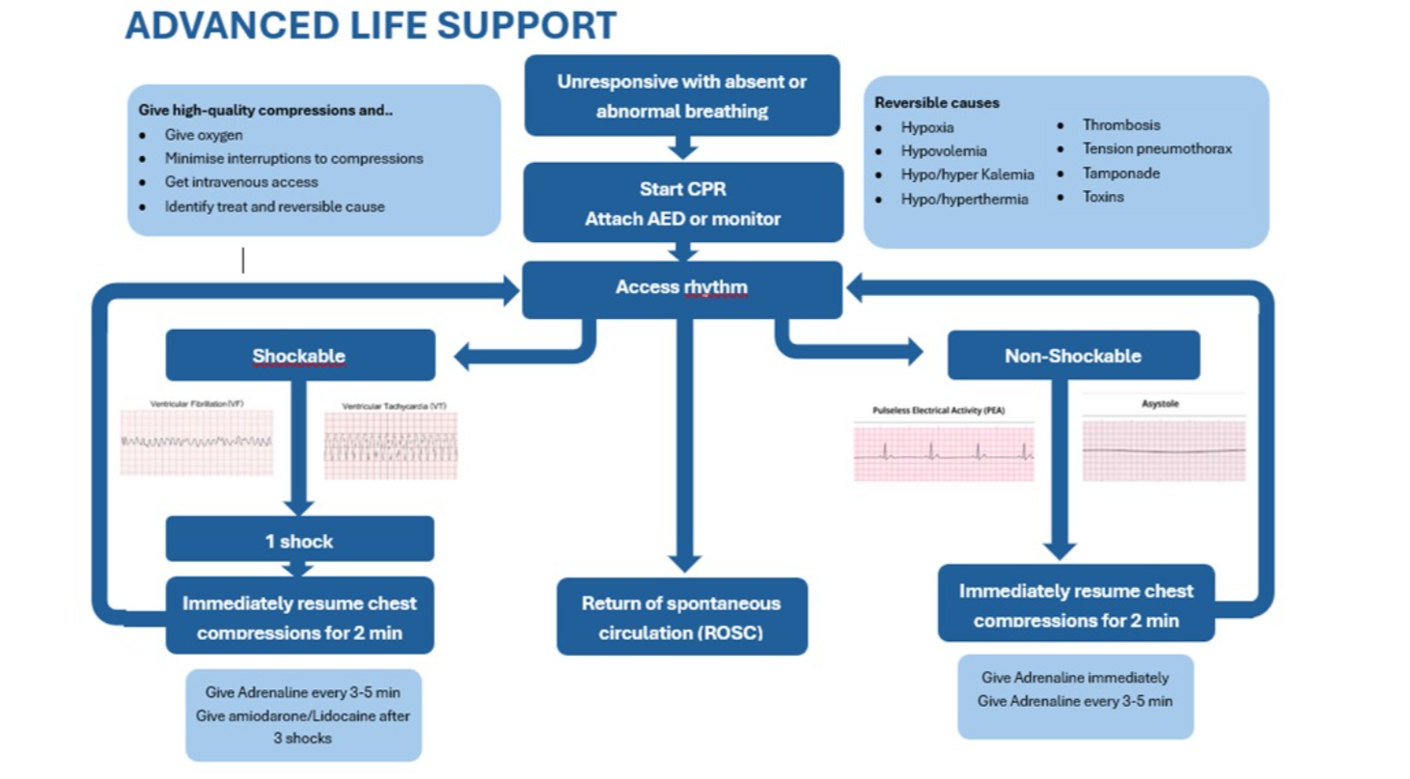

  - Distribution of tasks
Contact with hospital and the experts | Aude & Britt: took initiative
Individual literature study | Individual
Methodology | All together
Powerpoint | Nomie layout, Britt first 10 dia’s and Aude last 10 dia’s
Poster/flowchart | Aude
Questionnaire | Britt
Interpretation questionnaire | Britt: question 1-4 + post questionnaire  Aude: question 5-9  Nomie: question 10-14

