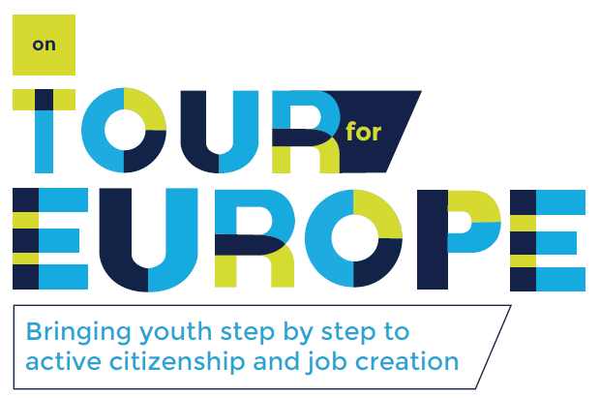

ANALYSING THE
ON TOUR FOR EUROPE PROJECT
ABOUT BRINGING YOUTH STEP BY STEP TO ACTIVE CITIZENSHIP AND JOB-CREATION

Lotte Kerkhofs
Bachelor thesis
3rd year Office Management – Management Assistant
Academic year 2015-2016
Promotor: Erna Geris – PXL tutor
Principal: stad Hasselt

Project mentor: Marc Verachtert - Manager General Affairs, Municipality of Hasselt
Project mentor: Leen Scheelen - Coordinator European Projects, Municipality of Hasselt



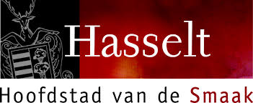

ANALYSING THE
ON TOUR FOR EUROPE PROJECT
ABOUT BRINGING YOUTH STEP BY STEP TO ACTIVE CITIZENSHIP AND JOB-CREATION

Lotte Kerkhofs
Bachelor thesis
3rd year Office Management – Management Assistant
Academic year 2015-2016
Promotor: Erna Geris – PXL tutor
Principal: stad Hasselt

Project mentor: Marc Verachtert - Manager General Affairs, Municipality of Hasselt
Project mentor: Leen Scheelen - Coordinator European Projects, Municipality of Hasselt

Foreword

This thesis is the last part to complete my professional bachelor Office Management – Management Assistant at the University College PXL Hasselt. I had the chance to combine this thesis with an internship by the staff department of the city of Hasselt. Thanks to this internship, I had the chance to follow up the On tour for Europe project from the beginning and thus I had the chance to take part in the first and second OTE-conference. This experience helped me to network with the partners of the project and to gain knowledge from them for writing this thesis.

I would like to thank certain persons for their help and support during the process of this thesis, because without their help, this thesis wouldn’t be complete.

Firstly, I would like to gratitude Marc Verachtert, Manager of General Affairs and Leen Scheelen, Coordinator of European projects, both from the city of Hasselt. I really appreciate their input, advice and support from the beginning of this thesis until the end.

In addition, I would like to thank all the coordinators and participants of project partners. I am very thankful for their input and knowledge before, during and after the conferences in order to complete this thesis.

Furthermore, I would like to express my gratitude to my thesis advisor Erna Geris for her support, assistance and answers to all my question during the whole progress of the thesis.

The last persons I would like to thank are all the colleagues of the staff department from the city of Hasselt, my friends and parents for their support and encouraging talks during this academic year.

Lotte Kerkhofs,
Hechtel-Eksel, June 2016.

Abstract

The On Tour for Europe project “Bringing youth step by step to active citizenship and job-creation” is a European project supported by Europe for Citizens. This project is between nine partner cities and one partner NGO. The project started in July 2015, the end of the project is scheduled for 31 March 2017.

The project consists of four local activities and international conferences, in Lithuania, Spain, Belgium and Germany, which are focused on the interest and the participation in the European Union policy regarding creating job opportunities for youngsters and entrepreneurship by youngsters. In addition, this project has special attention to youngsters who are part of vulnerable groups.

The aim of this On Tour for Europe project is to deal with local youth unemployment problems and to create a better and more cohesive society in Europe. In the medium term, the project wants to create active partners in the European Union-employment policy who will inform and inspire twin cities, partner organisations and network contacts about their experiences and best practices. The second aim in the medium term is to create more and sustainable jobs in the regions. The long-term aim of the project is a European co-funded project in each participating city. Each city has to think about what they want to realize in their city for the unemployed youth and to seek for budget by the European Union to realize this.

This thesis includes an introduction of the On Tour for Europe project and an overview of all the eight participating cities and one NGO together with their local unemployment problems. All data for the thesis and research were collected by: desk research, conversations with participants and representatives of the participating cities, own experience after taking part in two OTE-conferences (Kaunas and Abegondo), feedback from participants by an evaluation questionnaire after these two conferences and by preparing the next two conferences in Hasselt and Detmold.

Despite the fact the project is still in progress, it can be concluded that the On Tour for Europe project is already successful. On the basis of the results of these conferences, several cities have taken the initiative to establish a local project with regard to youth-unemployment.

The development of the thesis

I had the chance to combine this bachelor thesis with an internship by the staff department of the city of Hasselt. For this cooperation, I first made in June 2015 an appointment with Mr. Marc Verachtert, Manager General Affairs from the city of Hasselt. During our first meeting, he proposed and explained the project to me and there was an exchange of views. The acquaintance with the study group of the project followed after this first meeting. There followed some agreements during the summer break for the succession of the project and for the preparation of the first conference in Kaunas (September).

The first assignment within the framework of the course ‘Bachelor thesis’ was a project proposal. I described in this project proposal an inducement of the project, the principal, the aims and results of the project. The following assignments were a plan of action and a scenario to describe the elements of this thesis. Finally, I made a consistent schedule to create a time schedule for this thesis. At least, I made a consistent planning to create a time schedule for this thesis. After all these appointments and assignments, I started to gather information and began writing this thesis. There were still several meetings with project coordinators and the study group during the academic year to follow up the project.
I have written this thesis in several parts. Before and after the first conference in Kaunas, I wrote the chapter about: the content of the project, the participating cities and the content of the first conference. At the end of the first conference, the city from Hasselt handed out evaluation- and feedback questionnaires. I made and wrote an analysis of these questionnaires for chapter 3 about the cost-benefits after the first conference. Towards the second conference, I wrote about the European initiatives regarding youth unemployment and about the content of the second conference. After that conference, I wrote about the content: workshops, visits, key results, etc. Later, I wrote about the preparations for the next two conferences: Hasselt and Detmold. So I wrote about the content of these conferences, the preparations and the draft programme. Between the different conferences and meetings, I made an overview of the conference costs. After all this, I added information and made changes where necessary.
What is more, I started my internship in September with one day training a week. The full-time internship of ten weeks followed on 21 March 2016. Because my internship was linked to my bachelor thesis and because I started in September, I had the opportunity to monitor the project for one year, from June 2015 until June 2016. Due to starting my internship in September, I had the opportunity to take part in the first conference in Kaunas. During the academic year, I could observe the conferences and the project especially before I started my full-time internship. With the start of the full-time internship, I had the chance to take part in the second conference in Abegondo too. Due to my internship, I was strongly involved with the preparations for the conference in Hasselt and Detmold.
All these assignments, meetings, participation in conferences, monitoring the project and preparing the next conferences resulted in the creation of this bachelor thesis.

Table of content
Foreword 2
Abstract 3
The development of the thesis 4
Table of content 5
List of figures 8
List of tables 9
List of abbreviations 10
Introduction 11
Chapter 1 International cooperation leading to a project 12
1.1 Introduction 12
1.2 Europe for Citizens Programme 12
1.3 Participating partners 13
1.3.1 Presentation of the partner cities 14
1.3.1.1 Abegondo, Spain 14
1.3.1.2 Detmold, Germany 15
1.3.1.3 Hasselt, Belgium 15
1.3.1.4 Kaunas, Lithuania 16
1.3.1.5 Oraiokastro, Greece 17
1.3.1.6 Reggio Emilia, Italy 17
1.3.1.7 Saint-Omer, France 18
1.3.1.8 Sandwich, United Kingdom (no official partner yet) 18
1.3.1.9 Schiedam, the Netherlands 19
1.3.2 Presentation of the partner NGO’s 20
1.3.2.1 Ethercentrum VZW, Belgium 20
1.3.3 Unemployment rate of the participating cities 20
1.4 On Tour for Europe project 21
1.4.1 Objectives 21
1.4.2 Other applicants 21
1.4.3 Support 22
Chapter 2 On Tour for Europe project: details of the conferences 23
2.1 Introduction 23
2.2 Conference 1: Kaunas, Lithuania 23
2.2.1 Workshops 24
2.2.2 Visits 25
2.2.3 Key results 26
2.3 Conference 2: Abegondo, Spain 27
2.3.1 Workshops 28
2.3.2 Visits 28
2.3.2.1 Visits related to European projects 28
2.3.2.2 General visits 29
2.3.3 Key results 30
2.4 Conference 3: Hasselt, Belgium 31
2.4.1 Preliminary work 31
2.5 Conference 4: Detmold, Germany 31
2.5.1 Preliminary work 31
2.6 Temporary results of the conferences 32
2.6.1 Involved people 32
2.6.2 Next projects initiated by partners 32
2.6.2.1 "Focus on Youth", Kaunas 32
2.6.2.2 "Genesis", Oraiokastro and Deal Community 33
2.6.2.3 “Community Interest Company (C.I.C.)”, Sandwich Community 33
2.6.2.4 "School of excellence", Saint-Omer 34
2.6.3 Indirect outcomes 34
2.7 Dissemination 35
2.7.1 Logo 35
2.7.2 Website 35
2.7.3 Forum 36
2.7.4 Facebook 36
2.7.5 Printed flyers and press releases 37
2.7.5.1 Flyer for the Abegondo conference 37
2.7.6 Publicity 38
Chapter 3 Cost-benefit 40
3.1 Evaluation 40
3.1.1 Background 40
3.1.2 Results 40
3.1.3 Conclusion 40
3.2 Budget 41
3.2.1 Total cost of the organisation of the conference 41
3.2.2 Travel costs 42
3.2.3 Secretariat cost 43
3.2.4 Summary overview of expenses per conference 44
Chapter 4 Youth unemployment 45
4.1 Initiatives 45
4.1.1 Youth Guarantee Plan 45
4.1.1.1 Funding 46
4.1.1.2 Results 46
4.1.2 Youth on the Move 47
4.1.2.1 Funding 47
4.1.2.2 Results 48
4.1.3 Youth Employment Initiative (YEI) 48
4.1.3.1 Funding 49
4.1.3.2 Results 49
Conclusion 50
List of references 51
Attachments 54

List of figures

Figure 1: Map of Europe. 14
Figure 2: Abegondo. 15
Figure 3: Detmold. 15
Figure 4: Hasselt. 16
Figure 5: Kaunas. 16
Figure 6: Oraiokastro. 17
Figure 7: Reggio Emilia. 18
Figure 9: Sandwich. Retrieved from www.visitsandwich.co.uk 19
Figure 10: Schiedam. 19
Figure 11: Kaunas conference. 23
Figure 12: Participants visiting the Kaunas Pupils' Technical Creation Centre. 24
Figure 13: Participants visiting the Youth Job Centre. 25
Figure 14: Pictures of the embroidered visits cards. 26
Figure 15: Pictures of reciting the poems in different languages. 26
Figure 16: Group discussion during the Abegondo conference. 28
Figure 17: Videoconference with Mr. Stanislav Ranguelov. 29
Figure 18: Visit to the primary school in Abegondo. 29
Figure 19: Inn Museum “Xentes no Camiño”. 30
Figure 20: Visit to the planting vine "Vino de la Tierra". 30
Figure 21: Logo On Tour for Europe. Created by Stoorzender. 35
Figure 22: Leaflet Abegondo conference. Design: Stoorzender (Ethercentrum vzw). Text: Lotte Kerkhofs (city of Hasselt). 37
Figure 23: Leaflet Abegondo conference. Design: Stoorzender (Ethercentrum vzw). Text: Lotte Kerkhofs (city of Hasselt). 37
Figure 24: Banner of the OTE project in Abegondo. 38
Figure 25: Banner of the OTE project in Abegondo. 38
Figure 26: OTE file for participants. 39
Figure 27: Banner of the OTE project. 39
Figure 28: Regions eligible under the YEI. 49

List of tables

Table 1: Youth unemployment rate (people aged 15-29) and unemployment rate and of the participating countries. 20
Table 2: Involved people in the OTE conferences. 32
Table 3: Results of the feedback- and evaluation questionnaires. 40
Table 4: Total costs of the organisation of the OTE conferences. 42
Table 5: Secretariat costs for the OTE conferences. 44
Table 6: Summary overview of expenses per conference. 44
Table 7: youth unemployment rate (people aged 15-24) in Europe from 2012 until 2014. 63
Table 8: unemployment rate in Europe from 2003 until 2014. 64

List of abbreviations

EU European Union
OTE On Tour for Europe
CEP Customized Employment Projects
NEET Not in employment, education or training
NGO Non-Governmental Organisation
KGB Komitet Gosudarstvennoy Bezopasnosti (Committee for State Security, former USSR)
MEP Member of the European Parliament
VET Vocational Education and Training
YfEJ Your first EURES Job
ESF European Social Fund
YEI Youth Employment Initiative
MFF Multiannual Financial Framework

Introduction

Active involvement of citizens in EU-policy is for many cities very hard, especially for youth. Many adult citizens, young people and vulnerable groups have barely any idea what information exists on employment and how they can get this information. In addition, the On Tour for Europe project gives special attention to youngsters and vulnerable groups.

The aim of the project is to help cities, institutions and youth organisations to find their way in the EU policy and funding possibilities, regarding creating job opportunities and entrepreneurship. Another aim of the project is to stimulate youngsters to take own responsibility in employment initiatives.

Four consecutive conferences are all set up with the accent on how to inform, how to enter into a dialogue, how to participate and how to show a lasting commitment in the field of EU-policy. All the participating cities and organisations share their knowledge and best practices during the conferences to create active partners in het EU-employment policy. Furthermore, the result of the project will be creating more and sustainable jobs in each participating city.

The first chapter describes the realization and description of the OTE-project and gives a view of the participating partners. In addition, the first chapter explains the Europe for Citizens programme which gives the OTE-project support.

The second chapter includes the details of the four conferences. First of all, the working method is described because the work program of the project contains of typical parts. Each conference is divided in four parts: the theme and objectives of the conference, the visits, the workshops and the key results.

The third chapter is an analysis of cost-benefits. The analysis is made to evaluate everything which has to do with the satisfaction of the participants, finances and budget of the project. The evaluation is necessary to make improvements for the next conferences and projects. In the second part of this chapter is given an overview of the conference costs. Various costs of the conference are included in this category: organisation costs per conference, travel costs of the participating cities and secretariat costs.

The fourth and last chapter is about European initiatives regarding youth-unemployment to reduce the youth-unemployment rate and stimulate entrepreneurship.

- International cooperation leading to a project

  - Introduction

The On Tour for Europe project is the follow-up project of the “Customized Employment Project for cities; opportunities for growth” (CEP) from Europe for Citizens. The CEP project was a project about employment between eight partner cities for which Hasselt was the leading partner. The project was organised from 10 June 2013 until 1 June 2015 and it was a sequel to a conference about employee rights, which was part of the Europe for Citizens project about climate change. The results of this conference were picked up and developed during the concept of the CEP-project. (Report CEP, 2013)
The project partners of CEP concluded that they do not know enough about the employment policy and supporting measures of the Europe Union. The partner cities of the CEP project strive for a long-lasting cooperation to share their experiences. Due to the cooperation between the cities and the need for knowledge about employment policy, the idea for the On Tour for Europe project came into being during the last days of the CEP project. It became clear to the delegations that it is very hard for youth to find job opportunities. Marc Verachtert, Manager General Affairs from the city of Hasselt, wrote the case of this project and did the application by Europe for Citizens. The city of Hasselt asked Europe for Citizens in the application to be the leading partner of the project. The OTE-project was approved in May 2015 and started effectively in July 2015. The end date of the project is scheduled on 31 March 2017. The task of Hasselt is to lead the partners to the goal of the project, a local project in each participating city to decline youth-unemployment and to stimulate entrepreneurship by youngsters.

  - Europe for Citizens Programme

The On Tour for Europe Project is a project which could start with the support of the Europe for Citizens Programme. The programme is set up to contribute citizens’ understanding of the EU, its history and diversity. Furthermore, it is set up to foster European citizenship and improve conditions for civic and democratic participation at EU level. Europe for citizens provides financial support in the form of action grants and operating grants. Europe for Citizens is implemented by the Executive Agency for Education, Audiovisual and Culture (EACEA).

The programme is open to the 28 EU Member States: Austria, Belgium, Bulgaria, Croatia, Cyprus, Czech Republic, Denmark, Estonia, Finland, France, Germany, Greece, Hungary, Ireland, Italy, Latvia, Lithuania, Luxembourg, Malta, the Netherlands, Poland, Portugal, Romania, Slovakia, Slovenia, Spain, Sweden and the United Kingdom. In general, public bodies or non-profit organisations with a legal personality can apply.

To get the support for the OTE project, the city of Hasselt had filled out an application of the project. This application needed to be approved by Europe for Citizens. The input of the application was based on the former CEP conference.

  - Participating partners

There are in total eight partners involved in the project and the city of Sandwich, who is not an official partner for the moment, is involved too. Both cities and organisations participated in the project. The participating cities are: Abegondo (Spain), Detmold (Germany), Hasselt (Belgium), Kaunas (Lithuania), Oraiokastro (Greece), Reggio Emilia (Italy), Saint-Omer (France) and Schiedam (the Netherlands). There is also one participating organisation: Ethercentrum vzw (Belgium) who brings in their expertise in working with youngsters. The project will strongly be attached to the network of Medium Sized cities: Eurotowns. Eurotowns is a Europe-wide network for towns and cities from 50.000 until 250.000 inhabitants. Nowadays, 17 towns and cities are member of the network. The members of Eurotowns work together in the development of European legislation. Thanks to Eurotowns, there is a lasting effect of the project results. Moreover, Eurotowns can be used in the project as a larger platform to disseminate information. Four of the eight participating cities are member of Eurotowns, actually: Detmold, Hasselt, Reggio Emilia and Schiedam.

The applicant organisation for the On Tour for Europe project is the city of Hasselt, they are the leading partner of the project. Hasselt has as leading partner additional responsibilities: secretariat tasks (preparations for each conference), administrative tasks and financial commitments.

Hasselt and Detmold (Germany) are twin cities for already 40 years now. Furthermore, Reggio Emilia (Italy) and Schiedam (the Netherlands) are co-operating cities regarding network activities.

To reach as many youngsters as possible, the project proposes the participation of policymakers, youth-workers, community groups as well as representatives of councils and business, more specifically everyone who can speak for youngsters and/or are strongly cooperating with them.

    - Presentation of the partner cities

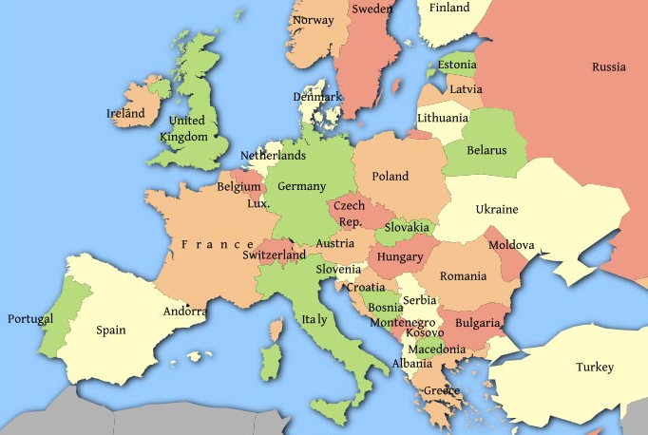
9
3
4
8
2
1
5
7
6
1 Abegondo (Spain)
2 Detmold (Germany)
3 Hasselt (Belgium)
4 Kaunas (Lithuania)
5 Oraiokastro (Greece)
6 Reggio Emilia (Italy)
7 Saint-Omer (France)
8 Sandwich (United Kingdom)
9 Schiedam (the Netherlands)

Figure 1: Map of Europe.
Retrieved from http://thepoliticalcarnival.net/2013/03/31/european-austerity-costing-lives-shredded-social-net

      - Abegondo, Spain

Abegondo is a municipality of Spain in the Province of A Coruña and in the region of Galicia. The city is situated in the northwest of Spain, bordered to the Atlantic Ocean and to the south of Portugal. The region of Galicia is known for its food, their fishing industry is the largest in Spain. Geographically, Abegondo has an extension of 83,81 km² and a population of 5798 inhabitants (2015). It is a really small town who has already realized several initiatives co-funded by the European Union in the past. One of the aims of the project is to show other cities that every country and city, how small they are, is able to undertake initiatives co-funded by the European Union and that is why it is important to take Abegondo as a partner in the project. During the conference in Abegondo (April 2016), several initiatives supported by the European Union are showed to the participants of the conference.

In 2014, the youth unemployment rate in Spain was 53,2% in contrast with an unemployment rate of 24,5%. Mainly youth have an active part in unemployment in Spain so for them is the unemployment a big issue.
Website: www.abegondo.es
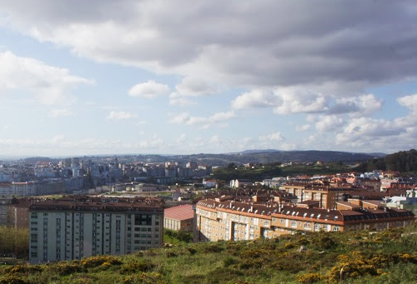
Figure 2: Abegondo.
      - Detmold, Germany

Detmold is a city in the region of North Rhine-Westphalia in Germany, between the main centres of Bielefeld and Paderborn. The city has 27 districts and a population of 73.586 inhabitants (2015).
Detmold leaded already other Europe for Citizens and other EU-collaboration projects. Furthermore, Detmold supports partnerships between different cities. Detmold is twinned with: Hasselt (Belgium), Saint-Omer (France), Savonlinna (Finland), Zeitz (Germany) and Kalithea (Greece). Being a twin city means that there is a form of legal social agreement between the cities to promote culture and commerce.
In 2014, the unemployment rate in Germany was merely 5,0%. Nevertheless, the youth unemployment rate was 7,7% in the same year. Thanks to several industries and trade markets in Detmold, the unemployment rate is low.
Website: www.stadtdetmold.de
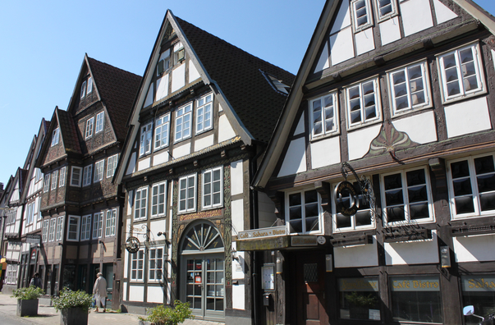
Figure 3: Detmold.
Retrieved from http://www.detmold.de/startseite/zu-gast-in-detmold/tourismus/sehenswuerdigkeiten/historischer-altstadtkern/
      - Hasselt, Belgium

Hasselt is a city in Belgium and also the capital of the province of Limburg. The city has an area of 102.24 km² and a total population of 76.000 inhabitants (2015). Hasselt has several small- and medium-sized enterprises. A lot of young entrepreneurs find their way in Hasselt, thanks to the Corda Incubator who give support to new entrepreneurs.

Hasselt is known for its education opportunities. The city is becoming larger and more popular by students over the years. Hasselt has one university with departments in Hasselt and Diepenbeek and two university colleges and counts more than 47.000 pupils and students.
In 2014, the youth unemployment rate in Belgium was 23,2%, in contrast to the unemployment rate of 8,5%.
Website: www.hasselt.be
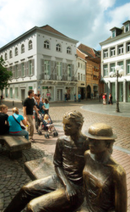
Figure 4: Hasselt.
Retrieved from http://toerisme.hasselt.be/nl/press/1044463/maandagwandeling-smaakroute.html
      - Kaunas, Lithuania

Kaunas has 368.917 inhabitants and by that, it is the second-largest city in Lithuania and located in the center of Lithuania. Historically, Kaunas has been a leading center of Lithuanian cultural, economic and academic life.

The city counts six universities with more than 35.000 students. A lot of youngsters are unemployed in Lithuania, so the youth unemployed rate in Lithuania was 19,3% in 2014. More and more young people are leaving Lithuania in order to find a job in a foreign country.
Website: www.kaunas.lt
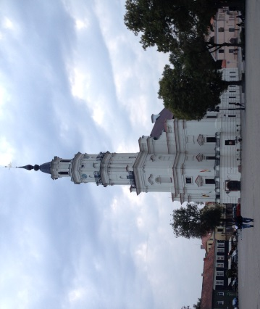
Figure 5: Kaunas.

      - Oraiokastro, Greece

Oraiokastro is a municipality situated in the north of Greece, next to Thessaloniki. The city of Oraiokastro has 38.330 inhabitants (2011). Since the financial crisis in 2009, the unemployed rate is very high in Greece. In 2014, the unemployment rate was 26,5% but mostly young people are attacked by unemployment. So was the youth unemployment rate for the year 2014 52,4% which is an extremely high rate.

Oraiokastro has many youngsters and students who have difficulties to find a job. In addition, not only youngsters have problems to find a job, also inhabitants older than 50 are facing problems with finding a job.
Website: www.oraiokastro.gr
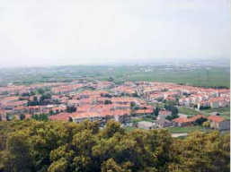
Figure 6: Oraiokastro.
Retrieved from http://www.oraiokastro.gr/index.php/2014-04-09-10-27-17/2014-04-09-10-26-26

      - Reggio Emilia, Italy

Reggio Emilia is the capital of the province Reggio nell'Emilia and situated in the middle of the prosperous Po Valley. Reggio Emilia is a very forward-looking and enterprising city. The city has 170.000 inhabitants (2015) and by that, it is one of the most privileged areas in Italy. The most important sectors are the ceramics, clothing and mechanical industry.

In 2014, the youth unemployment rate very high, namely 42,7%. This rate is in contrast to the unemployment rate of 12,7%.

Website: www.pdreggioemilia.it
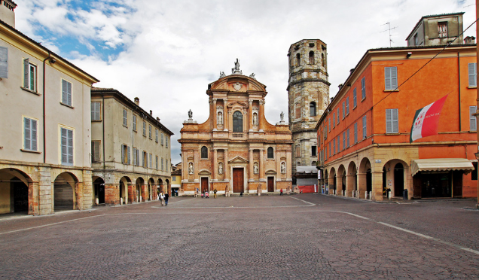
Figure 7: Reggio Emilia.
Piazza San Prospero. Retrieved from http://www.italyzone.it/viaggi/emilia-romagna/reggio-emilia/

      - Saint-Omer, France

Saint-Omer is a French commune located in the north of France with 15.777 inhabitants (2015). The city was associated with the production of textile and clothing in the past. The service sector and public institutions are more important nowadays. The region is known for her local enterprises and artisanal businesses.

The economy has changed dramatically in Saint-Omer over the years. What is more, young people in Saint-Omer have difficulties to find a job. Therefore, the youth unemployment rate in France was 24,1% in 2014.
Website: www.ville-saint-omer.fr
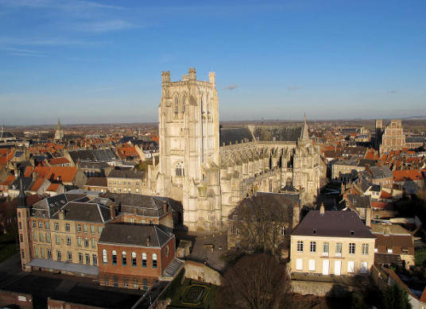
c

      - Sandwich, United Kingdom (no official partner yet)

Sandwich is a small town in the south-east of the United Kingdom. The population of sandwich is 4,500 inhabitants (2015). Sandwich is not yet an official partner of the project. Sandwich has submitted an application to be a partner of the project, up till now, the application is still pending (June 2016).

A representative from Sandwich is lobbying with various agencies for the approval of the application. This representative of Sandwich will participate in each conference. For now, he took part in the conference of Kaunas and Abegondo.
Website: http://www.visitsandwich.co.uk/
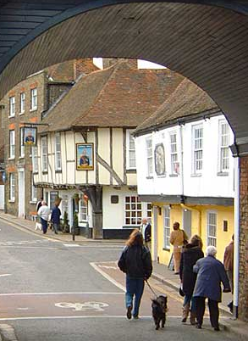
Figure 8: Sandwich. Retrieved from www.visitsandwich.co.uk

      - Schiedam, the Netherlands

Schiedam is a city in the province of South Holland in the Netherlands with a population of 76.000, located west of Rotterdam. In 2014, the youth unemployment rate was 12,7%. In the same year, the youth unemployment rate was almost two times the general unemployment rate which was 7,4%.

The city is known for its historical centre with canals and for having the tallest windmills. Schiedam is also well known for the distilleries and malthouses and production of jenever (gin). This was the town's main industry during the early Industrial Revolution in the 18th and 19th century. Furthermore, the city is known for Saint Lidwina, one of the most famous Dutch saints.
Website: www.schiedam.nl
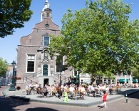
Figure 9: Schiedam.
Stadhuis. Retrieved from http://www.sdam.nl/zien-doen/historie

    - Presentation of the partner NGO’s

Most of the participating partners of the project are the city itself. Besides the communities, there is one other organisation (NGO) who is participating in the OTE-project as partner, namely Ethercentrum VZW (Belgium).

      - Ethercentrum VZW, Belgium

Ethercentrum VZW (NGO) is a cooperation of local radios with the headquarter in Gent. Ethercentrum VZW is the umbrella organisation for Chase and Stoorzender. The name they use for their organisation is ‘VZW Radiocentrum (REC)’. REC inspires, trains and launch young storytellers for the digital world. REC organises events to bring young professionals in the field of media in contact with professionals. In addition to providing free platforms, REC also offers opportunities people with talent to make media content for professional media companies and other customers by intensive coaching.
Ethercentrum VZW (NGO) is involved as a partner in the project to bring in their expertise in working with youngsters. They will share their experiences in contacting youngsters and working-methods leading to make them curious for policy, the way that EU-politicians are open for communication and guide them to active citizenship and the possibility to express needs and suggestions on employment for youngsters on short and long term.

    - Unemployment rate of the participating cities

Country | Youth unemployment rate (2014) | Unemployment rate (2014)
Belgium | 23,2 % | 8,5%
France | 24,1 % | 10,3%
Germany | 7,7 % | 5,0%
Greece | 52,4 % | 26,5%
Italy | 42,7 % | 12,7%
Lithuania | 19,3 % | 10,7%
Netherlands | 12,7 % | 7,4%
Spain | 53,2 % | 24,5%
United Kingdom | 16,9 % | 6,1%
Table 1: Youth unemployment rate (people aged 15-29) and unemployment rate and of the participating countries.

  - On Tour for Europe project

The On Tour for Europe project is a EU-funded Europe for Citizens project. This project could be started with thanks to Europe for Citizens. On Tour for Europe wants to offer help and EU-funding possibilities for creating job opportunities.

The Mayor and the Board of Aldermen from the city of Hasselt applied for a project proposal for one Europe for Citizens Project to get support. The project focuses on active EU citizens leading to job creation and encourage entrepreneurship and international partnership. Hasselt followed different procedures to receive a grant for the project. On May 2015, Hasselt received the approval of the project. The project consists of four local activities and international conferences (in Lithuania, Spain, Belgium and Germany).

The focus of the conferences is on how to inform, how to enter into a dialogue, how to participate and how to show a lasting commitment on the issue of youth employment and entrepreneurship. EU bodies, international teams of experts and representatives of the partner cities will share their experiences during each conference. Knowledge is shared through world cafés, debates and workshops and best practices are formulated.

    - Objectives

Each conference or event will be prepared and evaluated with respect to the content and turned into concrete projects or collaborations through regular meetings.

The main goal of the project is focused on youth. The projects want to create more and sustainable jobs in our regions by giving cities, institutions and youth organisations free help to find their way in the EU policy and help them to find funding possibilities regarding creating job opportunities and entrepreneurship. Furthermore, by stimulating youngsters to take own responsibilities in employment initiatives and entrepreneurship, in particular for youngsters who are part of vulnerable groups. The project encourages citizens and local governments to gradually work on a permanent involvement for a better and more cohesive EU society, based on communication with and by citizens.

The aim of the project is that the successive conferences will lead to a concrete EU subsidized employment project in each participating city. This employment project focuses on active EU citizens leading to job creation and the promotion of citizenship.

    - Other applicants

In the first place, all the countries who are member of the European Union can participate in the Europe for Citizens Programme. These 28 countries are: Austria, Belgium, Bulgaria, Croatia, Cyprus, Czech Republic, Denmark, Estonia, Finland, France, Germany, Greece, Hungary, Ireland, Italy, Latvia, Lithuania, Luxembourg, Malta, the Netherlands, Poland, Portugal, Romania, Slovakia, Slovenia, Spain, Sweden and the United Kingdom.

At the start of the On Tour for Europe project, the NGO 'Verein für Jugendhilfe im Landkreis Böblingen e.V.' from Germany imagined to be a partner of the project. Their application was approved, however they later decided to withdraw from the project. The person who acted as representative for this organisation changed from employer at the start of the project. The organization was not able to be a partner in the project anymore without this representative. This person made an attempt to get his new employer in the project, but unfortunately, this was not possible.
Besides the participants of the official partner cities, the project gives partners the opportunity to invite other cities to participate in the conferences. Thus Kaunas invited two participants of Tartu (Estonia) during their conference. Furthermore, Abegondo invited two participants of Mölndal (Sweden) to their conference.

    - Support

On Tour for Europe received a total allowance of 100.000 euro (decision nr 2015 – 1026 / 001-001) for the organisation of meetings, the organisation of an international event in Hasselt, secretarial costs and coordination costs.

There is 25.000 euro budget for each meeting in four partner cities (Kaunas, Abegondo, Hasselt and Detmold). The lead partner decided that 20.000 euro of the budget is intended for the local organisation costs and 5.000 euro of the budget is intended for the coordination and secretarial costs.

25.000 is the maximum grant per conference. The size of grant depends on the number of international and local participants. In order to get the maximum grant of 25.000 euro, the event has to have at least 30 international participants and 75 local participants during the event. When there are fewer participants as the norm, the allowed budget decreases equally.

The project expects three delegates from each partner at every conference, their participation is free. More delegates can be permitted after a request to the project coordinator. This free participation includes accommodation, meals, transport during the conference, study visits and workshops. Travel costs will be reimbursed at 50% of the expenditure with a maximum of 450 euro per project partner and per conference.

The final grant will be attributed after the analysis of the final report which has to be submitted to the Europe for Citizens Programme within two months after the end of the project.

The detailed overview of the cost per meeting and per event are summarized in chapter 3.

- On Tour for Europe project: details of the conferences

  - Introduction
Participants from EU bodies, teams of experts and representatives will share their experience through different activities during the four conferences: debates, workshops and study visits. The conference languages are English and the local language of the conference-city.
Each conference has a different accent within the theme of ‘enter into a dialogue and participate on EU policy and funding possibilities towards job opportunities and entrepreneurship by youngsters’.

  - Conference 1: Kaunas, Lithuania

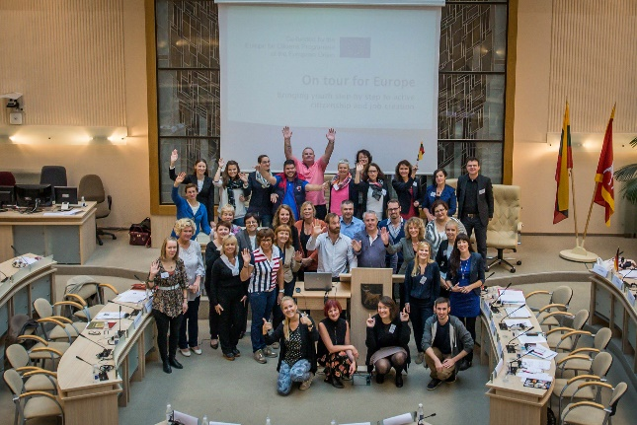
The first conference and the take-off of the On Tour for Europe project took place in Kaunas (Lithuania). The conference lasted from 23 September until 26 September 2015. The accent of the first conference was put on ‘where to find and how to use EU-information on employment and entrepreneurship’. The reflection on freedom of information, remembering the Soviet occupation in Lithuania, was a part of the conference too.
Figure 10: Kaunas conference.
The aim of the event was to provide a platform for local, national and international stakeholders (NGOs, educators at school, vocational and university level, non-formal education institution and youth policy makers at local and national level) to share best practices and new initiatives on the inclusion of youth into active citizenship and labour market. The main themes of the conference were: the availability of information for youth about labour market, youth guarantee initiative, business start-ups and information campaigns for young people.

The cultural theme of the project explored the historical remembrance of European Countries. The topics of discussion in Kaunas were: the freedom of speech, opinion, beliefs and self-expression in historical hardships as well as contemporary Europe.

The conference in Kaunas had been organised by Kaunas City Municipality in cooperation with Vytautas Magnus University Faculties of Social Sciences and Political Sciences and Diplomacy, Centre of Business Practitioners, Institute of Foreign Languages, Science and Technology Park “Technopolis”, Kaunas “Europe Direct” Information Centre and the Society of XXVII Book Lovers.

The conference involved 140 citizens, 26 international participants and 114 national participants. At the conference were: 114 participants from Kaunas (Lithuania), 2 participants from Oraiokastro (Greece), 6 participants from Detmold (Germany), 3 participants from Abegondo (Spain), 3 participants from Saint Omer (France), 5 participants from Hasselt (Belgium), 2 participants from Sandwich (UK), 3 participants from Schiedam (the Netherlands) and 2 participants from Tartu (Estonia).

    - Workshops

To give the participants a description of the organisations in Kaunas working for (unemployed) youth, there were planned, five visits, to: NGO Actio Catholica Patria, Kaunas Maironis University Gymnasium, Kaunas Pupils’ Technical Creation Centre, Kaunas Business Information Centre Business People and Kaunas Territorial Labour Exchange Youth Job Centre. Participants were split up in groups and had to decide which institution they wanted to visit.

NGO Actio Catholica Patria is one of the first organisations that has been actively engaging in youth affairs in Lithuania since the liberation of the Soviet Occupation in 1991. The organisation has lots of different activities. So they have a Youth Centre where young people can connect with each other and spend their time in a meaningful way. In addition, they have a Volunteering Service which acts as a step stone to a job or to acquire skills. Volunteering is for many youngsters in Kaunas a meaningful way to contribute to society. NGO Actio Catholica Patria has also a consultation centre where youngsters are helped by social workers to apply for a job.

Another possibility to visit was the Kaunas Maironis University Gymnasium. The Gymnasium was founded in 1863 under the Russian regime. The language in the school was Russian until 1920. Later, they started to speak Lithuanian and this was the start of higher education in Lithuania. Today, the Gymnasium has more than 500 students and in total, Kaunas has 5 universities. The Kaunas Maironis University Gymnasium organises lots of career education events. For example: the 'Study Week'. During this week pupils have the chance to talk with university lectures and students from various faculties. They provide career counselling for individuals and for groups after the lessons or during breaks.

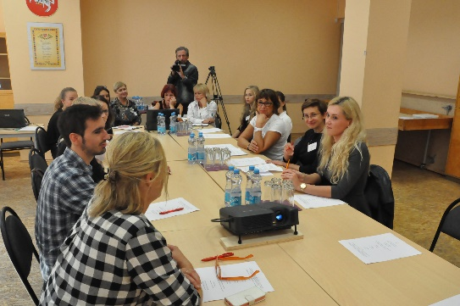
The third possibility to visit was the Kaunas Pupils’ Technical Creation Centre. The centre provides youth activities with different kinds of after school projects. This centre is confronted with mutual problems: young people are looking for a place to develop their own talent and young people are searching for their place in the society. The centre wants to reduce the gap between the daily world and the digital or online world so they can reach young people by using the right channels. The centre learns young people a local language because it is the key for strengthen families and involving parents.
Figure 11: Participants visiting the Kaunas Pupils' Technical Creation Centre.

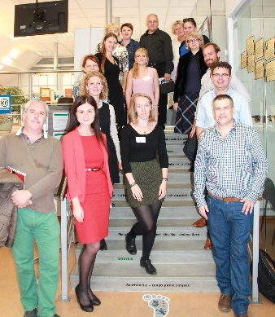
The fourth possibility to visit was a combination of two institutions: the Kaunas Business Information Centre Business and the Kaunas Territorial Labour Exchange Youth Job Centre. Kaunas Business Information Centre Business People has 4 organisations under their roof: the Business Information Centre, the Kaunas Small and Medium Enterprises, the Club entrepreneurs (young entrepreneurs) and the Business club for disabled persons. The Business Information Centre counsels companies up to four years old. Later, when the companies are older, they are supported by other organisations. The Business Information Centre has 100 till 150 businesses start-ups every year. Most of their clients start up small businesses, like retail shops, car-repair services and restaurants. The main service of the centre is counselling new enterprises on their business ideas and give them advise on their business plan.
Figure 12: Participants visiting the Youth Job Centre.

The Territorial Labour Exchange Youth Job Center gives services to youth people who are unemployed. Their clients are mostly unemployed young people, but not only youth, they help everybody who contacts the center. Their main goal is to inform the unemployed about the situation of the labour market. The Youth Job Centre gives the unemployed advice about job vacancies, schools higher education, vocational schools and trainings. The Centre helps also students to find a summer job.

    - Visits

Besides the study visits to the institutions, there were two visits with a reflection to the Soviet occupation in Lithuania: a visit to the secret underground printing house “ab” and a visit to the Vytautas Magnus War History Museum.

The secret underground printing house “ab” was born in 1978. Andziulis Vytautas started to build a secret underground printing house, it took two years to prepare the building. Andziulis Vytautas and his friend Juozas Bacevičiu, decided to start printing in the secret printing house in 1980. They called the house “ab”, it comes from the initials of their last names. Until 1992, people in Lithuania were not allowed to write down anything. Throughout those periods, printed publications and books played a crucial role in Lithuanian lives. People could read only books that were allowed by government. In the secret underground printing house, they printed about subjects they were not allowed to speak about in public: religion, political people and poetry of religious people. The printing house was hidden very well for public, police and government. The rooms for printing activities were constructed around 3 meters underground at the home of Vytautas Andziulis. The entrance was hidden by a cement watering pool in the greenhouse, a handle made it possible to move the watering pool for an entrance. After the restoration of Independence of Lithuania in 1990 was the situation in Lithuania still dangerous. Nowadays, the printing house is exposed as a museum in order to reconstruct the history of Lithuania for the future.
The Genocide Victims Museum in KGB cellar was the second visit with a reflection to the Soviet occupation in Lithuania. The museum is situated in the former KGB building, where the crimes of the Soviet regime were planned and executed for fifty years. Several rooms in the KGB cellar are opened for visitors, like the KGB prison, the execution chamber and a chamber with an exhibition dedicated to the Nazi occupation and the Holocaust in Lithuania.

The first time the freedom of expression and information came up in Lithuanian was in October 1992. To remember the freedom of speech, the city of Kaunas organised an exhibition of embroidered visit cards at the Vytautas Magnus University Faculty of Humanities. The cards have been created by pupils and community members in the cities of project. During this exhibition, each country recited a poem in their own language.

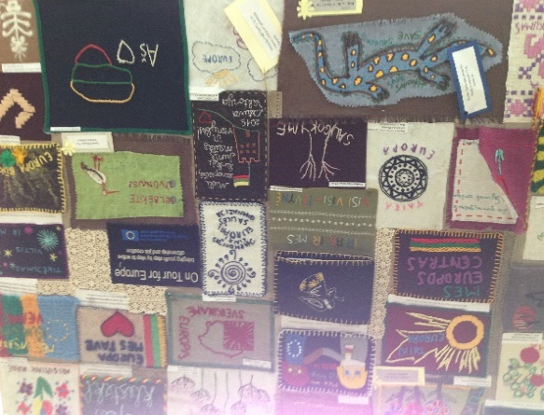
Figure 13: Pictures of the embroidered visits cards.
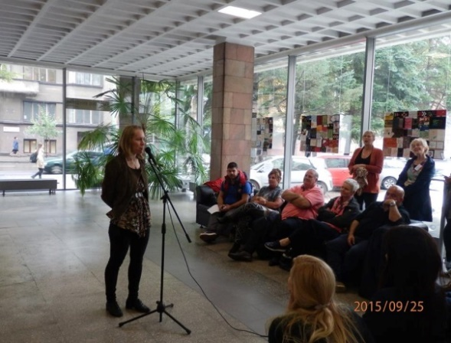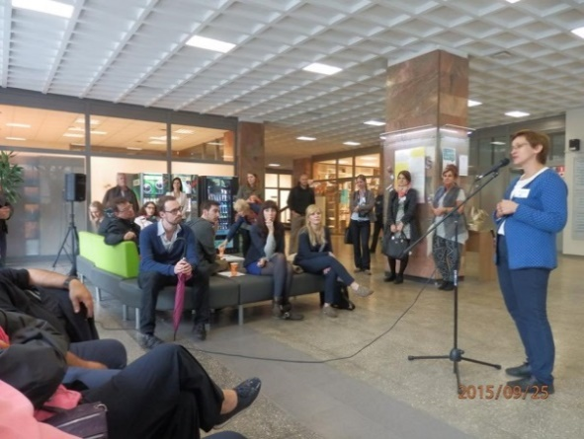
Figure 14: Pictures of reciting the poems in different languages.

    - Key results

One of the learned lessons is that local communities should work more with youth. Local communities should take responsibility for setting up projects for employment and entrepreneurship for young people. Municipalities should encourage and support local communities because they are closer to youth. That is why NGO’s need support, so they would provide all the necessary facilities to youth.

Despite volunteers are the biggest value for the society, not many young people are committed to voluntary organisations. Nowadays, youngsters see volunteering as something strange and it is important to change their point of view because volunteering is an important preparation for the labour market.

Furthermore, psychological counselling for youth is an important thing. Especially for those who are from children care centres or even those, who are spending most of their time by the computers. What the participants of the conference carry away are the input for new project, methodologies, the networking and valuable initiatives on entrepreneurship from partner cities.

Towards the next conference in Abegondo in April 2016, each participating city needed to think about a project supported by Europe, they want to launch to support youth regarding employment. Their homework was to make a brief presentation of their project and present this project to the other partners during the Abegondo conference.

  - Conference 2: Abegondo, Spain

The second conference of the OTE-project took place in Abegondo (Spain). The conference lasted from 27 April until 30 April 2016. During the first conference in Kaunas (September 2015), there was found out where to find and how to use EU information on employment and entrepreneurship. The accent of the second conference was put on ‘information and taking positions on the strength that citizens have to affect EU-policy concerning employment/entrepreneurship, having insight in EU-structures and possibilities for dialoguing’.

The project has specifically chosen for a conference in Abegondo, a very small town in northern Spain. Although Abegondo is very small, they have several business initiatives in the field of employment supported by Europe. By visiting Abegondo and her initiatives, this city has the chance to show the participants that it is possible, as a small town, to start initiatives supported by Europe. During this conference, participants visited several local initiatives and a number of partners presented the homework that was specified at the Kaunas conference.

The conference involved 114 citizens: 32 international participants and 82 national participants. At the conference were: 82 local participants (from Spain), 3 participants from Oraiokastro (Greece), 3 participants from Detmold (Germany), 3 participants from Kaunas (Lithuania), 3 participants from Saint Omer (France), 11 participants from Hasselt (Belgium), 2 participants from Sandwich (UK), 4 participants from Schiedam (the Netherlands) and 3 participants from Reggio Emilia (Italy).

    - Workshops
During the Abegondo conference, there were several workshops for the participants to share their experiences and knowledge about youth unemployment. Participants had the chance to have a chat and discussion with local youth too.
During the third day of the conference, participants were split up in two groups. There were two group discussions for each group. The first two discussions for the two groups were with Romyna Fraga Lesta, from the Chamber of Commerce about helping youngsters to discover talents and prepare them for the labour market or with Adrián Saborido Lopez, from the Chamber of Commerce about working with young enterprises and coaching entrepreneurs. The second two discussions for the two groups were with Covadonga López, EURES adviser from the Galicia Public Employment Service about the cooperation network between public employment services in 32 countries in Europe or with Fernando Rodriguez, from the Technical Department of Youth and Volunteering about the experience of young students studying abroad or volunteers in other countries. The feedback and evaluation questionnaires which are filled in by the participants after the conference, showed that these group discussions were very instructive. Participants could share their ideas and experiences with local experts from the field of youth unemployment.
The detailed overview of the feedback and evaluation questionnaires is summarized in chapter 3.
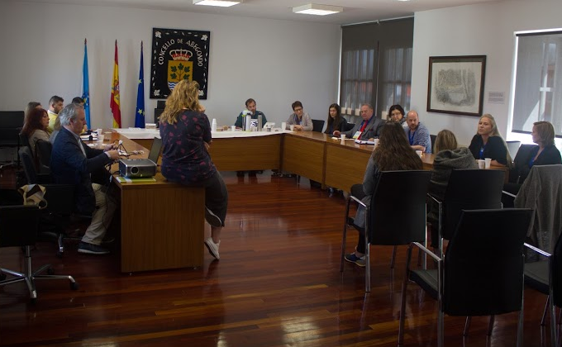
Figure 15: Group discussion during the Abegondo conference.
    - Visits

      - Visits related to European projects
During the second conference day, participants had the change to come in contact with projects supported by the European Union.

The participants visited the project “Galiña Piñeira”. This is a project from fourth-year students of the Instituto de Viós, a secondary school in Abegondo. The project is supported by Europe for Citizens. The main goal of Galina Pineira is to take car for hens and afterwards, the students will sell the eggs of the hens. The project is still in the initial phase, so participants could see in a presentation how the project started. After the presentation, the participants visited the field of the hens.

By the start of the second conference day, participants had a videoconference with Mr. Stanislav Ranguelov, ESF (European Social Fund) manager for Spain and Malta. Mr. Stanislav gave the participants an introduction on the Youth Guarantee Plan. After the videoconference, participants had the chance to ask questions about the Youth Guarantee Plan.

The Youth Guarantee Plan is explained in chapter 4.

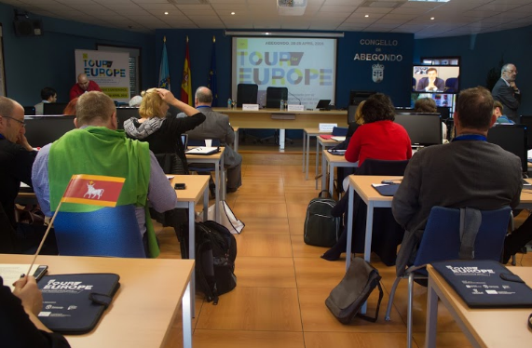
Figure 16: Videoconference with Mr. Stanislav Ranguelov.

      - General visits

Next to the visits related to European projects, there were also several local visits for the participants. The first visit was to the primary school, CEIP Plurilingüe San Marcos on the second conference day. Teachers from this school prepared together with their pupils an activity for the participants: they made posters with typical characteristics from each participating country and prepared a dance with typical music of each participating country.

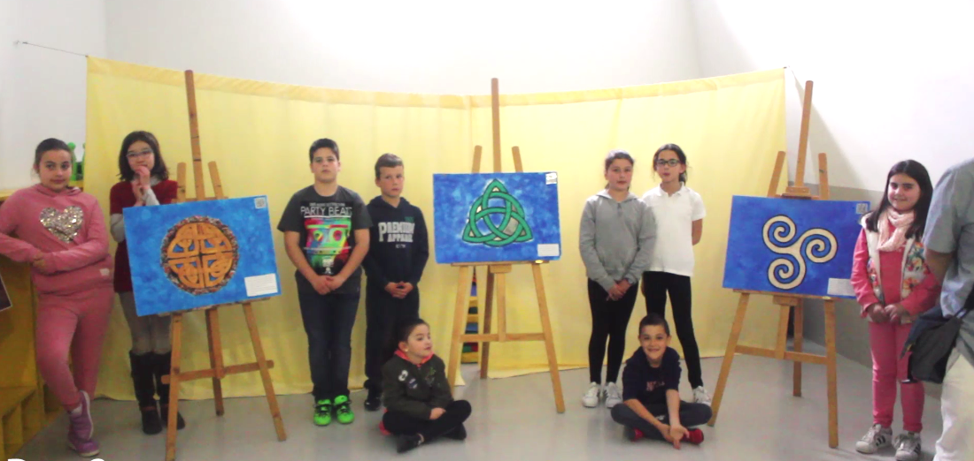
Figure 17: Visit to the primary school in Abegondo.
The lunch of the second conference day took place in the Inn Museum “Xentes no Camiño”. In this restaurant, the owner Alfredo Martinez, exhibits Christian paintings which he made himself. So the restaurant is at the same time a musuem. Alfredo Martinez explained the meaning and story of some paintings during the lunch. After the lunch, there was a presentation on the Lupulus project. This project is about planting hops in Presedo Abegondo. This hopfield is located in front of the museum.
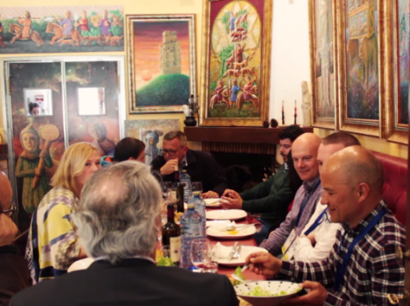
Figure 18: Inn Museum “Xentes no Camiño”.

In the afternoon of the second conference day, the participants visited the planting vine “Vino de la Tierra” in the municipality of Paderne. The owner showed the participants the planting vine and wine cellar. Afterwards, the participants had the possibility to taste wines from local varieties.

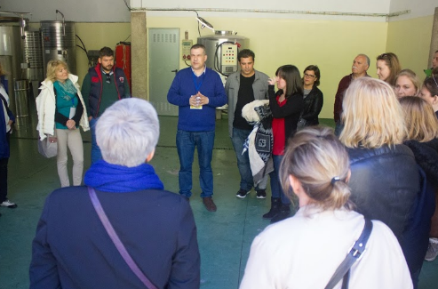
Figure 19: Visit to the planting vine "Vino de la Tierra".

    - Key results

During this conference, there was an excellent networking between the participants from the participating cities. This conference was a great opportunity to share ideas and local initiatives about youth unemployment. Current and future projects from partners are enormously inspiring for other delegations. Each partner takes this experience of projects to his own daily labour. Participants may appeal to this experience in short or long term in order to invent and submit a new project.

Abegondo is an excellent example of what a small community can do due to European projects. Participants are stunned how well Abegondo is doing in European projects and how they get grants from European fundings. In addition, Abegondo inspires other small communities and small organisations and motivates them for coming up with new projects.

  - Conference 3: Hasselt, Belgium

The third conference will take place from 6 until 9 September 2016 in the city of the lead partner, Hasselt (Belgium). The theme of this conference is the organisation and working of EU-institutions and receiving an insight in participative policy possibilities on employment. During this conference, participants will visit the European parliament and European institutions.

Hasselt wants to give the international and the national participants the change to communicate and discuss with MEP’s about the organisation and working of the EU-institutions. Moreover, giving the participants insight in participative policy possibilities on employment and eliminate a number of prejudices.

    - Preliminary work

The city of Hasselt organises a working group for the On Tour for Europe project on a monthly basis. This working group is responsible for the monitoring of the project and the organisation of the conference in Hasselt. In this working group are aldermen, officials and trainees from different departments and fields working together. Thanks to this project, new partnerships between local institutions of Hasselt came into being. Among other things, partnerships between VDAB, JCI and Arktos are originated.

  - Conference 4: Detmold, Germany

The fourth and last conference will take place from 7 until 10 November 2016 in Detmold. During this conference, participants will develop a way how they can stimulate lasting involvement of citizens and youngsters in the EU-participation. Furthermore, participants will learn how they can improve input and contacts, and exchange their vision on the future of Europe. Remembering the Holocaust and the fall of the Berlin Wall are a part of the conference too.

    - Preliminary work

Several representatives from the municipality of Detmold work together to prepare the content of the conference. The organisation prepares several visits regarding active citizenship and historical awareness. Besides the visits, the organisation prepares also presentations about these topics.

For the preliminary work, Leen Scheelen (coordinator European projects, the city of Hasselt) and Lotte Kerkhofs (trainee Office Management, the city of Hasselt) will stay in Detmold from 20 until 22 June 2016 to help the municipality of Detmold with the preparations of the conference. The main objective of this visit is to look how Detmold has spent its budget for the Conference. In addition, they will check if the programme of the conference has sufficient European content. European projects and European funding opportunities are an important aspect which certainly should be addressed during this Conference. The lead partner will check during the preparatory visit if these aspects get a change in the programme of the conference.

During these days, Leen and Lotte will also visit places to visit possibly during the Conference, together with representatives from Detmold. In addition, they also visit the accommodation for the participants and restaurants to make arrangements e.g. about times and prices.

  - Temporary results of the conferences

    - Involved people

Conference | Local participants | International participants | Total
OTE Kaunas | 114 | 26 | 140
OTE Abegondo | 75 | 32 | 107
OTE Hasselt | 100* | 30* | 130*
OTE Detmold | 100** | 30** | 130**
Total | 389 | 118 | 507
Table 2: Involved people in the OTE conferences.
* Expected number of participants, the OTE Hasselt conference will take place from 6 until 9 September 2016.
** Expected number of participants, the OTE Detmold conference will take place from 7 until 10 November 2016.
    - Next projects initiated by partners

      - "Focus on Youth", Kaunas
The project “Focus on Youth (FOY): Uniting, Informing and Inspiring Professionals and Citizens to Cooperate Towards Stronger Community” is a Europe for Citizens project to motivate, inform and inspire youth work professionals. They have received a grant of 7500 euro from Europe for Citizens for this project and 40 participants will be involved in the project.

The aims of the project are to increase the knowledge about youth work methods that are making positive impact in local communities and to increase the professional development and quality on youth work. Furthermore, Kaunas wants to share good practices about cross-sectorial cooperation between local authorities and communities working towards better inclusion of youngsters and to raise awareness about European dimension in youth work. In addition, Kaunas wants to provide wider knowledge to its citizens on how to use EU financial resources. At least, Kaunas would like to develop programs about the cooperation with a NGO at the European level and about the involvement of young people in volunteering in local services.

      - "Genesis", Oraiokastro and Deal Community

The Genesis project is about the rebirth of an old amphitheatre that will be reused by events supported by the social enterprise Genesis, e.g. for training opportunities. The project has to be funded by EU resources, local match funding and sponsorship. The project idea was created by the fact that the local auditorium of Oraiokastro had been left into disrepair since the 90` and the objective is based on the previous CEP conference held in Oraiokastro about eco housing.
The objective is to bring an old quarry back to life with arts, conferences and events. Each community can decide which or what they would like to have organised in their amphitheatre. The project needs input from the communities to know what kind of activities are needed. The project strongly believes that they can support aspirations and local economies.

The project has several goals:
- To support and integrate alternative cultures.
- To encourage European cohesion with cooperative skills and work ethic.
- To increase employment opportunities through utilising improved and new skills.
- To reduce conflicts from fair competition in marginal areas in Europe.
- To increase the economic viability of marginalised areas in Europe by creating eco and arts employment opportunities.
- To encourage and develop social enterprises to support marginalised areas of Europe by good practice.

      - “Community Interest Company (C.I.C.)”, Sandwich Community
The C.I.C. project is a project with representatives from social enterprises from the communities of the participating countries. The representatives will support and encourage the community empowerment and ownership of agreed sustainable projects to encourage local employment for vulnerable groups. The social enterprises are committed to the social economic integration of disadvantaged and excluded persons.

Each social enterprise consultant will source suitable candidates to support project needs from relevant local agencies. The needs could be: care for elderly, care for people with disabilities, health care and medical services. But also public services as community transport, maintenance the public spaces, etc.

The project is financed by public fundings through associated European grant programmes: crowdfunding, company sponsorship, match funding or other combinations.
So the target group of this project are vulnerable groups. To vulnerable groups belong:
- Persons aged 18 plus who have left education and who are unemployed.
- Persons aged 18 – 26 who have left the armed services and who are unemployed.
- Persons aged 50 plus and unemployed.
These groups have aspirations but they have not been able to attain them. In addition, there is an increased possibility that society will use more resources in supporting the unemployment needs of these vulnerable groups. The projects want to helps these groups by giving them opportunities to find their skills.

The aim of this project is to strength democracy, civil rights and digital participation. What is more, the second aim is to do environmental activities such as reducing CO² and waste and create renewable energy.

      - "School of excellence", Saint-Omer

Saint-Omer has the idea to create a “School of excellence” to support youth employability. The aim of the idea is to create a connection between school and enterprises at two levels:
- A national education axis: developing an awareness of the spirit of initiative and introduction to business world for secondary school students
- Integration: offering experience to young graduates, job seekers to develop their experience in the business world.

Marcel Ciantar, director of the Budmouth College and Centre of Excellence for Industrial Liaison (CEIL), has taken this initiative earlier in England. The mayor of Saint-Omer was very interested in this project and wanted to introduce the concept in Saint-Omer.

Saint-Omer would like to open the School of excellence late 2016, early 2017. They are thinking of ways to integrate a European dimension to the project by integrating programs such as “Erasmus + for Young Entrepreneurs” or “Your first EURES job”.

    - Indirect outcomes

The OTE project has not only direct outcomes but also indirect outcomes. Firstly, the view of the participants regarding European subjects is broader. For the second, there is created a network of projects which already exists on local level. This network ensures that experiences and ideas are exchanged. In addition, participants have also many contacts with persons from different countries and agencies. These are all indirect outcomes that provide new ideas in the participating cities. In addition, this will create new projects on a long-term basis.

  - Dissemination

In order to allow an effective transfer and exchange of expected results, a dissemination is needed. The dissemination is a proof for Europe to receive the European subsidy for the OTE project.
Before the first event, the lead partner launched a call to develop a logo. What is more, each event was and will be announced by posters, leaflets, web publications and by actions on social media. The press needs to be informed before and during the event about the conference and its EU embedding. After the conference, there is and will be made an after movie for a review of the conference.

    - Logo

Partner of the project Stoorzender (Ethercentrum vzw) designed several logos at the beginning of the project. Out of seven different logos, the project partners have chosen for the logo below.
This letter logo is in the colours of Europe, blue and yellow. Some areas in the letters overlap each other. This overlap is indicated by a dark blue colour and refers to synergy of the cooperation with various cities: 1 + 1 = 3.

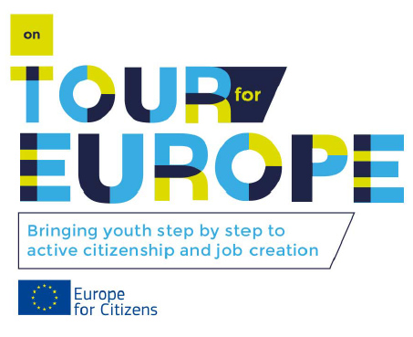
Figure 20: Logo On Tour for Europe. Created by Stoorzender.

    - Website
On the website www.hasselt.be/europa is important information shared within the framework of the OTE project. It presents an essence of the project, the objectives and aims. In addition, the website of Eurotowns presents information about the project too (www.eurotowns.com). Through the website of Eurotowns, the key results and learning lessons of the conferences can be shared to the whole network of Eurotowns.

Additionally, other project partners published articles on their websites. So published the municipality of Abegondo articles on the website abegondoeuropa.blogspot.be and www.dicoruna.es. The municipality of Detmold published articles on the website of the newspaper Lippe News (www.lippe-news.de).

    - Forum

After the creation and launch of the logo, the lead partner Hasselt designed in cooperation with Stoorzender a forum for the official communication of the project. The forum is created with zifboards, a free forum hosting. People (in)direct involved in the project can register themselves as a member, the lead partner Hasselt has to approve the registration. The forum is divided in several categories and topics. So has each conference an own category with several topics: general information, the programme, documents, presentations, etc.

    - Facebook

The lead partner Hasselt launched after the first conference in Kaunas the Facebook group ‘On Tour for Europe’. This is a public group where people who are (in)direct involved to the project and subjects of youth unemployment and entrepreneurship can become a member. For now, almost 50 persons are member of the group. Information about the OTE project and projects of the partners is shared in this group. Participants of the conferences can share their pictures made during the conferences in this group too. What is more, the lead partner informs members about possibilities for European funding possibilities for future projects within this group.

    - Printed flyers and press releases

      - Flyer for the Abegondo conference
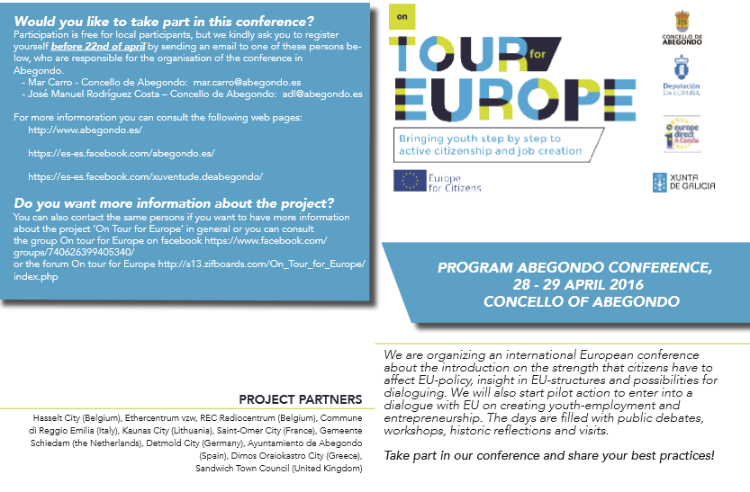
Figure 21: Leaflet Abegondo conference. Design: Stoorzender (Ethercentrum vzw). Text: Lotte Kerkhofs (city of Hasselt).
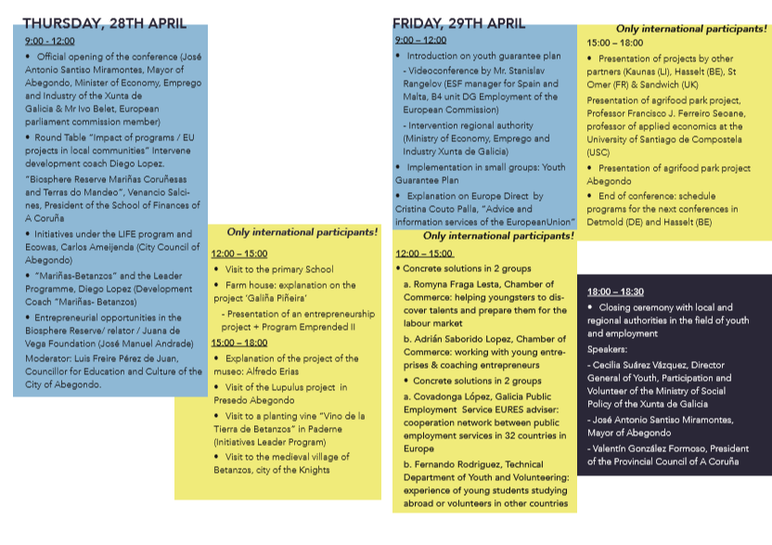
Figure 22: Leaflet Abegondo conference. Design: Stoorzender (Ethercentrum vzw). Text: Lotte Kerkhofs (city of Hasselt).

    - Publicity

The OTE-project was and will be announced by banners and flyers in the municipality of the conference city. The banners tend to awareness of the project by local inhabitants, so they know their city is participating in a European project. In addition, the participants from the Abegondo conference all received a file with the logo of the project to collect their documents.

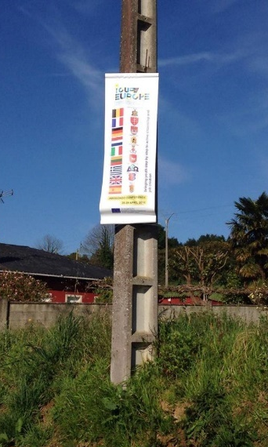
Figure 23: Banner of the OTE project in Abegondo.

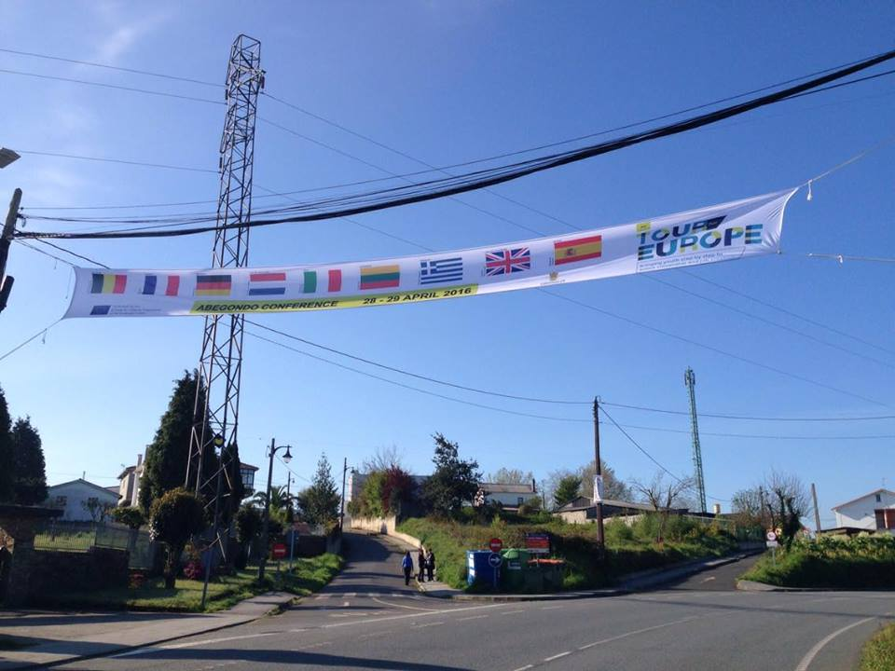
Figure 24: Banner of the OTE project in Abegondo.
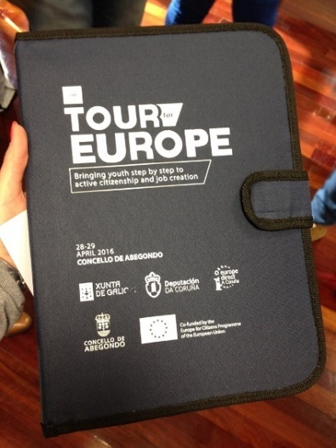
Figure 25: OTE file for participants.

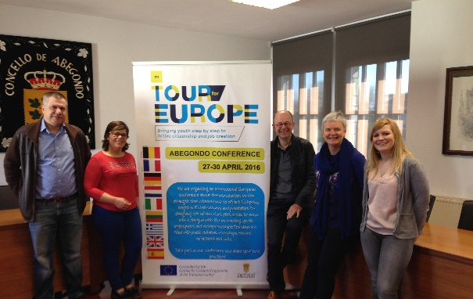
Figure 26: Banner of the OTE project.

- Cost-benefit
  - Evaluation

    - Background
Each conference, until now the conferences in Kaunas (September 2015) and Abegondo (April 2016), was and will be evaluated. This evaluation is done by a feedback and evaluation questionnaire which will be hand out to the participants at the end of the conference to fill in. The results of these evaluations can be used to improve the following two conferences, in Hasselt (September 2016) and Detmold (November 2016).

    - Results
Conferences | Average score ‘general’ | Average score ‘presentation’ | Average score ‘organisation’ | Average score ‘Readings, workshops & visits’
OTE Kaunas | Very satisfied | Very satisfied | Very satisfied | /
OTE Abegondo | Satisfied | Satisfied | Very satisfied | Very good
OTE Hasselt | The OTE Hasselt conference will take place from 6 until 9 September 2016.
OTE Detmold | The OTE Detmold conference will take place from 9 until 12 November 2016.
Table 3: Results of the feedback- and evaluation questionnaires.

    - Conclusion

Given the results of the feedback and evaluation questionnaires, many participants think the past two conferences were well organized with a comprehensive programme. All involved people were motivated and able to imagine the opportunities to find solutions regarding unemployed youth. The content of the conferences was useful and inspiring for new ideas. Many participants think the brainstorm and development at inter-European cooperation were successful. Almost every participant thinks the content of the conference is suitable to his or her daily work activities. Some participants think the link with the knowledge of the conference and the job is not always easy for all participants, as well as the implementation of that knowledge.

The results show that participants were satisfied or very satisfied about the presentations during the conferences. Some of them think the presentations and/or speakers were sometimes too long and not related to the content. The conferences need to pay attention to the balance between public talks of officials and speakers related to the content. There were also a few additional comments of the participants about the presentations: the participants prefer speakers and presentations in English so the content is clear. A stronger presence and participation of members of the target group, young people, might be better to get a direct and useful feedback. For the next conferences it is a good idea to work in small groups with local youth to share ideas.
In contrast to the Kaunas conference, there was more space to discuss and bring in own ideas during the Abegondo conference. But a part of the participants wants even more space to discuss. In addition, the comments of the participants show that they think the group discussions and round tables are the most beneficial aspect because they can compare notes and share knowledge and experiences. Some participants would like to have more time to apply the information practically and some think the programme of the conferences were too tight.

In general, participants think the readings, workshops and visits were all good. The group discussions and the round tables are workshops that are very good for the participants. We can interpret that the participants highly appreciate interactions.

There were also some points that the organization can improve for the next conferences: a better balance between the presentations of host-city and the input of participants, and more space to discuss and bring in new ideas.

  - Budget

    - Total cost of the organisation of the conference
The table below gives an overview of the expenses for the organisation of the conference. In addition, in the table are also made estimations of expenditures for the next two conferences. The local organisation pre-financed the conference costs and afterwards, the municipality of Hasselt compensate the costs.

Conference | Total amount  of organisational costs (in EUR) | Division of costs  per category (in EUR)
OTE KAUNAS | € 8 067,87 | Speakers/  presentations | € -
OTE KAUNAS | € 8 067,87 | Hotel | € 3 234,77
OTE KAUNAS | € 8 067,87 | Meals | € 2 514,14
OTE KAUNAS | € 8 067,87 | Translation costs | € 683,35
OTE KAUNAS | € 8 067,87 | Printing costs | € 125,51
OTE KAUNAS | € 8 067,87 | Transport | € 381,00
OTE KAUNAS | € 8 067,87 | Excursion | € 1 129,00
OTE KAUNAS | € 8 067,87 | Others | € 125,51
OTE Abegondo | € 16 960,00 | Speakers/  presentations
OTE Abegondo | € 16 960,00 | Hotel | € 5 040,00
OTE Abegondo | € 16 960,00 | Meals | € 6 100,00
OTE Abegondo | € 16 960,00 | Translation costs | € 3 600,00
OTE Abegondo | € 16 960,00 | Printing costs | € 500,00
OTE Abegondo | € 16 960,00 | Transport | € 1 600,00
OTE Abegondo | € 16 960,00 | Excursion | € -
OTE Abegondo | € 16 960,00 | Others | € 120,00
OTE Hasselt | € 12 778,25 | Speakers/  presentations | € 500,00
OTE Hasselt | € 12 778,25 | Hotel | € 2 378,25
OTE Hasselt | € 12 778,25 | Meals | € 6 300,00
OTE Hasselt | € 12 778,25 | Translation costs | € 1 700,00
OTE Hasselt | € 12 778,25 | Printing costs | € 500,00
OTE Hasselt | € 12 778,25 | Transport | € 1 000,00
OTE Hasselt | € 12 778,25 | Excursion | € 100,00
OTE Hasselt | € 12 778,25 | Others | € 300,00
OTE Detmold | € 23 698,00 | Speakers/  presentations | € 500,00
OTE Detmold | € 23 698,00 | Hotel | € 9 198,00
OTE Detmold | € 23 698,00 | Meals | € 8 100,00
OTE Detmold | € 23 698,00 | Translation costs | € 4 000,00
OTE Detmold | € 23 698,00 | Printing costs | € -
OTE Detmold | € 23 698,00 | Transport | € 1 000,00
OTE Detmold | € 23 698,00 | Excursion | € 100,00
OTE Detmold | € 23 698,00 | Others | € 800,00
Total | € 61 504,12
Table 4: Total costs of the organisation of the OTE conferences.
    - Travel costs

The transport costs to come to each conference are paid by the participating city self. The Travel costs will be reimbursed by the municipality of Hasselt at 50% of the expenditure with a maximum of 450 euro/project partner and per conference. There is an exception made in some cases.

Conference | Participating  cities | Reimbursement  (in EUR) | Coordinating Partner  (in EUR) | Own expenses  (in EUR)
OTE Kaunas | Abegondo | € 450,00 |  | € 496,00
OTE Kaunas | Detmold | € 800,00 |  | € 2 119,22
OTE Kaunas | Oraiokastro | € 378,05 |  | € 378,05
OTE Kaunas | Saint-Omer | € 424,13 |  | € 424,13
OTE Kaunas | Sandwich | € 269,17 |  | € 242,16
OTE Kaunas | Schiedam | € 402,39 |  | € 402,39
OTE Kaunas | Hasselt | € 0,00 | € 2 043,60 | € 0,00
OTE Kaunas | Total | € 2 723,73 | € 2 043,60 | € 4 061,94
OTE Abegondo | Detmold | € 450,00 |  | Unknown
OTE Abegondo | Kaunas | € 450,00 |  | € 1 170,00
OTE Abegondo | Oraiokastro | € 794,83 |  | € 0,00
OTE Abegondo | Stoorzender | € 450,00 |  | € 606,00
OTE Abegondo | Saint-Omer | € 450,00 |  | Unknown
OTE Abegondo | Sandwich | € 450,00 |  | Unknown
OTE Abegondo | Schiedam | € 450,00 |  | € 1 147,75
OTE Abegondo | Reggio Emilia | € 143,59 |  | € 143,59
OTE Abegondo | Hasselt | € 0,00 | € 2 983,00 | € 0,00
OTE Abegondo | Total | € 3 638,42 | € 2 983,00 | € 3 067,34
OTE Hasselt | Abegondo | € 450,00
OTE Hasselt | Detmold | € 450,00
OTE Hasselt | Kaunas | € 450,00
OTE Hasselt | Oraiokastro | € 450,00
OTE Hasselt | Saint-Omer | € 450,00
OTE Hasselt | Sandwich | € 450,00
OTE Hasselt | Stoorzender | € 450,00
OTE Hasselt | Schiedam | € 450,00
OTE Hasselt | Reggio Emilia | € 450,00
OTE Hasselt | Hasselt | € 0,00 | € 0,00 | € 0,00
OTE Hasselt | Total | € 4 050,00 | € 0,00 | € 0,00
OTE Detmold | Abegondo | € 450,00
OTE Detmold | Kaunas | € 450,00
OTE Detmold | Oraiokastro | € 450,00
OTE Detmold | Saint-Omer | € 450,00
OTE Detmold | Sandwich | € 450,00
OTE Detmold | Schiedam | € 450,00
OTE Detmold | Stoorzender | € 450,00
OTE Detmold | Reggio Emilia | € 450,00
OTE Detmold | Hasselt | € 0,00 | € 500,00 | € 0,00
OTE Detmold | Total | € 3 600,00 | € 500,00 | € 0,00
Total |  | € 14 012,15 | € 5 526,60 | € 7 129,28

    - Secretariat cost

Secretariat costs are costs made by the lead partner during the preparatory visits. The costs of these visits are charged within the OTE project.

 | Total amount of  secretariat costs  (in EUR) | Division of costs per catergory  (in EUR)
OTE Kaunas  15 - 18/07/2015 | € 760,15 | Hotel | € 219,35
OTE Kaunas  15 - 18/07/2015 | € 760,15 | Meals | € 59,84
OTE Kaunas  15 - 18/07/2015 | € 760,15 | Translation costs | € 0,00
OTE Kaunas  15 - 18/07/2015 | € 760,15 | Transport | € 464,96
OTE Kaunas  15 - 18/07/2015 | € 760,15 | Others | € 16,00
OTE Abegondo  8-11/09/2015 | € 1 139,45 | Hotel | € 182,00
OTE Abegondo  8-11/09/2015 | € 1 139,45 | Meals | € 219,70
OTE Abegondo  8-11/09/2015 | € 1 139,45 | Translation costs | € 0,00
OTE Abegondo  8-11/09/2015 | € 1 139,45 | Transport | € 539,00
OTE Abegondo  8-11/09/2015 | € 1 139,45 | Rented Car | € 181,00
OTE Abegondo  8-11/09/2015 | € 1 139,45 | Others | € 17,75
OTE Abegondo  1-4/02/2016 | € 1 336,00 | Hotel | € 661,00
OTE Abegondo  1-4/02/2016 | € 1 336,00 | Meals | € 54,00
OTE Abegondo  1-4/02/2016 | € 1 336,00 | Transport | € 621,00
OTE Abegondo  1-4/02/2016 | € 1 336,00 | Others | € 26,46
OTE Hasselt |  | Hotel | € 0,00
OTE Hasselt |  | Meals | € 0,00
OTE Hasselt |  | Transport | € 0,00
OTE Hasselt |  | Others | € 0,00
OTE Detmold  7-9/06/2016 | € 772,00 | Hotel | € 192,00
OTE Detmold  7-9/06/2016 | € 772,00 | Meals | € 330,00
OTE Detmold  7-9/06/2016 | € 772,00 | Transport | € 250,00
OTE Detmold  7-9/06/2016 | € 772,00 | Others | € 0,00
Others: Sandwich | € 193,00 | Transport | € 193
Total | € 4 200,60 |  | € 4 227,06
Table 5: Secretariat costs for the OTE conferences.
    - Summary overview of expenses per conference

 | OTE Kaunas | OTE Abegondo | OTE Hasselt* | OTE Detmold*
Allowance | € 22 500,00 | € 25 000,00 | € 25 000,00 | € 25 000,00
Costs: | € 13 595,32 | € 26 056,87 | € 16 828,25 | € 28 570,00
Local costs | € 8 067,87 | € 16 960,00 | € 12 778,25 | € 23 698,00
Secretariat costs | € 760,12 | € 2 475,45 | € 0,00 | € 772,00
Reimbursement | € 4 767,33 | € 6 621,42 | € 4 050,00 | € 4 100,00
Total | € 8 904,68 | -€ 1 056,87 | € 8 171,75 | -€ 3 570,00
Table 6: Summary overview of expenses per conference.
*Estimation.

- Youth unemployment
  - Initiatives
In the EU, more than 4.5 million people aged between 15 and 24 are unemployed nowadays, 11% of those people aged 18-24 are early school leavers. Many young people aged 15 to 24 years are unemployed, but many of them are studying full-time. This does not necessarily mean that this group of 4.5 million unemployed young people is really large. What is more worrying is that 11% of these young people are leaving school without any diploma or certificate. These young people belong to the group of the low-skilled. They may have difficulties in the future with finding a job. The best insurance against unemployment is giving youngster educational qualifications. In addition, more than 7 million people of the young aged group are not in employment, education or training (NEETs).

Youth unemployment has always been high in the last decade, although this has been declining slightly since 2013 due to initiatives from Europe according to employment. Nevertheless, the unemployment rate is still very high in the European countries. There are large differences between the European countries: there is a gap of more than 40 percentages between the Member State with the lowest rate of youth unemployment, Germany (7%) and the Member States with the highest rates, Greece (50%) and Spain (49%). There are definitely differences in the level of youth unemployment, although in general, the youth unemployment rate in Europe is twice as high as the unemployment rate (21,4% compared with 10,2% in 2014).

The European Union is aware that youth unemployment is a major problem in European countries. Therefore, the EU established projects and measures to reduce youth unemployment and to help young people to get a job. In this chapter, I discuss some of these initiatives taken by the EU.

    - Youth Guarantee Plan

The Youth Guarantee is initiative that started in 2013 to deal with youth unemployment and to guarantee all people younger than 25 a concrete employment offer. This employment offer may be: a job, an internship, an apprenticeship, a traineeship or continued education. This offer should be adapted to each individual need and situation and the offer should be given four months after leaving formal education or becoming unemployed.

The aim of this project is that every EU-country set up its own national Youth Guarantee Implementation Plan and start the implementation. There is a strong cooperation needed to develop and deliver a Youth Guarantee Plan: public authorities, employment services, education and training institutions, career guidance providers, youth support services, etc. have to work together. The European Commission helped each country to develop its plan and supported awareness raising activities. Furthermore, the Commission provides an exchange of best practices between governments.

      - Funding

The total cost of the establishment of the Youth Guarantee Plan in all European countries is estimated on 21 billion Euro a year. It is hard to record the exact amount of the implementation for each EU-country. This measure has high costs, however doing nothing for youth unemployment would still cost more. Young people who are not in employment, education or training are estimated to cost the EU 153 billion Euro a year (benefits, foregone earnings and taxes). This does not necessarily mean that every Youth Guarantee measure is expensive. An example of a measure what is very effective but costs not that much money, is to create a better cooperation between the stakeholders.

Each EU-country need to reserve national budget for the establishing of the Youth Guarantee Plan. This national budget is very important to avoid costs on youth employment in the future. The EU will complete this national budget through the European Social Fund and the Youth Employment Initiative at the value of six billion Euro.

      - Results

Between August and December 2013, eighteen small scale pilot projects were launched for the Youth Guarantee Plan in several EU-countries. All these small scale pilot projects were supported by the European Commission. These projects were all running for around 12 months in seven countries, namely: Ireland, Italy, Lithuania, Poland, Romania, Spain and the United Kingdom.

Next to these small scale pilot projects, other European countries have taken initiatives too. For example, the Belgian public employment service Actiris set up a dedicated Youth Guarantee service. This service provides specific support in finding jobs and internship for young people (people younger than 25 years old) who are officially registered as jobseeker. Actiris aims at targeting 400 to 800 NEETs in Brussels through identification work undertaken by street social workers (European Commission 2015). Furthermore, 27 youth guarantee centres were created in Romania and most of them were supported by the European Social Fund. The aim of these centres is to identify young NEETs and offer them services that are tailored to their personal needs.

Italy set-up integrated e-Portals where people can register themselves directly and can be connected to a national register. This e-Portal provides an automatic verification of the requirements that the unemployed people must have and job offers can be transferred via this e-Portal.
To promote the activation of young unemployed, some EU-countries prolong start-up subsidies or subsidies to stimulate the hiring of young people. Employers who are hiring young people who receive unemployment benefits or social assistance for a period up to two years, received a tax rebate in the Netherlands. In addition, Poland introduced exemptions from social insurance contributions for under-30-year olds.

Many EU-countries took measures to make their vocational and education training systems (VET) better. Several countries introduced legislative revisions of their VET systems. France, for instance, introduced a new law for people who have fewer qualifications. The law is based on lifelong learning and VET increase support for apprenticeships. Furthermore, Denmark has also made efforts in the field of VET. Denmark made a reform of vocational education and training to ensure that more people complete a VET programme and to ensure education guarantee for young people.

    - Youth on the Move

Youth on the Move was launched in 2010 and is a comprehensive package of policy initiatives on education and employment for young people in Europe. Youth on the Move is an initiative of Europe 2020. Europe 2020, also launched in 2010, is the strategy from the EU to create conditions for smart, sustainable and inclusive growth.

The aim of Youth on the Move is to improve the education and employability of young people. The second aim is to ensure that more young people will have a job so the youth unemployment declines. Therefore, Youth on the Move is working on three territories: education and training; youth mobility; employment and entrepreneurship. The objectives are: more relevant education and training for young people, stimulating young people to go abroad for studying or training by benefitting of EU grants and help EU countries to take measures to facilitate the way from education to the labour market for youngster.

Youth on the move is working with 2 methods to achieve its goals. The first one is a coordinating policy to identify and stimulate action at EU and national level. The second method is a design of specific actions for young people for labour market mobility within the EU and increased support for young entrepreneurs via the European progress microfinance facility.

      - Funding

The total cost of the Youth on the Move initiative is unknown for public. Only the fundings of the result initiatives are published:

The Youth Opportunities Initiative is funded by the European Social Fund (ESF):
- €1.3 million in ESF technical assistance to set up apprenticeship schemes.
EU countries were asked to contribute to a 10% funding increase.
- €3 million in ESF technical assistance for young business starters and social entrepreneurs.

Your first EURES Job is financed under the EURES axis of the EaSI programme. Activities are funded through annual calls for proposals.

      - Results

Two initiatives resulting from Youth on the Move were: Youth Opportunities Initiative and Your first EURES Job.

The Youth Opportunities Initiative includes a set of measures to drive down youth unemployment. This initiative was taken in 2012 and 2013 to support unemployed young people. The target group of this initiative are: graduates and people who left school without achieving upper-secondary education. Youth Opportunities Initiative is promoting youth employment through: greater use of the European Social Fund, making it easier for young graduates to find a job abroad, a policy guidance and assistance from the European Commission and stronger partnerships between political authorities, business and trade unions.

Your first EURES Job is a targeted mobility scheme to help young people to fill in job vacancies throughout the EU. This initiative is open to young people and employers of the 28 EU countries. In addition, people from Norway and Iceland can take part in this initiative too. The only condition is that candidates are nationals and legal residents in any of these countries. The target group of this initiative are jobseekers and employers younger than 35. The aim of the initiative is to help jobseekers to find a job, traineeship or apprenticeship abroad. The scheme aims to help employers is to find the skills they need for their hard to fill vacancies.

    - Youth Employment Initiative (YEI)

In 2013, the European Council agreed the Youth Employment Initiative (YEI) to tackle youth unemployment. The initiative runs from 2014 until 2020. This initiative focuses on people younger than 25 who are living in regions where the youth unemployment was higher than 25% in 2012. By defining the region and age, these youngsters can get the most effective support that is needed. The target group of YEI are NEETs, but also long-term unemployed youngster and job-seekers who are not registered. The Youth Employment Initiative wants to help young people to the labour market by offering different services: internships, job placements, apprenticeships and further education.
Countries who are eligible for funding under the YEI are: Belgium, Bulgaria, Croatia, Cyprus, Czech Republic, France, Greece, Hungary, Italy, Ireland, Latvia, Lithuania, Poland, Portugal, Romania, Slovenia, Slovakia, Spain, Sweden and United Kingdom.
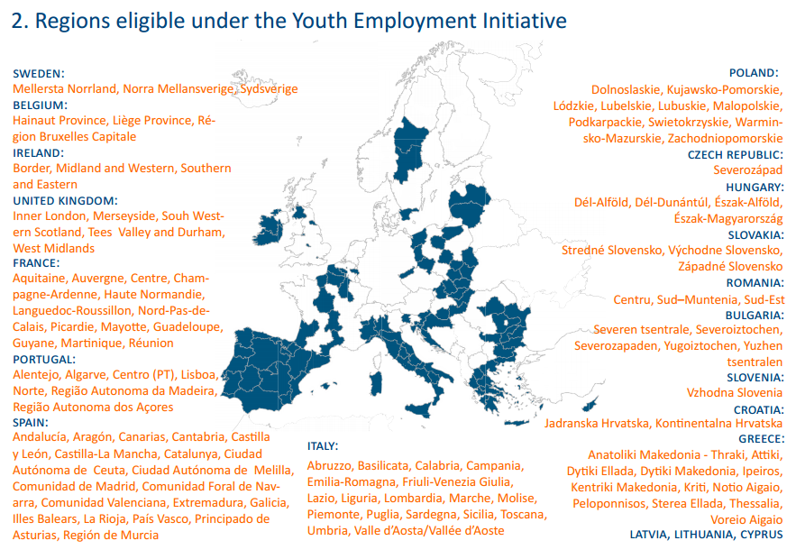
Figure 27: Regions eligible under the YEI. Retrieved from https://epthinktank.eu/2014/04/03/youth-employment-initiative
      - Funding

The total budget of the YEI is 6,4 billion euro: 3,2 billion euro comes from the ESF and 3,2 billion euro comes from a dedicated Youth Employment budget line. The Youth Employment Initiative is one of the main EU financial resources to support the implementation of Youth Guarantee schemes. The substantial funding was released to the participating countries in the form of pre-financiering so the initiative could start earlier. In 2015, the budget was exceptionally increased to 30% of the budget line.

      - Results

Despite the fact the YEI is running until 2020, it is too early to make an assessment of the initiative. Each Member State will evaluate the effectiveness, efficiency and impact of the initiative two times. The first evaluation had to be completed by the end of 2015, the second evaluation is planned to be completed on the end of 2018. The first evaluation will inform the overall process review of YEI and will feed into the mid-term budgetary review of the MFF (Multiannual Financial Framework).

Furthermore, the European Commission will publish a report on the implementation of the Youth Guarantee and the operation of the YEI in 2015.
Conclusion
The On Tour for Europe project started in June 2015 and consists of four conferences. The first two conferences are finished now. The end of the OTE project is scheduled in March 2017, but before this time, there are still two conferences in September (Hasselt, Belgium) and in November (Detmold, Germany).

Although the OTE project is currently still in progress, it can be concluded that the project is already successful. Several participating cities have submitted a European project with the intention to create jobs for youngster and to reduce youth unemployment. Other cities have gained ideas for new initiatives and projects through sharing experiences during the conferences.

Cities who have already taken initiative to establish a local project are:
- Kaunas: Focus on Youth (FOY). A Europe for Citizens project that focuses on youth work professionals. The aim is to motivate, inform and inspire them by increasing the knowledge about youth work methods and by sharing good practices. The project wants to give the young professionals a wider knowledge of EU financial resources.
- Saint-Omer: School of Excellence. A project where companies express their desires of employees to the schools. The school makes sure that students have these skills so they are ready for the job market.
- Sandwich Community: Community Intrest Company (C.I.C.). The project is set up to support and encourage local employment for vulnerable groups. The project partners are social enterprises who are involved with social economic integration of disadvantaged and excluded persons. The aim of the project is to search persons of the target group who can support project needs from local agencies.
- Oraiokastro and Deal Community: The Genesis project. A project to rebirth an old amphitheatre so it can be used for training opportunities and social activities. Genesis is a social enterprise with the aim to encourage and develop other social enterprises and to increase employment opportunities.
Not only participating cities are taking initiatives regarding youth unemployment. The European Union focuses on initiatives to reduce youth unemployment too. Some initiatives are: the Youth Guarantee Plan, Youth on the Move and the Youth Employment Initiative. All these initiatives have a different target group among young people, this may include age, region, education level or background.

After two conferences, the project partners have inspired each other by sharing their experiences and best practices. Given the results of the feedback- and evaluation questionnaires, participants highly appreciate group discussions and interactions.

With all these preliminary but very positive results, the project has even more good prospects for the end of the project in March. To the following conferences, the project would create even more initiatives and projects to decline the local youth unemployment.

List of references
Detmold (image). (n.d). Consulted on 17 October 2016 via http://www.detmold.de/startseite/zu-gast-in-detmold/tourismus/sehenswuerdigkeiten/historischer-altstadtkern/
EACEA. What is it about? (n.d.). Consultend on 13 November 2015 via https://eacea.ec.europa.eu/europe-for-citizens_en
Europe 2020 in a nutshell. (n.d.). Consulted on 24 May 2016 via
http://ec.europa.eu/europe2020/europe-2020-in-a-nutshell/index_en.htm
Europa. EU Youth Guarantee: Questions and Answers. (04 February 2015). Consultend on 5 February 2016 via http://europa.eu/rapid/press-release_MEMO-15-4102_en.htm
Europe. (n.d.). Unemployment statistics. Consulted on 23 October 2015 via http://ec.europa.eu/eurostat/statistics-explained/index.php/Unemployment_statistics
Europe. (n.d.) Unemployment statistics. Consulted on 14 November 2015 via http://ec.europa.eu/eurostat/statistics-explained/index.php/Unemployment_statistics
Europe. (n.d.). Your first EURES Job (YfEJ). Consulted on 24 May 2016 via http://ec.europa.eu/social/main.jsp?catId=1160
Europe. (n.d.). Youth Guarantee. Consulted on 5 February 2016 http://ec.europa.eu/social/main.jsp?catId=1079&langId=en
Europe. (n.d.). Youth Guarantee, Cost-benefits of a Youth Guarantee. Consulted on 5 February 2016 via via http://ec.europa.eu/social/main.jsp?catId=1079&langId=en
Europe. (n.d.). Youth on the Move. Consulted on 24 May 2016 via http://ec.europa.eu/social/main.jsp?catId=950&langId=en
Europe. (n.d.). Youth Employment Initiative (YEI). Consulted on 28 May 2016 via http://ec.europa.eu/social/main.jsp?catId=1176
Europe. (n.d.). Youth Opportunities Initiative. Consulted on 25 May 2016 via
http://ec.europa.eu/social/main.jsp?catId=1006&langId=en
European Commission. (n.d.). EU Programme for Employment and Social Innovation (EaSI). Conulted on 24 May 2016 via http://ec.europa.eu/social/main.jsp?catId=1081&langId=en
European Commission. (September 2015). Guidance on evaluation of the Youth Employment Initiative. Consulted on 25 May 2016 via file:///C:/Users/Gebruiker/Downloads/YEI%20Evaluation%20Guidance%20September%202015%20(2).pdf.
European Commission. PES Practices for the outreach and activation of NEETs. Brussels: European Commission, 2015.
Eurostat. (N.d.) Youth unemployment, 2014Q4 (%). Consulted on 23 October 2015 via http://ec.europa.eu/eurostat/statistics-explained/index.php/File:Table_1_Youth_unemployment,_2014Q4_(%25).png
Eurotowns. (n.d.) Detmold. Consulted on 6 January 2016 via http://eurotowns.org/detmold/#.V1SQeZGLS00
Eurotowns. (18 August 2013). Hasselt. Consulted on 28 December 2015 via http://eurotowns.org/hasselt/#.V1SQ95GLS00
Eurotowns. (2 October 2012). Reggio Emilia. Constuled on 18 December 2015 via http://eurotowns.org/sic-amet
Eurotowns. (17 August 2013). Schiedam. Consulted on 19 December 2015 via http://eurotowns.org/schiedam/#.VwgKcKSLTIU.
Ferrer, Jorge Núñez, Niccolo Durazzi, Leonard Geyer, and Gilles Thirion. (2016). Assessment of Youth Employment Initiative. Brussels: Policy Department on Budgetary Affairs. Consulted on 25 May 2016 via http://www.europarl.europa.eu/RegData/etudes/IDAN/2016/572680/IPOL_IDA(2016)572680_EN.pdf
Genocid. (4 November 2013). The Genocide and Resistance Research Centre of Lithuania. Consulted on 12 November 2015 via http://genocid.lt/centras/en/
Hasselt (image). Consulted on 30 May 2016 via http://toerisme.hasselt.be/nl/press/1044463/maandagwandeling-smaakroute.html
Illers, Astrid. (10 December 2015.) “Detmold in Europa.” Europe Zentrum. Consulted on 1 May 2016 via http://www.europa-zentrum-nrw.de/pdf/Detmold%20in%20Europa.pdf
ispakaunas2014. (n.d.). About Kaunas. Consulted on 12 October 2016 via http://ispakaunas2014.vdu.lt/index.php/ispa2014/index/pages/view/kaunas
Map of Europe (image). (n.d.) Consulted on 10 October 2016 via http://thepoliticalcarnival.net/2013/03/31/european-austerity-costing-lives-shredded-social-net
Municipality of Hasselt. (2015). Report CEP. Consulted on 14 November via U-Database Municipality Hasselt , 2015.
Oraiokastro (image). (n.d.). Consulted on 23 December 2015 via http://www.oraiokastro.gr/index.php/2014-04-09-10-27-17/2014-04-09-10-26-26
Piazza San Prospero (image). (n.d.). Consulted on 14 January 2016 via http://www.italyzone.it/viaggi/emilia-romagna/reggio-emilia/
Pollefliet, L. (2014). Schrijven: van verslag tot eindwerk: do’s en don’ts. Gent: Academia Press. Consulted during the whole academic year.
Regions eligible under the YEI (image). (n.d.). Consulted on 24 May 2016 via https://epthinktank.eu/2014/04/03/youth-employment-initiative
Radiocentrum. (2014). Over (REC). Consulted on 24 March 2016 via http://www.radiocentrum.be/#!over-rec/c15nr
REC. (n.d.) REC.about. Consulted on 24 March 2016 via http://www.rec.be/NL/About
Sandwich. (2007). SANDWICH IN KENT UK. (2007). Consulted on 22 May 2016 via http://www.visitsandwich.co.uk/.
Sandwich (image). (n.d.). Consulted on 22 May 2016 via http://www.visitsandwich.co.uk/.
Schiedam. (n.d.) Stadhuis (image). Consulted on 18 April 2016 via http://www.sdam.nl/zien-doen/historie
Van Dale. (n.d.). Consulted regularly from September 2015 until June 2016 via http://www.vandale.be.
Verachtert, Marc, interview by Lotte Kerkhofs. On Tour for Europe project (3 July 2015).
Verachtert, M. (2015). (Manager General Affairs of the Municipality of Hasselt). Back ground information OTE. Consulted on a regularly basis from September 2015 until May 2016 via U-database Municipality Hasselt.
Worldcityinfo. (n.d.). Abegondo. Consulted on 18 December 2015 via http://spain.worldcityinfo.com/galicia/a-coruna/abegondo

Attachments
Table of content
Attachment 1 plan of action
Attachment 2 scenario
Attachment 3 consistent planning
Attachment 4 Overview of the unemployment and youth unemployment statistics.
Attachment 5 Detailed program of the Kaunas conference
Attachment 6 Summarize of the study visits in Kaunas
Attachment 7 Detailed program of the Abegondo conference
Attachment 8 Draft program of the Hasselt conference
Attachment 9 Draft program of the Detmold conference

- Plan of action
- Research questions
Research question 1: Achieving information
- Achieving information from the conference in Kaunas (Lithuania), September 2015.
- Achieving information from the conference in Abegondo (Spain), April 2015.
- Preparing and organizing the conference in Hasselt (Belgium), September 2016.

Research question 2: How can we deal with youth unemployment?
- What kind of measures have been taken to deal with youth unemployment?
- How can we ensure job-creation for youngster?
- Which trends were there in unemployment over the past 10 years?

- Research method
- Achieving information from the conference in Kaunas (Lithuania), September 2015.
Research method 1: desk-research
Argumentation: there is an official report from the European Union about information of the project. In this report is the subject of each conference written with additional information.
Research method 2: observation, structured and participative
Argumentation: in my bachelor thesis will a report from the conference in Kaunas be written. This report includes presentations, activities, discussions and conclusions from the conference in Kaunas. This report is based on the observation of the conference and the participation in the conference.

- Achieving information from the conference in Abegondo (Spain), April 2015.
Research method 1: desk-research
Argumentation: there is an official report from the European Union about information of the project. In this report is the subject of each conference written with additional information.
Research method 2: observation, structured and participative
Argumentation: in my bachelor thesis will a report from the conference in Abegondo be written. This report includes presentations, activities, discussions and conclusions from the conference in Abegondo. This report is based on the observation of the conference and the participation in the conference.

- Preparing and organizing the conference in Hasselt, September 2016.
Research method: database-analysis
Argumentation: based on the information about the organization of previous conferences, from the database of the city of Hasselt, I will include the realization, preparation and organization of the conference in Hasselt in my bachelor thesis.

- What kind of measures have been taken to deal with youth unemployment?
Research method: desk-research
Argumentation: there are a number of scientific articles and books about (youth) unemployment. By the means of articles and mines of information from the European Union, I will examine the measures that are already taken to deal with youth unemployment.

- How can we ensure job-creation for youngster?
Research method: experiment, observing
Argumentation: the result of this On Tour for Europe project, will be measures and projects to create jobs for young people. During and after the conferences will be discussed which measures and projects will be realized. This question will be the conclusion of the four conferences.
- Which trends were there in unemployment over the past 10 years?
Research method: desk-research
Argumentation: there are a number of scientific articles and books about (youth) unemployment. By the means of articles and mines of information from the European Union, I will examine which trends there were in unemployment over the past 10 years.

- Scenario

- Preparation

Activity 1: project proposal
- Executer: Lotte Kerkhofs
- Description: this On Tour for Europe Project, bringing youth step by step to active citizenship and job-creation, is set up to develop best practices to create active partners in the EU-employment policy and to develop best practices to create more and sustainable jobs in the regions.
- Planning: mid-September 2015 till mid-October 2015
- Means: - laptop
- access to the Internet
- access to the U-database from the city of Hasselt
- What can go wrong? Rejected access to the European documents related to the project.

Activity 2: plan of action
- Executer: Lotte Kerkhofs
- Description: research questions, sub-questions, research methods and a consistent planning with the duration and number of researchers or people on the project.
- Planning: mid-October 2015 till the second week of November (12/11/2015)
- Means: laptop
- What can go wrong? The laptop can break down, so finishing the plan of action is impossible.

Activity 3: screenplay
- Executer: Lotte Kerkhofs
- Description: preparation for the execution of the report. The screenplay contains who will do what and when and also which resources are required. The screenplay contains also a list for each scheduled activity with what is needed to carry out the activity: information, means and people.
- Planning: mid-October 2015 till the second week of November (12/11/2015)
- Means: laptop
- What can go wrong? The laptop can break down, so finishing the screenplay is impossible.

- Collection of data
Sub-question 1: achieving information from the conference in Kaunas (Lithuania), September 2015.
Activity 1: observing the presentations, study visits and discussions during the conference in Kaunas.
- Executer: Lotte Kerkhofs
- Description: taking notes during the presentations, study visits and discussions from the conference, in order to write a report for the bachelor thesis.
- Planning: 23 September till 26 September 2015
- Means: - laptop
- paper and stationery
- camera to make pictures
- What can go wrong? The information from the notes may be incorrectly interpreted.

Activity 2: writing a report from the conference in Kaunas.
- Executer: Lotte Kerkhofs
- Description: writing a report from the presentations, study visits and discussions during the conference in Kaunas, as part of the bachelor thesis.
- Planning: October 2015
- Means: - laptop
- notes
- additional information from the U-database from the City of Hasselt
- What can go wrong? There can be a lack of information to write a well substantiated report.

Sub-question 2: achieving information from the conference in Abegondo (Spain), April 2015.

Activity 1: observing the presentations, study visits and discussions during the conference in Abegondo.
- Executer: not known yet. It is not clear yet which persons will participate in the conference in Abegondo, it is not sure that I personally will attend the conference.
- Description: taking notes during the presentations, study visits and discussions from the conference, in order to write a report for the bachelor thesis.
- Planning: 27 till 29 April 2016
- Means: - laptop
- paper and stationery
- camera to make pictures
- What can go wrong? The information from the notes may be incorrectly interpreted.

Activity 2: writing a report of the conference in Abegondo.
- Executer: Lotte Kerkhofs
- Description: writing a report from the presentations, study visits and discussions during the conference in Abegondo, as part of the bachelor thesis.
- Planning: the beginning of May 2016
- Means: - laptop
- notes
- additional information from the U-database from the City of Hasselt
- What can go wrong? There can be a lack of information to write a well substantiated report.

Sub-question 3: What kind of measures have been taken to deal with youth unemployment?

Activity 1: examine the measures at European level on youth unemployment
- Executer: Lotte Kerkhofs
- Description: examining what measures have already been taken at European level on youth unemployment. Also considering the impact of the measures and the influence of the measures on the future.
- Planning: January 2016
- Means: - laptop
- additional information from the U-database from the City of Hasselt
(previous EU-projects on (youth-)unemployment)
- scientific articles and articles from the European Union
- What can go wrong? The information from the articles can be insufficient.

Sub-question 4: Which trends were there in unemployment over the past 10 years?
Activity 1: examining the trends in youth unemployment over the past 10 years
- Executer: Lotte Kerkhofs
- Description: searching for trends related to unemployment, see what similarities there are in several European countries.
- Planning: February 2016
- Means: - laptop
- scientific articles and articles from the European Union
- books about youth unemployment
- What can go wrong? The information from the articles and books can be insufficient.

- Data analysis
Sub-question 1: preparing and organizing the conference in Hasselt, September 2016.

Activity 1: preparing the conference in Hasselt
- Executer: Lotte Kerkhofs
- Description: based on the information about the organization of previous conferences, from the database of the city of Hasselt, I will include the realization, preparation and organization of the conference in Hasselt in my bachelor thesis. The preparation includes: making a screenplay of the conference, taking care of the administrative documents, booking the accommodation for all the participants, capturing speakers, preparing a day trip to the European parliament, etc.
- Planning: March till May 2016
- Means: - laptop
- telephone
- access to the U-database from the City of Hasselt
- budget from the European Union: 100.000 euro
- What can go wrong? The desired location can be fully booked, so we have to look for another location or we can't reach the minimum number of participants.
- Reporting: write out the report and the presentation
Activity 1: to write a temporary report
- Executer: Lotte Kerkhofs
- Description: this temporary report contains a description of the project, a description of the conference in Kaunas and some preparations for the conference in Hasselt. The conference in Abegondo can't be included in this report, because the conference in Abegondo will take place in April.
- Planning: November 2015 till March 2016
- Means: - laptop
- access to the Internet
- access to the U-database from the City of Hasselt
- What can go wrong? The laptop can break down or the access to the U-database of the city of Hasselt is no longer accessible.

Activity 2: verification of the report by the external client
- Executer: Mr. Marc Verachtert, Ms. Leen Scheelen
- Description: Marc and Leen will examine the report. They will advise what is missing in the bachelor thesis or what need to change.
- Planning: the beginning of March 2016
- Means: - laptop
- printer
- a printed version of the report
- What can go wrong? The ink in the printer may be used up or the printer can be damaged.

Activity 3: feedback by the supervisor on the temporary report
- Executer: Ms. Erna Geris
- Description: at the end of March, I will submit the temporary report to Ms. Geris in order to get feedback.
- Planning: 25 March 2016
- Means: - laptop
- printer
- a printed version of the report
- What can go wrong? The ink in the printer may be used up or the printer can be damaged.

Activity 4: making changes in the report
- Executer: Lotte Kerkhofs
- Description: at the beginning of April, I will get feedback from Ms. Geris on the temporary report. After her feedback, the temporary report will be adapted and further developed.
- Planning: mid-April 2016
- Means: - feedback from Ms. Geris
- laptop
- What can go wrong? The laptop can break down.
Activity 5: printing and binding
- Executer: Lotte Kerkhofs
- Description: printing and binding of the final report in two copies. I choose to print and bind the final report by a printing office.
- Planning: the end of April 2016
- Means: a USB stick with the final report for the printing office.
- What can go wrong? There may go something wrong by the printing office which makes the printing and binding takes longer than expected.

Activity 6: preparing the presentation
- Executer: Lotte Kerkhofs
- Description: making a presentation of the final report in order to present the report to a jury.
- Planning: end of April 2016
- Means: - laptop
- Microsoft Office PowerPoint
- What can go wrong? The laptop can break down. Microsoft Office PowerPoint can get stuck.

Activity 7: practicing the presentation
- Executer: Lotte Kerkhofs
- Description: practicing the presentation, I will practice the presentation out loud at home. If possible, I will recite the presentation to an audience (friends, family) as an exercise.
- Planning: the beginning of May 2016
- Means: - laptop
- Microsoft Office PowerPoint
- What can go wrong? The laptop can break down. Microsoft Office PowerPoint can get stuck.

Activity 7: readjust the presentation
- Executer: Lotte Kerkhofs
- Description: correcting faults noted during exercising of the presentation.
- Planning: the beginning of May 2016
- Means: - laptop
- Microsoft Office PowerPoint
- What can go wrong? The laptop can break down. Microsoft Office PowerPoint can get stuck.

Activity 8: presenting
- Executer: Lotte Kerkhofs
- Description: introducing the presentation of the bachelor thesis to a jury.
- Planning: the 20th of June
- Means: - laptop
- Microsoft Office PowerPoint
- USB stick with a copy of the presentation
- Projector
- What can go wrong? The laptop or projector can no longer work.

- Consistent planning

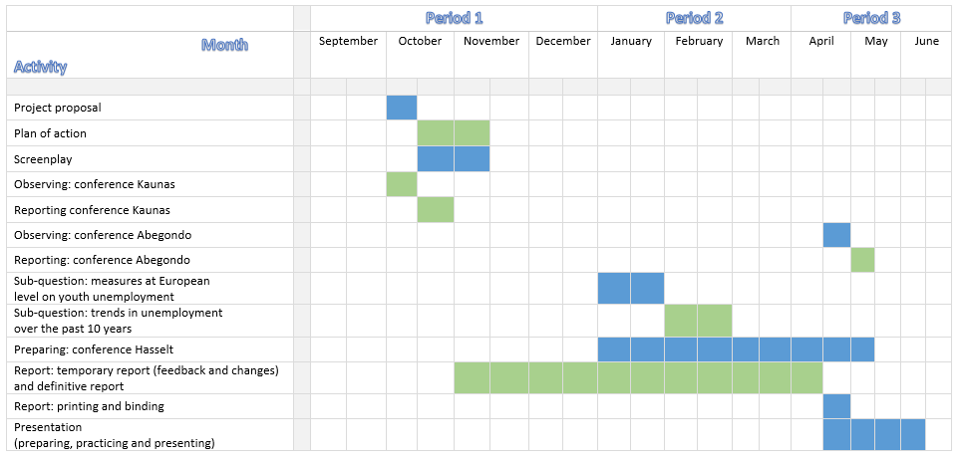
- Overview of the unemployment and youth unemployment statistics.
Detailed overview of the youth unemployment rate (people aged 15-24) in Europe from 2012 until 2014.
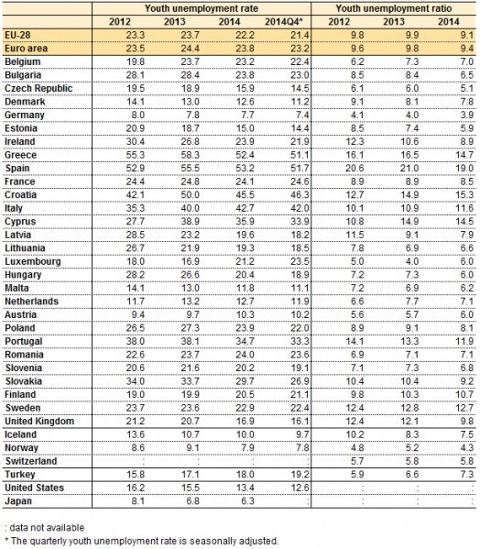
Table 7: youth unemployment rate (people aged 15-24) in Europe from 2012 until 2014.
Retrieved from http://ec.europa.eu/eurostat/statistics-explained/index.php/File:Table_1_Youth_unemployment,_2014Q4_(%25).png

Detailed overview of the unemployment rate in Europe from 2003 until 2014.

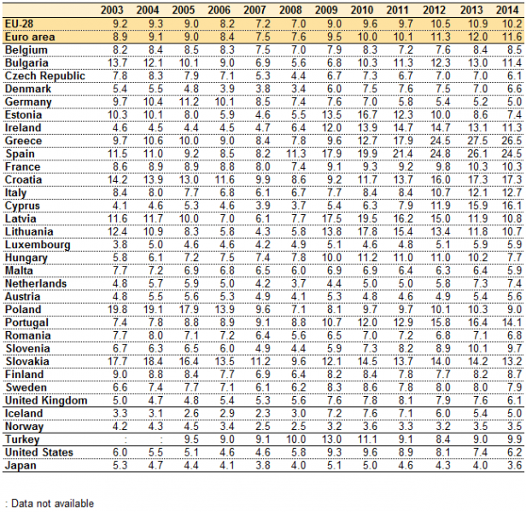
Table 8: unemployment rate in Europe from 2003 until 2014.
Retrieved from http://ec.europa.eu/eurostat/statistics-explained/index.php/File:Table_2_Unemployment_rate,_2003-2014_(%25).png

- Detailed program of the Kaunas conference, 23–26 September 2015
Wednesday, 23 September 2016
Arrival of international guests. Accommodation – hotel „Kaunas“ (Laisves Ave. 79)
19–22.00 Project kick-off meeting and buffet dinner at Communications History Museum.
19.00–19.30 Short tour through the history of communications and information technology
19.30–20.00 Ice-breaking tasks and welcome word by the inniciator of the project – the City of Hasselt (Belgium) on the principles and themes of the four international events of the project, project logo and communication plan.
20.00–20.30 Introducing the themes of the conference by Rima Kubiliūtė, Kaunas. Short introduction into the historical dimention on the challenges of free flow of information, freedom of speech, opinion and belief, restrictions of expression, language ban, censorship, propaganda, Prof. Liudas Mažylis, Vytautas Magnus University, Political Sciences, Dalia Poškienė, The Society of XXVII Book Lovers.

Thursday, 24 September 2015
9.00 Registration of participants.
9.30 Welcome word from Kaunas City Mayor Mr. Visvaldas Matijošaitis.
9.35 Welcome from the member of European Parliament from Belgium Mr. Ivo Belet.
9.40–9.50 Welcome and introductory word by the innitiator of the project. Leen Scheelen, Hasselt City, Belgium.
9.50–10.10 Work with NEETs in the Framework of European Youth Guarantee Innitiative in Lithuania. Valda Karnickaitė, Head of Youth Policy Development and Programme Implementation Division, The Departament of Youth Affairs under the Ministry of Social Security and Labour of the Republic of Lithuania.
10.10–10.30 Activities and Services of the Youth Employment Centre. Karolina Pakarnaitė, Head of Youth Employment Centre under Kaunas Territorial Labour Exchange, and Julien Beltoise, volunteer from France.
10.30–11.00 Coffee break. Opening of the exhibition of historical remembrance „Letters of Resistance, Hope and Faith” in the Small Hall.
11.00–11.20 Integration into the Labour Market with the Help of Librarians. Eglė Kulikauskienė, Culture Project Manager of Kaunas County Public Library, Leader of international project "LinkInJob: Job-hunting with Help of Librarians”.
11.20–11.40 Promoting Youth Entrepreneurship: "About Business ", "Be in Business", " Do for a Business". Rita Baidokaitė, Head of International Relations Department of Kaunas Chamber of Commerce, Industry and Crafts, Adrián Garcia, participant of Erasmus programme for Young Entrepreneurs.
11.40–12.00 Enterprise Lithuania: from Start-up to Export Expansion. Dovydas Varkulevičius, Director of Entrepreneurship Department of NGO Enterprise Lithuania.
12.00–12.30 Pannel discussion of the speakers and the audience.
12.30–14.00 Lunch Break
14.00–17.00 Study visits and group discussions:
1) NGO Actio Catholica Patria, is one of the first organizations that has been actively working with youth affairs in Lithuania since 1991 and offers social and cultural services for young people. Youth Empowerment Centre “Kitaip” (“Otherwise”) provides help for the individual who has left or is leaving a foster care house, prepares him/her for the independent life, finds an institution of education, job and staying in it. Empowerment centre works in two directions: there is a “Consultation Centre” and “The half-way home”. In “Consultation Centre” workers are teaching social, employability and maintaining job skills, professional orientation. They also organize professional apprenticeship training, camps and experiential hikes. “The half-way home” offers housing which can host 6 youngsters at a time and they are being prepared for the independent life. In order to assure successful socialization, each youngster has a personalized help plan which is oriented to the specific needs of each person.
2) Kaunas Maironis University Gymnasium is one of the first schools in Lithuania in which career education became a significant part of the education process. The development of the Career Education Model and Career Education Programme were launched in 2002. The Professional Counselling Coordination Centre, established in 2005, provides vocational information and consulting, career education system integration and development services to other Kaunas City general education schools. The Centre, together with the Ministry of Education and Science, integrates and develops the career education system in general education schools, develops methodological tools and recommendations. The Gymnasium organizes a lot of career education events: the traditional event for pupils of Kaunas City and Region “Study Week”, quizzes, competitions, conferences, projects. The Centre is managed by Aurelia Naseckaitė.
Kaunas Maironis Academic Gymnasium also organizes pupils’ training enterprises “PostCats”, “INlight”, “BurrningICE”. The students make festival postcards, “green” ice candles, promotional brochures, business cards. Taking part in business activities pupils can develop team work, leadership and enterprise skills, to gain practical business experience, to understand the goal and the importance of planning the way to achieve it. The companies compete in national competitions Junior Achievement Contest; sell their production in various fairs. The teacher of Economics Ingrida Danauskienė is responsible for the coordination of the business activities in the gymnasium.
3) Kaunas Pupils’ Technical Creation Centre is one of 10 children non-formal education institutions in the City. The Centre offers 25 clubs in technical, artistic and visual fields to about 500 pupils. The Centre is the only institution in the City which continues the interwar traditions of technical creativity clubs like: cosmic, aero-modelling, auto-modelling, radio-electronics. The pupils of visual arts activities create movies, documentaries, TV shows, and theatre performances, publish the magazine. The clubs of traditional craft technologies like clothing design, wicker weaving, leather crafts, and ceramics cherish ancient Lithuanian traditions. The Centre organises projects, contests, takes part in prevention programmes.
4) Kaunas Business Information Centre Business People House gives free information to people who start business as well as to the existing companies. Such events like seminars, discussions, conferences and meetings with representatives of political institutions take place in the House of Businessmen. A big part of the events is for free. The consultations are given on the following subjects: establishment of the company, accounting, taxes, business plan, IT and its usage, EU structural funds, financial support and etc. Visitors can use the acquired business information database, the accounting digest and business periodicals.
Kaunas Territorial Labour Exchange Youth Job Centre. The main goals of the Youth Job Centre are to inform our clients about the situation in labour market, about vacancies or vocational training institutions, to provide information and consultations about career planning and finally to improve soft skills of youth for an easier integration in the labour market. Our basic activities consist of information and consultations about employment and career planning for everybody who is looking for a job or for a staff and also for those who are choosing a profession.
Group activities. Getting to know various local innitiatives working with youth. Sharing experience from different countries and cities. (Homework Task 1) Foreign participants prepare to present the system of youth orientation to labour market and interesting local iniciatives exiting in their city/ country, reflection of opinions and comparisons with what they have heard in Kaunas. Creative task of the host. Discussion of the issues which cause most complicated problems or challenges, ideas for the future projects in this field. Every group makes a summary which they will present next morning.
19.00 – Dinner and Brain Fight TOUR AROUND EUROPE at the restaurant in the old town Bernelių užeiga.
Friday, 25 September 2015
9.00–9.40 Summaries and reflections from the work groups. Presentations of the most interesting ideas or inniciatives having greatest impact. Suggestions in which direction it is necessary to develop the system of youth work and improve the skills of the youth workers, ideas for future projects
9.40–10.00 The Power of Youth Participation: Benefits for Youth and their Environment. Soesja Boode, Director of De Kleine Ambassade (Schiedam, the Netherlands).
10.00–10.20 Is a Volunteer Different Carrier Seeker? Monika Simaškaitė, President of the Union of Kaunas Youth Organizations Round Table
10.20–10.40 Coffee break. The exhibition of historical remembrance „Letters of Resistance, Hope and Faith“ in the Small Hall.
10.50–11.00 European Union Information to Encourage Youth Citizenship and Awareness. Diana Lukoševičiūtė-Burneikienė, Head of Kaunas Europe Direct Information Centre
11.00–11.20 Erasmus +: Youth in Action – Possibility for a Young European Citizen. Lilija Gerasimienė, Director of Agency of International Youth Cooperation
11.20–11.40 Discussion with the speakers and audience sharing information which funding programmes cities have successfully used. (Homework Task 2) Resuming the ideas of the conference.
11.40–12.30 Lunch break
12.30–14.30 Study visit to the secret underground printing house “ab” of Vytautas Magnus War History Museum (Saliai village, Kaunas region) which functioned in 1980–1991. Discussion on the freedom of speech, opinion and beliefs, the importance of free flow of information, personal responsibility and engagement in civic matters, the virtue of the variety of European languages. The founders and keepers of the printing house are Birutė Andziulienė and Vytautas Andziulis.
15.00–17.00 Opening of the exhibition of embroidered visit cards VIZITĖLĖS – STITCHED GREETINGS TO EUROPE. Presentation of national poets, readings in national languages. (Homework Task 3 A, B) Venue:Vytautas Magnus University (Donelaičio Str. 52, Kaunas). Dinner at Hotel “Kaunas” restaurant (Laisvės ave. 79).
Saturday, 26 September 2015
8.00 Leaving for Vilnius
10.00–11.30 Visiting Genocide Victims Museum in KGB cellar continueing the discussion on the importance of the freedom of speech.

- Summarize of the study visits in Kaunas
NGO Actio Catholica Patria
NGO Actio Catholica Patria is one of the first organizations that has been actively engaging in youth affairs in Lithuania since the liberation of the Soviet Occupation in 1991. The organization has lots of different activities:
- Youth Centre where young people can connect with each other and spend their time in a meaningful way. Import focus on NEET’s, but the young people who come there have a varied background:
- who stay in social risk families
- youngster who don’t have a lot of friends
- are engaging in criminality
- Volunteering Service which acts as a step stone to a job or to acquire skills. Volunteering is for many youngsters in Kaunas a meaningful way to contribute to society. The NGO has accredited partners where young people can go to do some volunteering work.
- Consultation centre: social workers help youngsters to apply for a job. Very recognizable compared to the stories we heard from the own public employment service. (They think they can lie about their working history in the job interview, who don’t know how to dress and so on).
The NGO is promoting its activities by:
- Youth fair
- Hiking/Camps (mouth to mouth)
- Foster Parents
- Deploying activities (Street Workers)
- Important foundation: voluntary work

From this visit, participants remember the energy and involvement of the social workers and also the way this dedication can lead to a very dynamic and flexible organisation which can cope with different kinds of challenges.
Challenges for the organisation: two important problems:
- Renovation of the youth centre
- Funds for the project which have run out; some social workers pay a part of their salary for
the independent living flats.

Kaunas Maironis University Gymnasium
The Gymnasium is one of the oldest schools in Lithuania. It was founded in 1863 under the Russian regime. The language in the school was Russian until 1920. Then they started to speak Lithuanian and this was also the start of higher education in Lithuania. Today they have more than 500 students. Kaunas has also 5 universities.
The career guidance centre of the school started in 2003. They organize lots of career education events. For example: 'Study Week'. During this week pupils have the chance to talk with university lectures and students from various faculties. They provide career counselling for individuals and for groups after the lessons or during breaks.
They work on:
- self-cognition
- clear communication
- career planning
- teamwork

Therefore, they organize various activities:
- They use drama methods so the pupils have to leave their comfort zone.
- They practice job interviews by simulating them.

Another activity is walking blind where pupils walk in pairs and one is blindfolded. The guide learns to take responsibility and blindfolded one learns to trust.
Another activity Is ‘pupils training enterprises’. The aim of pupils training enterprises is to learn the pupils to work in team, develop several skills, make a good product and manage an enterprise.
The most successful enterprise of the school is Postcats, their products are postcards with cats, and the enterprise was successful in:
- advertising
- competitions
- looking for partners

It is very interesting how they kept the wishes and interest of the pupils in mind while they were helping them making school and career choices. The program for the pupils was very well developed and everyone can take some ideas back home because reaching and guiding pupils remains in all of our countries a challenge.
The transition from education to the labour market is and continues to be a big step for youngsters. This transition has to be improved. The ambition is that every school leaver qualified or not has already become acquainted with how the labour market functions and with the labour market actors.
Kaunas Pupils’ Technical Creation Centre
The centre provides youth activities with different kinds of after school projects.
Mutual Problems
- Young people are looking for a place to develop their own talent.
- Attract young people to participate in activities.
- Young people are searching for their place in our society.

Solutions
- Youngsters can work together in peer groups. They can learn from each other.
- We need to reach young people by using the right channels. There’s still a gap between our world and the digital / online world.
- Learning a local language is key for strengthen families and involving parents.

Kaunas Business Information Centre Business People

The Business Information Centre Business People has 4 organizations under their roof:
- Business Information Centre
- Kaunas Small and Medium Enterprises
- Club entrepreneurs (young entrepreneurs)
- Business club for disabled persons

There are 30 similar centres in Lithuania, four of them are entrepreneurial incubators. Incubators encourage entrepreneurship and minimize obstacles to new business formation and growth. The Business Information Centre counsels companies up to four years old. Later, when the companies are older, they will go to another organization. The Business Information Centre has 100 till 150 businesses start-ups every year. Most of their clients start up small businesses, like retail shops, car-repair services and restaurants. The main service of the centre is counselling these new enterprises on their business ideas and give them advise on their business plan.
The clients are people with ideas for a new enterprise, young people from foreign countries, unemployed people who want to start their own business and young people. 30% till 40% of their clients are youngsters. The Business Information Centre wants to focus on four priority groups: young people, unemployment, people who are older than 50 years and people with disabilities.
The Business Information Centre gives trainings and consultancies to Small and Medium Enterprises. The Centre wants to make the conditions for Small and Medium Enterprises better, they want to make changes in law and improve their business image.
Entrepreneurs start-up vouchers and micro-credit are the main projects of the Business Information Centre. The Business Information Centre gives a start-up 50 hours of consultancy with a voucher. Till now, almost 300 entrepreneurs used these vouchers and consultancy hours.
Another project of the Business Information Centre is micro credit. Many banks do not loan money to new (young) business people. The Business Information Centre created this micro credit to solve this problem. There are three conditions to get micro credit. First, you have to have an business idea. Second, you have a business plan which is checked and finished. Third, you have an amount to invest. If you meet these conditions, you get a budget of 25.000 Euros. Only 3% of the new established companies go bankrupt in four years. The Business Centre achieved this amazing result because they have three checkpoints for every new established company. They give the new companies an experienced consultancy on their idea, their business plan is checked by the credit union and checked by the Business Information Centre.
Another, finished, project of the Business centre is the project 'business assistant'. This project is a training for start-ups, together with large companies. Together, they network with ministers and chambers. With this project, the Business Information Centre wants to make sure you can start your own business in three days, by working together with all parties.
The Business Information Centre launched also two projects for refugees. The Centre wants to encourage refugees to start their own business. There started five small business already. Most of these businesses are restaurants.
The goal for the future for the Business Information Centre is to focus on their direct contact and share experience. 10% of the companies in Kaunas started by the Business Information Centre. The centre is getting smaller, because of the internet. Online is always advise available but for the Business Information Centre is direct contact more important.
Kaunas Territorial Labour Exchange Youth Job Centre
The Territorial Labour Exchange Youth Job Centre gives services to youth people who are unemployed. Their clients are mostly unemployed young people, but not only youth, they help everybody who contacts the centre. Their main goal is to inform the unemployed about the situation in the labour market. The Youth Job Centre gives the unemployed advice about job vacancies, schools higher education, vocational schools and trainings. The Centre helps also students to find a summer job. The Centre has only one condition; you have to register yourself in the databank. When you are registered, you have four months to search for a job, training, etc. In the Centre is a public place where the unemployed can use the internet, but only to search for a job. When employees of the Centre see that the customers are Facebooking, they have to stop their research on the internet.
The Territorial Labour Exchange Youth Job Centre support youngsters to go to work or train in a foreign country. When they come back to Lithuania, they bring new practices and ideas with them, which will benefit the economy.
The Territorial Labour Exchange Youth Job Centre wants to be distinctive; the centre plays classical music for the clients. They want the unemployed to feel relaxed, because they have already stress because they don’t have a job.
The Centre launched also some projects. They organized a job fair where employers can meet the unemployed youngster. Another project is a system where they pay 50% of the salary for the employer. These 50% is money from the government to encourage employers to hire the unemployed.
Secret underground printing house “ab”
In 1978 started Vytautas to prepare the secret underground printing house. Biruté, Vytautas’ wife, didn’t know what kind of idea Vytautas had and what he would start. It took two years to prepare the building. In 1980 two good friends, Vytautas Andziulis and Juozas Bacevičiu, decided to start printing in the secret printing house. They called the house “ab”, it comes from the initials of their last names. Only the two founders and Birutè knew about the printing facilities. Vytautas Andziulis was responsible for printing and Juozas Bacevičius for the printing materials. Sometimes, Juozas went to three or four different shops to buy paper and ink in order not to seem suspicious.
Throughout those periods, printed publications and books played a crucial role in their lives. People could read only those books that were allowed by government. In the secret underground printing house, they printed about subjects they were not allowed to speak about in public. They wrote about religion, poetry of religious people and political people. The printing house was hidden very well for public, police and government. The rooms for printing activities were constructed around 3 meters underground at the home of Vytautas Andziulis and his wife Birutè. The entrance was hidden by a cement watering pool in the greenhouse. They closed the entrance by turning the handle, the handle made it possible to move the watering pool for an entrance. Only the two founders and Birute knew of the printing facilities.
First they worked at nighttime, later at peak time because they wouldn’t attract any attention during nighttime. Every time they wanted to write stories, Juozas took his children with him, so he was able to go to the printing house with an excuse. His excuse was that he was on the road with the children, to go to family or to go walk with the children. In the meantime, they work, Birutè went walking with the children and go back when the boys finished work. They created a story for the children that they were working in a ‘secret laboratory’.
For the safety guarantee, they had an electric connection, a bell, between the kitchen and the printing house. The bell in the secret house was linked with the kitchen. Birutè had three types of signs. When she rang one time, it was to invite them but there was no rush. When she rang two times, it was to invite them and there was rush. When she rang three times, she wanted to warn the guys for extreme danger. For example, for a helicopter or when a police car drives around.
The printing house was never found by secret Soviet police. After the restoration of Independence of Lithuania in 1990 was the situation in Lithuania still dangerous. The printing house was no longer a secret and Vytautas Andziulis and Juozas Bacevičiu invested in new printing machines. After these heavy investments, they found out they had purchased old material from the Soviet Union and the printing house was no longer profitable.
Nowadays, the printing house is exposed as a museum. The main target group of visitors are schools and youngsters in order to reconstruct the history of the Lithuania for the future.
Opening of the exhibition of embroidered visit cards
For the free flow of information, it is important to respect linguistic variety, that is why European Union Member States celebrate September 26 as the Day of European Languages. To commemorate this day, the project initiated the opening of the exhibition VIZITĖLĖS – THE STITCHED GREETINGS TO EUROPE on 25 September at Vytautas Magnus University Faculty of Humanities. The handcrafted greeting cards have been created by pupils and community members in the cities of project participants reflecting the most important symbols and words with expectation for peaceful, friendly and welfare future.
Visiting Genocide Victims Museum in KGB cellar
The museum is situated in the former KGB building, where the crimes of the Soviet regime were planned and executed for fifty years.
The Museum is founded in the former KGB building. It houses historical-documentary material about repressions against residents of Lithuania carried out by the occupation regimes (1940–1990 m.), material about anti-Soviet and anti-Nazi resistance and information about the participants in the fights for freedom and genocide victims.
The Museum is set up in the former KGB headquarters where soviet crimes were planned and committed in the course of fifty years. The main part of the exposition is the former KGB inner prison preserved the way the soviet security men left it when they moved out of it in 1991. Modern expositions acquainting visitors with the loss of independence in the middle of the 20th century, repressions of the soviet authorities, and a selfless life-and-death struggle for recovery of independence are displayed on the ground and first floors of the Museum.

- Detailed program of the Abegondo conference, 27-30 April 2016
Wednesday, 27 April 2016
Arrival of all participants in the afternoon (airport shuttle or taxi)
19:00 Ice breaking
20:00 Welcome dinner (with products of the local economy) in Restaurant Plaza A Coruña.
Address: Avda. Santiago Rey Fernández Latorre, 45 A Coruña, Spain.

Thursday, 28 April 2016
9:00 Pick up of participants in La Coruna and travel by bus to Abegondo.
9:30 Concello of Abegondo (Multimedia Room). Address: Calle San Marcos, 1 15318 Abegondo A Coruña.
9:30 – 10:00 Registration of participants.
10:00 – 10:15 Official opening of the conference (Mayor of Abegondo, Minister of Economy, Emprego and Industry of the Xunta de Galicia & Mr Ivo Belet, European parliament commission member).
10:15- 11:00 Round / interventions Table: "Impact of programs / EU projects in local communities”, Intervene development coach Diego Lopez.
“Biosphere Reserve Mariñas Coruñesas and Terras do Mandeo”, Venancio Salcines, President of the School of Finances of A Coruña.
- Initiatives under the LIFE program and the Europe for Citizens program (Proxecto Ecowas) / Carlos Ameijenda, City Council of Abegondo.
- The Association of Rural Development "Mariñas-Betanzos" Galicia and the Leader Programme (2007-2013), FEADER funds / Jorge Blanco, Manager Association "Mariñas-Betanzos".
- Entrepreneurial opportunities in the Biosphere Reserve/ relator / Juana de Vega Foundation (José Manuel Andrade).
Moderator: Luis Freire Pérez de Juan, Councillor for Education and Culture of the City of Abegondo.
11:00- 11.30 Questions and discussion including coffee/tea break in sala de plenos.
11:30- 12.15 Visit to the primary School walking (only international participants).
Address: C.E.I.P Plurilingüe San Marcos, Calle de Agra San Marcos, s/n, 15318 Abegondo.
12:30 –13:15 Farm house: explanation on the project ‘Galiña Piñeira’.
Address: A Cerca – Cullergondo, 15318 Abegondo, Spain.
- Visit of the hens project galina piniera by students of the secondary school
- Presentation on the promotion of entrepreneurship in the education community.
- Presentation of an entrepreneurship project promoted by the students from the Institute / Program Emprende II, including questions and discussion (only international participants)
13:15-13:30 Transport by bus to the museum/restaurant.
13:30 - 15:00 Lunch at the Inn Museum "Xentes no Camiño". Address: Lugar Campo da Saleta, 30 - Presedo (Abegondo).
15:00 – 15:30 and 15.30 – 16:00
- Explanation of the project of the museum: Alfredo Erias.
- Visit of the Lupulus project: Lutega/planting hops in Presedo Abegondo (in front of the museum).
16:30 – 17:00 Visit of project Reservoir of Beche, Abegondo (Life / tourist product / Initiatives Leader (Company Dumas, leisure and recreation) program product.
17:25 – 18:25 Visit to a planting vine from the varieties and legitimate target mencía / wine cellar "Vino de la Tierra de Betanzos" in the municipality of Paderne (Initiatives Leader program) / tasting wines from local varieties and mencía legitimate target.
Address: Lugar de Chedas, 15319 Paderne.
18:30 – 19:30 Brief stop in the medieval village of Betanzos, city of the Knights.
19:30 – 19:45 Transport to hotel.
19:45 – 20:30 Free time.
20:30 – 21:00 Transport to restaurant with brief tour of the waterfront.
21:00 Dinner in Taberna O Secreto. Address: Calle Alameda Nº18, 15003 La Coruña.

Friday, 29t April 2016
8:45 Pick up of participants in A Coruna and travel by bus to Abegondo.
09:15 Concello of Abegondo (Multimedia Room). Address: Calle San Marcos, 1 - 15318 Abegondo.
09:15 – 09:45 Registration of participants.
9.45 – 10.30 Introduction on youth guarantee plan.
Videoconference by Mr. Stanislav Ranguelov (ESF manager for Spain and Malta, B4 unit DG Employment of the European Commission).
Intervention regional authority (Ministry of Economy, Emprego and Industry Xunta de Galicia).
10.30 – 11.00 Implementation in small groups including coffee break: Youth Guarantee Plan.
11:00 – 11:30 Plenum with feedback of the discussions.
11:30 – 11:45 Explanation on Europe Direct in general by Cristina Couto Palla (“Advice and information services of the European Union”).
11:45 – 12: 15 Concrete solutions in 2 groups working:
a. Romyna Fraga Lesta, Chamber of Commerce, helping youngsters to discover talents and prepare them for the labour market.
b. Adrián Saborido Lopez, Chamber of Commerce, working with young enterprises & coaching entrepreneurs.
2 meeting rooms: Plenary hall (Concello of Abegondo) & Meeting room (Concello of Abegondo).
12:15 – 12:45 Concrete solutions in 2 groups working:
a. Covadonga López, Galicia Public Employment Service EURES adviser: cooperation network between public employment services in 32 countries in Europe.
b. Fernando Rodriguez, Technical Department of Youth and Volunteering: experience of young students studying abroad or volunteers in other countries.
2 meeting rooms: Plenary hall (Concello of Abegondo) & Meeting room (Concello of Abegondo).
13:00 – 13:30 Transport to restaurant.
13:30 – 15:00 Lunch at the restaurant "O Garaxe" Crendes (Abegondo). Address: Calle Trasiglesia, s/n, 1 - 5318 Abegondo.
15:15 – 16:15 Presentation of projects by other partners (Kaunas, Hasselt and the Genesis project from Deal Community/Oraiokastro, Community presented by Chris Tough, Community Advocate, Kent YUTH in Europe cic.), Sala multimedia.
16:15 – 16:30 Mobile coffee/tea break.
16:30 – 16:45 Presentation of agrifood park project Abegondo.
Intervention Francisco Jesús Ferreiro Seoane, professor of Applied Economics at the University of Santiago de Compostella (USC).
16:45 – 17:15 Discussion in 3 small groups about ideas for agrifood park project and local initiatives.
17:15 – 17:30 Plenum with feedback on results of small groups.
17:30 – 17:45 Presentation of project of Chris Tough, Community advocate from the Sandwich Community: community interested company.
17:45 – 18:00 End of conference with homework for next conference and schedule Conference program in Hasselt and Detmold.
18:00 – 18:30 Closing ceremony with local and regional authorities in the field of youth and employment.
Speakers:
- Cecilia Suárez Vázquez, Director General of Youth, Participation and Volunteer of the Ministry of Social Policy of the Xunta de Galicia.
- José Antonio Santiso Miramontes, Mayor of Abegondo.
- Valentín González Formoso, President of the Provincial Council of A Coruña.
18:30 – 19:00 Transport to hotel.
19:00 – 20:30 Free time.
20:30 – 21:00 Transport to the restaurant.
21:00 Farewell dinner at the restaurant "O Pantano" Orto (Abegondo). Address: San Román - Orto
15318 Abegondo.

Saturday, 30 April 2016
Participants depart in the morning (airport shuttle or taxi).
9:00 – 12:00 Guided tour to the Santa Cruz Castle.

- Draft program of the Hasselt conference, 6-9 September 2016
Tuesday 6 September 2016
Arrival of all participants in the afternoon (airport shuttle).
17:00 - 19:00 Introduction with the city of Hasselt and city walk (incl. street art).
19:00 Ice breaking.
20:00 Welcome dinner (with products of local young enterprises) in Youth Hostel H.
Address: Spoorwegstraat 80, 3500 Hasselt (www.jeugdherbergen.be/en/youth-hostels/city-hostels/hasselt)

Wednesday 7 September 2016
9u:00 – 10:30 Travel to Brussels by bus.
10:30 – 12:00 Visit to the European Parliament and interaction with Members of the European Parliament. Welcome by Mr Ivo Belet (MEP Belgium) & Mrs Marianne Thyssen (tbc). Discussion with MEPs from all participating countries
12:00 – 13:30 Lunch
13:00 – 14:30 Interaction with Members of the European parliament.
15:00 – 17:00 Visit to European institutions (VLEVA, JINT, Erasmus, Vlajo,…).
17:00 – 19:00 Transport to Hasselt by bus.
19:00 – 20:00 Free time.
20:00 – 22:00 Dinner in restaurant ‘Het Borrelhuis’. Address: Witte Nonnenstraat 28 Hasselt incl. short visit of Jenever Museum.

Thursday 8 September 2016
9:00 – 9:30 Departure by bus to Corda Campus (the leading tech campus in the heart of the EUREGIO, a motivating business community for countless innovative businesses and start-ups). Address: Kempische Steenweg 293, Hasselt.
9:30 - 10:00 Registration of participants.
10:00 - 10:30 Welcome word by Mr Tom Vandeput (alderman Economy city of Hasselt), Mr.
Raf Degens, general Director Corda Campus: presentation of programme by city of Hasselt.
10:30 - 11:00 Short presentation (speed date) of 4 young entrepreneurs and initiatives to support young entrepreneurs in the region.
11:00 – 11:20 Round table with discussions and Q&A in 2 groups incl. coffee break.
Limburg StartUp (open platform starters community for entrepreneurs): Mr Marc Beenders.
Start-up Ocean (project from city of Hasselt and partners): Mrs. Lien Beck.
Cr3do (start-up specialised in 3d consultancy and 3d printing).
11:20 – 11:40 Second round table with discussions and Q&A in 2 groups.
Passwerk (cooperative company with social purpose) : Mr Roeland Briers.
Project collaboration Students College PXL & Cronos (enterprise e-commerce): Mrs. Suzy Buteneers.
11:40 – 12:00 Presentation of 2 other initiatives by video (Way to Work & Digitalent).
Presentation of the workshops for the afternoon.
12:00 - 13:30 Lunch at the Corda Bar.
14:00 - 15:30 Visit to Arktos (guidance and training centre for vulnerable children & youngsters): interaction with youngsters in 3 groups. Address: Kiewitstraat 101 - Hasselt
- Project Way to Work.
- Project I Can.
- Hatch (organisation of talent development for young entrepreneurs): Mr Toon Carpentier.
15:30 – 16:00 Transport to centre.
16:00 - 16:30 Roundup & conclusions.
16:30 – 18:30 Free time.
18:30 – 19:30 Presentation about youth policy in the city of Hasselt.
19:30 – 22:00 Dinner in restaurant ‘Het Smaaksalon’. Address: Maastrichterstraat 61 Hasselt.

Friday 9 September 2016
Participants depart in the morning.
Before departure: Guided tour to the abbey of Herkenrode & other EU funded projects related to employment and entrepreneurship.

- Draft program of the Detmold conference, 7 - 10 November 2016
Monday 7 November 2016
19:00 – 21:00 Welcomdinner with a welcome word and summary of former conferences by the Lead partner. Presentation of Detmold, the program and the participants.
Tuesday 8 November 2016
8:30 - 9:00 Registration of participants and welcoming.
9:00 - 9:15 Welcoming by the mayor of Detmold Mr. Rainer Heller and by the lead partner Hasselt.
9:15 - 10:00 Initial presentation by Elmar Brok, Stefan Gran, Frau Sippel.
10:00 - 11:30 Presentations (including coffee break):
- Which tools does Europe provide to make the European idea come across „the bottom“? (World Café).
- What is there on local level?
School twinning, Europe- Schools, exchange of interns (economy).
- European film Bonhoeffer (Wilhelm John – Bonhoeffer).
- What can we do to enthuse people for Europe? Demonstrate positive aspects;
- What are the 5 success factors of Europe? (keyword: still fear, personal contact, chances, make real life come to life).
- Can these aspects be transferred to other sectors?
11:30 - 13:00 Presentation of the group results and discussion.
13:00 – 14:00 Lunch.
14:00 – 15:30 What kind of European activities do we have in Detmold?
Participants go to several locations: there will be one expert each at a table telling something about Europe (p.e. Dieter Rügge – European Union).
15:30 – 16:30 Round table: group discussion.
16:30 – 17:30 Presentation „Consideration of the entrepreneurial aspect: Weidmüller, Wortmann, Jowat – dual apprenticeship; how are employees motivated for Europe?” Career and development.
17:30 – 19:00 Free time.
19:00 – 21:00 Dinner at the restaurant „Lippischer Hof”.

Wednesday 9 November 2016
8:30 – 9:00 Registration of participants.
9:00 – 9:15 Welcoming, introduction to topics of the day.
9:15 – 9:45 Bärbel Sunderbrink: presentation as introduction to the topic: European future has a past/ contemporary witnesses.
9:45 – 10:15 Historical reflection DDR:
- Catrin Hermann: My life in the DDR, humorous, old records, old pictures. (Music: Wind of Change- Scorpions; I`m looking for freedom).
- Birgit Meyer-Ehlert My life with a view to East- Berlin/ DDR.
- Katrin Gröschel: How did Zeitz witness the reunification?
10:15 – 12:00 Questions in working groups (including coffee break):
- What does the German reunification mean for Europe today?
- What responsibility does Germany have for Europe today?
- How is Germany seen by European Partners?
- Which European values do we already have today?
12:00 – 13:00 Evaluation of questions in working groups.
13:00 – 14:00 Lunch.
14:00 – 15:30 City Tour.
15:30 – 18:00 Free time.
18:00 – 18:30 Commemoration.
19:00 – 21:00 Dinner in the restaurant “Brauhaus”.

Thursday 10 November 2016
Participants leave in the morning.

ANALYSING THE ON TOUR FOR EUROPE PROJECT
ABOUT BRINGING YOUTH STEP BY STEP TO ACTIVE CITIZENSHIP AND JOB-CREATION

Lotte Kerkhofs
Bachelor thesis
3rd year Office Management – Management Assistant
Academic year 2015-2016
Promotor: Erna Geris – PXL tutor
Principal: stad Hasselt

Project mentor: Marc Verachtert - Manager General Affairs, Municipality of Hasselt
Project mentor: Leen Scheelen - Coordinator European Projects, Municipality of Hasselt

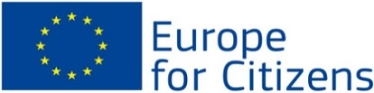

See attachment 1 for the plan of action. See attachment 2 for the scenario. See attachment 3 for the consistent planning.
Europe for Citizens are funding initiatives to strengthen remembrance and to enhance civic participation at EU level.
(EACEA n.d.)
See attachment 4 for an overview of the unemployment and youth unemployment statistics. (Eurostat n.d.) (Eurostat n.d.)
(Worldcityinfo n.d.)
(Illers 2015) (Eurotowns n.d.)
(Eurotowns 2013)
(ispakaunas2014 n.d.)
(Municipality Hasselt 2015)
(Eurotowns 2012)
(Municipality Hasselt 2015)
(Sandwich 2007)
(Eurotowns 2013)
(Radiocentrum 2014) (REC n.d.)
(Verachtert 2015)
See the detailed program of the conference in Kaunas in attachment 5.
See the summary of the study visits in attachment 6.
(genocid 2013)
See the detailed program of the conference in Abegondo in attachment 7.
See attachment 8 for a draft programme of the Hasselt conference.
See attachment 9 for a draft programme of the Detmold conference.
Link to the forum: http://s13.zifboards.com/On_Tour_for_Europe/index.php.
Link to the Facebook group: http://www.facebook.com/groups/740626399405340
(Eurostat n.d.)
(Europe n.d.)
(Europe n.d.)
(Europe 2015)
(European Commission n.d.)
(European Commission n.d.)
(European Commission n.d.)
The Employment and Social Innovation (EaSI) programme is a financing instrument at EU level to promote a high level of quality and sustainable employment, guaranteeing adequate and decent social protection, combating social exclusion and poverty and improving working conditions. (European Commission n.d.)
(European Commission n.d.)
(European Commission n.d.) (Ferrer, et al. 2016)
(European Commission September 2015)
The U-database is a hard drive on any computer of the city of Hasselt. Anyone with an account of the city of Hasselt can access this hard drive on a computer of the city.

