The Influence of Communication Channels on the Response of Customers in the Exploration and Maturity Stage of the Customer Lifecycle
The mediating role of personalization and intrusiveness

MASTER OF BUSINESS ADMINISTRATION

faculteit economie en bedrijfswetenschappen
R0254878
Anne Vandenberk
Master thesis offered to obtain the degree of

Promotor: Dr. Els Breugelmans
Co-Promotor: Dr. Saeid Vafainia

Academic year 2015 – 2016
Table of content
Abstract 3
1 Introduction 4
2 Literature overview 7
2.1 Customer Relationship management 7
2.1.1 Introduction and importance 7
2.1.2 The customer lifecycle 7
2.2 Channels 10
2.2.1 From multi-channel to omni-channel 10
2.2.2 Channel types and characteristics 11
3 Hypotheses 13
3.1 The influence of the channels on the response of consumers 14
3.2 The influence of CLC stages on the response of consumers 15
3.3 The interaction between the 4 channels and the different CLC stages 15
4 Research procedure 16
4.1 Research design 17
4.1.1 Content and design of the promotional message 17
4.1.2 Scenarios Customer Lifecycle stages 17
4.1.3 Scenarios channels 18
4.1.4 Data collection 18
4.1.5 Sample 21
4.2 Method 22
5 Results 24
5.1 Descriptive statistics 24
5.2 Main analyses 28
5.2.1 Assumptions 28
5.2.2 The influence of the channels and the CLC stages on the response of consumers (H1a) 29
5.2.3 The mediating effect of the channel characteristics 31
5.2.4 The influence of CLC stages on the response of consumers (H2) 34
5.2.5 The interaction between the 4 channels and the different CLC stages (H3) 35
5.3 Post hoc analysis channel preference 37
6 Conclusion and implications for managers 39
6.1 Conclusion 39
6.2 Implications for managers 41
7 Limitations and suggestions for further research 42
8 Bibliography 44
Attachment 1: Questionnaire 50
Attachment 2: Operationalization of the variables 57
Attachment 3: Frequency tables demographical data 60
Attachment 4: Assumptions univariate tests main analyses 61
Attachment 5: Results 62
Press article 63

Abstract
This master thesis examines the effect of different channels on a consumer’s willingness to accept a hypothetical promotional invitation. The channels that are investigated are mobile, social media, direct mail and personal selling. The difference in the response to the channels among the exploration and maturity stage of the customer lifecycle are also investigated. The goal of this thesis is to recommend to retailers which channels they should use and at what point in the customer relationship these should be applied. This research offers insights into an important practical problem that to date has not been extensively investigated by academicians.
The research in this study is conducted via a combination of an experiment and an online questionnaire that was filled in by 513 respondents. Each respondent received a similar invitation for the opening of a hypothetical clothing brand via 1 specific channel and was appointed to 1 specific lifecycle stage. This results in 8 different conditions (2x4). For each condition, the respondent had to indicate his or her willingness to accept the invitation.
The results indicate that in general consumers are most likely to accept a promotional invitation via personal selling and in the maturity stage. A combination of the channels and the CLC stages results in consumers being more likely to accept the promotional invitation via direct mail and social media in the maturity stage than in the exploration stage.

Word of thanks
This master thesis presents the final piece of my degree of Master of Business Administration. It took me a year of blood sweat and tears, but I’m very proud of the result. Nevertheless, this would not have been possible without the great support of Mrs. Breugelmans and Mr. Vafainia, who have guided me throughout the whole process and stood by me with a lot of patience and wise advice. Therefore, my sincere gratitude!
I would also like to thank my parents, brother, boyfriend and friends for their unconditional support and great help with the collection of respondents. Without them my research would not have been possible. Another special thanks goes to Eva Maussen who helped me with the creation of the visuals for my research. Next, I would also like to thank Mrs. Kerkhofs and the members of our writing group for their linguistic support.

Introduction
The retail landscape is known to be changing continuously and adapting rapidly to new emerging technologies. Although the digital retail technology knew a rough start in the early nineties, it is nowadays steadily nested in our digital society (Rigby, 2011). The emerging of the online channel and the ongoing digital revolution brought along a whole other retail mix that caused a lot of retailer’s business models to change (Verhoef et al., 2015).
Neslin et al. (2006) define multi-channel customer management as “the design, deployment, coordination, and evaluation of channels to enhance customer value through effective customer acquisition, retention and development”. In this definition, channels refer to the mediums through which consumers and retailers interact with each other. In prior research the focus has been mainly on online channels, offline channels and traditional direct marketing channels that are being managed separately (Verhoef et al., 2015).
Today in the 21st century there are multiple channels through which retailers can communicate with their customers, such as websites, mobile devices, social media, catalogues, and so on (Rigby, 2011). The digital revolution brings along a lot of challenges that urge retailers to adapt their current retail strategy to embrace the multiple channels available nowadays (Verhoef et al., 2015). These new channels enable consumers to search for information on a smartphone while shopping in a regular store (Leeflang et al., 2014; Verhoef et al., 2015). Not only consumers can use different channels at the same time. Companies can also do this by using several channels in order to combine them into one coherent omni-channel experience (Rigby, 2011; Verhoef et al., 2015). In contrast to multi-channel management, omni-channel management uses multiple touchpoints, including traditional mass communication channels and other interactive channels (Verhoef et al., 2015).
The objective of this research is to indicate which channels retailers should use when communicating with customers. The channels that are investigated concern 2 new channels that are a result of the current digitalization: mobile (i.e. MMS via smartphone) & social media and 2 traditional channels: direct mail & store. Direct mail entails the postal promotional message, while store refers to a salesperson handing over a promotional folder in the store. The new channels make it possible for consumers in the current omni-channel environment to use different channels interchangeably and seamlessly (Verhoef et al., 2015). For that reason, it seems interesting to use a combination of the 2 types in this research. Important to remark here is that by investigating the influence of these new channels that are a result of the ongoing digitalization on the response of consumers, we provide a starting point for the omni-channel challenge in this research, although we still focus rather on the sequential use of channels than on their simultaneous use.
Companies however, are not only challenged on how to adopt an effective channel strategy, they also need to take the customer lifecycle (hereafter CLC) into consideration when developing a communication and marketing strategy. Prior research has stressed the importance of interacting differently with customers at each stage of the relationship as well as managing these different stages profoundly (Srivastava et al., 1998). As customers move through the different stages of the relationship, they communicate and interact with firms via different channels, such as via the Internet, brick-and-mortar stores, social media and so on (Neslin et al., 2006, Verhoef et al., 2015). Leeflang et al. (2014) already stated that with the emergence of digital marketing, new types of media and channel challenges are brought to the surface. Firms are challenged to leverage and develop profound customer insights and to optimize the value of the relationship in each stage of the customer relationship across all channels. This is where Customer Relationship Management (hereafter CRM) arises (Reinartz et al., 2004; Leeflang et al., 2014).
Regardless of its increasing importance, there is not yet a lot of research available on how to use different channels to communicate with customers during the CLC. Verhoef et al. (2015) and Venkatesh et al. (2012) stress the importance of investigating the performance of new channels that are a result of the ongoing digitalization. Other researchers emphasize the relevance of research that can reveal the channels a firm should use in each stage of the CLC (Neslin et al., 2009). The research of Verhoef et al. (2006) indicates that prior research mainly focused on buying decisions and ignored the CLC stages. Keller (2010) stated that companies should implement short-term sales strategies next to long-term customer relationship building into their multi-channel corporate strategy, where they are now mainly purchase-focused. Other research focuses on channel synergies, which can be reached by coordinating different channels (Berry et al., 2010). Van der Veen et al. (2015) reveal the several channels customers use in their buying-decision process, again neglecting the CLC stages. Prior research that did investigate the CLC focused on the content of the message, rather than on the channel (Gázquez-Abad et al., 2011). That is why our research focuses on the impact of channels on consumer response to a firm’s communication, across different stages in the CLC. By using an identical message across all channels, the focus of this research is on the medium and thus on how the message is conveyed.
In order to make a valuable contribution on the differences between channels’ value and their influence in the different stages of the CLC, this paper focuses on the exploration stage and the maturity stage. These stages differ considerably in terms of the way buyers and sellers view each other (Dwyer et al., 1987). In the exploration stage of the CLC, search and trial take place, while in the maturity stage an implicit or explicit agreement exists between both exchange parties concerning the relational exchanges. Although the research of Bolton et al. (2000) and Gázquez-Abad et al. (2011) suggests a positive effect of a promotional message on the response of consumers in both the exploration and maturity stage of the CLC, other researchers suggest a negative effect of the promotional message in the maturity stage of the CLC. According to the usage dominance theory consumers become less responsive to promotional messages and activities when they are more familiar with a brand, because external information about the brand is dominated by their personal direct brand experience (Anderson, 1971; Kopalle & Lehmann, 1995). Due to the limited research period, a promotional message is used in the form of an invite to a new shop opening of a hypothetical clothing brand, despite the inconsistency regarding the effect of the message in the maturity stage of the CLC. As a result, the response is the willingness to accept (hereafter WTA) the promotional invitation.
Each of the 4 channels that are used in this research, is evaluated based on 2 channel characteristics, namely personalization and intrusiveness. Both aspects are expected to explain (partly) the effect of the dependent variable (channels) on the independent variable (response). As a result, personalization and intrusiveness are included as mediators in the research framework. The CLC stage operates as a moderator in the process, since the specific needs of the customer in each lifecycle stage influence the way a channel satisfies this need (van der Veen et al. 2015). Figure 1 visualizes the problem statement of this paper. The problem statement is defined as follows:
Does the channel influence the customer’s response? How do the channel characteristics ‘personalization and intrusiveness’ mediate this relationship? How is the relationship between the channels and the response of consumers moderated by the exploration and maturity stages in the customer lifecycle?
Figure 1 Visualisation problem statement
Channels:
- Mobile
- Social Media
- Direct mail
- Personal selling
Response: Willingness to Accept
Moderator:
Customer lifecycle stage
Mediator:
- Personalization
- Intrusiveness

Literature overview
The following part discusses some important constructs and knowledge from prior research concerning the problem statement of this paper. This literature overview serves as a base for the definition of the hypotheses and the methodology of the research. The following concepts are discussed: CRM and the different channels that are used in the research.

Customer Relationship management
The following part gives an introduction to the concept of CRM and outlines the importance of the concept. Next, the customer lifecycle and its different stages are discussed, with an emphasis on the 2 stages this research focuses on.

Introduction and importance
Kotler (2009) defines customer relationship management as the complete process of the development and maintenance of profitable relationships with customers by generating customer satisfaction through superior value for the customer.
Concerning the importance of CRM to firms, former research demonstrates that if firms use knowledge about their customers’ preferences and needs to develop a long-term relationship, stronger relationships will be created (Anderson et al., 1996; Bucklin et al. 1993). Kotler (2009) already stated the importance of developing valuable relationships with customers through the delivery of superior value for the customer, which is directly linked to brand equity (Kotler, 2009; Srivastava et al., 1998). Brand equity makes it possible for companies to gain a larger market share, to charge higher prices and to develop more efficient communication programs, since prior research states that well-differentiated brands have a higher response to promotions and advertising (Keller et al., 1993). Additionally, Kotler (2009) states that a high customer satisfaction results in a high customer lifetime value, which is the the total value of the stream of purchases a client would do during the entire duration of the relationship (Kotler, 2009). Venkatesan et al. (2004) also use the customer lifetime value as the performance indicator of marketing activities. They prove that customer lifetime value is a sufficient metric for marketing resource allocation and customer selection. Srivastava et al. (1998) on the other hand use shareholder value as a performance indicator for marketing activities. According to their study, customer relationships increase shareholder value by enhancing and increasing cash flows, increasing the residual value of cash flows and lowering the vulnerability and volatility, and thus uncertainty, of cash flows.

The customer lifecycle
Previously, marketing focused on the exchange relationship where transactions were studied as discrete events, largely neglecting the relationship aspect of buyer-seller behaviour as well as the effect of preliminary conditions and processes on the buyer-seller exchange relationships (Dwyer et al., 1987). Arndt (1979) drew the attention to the effect of long-term associations, joint ownership and contractual relations on the corporate exchange process. He thereby stated that transactions are mainly planned and managed, rather than happening on an ad hoc basis. A discrete transaction differs from a relational exchange in that it excludes any form of relational elements, the communication between the buyer and seller is limited and narrow in content and the identities of both parties remain unknown. Important to know is that a relational exchange evolves over time, determined by the history and the anticipated future of a transaction. The rationale behind relational exchange is that personal, complex and noneconomic satisfactions can be derived by participants, stressing the importance of social exchange and interdependence (Dwyer et al., 1987).
Several divisions exist for the consecutive relationship stages. According to Dwyer et al. (1987), there are 5 general stages through which relationships expand, namely awareness, exploration, expansion, commitment (maturity) and dissolution. The way both parties (buyer and seller) see each other evolves and differs in each stage. Reinartz et al. (2004) divide the relationship process into 3 consecutive stages, namely initiation, maintenance and termination. Their division is rather based on the different CRM-activities that are applicable as the buyer-seller relationship evolves (Reinartz et al., 2004). Rousseau et al. (1998) also simplified the customer lifecycle into 3 different stages, namely building, stability and dissolution, based on the differences in trust. Their vision is based on the insights of Miles & Creed (1995) who state that trust in a long-term relationship evolves over time. According to Rousseau et al. (1998) the expansion and maturity stage become more and more similar regarding their level of trust, after that in both stages a certain level of history and a comparison level of alternatives have been developed. Since Jap and Anderson (2007) have proven that the relationship theory of Dwyer et al. (1987) holds and given that the division of Dwyer et al. (1987) is more detailed and is used in several academic papers, this paper will continue with the division of Dwyer et al. (1987).
Table 1 gives an overview of the different customer lifecycle stages and their most important elements.
Table 1 CLC stages and their main characteristics
 | Customer lifecycle stages
Awareness | - Recognition of potential exchange partners  - Facilitator: situational proximity  - No bilateral interactions
Exploration | - Trial & search  - Evaluation of costs and benefits of the potential relationship
Expansion | - Increasing mutual benefits & interdependence  - Increase in taking risks  - Increase in both parties’ motivation to continue the relationship  - High mutual benefits limit the amount of potential alternative exchange partners
Maturity | - Relational persistence  - Awareness of potential alternatives continues
Dissolution | - End of the relationship  - High psychological, physical and emotional stress due to high interdependence  - Direct disengagement / other-orientation strategy (Baxter, 1985)
Source: based on Dwyer et al. (1987) and Baxter (1985)
In order to make a valuable contribution on the differences between channels’ value and their influence in the different stages of the CLC, this paper focuses on the exploration stage and the maturity stage of the CLC as these stages differ considerably in terms of the way buyers and sellers view each other (Dwyer et al., 1987). In the exploration stage of the CLC, search and trial take place, while in the maturity stage an implicit or explicit agreement exists between both exchange parties concerning the relational exchanges. Since the main focus of this research is on the exploration and maturity stage of the CLC, these 2 stages are discussed in more detail in the following part, concerning their characteristics and communication goals.

Exploration stage
In the exploration stage, search and trial take place. Both buyer and seller evaluate the benefits, costs, obligations and the exchange possibilities of the potential relationship (Dwyer et al., 1987). As a result, trial purchases can take place during this stage, but the relationship is still very fragile. The interdependence and investments are minimal, which makes possible termination simple (Dwyer et al., 1987). During the exploration stage, the relationship between buyer and seller is not yet established, but still evolving (Dwyer et al., 1987).
The communication goals in the exploration stage are closely linked to the communication goals in the introduction stage of the PLC. The communication goals in this stage of the CLC are to generate brand awareness and brand knowledge (De Pelsmacker et al., 2008). Brand knowledge means customers have knowledge of the most important qualities, features and advantages of a product. Customers are also able to summarize the strongest points of the brand in comparison to other brands and are conscious why they prefer to buy at retailer X instead of retailer Y (De Pelsmacker et al., 2008).

Maturity stage
In the maturity stage, there exists an implicit or explicit agreement between both exchange parties concerning relational persistence. Both parties inhibit transactions with other primary exchange parties that could deliver the same benefits, as in this stage of buyer-seller interdependence both exchange partners have entered a certain level of satisfaction from the transactional relationship (Dwyer et al., 1987). This does not mean the exchange partners refrain from looking at other alternatives, since their awareness of potential alternatives continues although they stop testing alternatives continuously and obsessively (Dwyer et al., 1987). Whether and how long some partners stay in the maturity phase depends on 3 criteria: (i) emotional, communicational and/or economical input invested in a relationship, (ii) durability or stability to nurture the relationship and (iii) consistency during relationship exchanges (Scanzoni 1979 as cited in Burgess & Huston, 1979). There are several other forces that influence a relationship negatively, such as a perceived decrease in the obstacles to start interactions with another exchange partner, changes in organizational or personal needs, an increase in transactional costs and so on (Dwyer et al., 1987). In contrast to this, the perceived benefits of each partner of the exchange relationship can strengthen the intentions of both parties to adjust, rather than dissolve the relationship. Efficiency and effectiveness of potential ameliorations and the certainty of the mutual anticipated goals and roles are examples of these benefits (McCall et al., 1966; Dwyer et al., 1987).
The communication goal in the maturity stage of the CLC is closely linked to the communication goal of the maturity stage in the PLC. In this stage the optimization of brand loyalty is a priority (De Pelsmacker et al., 2008). Brand loyalty is the mental involvement of the customer to a brand or the relationship between a brand and a customer (De Pelsmacker, 2008). Customers have to be made less receptive for the advantages of competing brands, through different communication goals such as the improvement of top-of-mind awareness, claiming a unique brand advantage, emphasizing the price in case of small differences, attracting attention with small product innovations and so on (De Pelsmacker, 2008).

Channels
This research focuses on 4 main channels, namely the mobile channel, social media, direct mail and personal selling in stores. This part of the paper first discusses the main differences between multi-channel and omni-channel marketing, before analysing the most important characteristics of these 4 channels.

From multi-channel to omni-channel
In the definition of Neslin et al. (2006), channels are referred to as mediums for interaction between the customer and the firm (Verhoef et al., 2014). Because of their focus on interaction, the channels here are limited to the ones providing two-way communication, excluding the traditional ones with one-way mass communication, such as advertisings on TV. Channels here are divided into 3 main groups, namely traditional direct marketing channels (i.e. catalogues), online channels (i.e. web stores) and offline channels (i.e. stores). The focus on multi-channel has mainly been driven by the growth of the online channels and their influence on the traditional channels, used by customers and firms. The channels in ‘multi-channel’ have rarely been integrated with each other and have often been managed separately within firms (Shankar et al., 2012).
According to Rigby (2011), the emerging of mobile channels in the new digital society has brought along a disruptive change in the retail environment. In comparison with the multi-channel stage, omni-channel involves more channels and the distinction between the different channels becomes vague as they are used seamlessly and interchangeably with each other. An example of a typical omni-channel phenomenon is the emerging of the showrooming phenomenon, in which customers simultaneously search for information in the store and on their mobile device in order to extend their current knowledge about the offer and vice versa. One of the major developments in omni-channel is the integration of traditional mass advertising channels with interactive channels (Verhoef et al., 2015). An example is Samsung Electronics Benelux that interacted with its customers via Facebook and Instagram during the match of the Red Devils in the World Cup in 2014. The company used the hashtag #ReadyForTheDevils to start conversations about the Red Devils while promoting their products by talking about the customers’ experience of the match (Sevenedge, 2014).

Channel types and characteristics
The following part discusses the different types and characteristics of the 4 channels that are used in the research of this paper. The channels that are investigated concern 2 new channels that are a result of the current digitalization (mobile & social media) and 2 traditional channels (direct mail & store). The new channels make it possible for consumers in the current omni-channel environment to use different channels interchangeably and seamlessly (Verhoef et al., 2015). Since the objective of this research is to provide a starting point on the omni-channel phenomenon, it seems interesting to use a combination of the new and traditional types of channels in this research. Important to remark here is that the channels that are used in this research consist of both the medium itself and location. A message received via social media (medium) for example can be either read on a laptop at home or via an application on a smartphone out of home (location). Therefore, table 2 provides a proper definition for each channel, highlights the main features and benefits and determines the location of each channel in this research.
Table 2 Channel types
 | Definition
MMS via mobile device | Location Based Advertising (hereafter LBA) is defined as “marketer-controlled information customized for recipients’ geographic positions and received on mobile communication devices” (Bruner & Kumar, 2007). Examples of LBA are advertisements via SMS or MMS (Unni & Harmon, 2007). This research will focus on push LBA: advertising messages sent to a consumer’s mobile device, based on the location or previously indicated product preferences of a consumer (Paavilainen, 2002). With mobile device is meant “a handled tablet or other device that is made for portability, and is therefore both compact and lightweight” (Techopedia, 2015).
Social media at home | “Social media is a group of Internet-based applications that build on the ideological and technological foundations of Web 2.0, and that allow the creation and exchange of user-generated content” (Kaplan and Haenlein, 2010, p.61). Widely taken, social media includes social networking sites, message boards, blogs and wikis (Beer and Burrows, 2007; Bernoff and Li, 2008). This research focuses on social media usage on a laptop or computer at home.
Direct mail at home | Kotler (2009) defines direct mail marketing as a form of direct marketing through sending a mailing with letters, advertising, samples, brochures, and such to potential customers on the mailing list. This definition implies that direct mail in this research refers to the versions received via the post.
Personal selling in stores | Personal selling is defined by Kotler (2009) as the verbal presentation in a conversation with potential customers – individually or in group – with sale as the objective. We focus here on in-store conversations.
Source: based on Bruner & Kumar (2007), Unni & Harmon (2007), Paavilainen (2002), Techopedia (2015), Kaplan and Haenlein (2010), Beer and Burrows (2007), Bernoff and Li (2008) and Kotler (2009)
Table 3 gives an overview of the comparison between the 4 channels, based on 2 aspects, namely personalization and intrusiveness, since both aspects are related to buyer-seller relationships. In this thesis personalization refers to a channel characteristic, rather than a message characteristic. The concept is closely linked to interaction and relevance, since interaction makes the communication through a channel more personalized and thus more relevant. With intrusiveness is meant “coming without invitation or welcome” and is thus closely linked to privacy concerns (Dictionary.com, 2015). One remark here is that for the mobile channel, social media and direct mail there exist 2 mechanisms. A consumer can receive a promotional message either based on permission or not (opt-in or no opt-in). With opt-in is meant that consumers have signed up to receive relevant promotions and advertisements (Barwise & Strong, 2002). This has implications for the level of personalization and intrusiveness of the 3 channels for both mechanisms. In this research we work with the non-opt-in mechanism for all 3 channels, since in the exploration stage not every consumer will yet have given an opt-in for promotional messages of a brand they are not very familiar with at that point.
Table 3 Channel characteristics
 | Personalization | Intrusiveness
Mobile channel | The mobile channel is characterized by omnipresence and localization, which makes it possible to deliver the right content, in the right format, to the right person, at the right time and location (Ho, 2012). The results are location-based ads and promotions, which make the communication very relevant and personalized (Pura, 2005; Bauer et al., 2005). | Pushed advertising, received via a mobile device can be seen as threatening to the personal privacy. Users also have fears for unauthorized access and manipulation of data and the unwanted tracking of usage patterns (Gao et al., 2013).
Social media | Social media users receive communication or ads from a brand they follow or like (Godes et al., 2012). Users also have the possibility to have a conversation with a company via commenting on or liking brand posts on brand pages (McAlexander et al., 2002; Muñiz et al., 2001). On the other hand, users can also receive communication or ads from brands they do not like on their wall, in case their friends like or follow the brand. | Annoyance towards social media can be due to pushed messages from brands a customer does not follow or like (eMarketer, 2012). On the other hand, users are aware of the privacy issues that are linked to involving in social media, but share personal information anyway (Jonyoung et al., 2015). Besides, users can decide for their own, whether they want to read the advertisements or just move past them.
Direct mail | Direct mail (DM) is a form of personalized communication (personal addressing) that intends to evoke a direct response from the receiver (Kotler, 2009). DM is seen as relevant if the content is in harmony with the receiver’s interests (Dolnicar et al., 2013). Notwithstanding the personal addressing, DM is less personalized than the other channels, as it is not based on location, nor on the interests of personal connections of the receivers. | DM can be seen as annoying junk mail or spam when sent to uninterested consumers (Kotler, 2009). Consumers provide personal information in exchange for information, expecting that their personal information will be protected and managed responsibly (Dolnicar et al., 2013). On the other hand, consumers can decide for themselves whether they want to read the received DM’s or not.
Personal selling in stores | Personal selling in stores makes it possible to have face-to-face conversations with customers, adapted to the characteristics of the customer. Examples are negotiations, information sharing, feedback and product demonstrations (Kotler, 2009). | Personal selling in stores can be seen as intrusive, as customers have no control over the appearance of salespeople during their visit in the shop and the questions they are asked. If the customer does not want to be helped nor wants to receive advice in a shop, personal selling can be seen as very annoying.
Source: Ho (2012), Pura (2005), Bauer et al. (2005), Gao et al. (2013), Godes et al. (2012), McAlexander et al. (2002), Muñiz et al. (2001), eMarketer (2012), Jonyoung et al., (2015), Dolnicar et al. (2013) and Kotler (2009)

Hypotheses
Table 4 is created based on the concepts and former research results discussed in the literature overview. The table shows the 2 dimensions that distinguish the 4 channels from one another and demonstrates the channels’ scores for each dimension. In the literature that is used to defend the hypotheses, there exists some controversy on whether personalization and intrusiveness are orthogonal concepts. According to Bleier et al. (2015) and White et al. (2008), both concepts are related, although the strength of the relationship depends both on the level of personalization and the level of trust a consumer has in a retailer. Since the level of trust differs per CLC stage and per sector, there is no sure one-dimensional relationship between personalization and intrusiveness and thus we cannot state with certainty that both concepts are each other’s direct opposites (Dwyer et al., 1987; van Doorn et al., 2013). In order to simplify the interpretation of the hypotheses, we will for now consider both concepts to cover 2 separate dimensions and to weigh equally in the total score. Their true level of orthogonality and impact is measured during the research, using respectively a measure of correlation and linear regression. The relevance of personalization and intrusiveness for the 2 CLC stages (exploration and maturity) is defined in table 4. The hypotheses of this research are defined, based on this table. Since the message that is used in this research is an invite to a new shop opening of a hypothetical clothing brand, the response refers to the acceptation of the promotional invitation.
Table 4 Characteristics of the 4 channels, linked with the CLC stage
 | Mobile | Social media | Direct mail | Personal selling in stores
Personalization | ++ | ++ | - | ++
Intrusiveness | - - | - | + | - -
Total score | 0 | + | 0 | 0

The influence of the channels on the response of consumers
The underlying mechanism for the main effect, namely the response of consumers on the message they receive through 1 of the 4 channels, are the mediators (personalization and intrusiveness). Former research showed that a higher personal relevance and personalization lead to a higher response of consumers on advertised message content, which is in line with the expectations of the Elaboration Likelihood Model (Micheaux, 2011). According to the Elaboration Likelihood Model, more personal relevant communication will increase a consumer’s motivation to process a marketing communication message and form an attitude about it (De Pelsmacker, 2008). On the other hand, other research shows that there is a relationship between high personalization and privacy concerns, depending on the trustworthiness of the retailer and the depth and breadth of the personalization (Bleier et al., 2015). Displaying and using very intimate consumer information may therefore trigger high privacy concerns and thus result in a high level of intrusiveness, rather than in a positive response (Bleier et al., 2015). In addition, Venkatesan and Kumar (2004) indicate in their research that rich modes of communication (e.g. personal selling) have a bigger influence on the response of consumers than standardized modes of communication (e.g. telephone, direct mail). This is probably due to the former’s interactive and thus personalized and relevant characteristics. Social media scores less negative on intrusiveness (only 1 minus sign), since social media users are less concerned with sharing personal information and can decide for themselves whether they want to read a message or not. It also scores high on personalization as social media users only receive messages from brands they or their friends like or follow. Regarding the total score row in table 4, only social media is expected to have a positive influence on the response of consumers. The results of the other 3 channels suggest all 3 channels have an equal influence on the response of consumers. As a result, the following hypothesis is formulated concerning the channels and the response of consumers:
H1a: Social media has a bigger influence on the response of consumers, regardless of the customer lifecycle stages they belong to, than the mobile channel, direct mail and personal selling.
Regarding the mediating role of the 2 channel characteristics (personalization and intrusiveness), the following hypotheses are formulated:
H1b: The effect of the channels on the response of consumers is mediated by personalization
H1c: The effect of the channels on the response of consumers is mediated by intrusiveness

The influence of CLC stages on the response of consumers
Concerning the response to the promotional message in the exploration and maturity stage of the CLC, there seems to be some inconsistency. There are namely 2 different theories that expect 2 opposing effects, which results in 2 opposing hypotheses. Theory based on the usage dominance states that consumers become less responsive to promotional messages and activities when they are more familiar with a brand, because external information about the brand is dominated by their personal direct brand experience (Anderson, 1971; Kopalle & Lehmann, 1995). On the other hand, based on the Elaboration Likelihood Model, former research proved cognitive elaboration is expected to be higher in case of a higher user experience (Cacioppo & Petty, 1985 as cited by Bridges et al., 2006). This implies consumers are expected to be more likely to process promotional information about a brand they are very familiar with in terms of usage. Besides, other research states that positive past experiences with a brand or retailer lead to favourable attitudes and thus to a higher response likelihood of the consumer to promotional activities (Oskamp, 1977 as cited by Gázquez-Abad et al., 2011). As a result, the following 2 opposing hypotheses are formed:
H2a: Consumers in the maturity stage have a lower response to the promotional message than consumers in the exploration stage of the customer lifecycle.
H2b: Consumers in the maturity stage have a higher response to the promotional message than consumers in the exploration stage of the customer lifecycle.

The interaction between the 4 channels and the different CLC stages
The research of Bleier et al. (2015) states that the effect of personalization depends on the level of personalization and the level of trust a consumer has in the retailer. Regarding the level of trust in the exploration stage of the CLC, firms should not use high personalization since consumers are still getting to know the firm in this stage and still have to form trust in them (Dwyer et al., 1987). A too high personalization could thus result in privacy concerns (Bleier et al., 2015). In the maturity stage, personalized interactions are seen as standard, while in the exploration stage, customers are not very eager to share a lot of personal information (Dwyer et al., 1987). On the other hand, relevance has an influence on a consumer’s motivation to process a message (Micheaux, 2011). As creating awareness is the most important objective in the exploration stage of the CLC, a certain level of relevance and thus personalization is required, but a high level of personalization will be more applicable in the maturity stage than in the exploration stage (Dwyer et al., 1987; De Pelsmacker, 2008). Intrusiveness is supposed to have a lower impact on the response in the maturity stage than in the exploration stage, as a distinct level of trust in the retailer has been formed in this stage and research shows that a higher trust results in lower privacy concerns (Milne and Boza, 1999).
Regarding the characteristics of the 4 channels in table 4, direct mail is suggested to be the best communication channel for the exploration stage of the CLC. Direct mail scores lowest on personalization and lowest (positive) on intrusiveness. Direct mail scores positive (and thus low) on intrusiveness since the receivers can decide for themselves whether they want to open and read the direct mailing or not. Concerning the other channels, these are more appropriate to use in the maturity stage of the CLC, as all 3 channels score high on personalization and high (minus signs) on intrusiveness. This results in the following 4 hypotheses per channel:
H3a: Consumers are more likely to respond to the promotional message via the mobile channel in the maturity stage than in the exploration stage of the customer lifecycle.
H3b: Consumers are more likely to respond to the promotional message via social media in the maturity stage than in the exploration stage of the customer lifecycle.
H3c: Consumers are more likely to respond to the promotional message via direct mail in the exploration stage than in the maturity stage of the customer lifecycle.
H3d: Consumers are more likely to respond to the promotional message via personal selling in the maturity stage than in the exploration stage of the customer lifecycle.

Research procedure
The main goal of this research is to investigate whether the channel (location and medium: mobile, social media, direct mailing, personal selling) through which consumers receive an invitation for a new shop opening, influences their response or intention to accept the invitation. In addition to this, we investigate the moderating role of the CLC stage (here exploration and maturity) and the mediating role of personalization and intrusiveness (channel characteristics) on the influence of the different channels on the response of consumers. Since little is known about the influence of different channels on the response of consumers in the exploration and maturity stage of the CLC, this research will be executed through an experiment (deductive research). An experiment is the most appropriate technique as it enables to manipulate the 4 channels through which the respondents receive the invitation as well as the hypothetical CLC stage in which the respondents find themselves (Smits, 2015). The experiment will be based on a questionnaire (attachment 1) in order to test the different relationships that are described in the hypotheses. In what follows, the research set-up and the method will be discussed in detail.

Research design
This chapter concerns the research set-up of this thesis and will discuss the content and design of the promotional message, the different scenarios for the manipulations, the data collection method and the sample that are used in this research.

Content and design of the promotional message
The research of Gázquez-Abad et al. (2011) discovered that promotional messages have an overall negative influence on a consumer’s long-term purchase decision. According to them, relational messages are more efficient as they have a long-term as well as short-term favourable influence on the buying decision of consumers, regardless of their relationship with the retailer (Gázquez-Abad et al., 2011). On the other hand, promotional messages are often used to stimulate trial purchases of consumers and do appear to have a positive influence regarding the response of consumers on the short-term (Gázquez-Abad et al., 2011; Pradhan, 2009). Besides, promotions such as enhanced services, used in terms of a loyalty programme, are proven to have a significant positive influence on the loyalty and usage of consumers (Bolton et al., 2000). Since the research period is short in time, this research uses a promotional message as it proves to be efficient for both the exploration and the maturity stage. Next, in order to exclude discrete transactions in which no relational exchanges take place, the product type that forms the subject of the promotional mail, is clothing. Clothing belongs to the limited problem solving group and implies an intermediate level of involvement, which makes relational exchanges between buyers and sellers possible and might reduce the event of discrete transactions (Assael, 1998). The message that is sent to consumers is as a result an invitation to a new shop opening of a hypothetical clothing brand. Important to remark here is that the invitation is made as gender neutral as possible by using neutral colours, a neutral image & font and keeping the message & terminology as basic as possible. Consequently, the response is the intention of the respondents to accept the invitation.

Scenarios Customer Lifecycle stages
Based on the between-subjects design of the experiment (4.1.4 Data collection), each respondent is appointed to 1 customer lifecycle stage (exploration or maturity stage) and thus 1 specific scenario. The description of each scenario is based on the theory defined in the literature overview (2.1.2 The customer lifecycle). In the exploration stage, customers are already aware of the existence of the brand but are not yet very familiar with the brand. During this stage of the CLC search, trial and evaluation take place (Dwyer et al., 1987). As a result, we stressed these elements in the exploration stage scenario. In the maturity stage on the other hand, customers are already very familiar with the brand and have reached a high level of interdependence based on the obtained mutual benefits and satisfaction (Dwyer et al., 1987). As customers in this stage stop looking for and testing alternatives extensively, this implies that they are fairly loyal to the brand in the maturity stage. As a result, we stressed this loyalty element in the maturity stage scenario of the experiment (Attachment 1: Questionnaire).

Scenarios channels
The format of the promotional message (here invitation), depends on the specific form of each channel. For the mobile channel, social media and direct mail, the non-opt-in element is stressed in the channel scenario, regardless of the CLC scenario that precedes as this would otherwise influence the degree of personalization and intrusiveness of the different channels. This makes that each of the channels is based on the same message-mechanism for each CLC stage. Next, each channel scenario contains a certain level of personalization and intrusiveness, since both channel characteristics form the underlying mechanism for the main effect, namely the response of consumers to the message they receive through 1 of the 4 channels.
Concerning the mobile channel, the respondent receives the invitation in the form of an MMS, while passing by a specific shop. MMS refers to Multimedia Messaging Service and enables mobile phone users to send pictures, images, audio fragments and movies (Rouse, 2007). This scenario is based on the LBA-technology, as this does not require an opt-in from the consumer. Further, the LBA-technology makes the mobile channel both relevant and thus personalized and intrusive, since the scenario suggests the respondent is walking by a specific shop, while actively searching and shopping for new clothes. Regarding social media, the respondent sees the invitation for the shop opening in the form of a post on the wall of his or her hypothetical Facebook page that is liked and/or commented on by a hypothetical friend on Facebook. Since the scenario suggests the respondent sees the invitation through the action of a hypothetical Facebook friend, the social media channel evokes both feelings of personalization and intrusiveness. On top, there is no opt-in from the consumer necessary in this scenario. With direct mail is meant the postal form, so the respondent sees a paper version of the invitation that is covered in a personal addressed envelope. Since companies can buy specific customer data, the personally addressed direct mail (channel) can evoke feelings of personalization and intrusiveness. Next, there is no opt-in required from the respondent in this scenario. With personal selling in a store is meant that a salesperson hands over the invitation through a flyer to the consumer, after having a conversation with the consumer. The conversation makes the channel (personal selling in store) personalized and triggers a certain level of intrusiveness.

Data collection
The experiment is executed via an online questionnaire (2 versions: English and Dutch), made via the software programme Qualtrics, that was sent to the respondents via social media and e-mails. This implies that a non-probability sampling procedure is used, namely judgement and snowball sampling. These 2 non-probability sampling procedures are more time-efficient, assure more committed respondents and make it easier to identify and collect appropriate respondents (Laerd Dissertation, 2012). On the other hand, these sampling procedures can endanger the representativeness of the sample, which makes it impossible to make statistical references based on the results of the sample (Laerd Dissertation, 2012). One of the implications might be that respondents have, due to the snowball sampling procedure, some specific characteristics in common or the judgement sampling method might be based on a poor judgement call of the researcher (Laerd Dissertation, 2012). The population of this research are Flemish consumers that own a smartphone and have a Facebook account. Since a lot of attention has been paid to the gender neutrality of the invitation, the population consists of both males and females. In order to execute the ANOVA-analysis, each cell has to contain 30 respondents. This implies that a minimum of 240 respondents (8x30) has to be collected. The actual number of respondents collected is 513.
The questionnaire for the experiment exists of 7 main parts. First, a general introduction is given and 3 selection questions (Flemish or not, smartphone owner or not, Facebook user or not) are asked. These questions are asked to make sure the respondent belongs to the population, namely Flemish consumers that own a smartphone and have a Facebook account. As a result, of all 513 respondents that were willing to fill in the questionnaire, 405 respondents were eligible according to the selection questions. Next, is the central part of the experiment concerning the intention to accept the invitation through 1 of the 4 different channels and for 1 specific CLC stage. This research uses a between-subjects manipulation, since this method assures that the respondents do not know what is being manipulated and thus do not know what the experiment is about. This results in more reliable answers (Smits, 2015). The between-subjects manipulation implies that each respondent is assigned to 1 CLC stage and 1 channel manipulation scenario only. Regardless of the CLC stage a respondent is appointed to and the channel through which a respondent receives the invitation, the design and the content of the message remain the same. Only the format differs (4.1.2 Channels). For each of the templates, the respondents have to indicate their willingness to accept the invitation. This willingness is measured through 1 statement that is based on a range of statements, used in the research of Dodds et al. (1991), concerning the willingness to pay. The statement used in this research best fitted the current research subject, namely the WTA rather than the willingness to pay. The statement concerning the WTA contains a 7-point Likert scale. The measurement scale of the response variable is thus interval scaled. Next, 2 questions are asked to test the level of orthogonality of the 2 channel aspects, namely personalization and intrusiveness. The respondents have to indicate the level to which they perceive the described hypothetical channel scenario as personalized and intrusive. Both concepts are measured through a 7-point Likert scale, which makes them interval scaled. After this, the respondents have to answer 2 questions to check if they are aware of the manipulation situation in order to guarantee the reliability and validity of this research. In these questions the respondents have to indicate in which hypothetical situation they find themselves and through which channel they received the invitation. This resulted in 265 respondents that were able to answer the manipulation check questions correctly. Then, the respondents have to answer a question to determine their preference for 1 of the 4 channels, given the CLC stage they find themselves in. This question enables us to rank the different channels for each CLC stage in terms of their influence on a consumer’s response to the invitation. Finally, to end the questionnaire, 4 demographical questions are asked to determine whether the sample matches the population and whether these variables have a significant influence on the responses of the respondents and a final acknowledgement was given. Table A.1 (attachment 2) gives an overview of the measuring instruments and the operationalization of the variables.
The experiment results in 8 different conditions, namely 4 conditions for the exploration stage of the CLC and 4 conditions for the maturity stage. Each channel that is used in this research implies a different condition for the 2 CLC stages, resulting in a 2 on 4 matrix that is demonstrated in table 5. In the table, the number of respondents per condition is mentioned between brackets.
Table 5 Conditions
 | Exploration stage | Maturity stage
Mobile | Condition 1 (28) | Condition 5 (42)
Social Media | Condition 2 (30) | Condition 6 (30)
Direct Mail | Condition 3 (32) | Condition 7 (32)
Personal Selling | Condition 4 (39) | Condition 8 (32)

Important to remark here is that the questionnaire resulted in a drop-out percentage of 35 %, namely 140 out of 405 respondents were unable to correctly fill in the questionnaire. After analysing the data, we found that 110 out of these 140 respondents failed to answer the manipulation check questions (hereafter MCQ) correctly. The remaining 30 respondents (140-110) failed to complete or end the questionnaire successfully. Of the 110 respondents that failed the MCQ’s, 50 respondents failed both MCQ’s, which might be due to a lack of attention or concentration. Next, 90 respondents were unable to indicate the correct CLC stage (figure 2) and 70 respondents were unable to indicate the correct channel scenario (figure 3) they received at the beginning of the questionnaire. Of the 90 respondents that were unable to indicate the correct CLC stage, 54% (49) belonged to the maturity stage condition. Regarding the 70 respondents that were unable to indicate the correct channel, the largest group received the mobile channel condition (37%), followed by the personal selling condition (31%) and the direct mail condition (23%). The smallest group belonged to the social media manipulation (9%). This high drop-out percentage presents an important limitation of this research.
Figure 2 and 3 give an overview of the manipulation check failures for each condition. After analysing the wrongly answered MCQ’s, it appears that there is no difference in the number of wrong answers per CLC stage, meaning that respondents were equally likely to wrongly indicate both CLC stages (χ²=0,711; p > 0,05). This can also be deducted from figure 2. Regarding the channels, the χ²-test for goodness of fit and figure 3 indicate that respondents more often wrongly answered the MCQ for the mobile and personal selling scenario, while social media is responsible for the lowest number of wrong answers (χ²=12,971; p < 0,05). What is interesting is that the majority of the respondents that wrongly answered the MCQ’s for mobile and personal selling indicated that they received the invitation via social media. This might be due to the ambiguous formulation of the MCQ’s that asked “Via which channel did you receive the invitation?”. Respondents might have wrongly taken it as a personal question, rather than related to the scenario, since the majority of the respondents received the questionnaire via Facebook.
Figure 2 Division wrong answers MCQ concerning the CLC stage
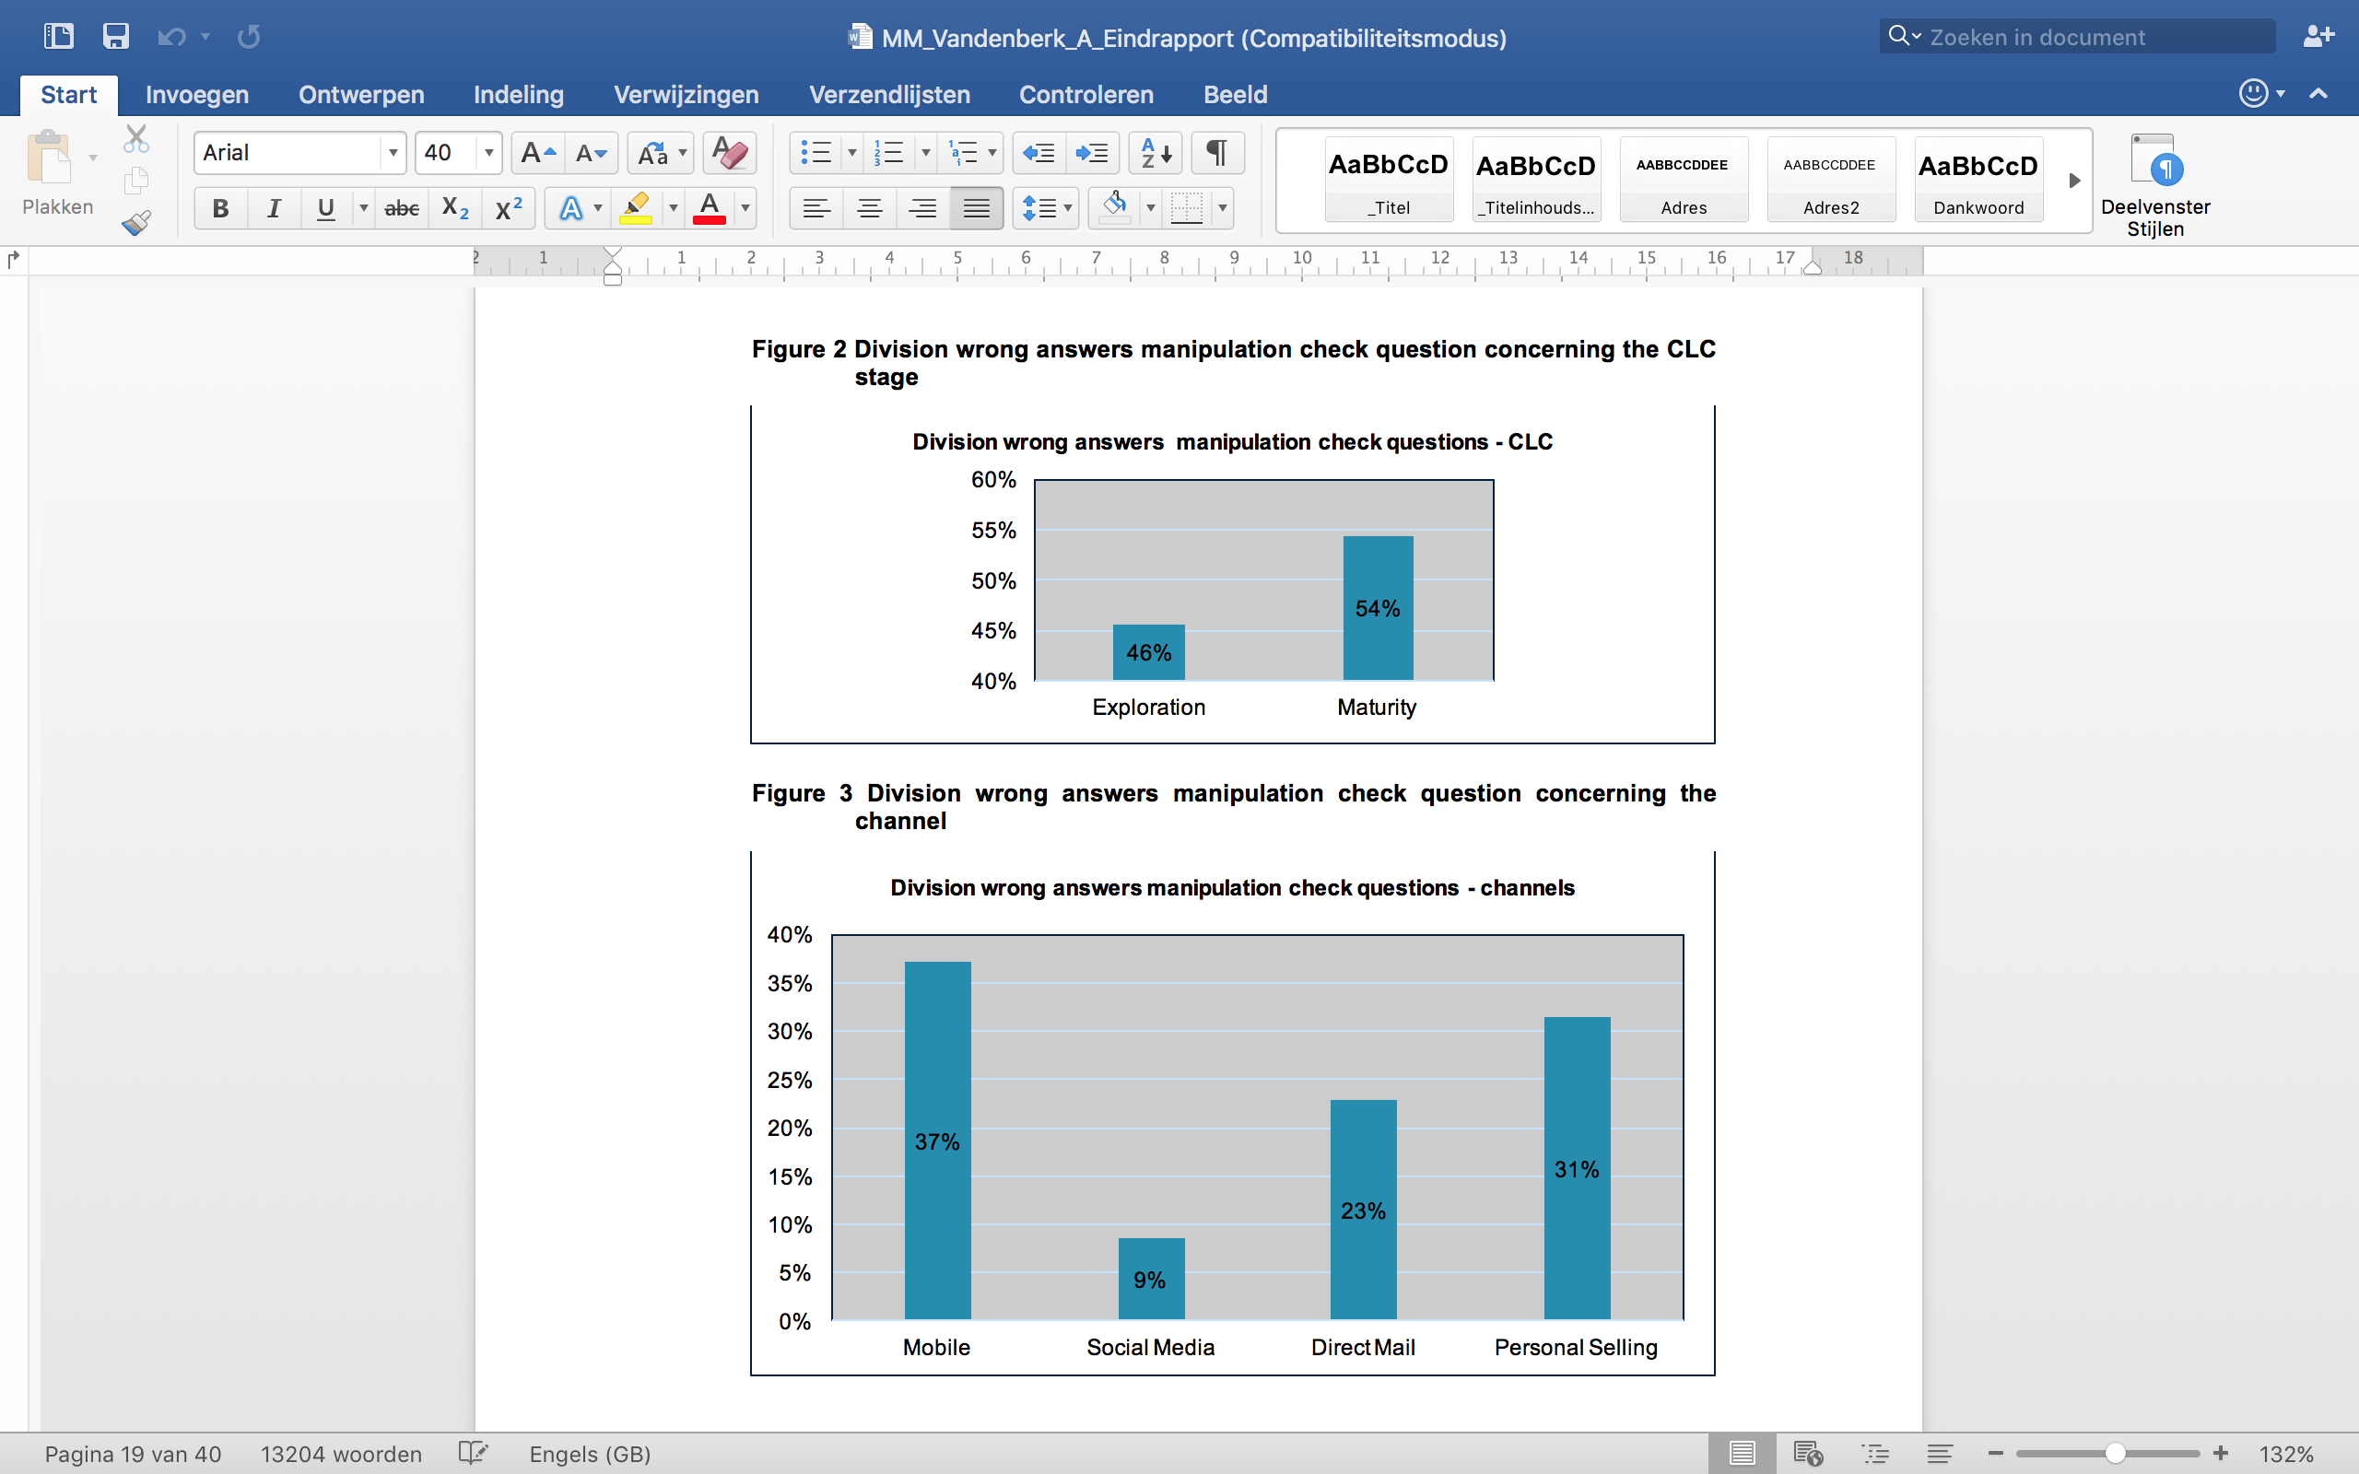

Figure 3 Division wrong answers MCQ concerning the channel

Sample
We use frequency tables in order to describe the population based on the socio-demographic information that is asked at the end of the questionnaire. Table A.2 in attachment 3 shows that the percentage of female respondents in this sample is much higher than the percentage of male respondents (65,3% > 34,7%). This implies that the sample misrepresents the Flemish population as the number of male respondents are significantly underrepresented in this sample (χ²=22,548; p < 0,05). The actual percentage of male inhabitants in Flanders amounts to 49,4% versus 50,6% of male inhabitants on the first of January 2015 (Belgian Federal Government, 2013). Next, table A.3 (attachment 3) indicates that the majority of the respondents in this sample is younger than 35 years old (88,6%). Compared to the age distribution of Flemish inhabitants, the age group ‘younger than 35’ is greatly overrepresented (88,6% > 40,3%) and the age group of the 55+’ers is highly underrepresented (1,5% < 30,3%). This implies that the sample again significantly misrepresents the Flemish population (χ²=25 3,277; p < 0,05). Important to remark here is that the population of this research does not cover the whole of Flanders, but Flemish inhabitants that own a smartphone and have a Facebook account. As a result, the Flemish population can only be used as a means of comparison. Besides, by using the snowball and judgement sampling procedure, the questionnaire is sent to a lot of fellow students and peers, which is also partly responsible for the overrepresentation of the age group ‘younger than 35’.
Regarding the level of education of the sample, table A.4 (attachment 3) indicates that the majority of the respondents have a higher level of education. 35,6% of the respondents has a professional bachelor, while 28,7% claims to have a master diploma and 13,8% an academic bachelor. The group of respondents of whom the highest level of education is primary or secondary school is highly underrepresented (16,9%).
Table A.5 (attachment 3) shows that the majority of the respondents in the sample are students (43,7%). This is again due to the delineation of the Flemish population to Facebook and smartphone users and the sample procedure used in this research. The second largest group of respondents are servants (37,9%). As a consequence, the other profession categories are highly underrepresented in the sample.
Since there is not much data available concerning the real demographics of Flemish Facebook and smartphone users, we can not conclude whether or not the sample is a good representation of the population of this research, but it seems quite plausible that it is not fully or correctly represented.

Method

In order to test the hypotheses, we mainly use linear regressions, except for hypothesis H1a and H2, which are also tested using respectively an ANOVA analysis and an independent samples t-test. The reason for these 2 alternative tests is to test the main effect for both hypotheses, without any control variables. Afterwards the results of both alternative tests are compared to the linear regressions that also test hypotheses H1a and H2 and include control variables, in order to determine whether there is a difference in effect when the control variables are added to the analyses. Besides, the results of the ANOVA analysis enable us to compare the mean values of the WTA for each channel.
First, hypothesis H1a is tested via an ANOVA analysis. In this analysis, the dependent variable (DV) is the response to the promotional message (WTA), which is measured through a 7-point Likert scale and is thus a metric variable. The independent variables (IV) here are the channels, which are transformed into dummy variables and are therefore nominally scaled. The results of this ANOVA analysis are then compared to the results of linear regression R1 that also tests hypothesis 1a. This analysis includes the response of consumers (WTA) as the DV and the channels and CLC-stages in the form of dummy variables are the IV’s. In a next step, the control variables (gender, age, education and profession) are added to regression R1, forming regression R2. After this, the mediating role of the channel characteristics personalization and intrusiveness are tested using 4 different linear regressions (R4, R5, R6 and R7) for each channel characteristic, in order to test hypotheses H1b and H1c. Next, the results of the independent samples t-test have to indicate whether there exists a significant difference in the WTA of consumers between the 2 CLC stages. An independent samples t-test is appropriate as the IV here is the response of consumers, while the DV consists of the 2 CLC stages, which are nominally scaled after their transformation into dummy variables. In a following step, the results of this independent samples t-test are compared to the results of regression R1. Finally, hypothesis H3 regarding the moderating role of the CLC stages is tested via regression equation R3. In order to form this regression equation, 4 interaction terms formed by a multiplication of the exploration stage and each of the channels, is added to regression equation R2. Important to remark here is that only the control variables that appear to have a significant influence on the WTA, are retained. Table 6 provides an overview of the different regression equations.
Table 6 Overview regression equations
H1a | R1 | WillingnessToAccept_{i} = | β0 + β1*Exploration +β2*Mobile_{i} + β3*SocialMedia_{i} + β4*DirectMail_{i} + ε_{i}
H3 | R2 | WillingnessToAccept_{i} = | + β5*Male + β7*Primaryschool_{i} + β8*Secondaryschool_{i} + β9*AcademicalBachelor_{i} + β10*Master_{i} + β11*Phd_{i} + β12*AdultEducation_{i} + β13*OtherEducation_{i} ε_{i}
H3 | R3 | WillingnessToAccept_{i} = | + β14*Exploration_{i}*Mobile_{i} + β15*Exploration_{i}*SocialMedia_{i} + β16*Exploration_{i}*DirectMail_{i} + β17*Exploration_{i}*PersonalSelling_{i} + εi
H1b (H1c) | R4 | Personalization(Intrusiveness)_{i} = | β0 + β1*Mobile_{i} + β2*SocialMedia_{i} + β3*DirectMail_{i} + ε_{i}
H1b (H1c) | R5 | WillingnessToAccept_{i} = | β0 + β1*Mobile_{i} + β2*SocialMedia_{i} + β3*DirectMail_{i} + ε_{i}
H1b (H1c) | R6 | WillingnessToAccept_{i} = | β0 + β1*Personalization(Intrusiveness)_{i} + ε_{i}
H1b (H1c) | R7 | WillingnessToAccept_{i} = | β0 + β1*Mobile_{i} + β2*SocialMedia_{i} + β3*DirectMail_{i} + β4*Personalization(Intrusiveness)_{i} + ε_{i}

After the main analyses regarding the hypotheses, we also execute 2 post hoc tests. The first post hoc test concerns the ranking question at the end of the questionnaire. In this question, respondents were shown all 4 channels and were asked to indicate their preference for a specific channel through which their intention to accept the invitation would be highest, taking into account the 2 scenario’s (2 manipulations) they received at the beginning of the questionnaire. The channel preference is examined in 2 steps. First we test the preference with the expectation that every channel has an equal chance to be chosen. This is tested using a χ²-square test for goodness-of-fit, since there is only 1 variable in this first step, namely the DV (channel preference) which is nominally scaled. Second, the CLC stage is linked to channel preference using a χ²-square test for independence. Finally, the second post hoc test is used to examine the level of orthogonality of the 2 channel characteristics (personalization and intrusiveness), using a measure of correlation.

Results
This part gives an overview of the univariate analyses that are executed in order to test the hypotheses concerning the several variables that are included in this research. Chapter 5.1 starts with a description of the data that was collected during this research. Since the description and evaluation of the sample (4.1.5) is based on the demographical questions (gender, age, education and profession), those variables are not included in the part about the descriptive statistics. Next, the main analyses are discussed in chapter 5.2. The results of these analyses are used to validate or invalidate the proposed hypotheses. Besides, we will also briefly look into the results of the 2 post hoc tests concerning the level of orthogonality of the channel characteristics (personalization and intrusiveness) and the channel preference.
The results section is limited to the dataset that contains all respondents that succeeded the MCQ’s. After analysing the dataset, regardless of the MCQ’s, and comparing it to the results of the dataset that did account for the MCQ failures, we found that the results practically did not differ. One possible explanation might be that the respondents did process the information unconsciously but were unable to indicate the correct scenario they received, due to the ambiguity of the MCQ’s. Since the MCQ’s do not explicitly refer to the received scenarios, this might have caused that respondents took it rather as a personal question and not so much related to the scenario and might therefore be responsible for the high number of wrong answers.

Descriptive statistics

The experiment resulted in 8 different conditions to which the respondents were randomly assigned. Figure 4 and 5 show that the respondents are more or less evenly distributed over the different conditions. Figure 4 on the one hand represents the respondents that correctly filled in the MCQ’s. Figure 5 on the other hand represents all eligible respondents: the respondents that belong to the population of this research regardless of the MCQ’s. The more or less even distribution of the sample is achieved by a function in Qualtrics that assures all conditions are evenly presented in the questionnaire. Figure 5 shows a slightly higher percentage of respondents in the mobile and personal selling condition. This is due to the fact that we removed the other 2 channel conditions from the questionnaire in Qualtrics in the last week of the data collection period, since there was a shortage of respondents for the mobile and personal selling condition, after removing the respondents that failed to correctly answer the MCQ’s. After analysing the division of the respondents over the 8 different conditions via a χ²-test for goodness of fit, we found that there is no significant difference in number per condition (χ²=6,085; p > 0,05). This means that the manipulation of the number of conditions did not affect the results.
Figure 4 Distribution of respondents that answered the MCQ’s correctly over the 8 conditions
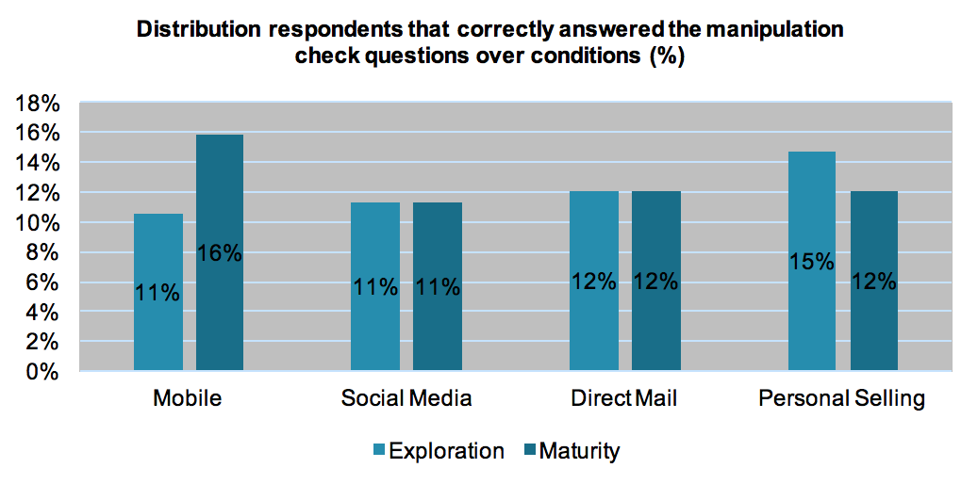

Figure 5 Distribution of all eligible respondents over the 8 conditions
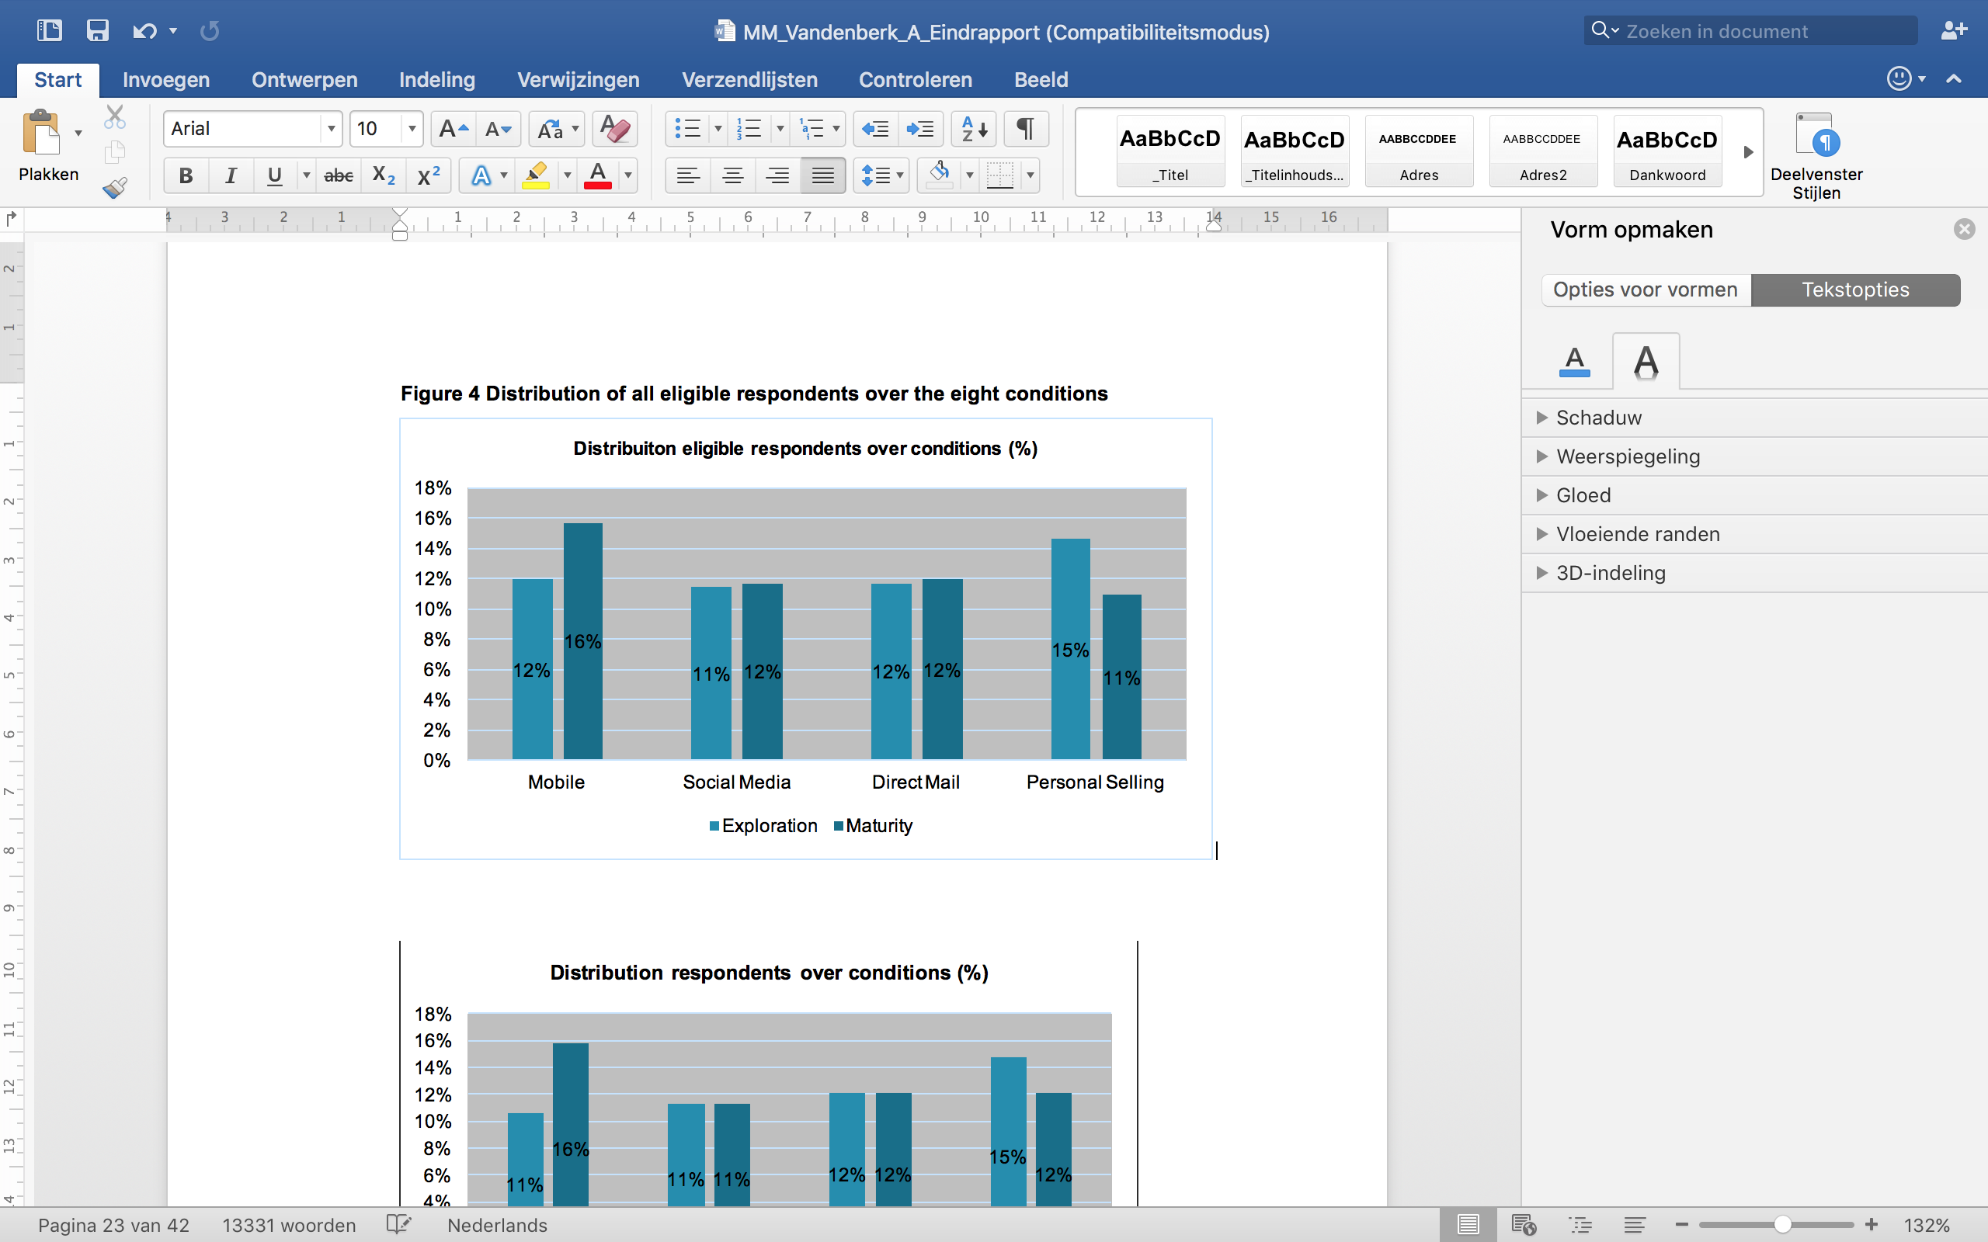
The dependent variable of this research is the WTA. The WTA is measured on a 7-point Likert-scale and is thus a metric variable that is interval scaled. The 2 channel characteristics personalization and intrusiveness are also measured on a 7-point Likert scale and are thus also interval scaled. Table 7 gives an overview of the descriptive statistics of the 3 metric variables. As a result of the 7-point Likert scale, all 3 variables have a minimum and maximum value of respectively 1 and 7. The mean value of the WTA shows that regardless of the different conditions respondents were assigned to, the average WTA is rather high, namely 4,88 out of 7. Next, according to the mean value of personalization, respondents see the channels that were used in this research as rather personalized (4,37 out of 7). For the level of intrusiveness there is no clear indication whether respondents perceive the channels as more or less intrusive (3,80 out of 7).
Table 7 Descriptive statistics of the variables WTA, personalization and intrusiveness over all respondents that correctly filled in the MCQ’s
 | Mean | Minimum | Maximum | Stdev.
WTA | 4,88 | 1 | 7 | 1,500
Personalization | 4,37 | 1 | 7 | 1,409
Intrusiveness | 3,80 | 1 | 7 | 1,405
In order to get a more detailed insight in the 3 metric variables, the average values have to be compared for each of the different conditions. The univariate tests in chapter 5.2 have to point out whether there exists a significant difference in the WTA, the level of personalization and the level of intrusiveness between the 2 CLC stages and across the different channels, and what the correct direction of the effects is. Figure 6 presents the average WTA per condition. The figure shows that respondents in the personal selling condition in general show the highest average WTA value (5,23 & 5,56). Further, the WTA is highest for respondents that received the invitation through personal selling in the maturity stage of the CLC (5,56 > 5,23). The overall lowest WTA is measured for respondents that received the mobile channel manipulation. More specific, the WTA is lowest for respondents that received the invitation through the mobile channel in the exploration stage of the CLC (4,14 < 4,64). Besides, for each channel manipulation, the WTA appears to be lower in the exploration stage than in the maturity stage manipulation. However, there is no clear indication in the literature overview about the expected direction concerning the WTA over the different CLC stages. This is discussed in chapter 5.2.
Figure 6 Average Willingness to Accept per condition
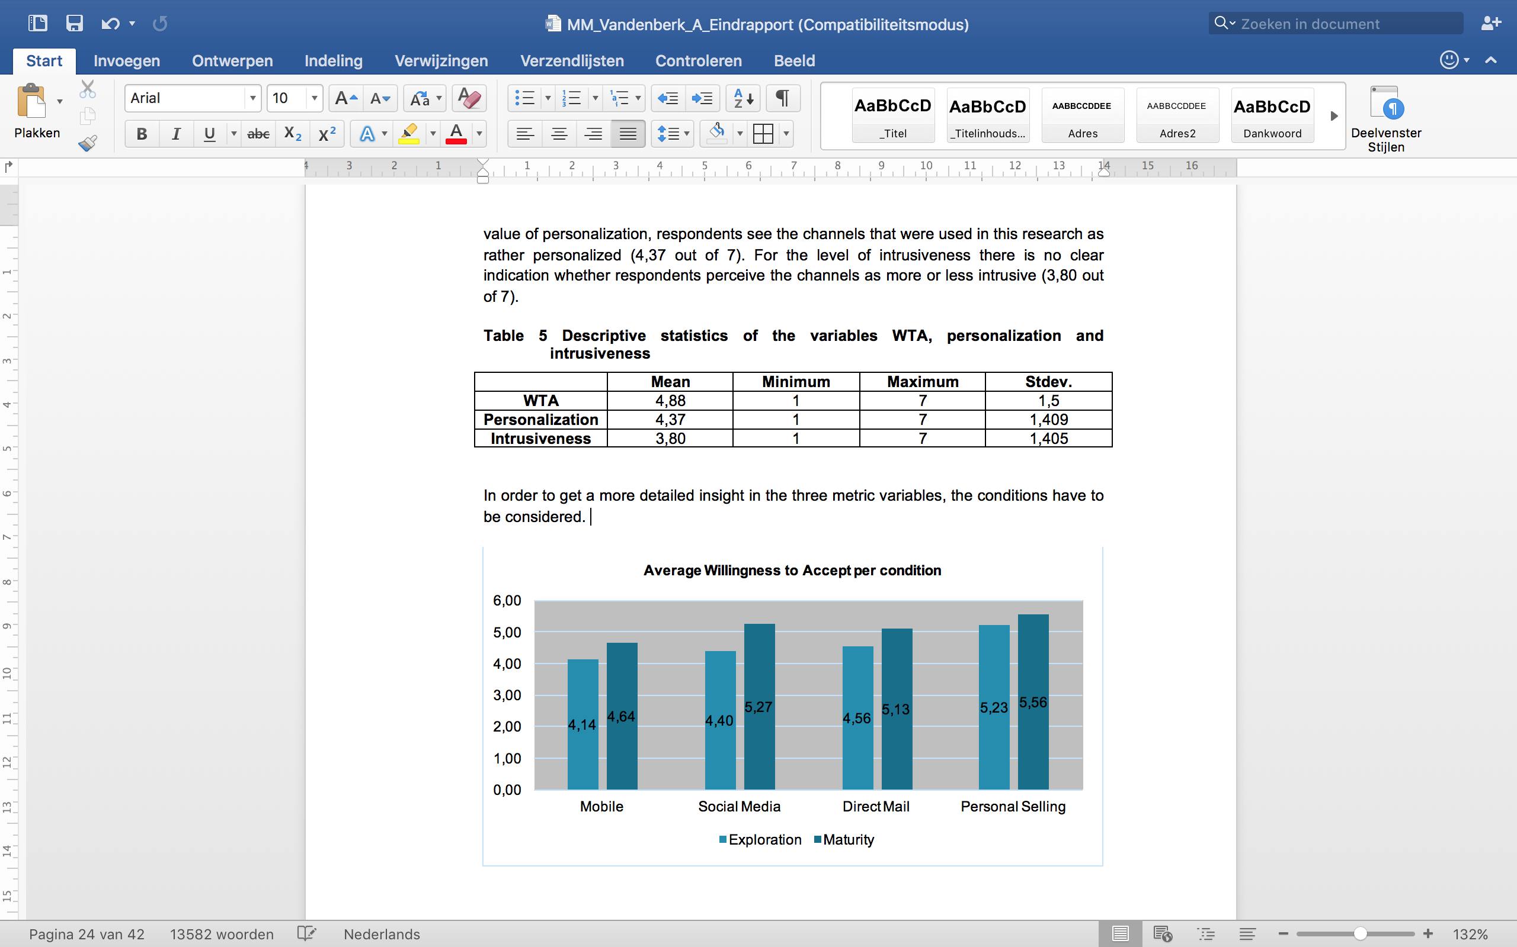
The average score on personalization per condition is represented by figure 7. According to this figure, personal selling is seen as the most personalized channel. There is practically no difference in the average value of personalization between the exploration and maturity stage for the personal selling condition. Also for the mobile channel there is only a small difference between the mean values for the exploration and maturity stage manipulation. Direct mail received the lowest personalization score, namely 3,84 out of 7, which indicates that there is no clear direction to whether respondents perceive the direct mail manipulation as either more or less personalized. Regarding the CLC stage manipulation, direct mail is seen as more personalized in the exploration stage of the CLC than in the maturity stage (5,13 > 4,56). The highest difference between the 2 CLC stages can be found for social media. Social media is perceived as more personalized in the maturity stage than in the exploration stage of the CLC (5,27 > 4,40). The same remark holds for the mobile channel (4,64 > 4,14). These results more or less match with what is hypothesized in chapter 3 (table 4).
Figure 7 Average score on personalization per condition
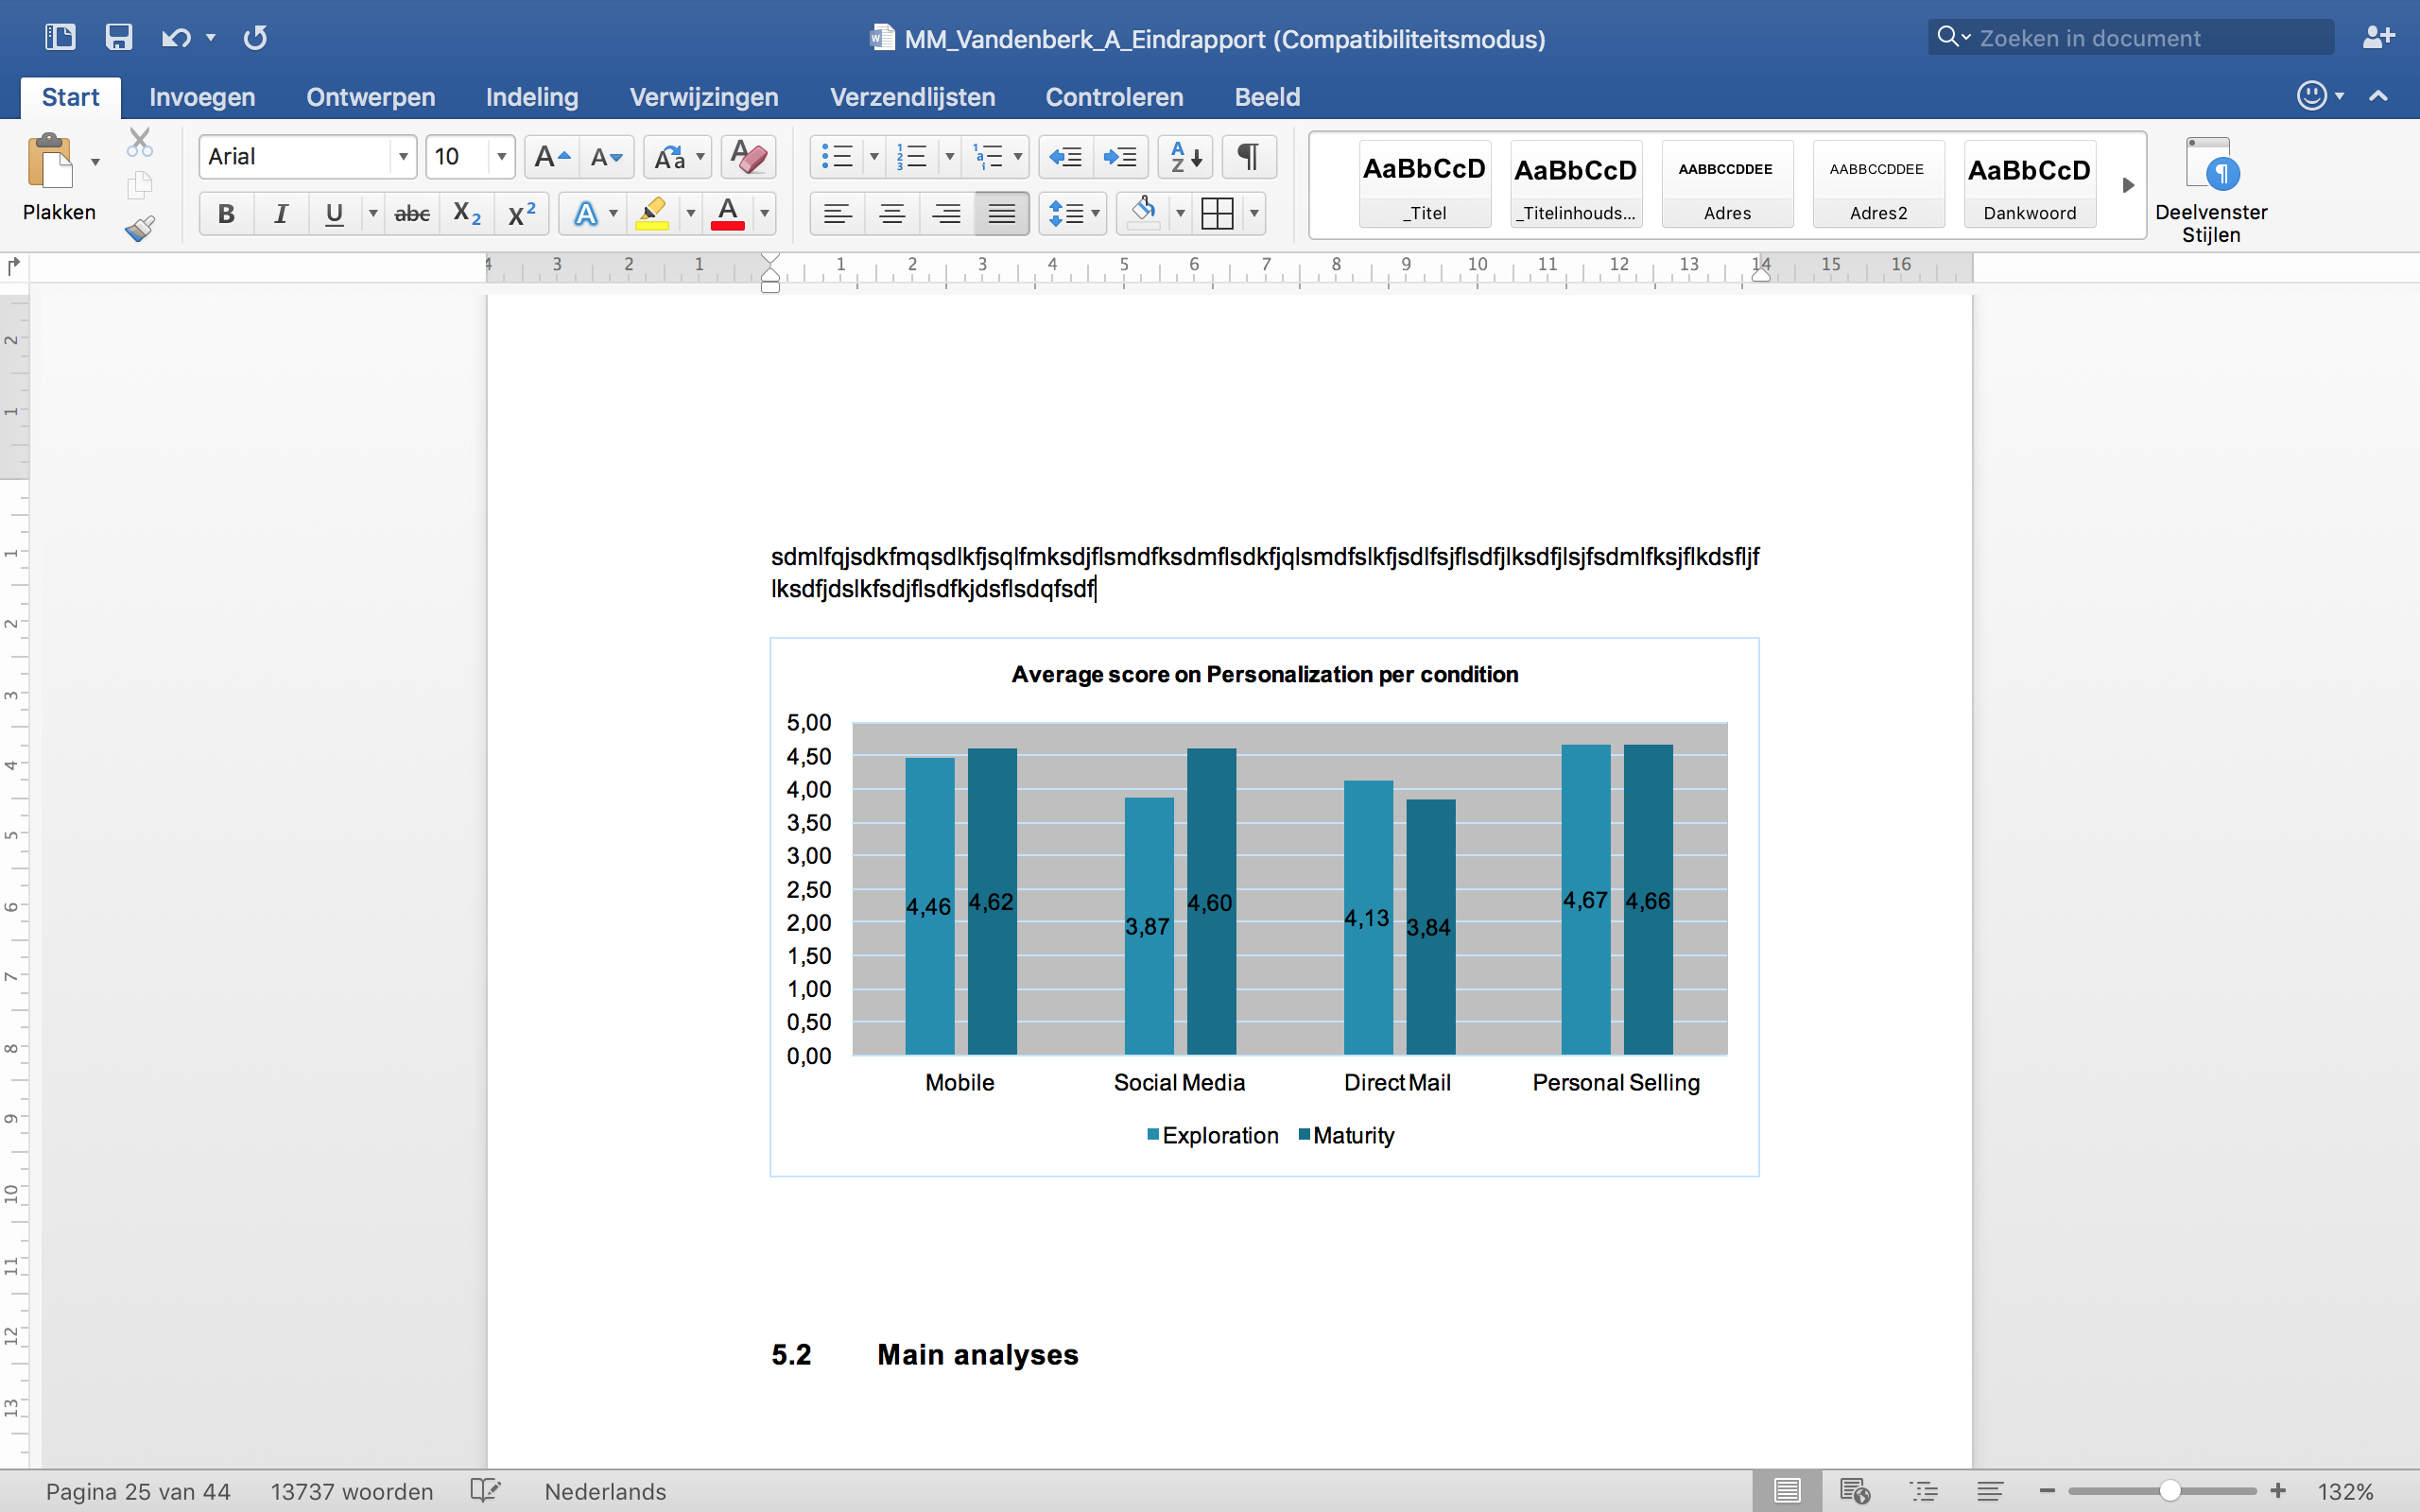
Regarding the level of intrusiveness, figure 8 shows that on the one hand the mobile channel is perceived as the most intrusive channel (4,64 and 4,68 out of 7). On the other hand, personal selling is seen as the least intrusive channel (3,15 and 3,22 out of 7). For each of the channels, the difference in the mean value between the 2 CLC stages is minimal, except for direct mail (3,88 - 3,38 = 0,50). According to figure 8, direct mail is perceived as more intrusive in the maturity stage than in the exploration stage (3,88 > 3,38).
Figure 8 Average score on intrusiveness per condition
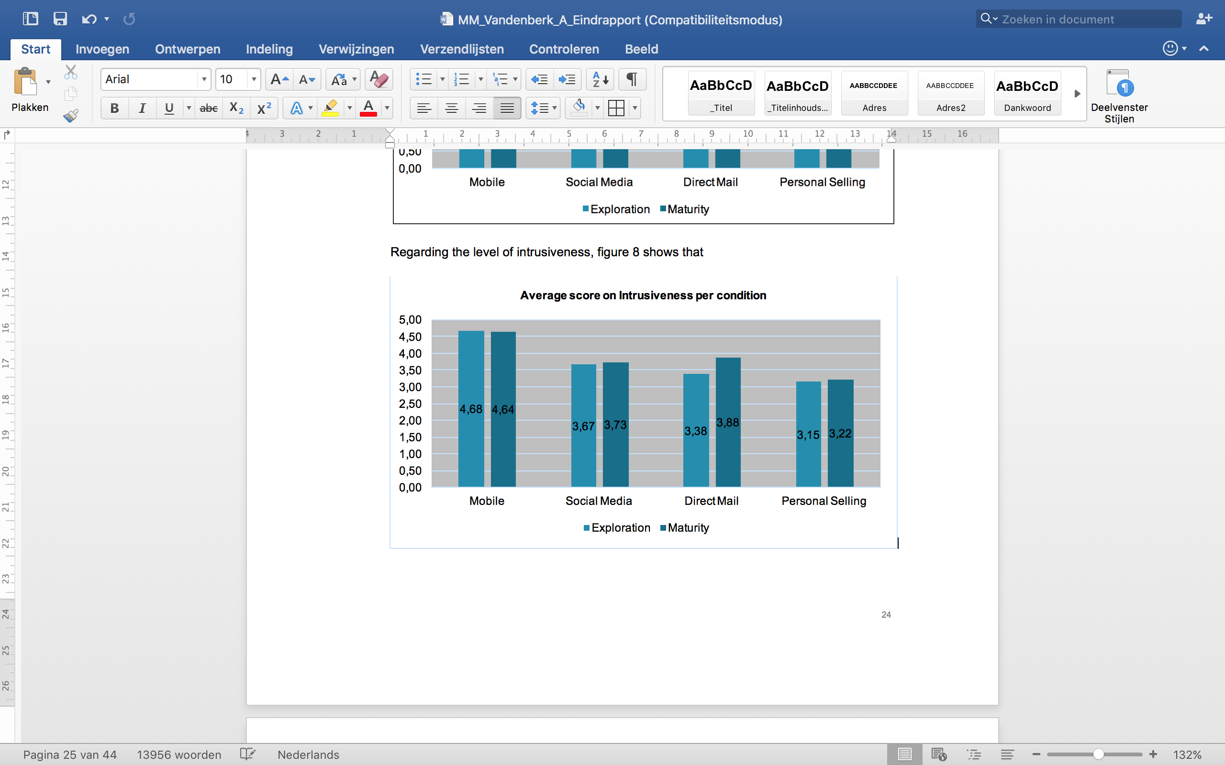

Main analyses
The purpose of this chapter is to test the hypotheses that are formulated in chapter 3, using several univariate tests. We start with hypothesis H1a concerning the influence of the channels on the WTA and continue with hypothesis H1b and H1c regarding the mediating role of the channel characteristics. Next, hypotheses H2 and H3 are discussed, concerning the influence of the CLC stages on the WTA and the interaction effect between the CLC stages and the different channels. To end the results chapter, the post hoc test concerning the channel preference is discussed. For the results, a cut-off value for alpha of 5% will be used.

Assumptions
Before analysing and interpreting the results, the assumptions for each of the univariate tests have to be verified and satisfied. Tables A.6, A.7 and A.8 (attachment 4) show the number of assumptions that have been satisfied for both the ANOVA analysis and the linear regressions.
The significance of the p-value (<0,05) of the Kolmogorov Smirnov test indicates that for both the ANOVA (H1a) analysis and the linear regressions R1 till R7 the residuals are not normally distributed. This implies that the null hypothesis stating that the residuals are normally distributed, has to be rejected. In order to solve this, several transformations of the WTA are used (log, squared and rooted transformation) for both types of analyses (ANOVA and linear regression), but neither transformation benefits the normal distribution of the residuals. Although this assumption is not satisfied, we decide to work further without normally distributed residuals, since the dataset contains a large number of respondents. Concerning the extreme observations, a standard deviation of 3 is allowed for both analyses, since a standard deviation of 2 would result in a loss of too much observations (16 in the case of the ANOVA analysis). A standard deviation of 3 results in a maximum of 4 extreme observations. All extreme observations are excluded from the analysis.
Next, regarding the linear regressions R1 till R7, the residuals are supposed to be free from autocorrelation. Since the used dataset is a cross section dataset, autocorrelation is out of the question. Next, in regression equation R1, not all relevant variables are yet included, as the control variables are to be included in regression equation R2 in a next step. Regarding regression equations R4 till R7, these equations are used to test for the mediating effect of the channel characteristics personalization and intrusiveness. As a result, these equations do not contain all relevant variables, but only the variables that are needed to analyse for the mediating role of the channel characteristics. Concerning the number of observations, a minimum of 10 respondents per parameter should be attained. With 265 respondents, a maximum of 4 extreme observations per regression analysis and a maximum of 9 parameters (the constant term included), this assumption is satisfied for each regression analysis. Finally, the VIF-values of the parameters included in the regression equations are far below 10. This implies there is no multicollinearity (Van Rompuy, 2014). After adding the control variables in regression equation R2, there appears to be a strong linear dependency between age, highest level of education and profession, since the VIF-values of the corresponding dummy variables are higher than 10. The Pearson correlation coefficients between the demographic variables indicate that especially being a student and being younger than 25 years old are highly correlated (PC = 0,669; p < 0,05). This is not surprising, since the majority of the respondents are students younger than 25, due to the sampling procedure used in this research. Since adding the highest level of education results in the highest increase in the adjusted R² (12,10% < 17,70%) and the most significant parameters in regression R2, the dummy variables for age and profession are excluded from the analysis. This results in much lower VIF-values for the dummy variables concerning the highest level of education.

The influence of the channels and the CLC stages on the response of consumers (H1a)
The influence of the channels on the response of consumers is tested via an ANOVA analysis. To facilitate the interpretation of the results, a new variable is created, based on the 4 channel dummies (1=MMS, 2=Social Media, 3=DM, 4=Personal selling).
Table 8 Results ANOVA analysis hypothesis H1a
 | N per group | Mean | F-stat | Df1 | Df2 | Sig. F-stat
Mobile | 70 | 4,44 | 4,848 | 3 | 261 | 0,003*
Social Media | 60 | 4,83
Direct Mail | 64 | 4,84
Personal Selling | 71 | 5,38
Total | 265 | 4,88
* two-sided p < 0,05
The results of the ANOVA analysis in table 8 show that there is a significant difference in the WTA between the different channels (F(3; 261) = 4,85; p < 0,05). The results indicate that there are significant differences concerning the WTA across the media, but they tend to go in another direction than was hypothesized in chapter 3. Therefore, we test two-sided. The results in table 8 show that the WTA is highest for personal selling (M = 5,38; SD = 0,174), followed by direct mail (M = 4,48; SD = 0,184) and social media (M = 4,83; SD = 0,190). The WTA appears to be lowest for the mobile channel (M = 4,44; SD = 0,176). Based on the Tukey post hoc test, there is only a significant difference between the WTA for personal selling and the mobile channel (MD = 0,94; p<0,05). We can thus conclude that there is a significant difference between the WTA over the different channels, but it tends to go in another direction than was expected. As a result, the null hypothesis of hypothesis H1a cannot be rejected. One possible reason for this deviation from the expectations is that we overestimated the level of intrusiveness for personal selling and overestimated the level of personalization for social media. Table A.9 and A.10 (attachment 5) give an overview of the estimated and actual levels of personalization and intrusiveness for each channel. It appears that the respondents view personal selling as less intrusive than expected, and social media as less personalized than expected. Besides, Venkatesan and Kumar (2004) indicate in their research that rich modes of communication (e.g. personal selling) have a bigger influence on the response of consumers than standardized modes of communication (e.g. telephone, direct mail). The high WTA for personal selling can thus be explained by its highest level of personalization and lowest level of intrusiveness, making it a rich mode of communication. Mobile on the other hand is seen as the most intrusive channel. On the one hand, his might be due to the fact that mobile is the most recent channel that is used in this research. As a result, respondents might not yet be very familiar with this channel. On the other hand, the LBA mechanism might have caused that respondents perceived the mobile channel scenario as more intrusive than any of the 3 other channel scenarios. Although mobile scores second highest on the level of personalization, the lowest WTA indicates that the level of intrusiveness weighs heavier for the mobile channel than its level of personalization. The other channels appear to have both a high level of personalization and a low level of intrusiveness, but respectively slightly lower and higher than personal selling. As a result, both channels have an intermediate effect on the WTA. Another possible explanation for the results is that the scenarios regarding the channel manipulation are not similar enough. That is, mobile, direct mail and social media all 3 have an explicit no opt-in, while personal selling has an implicit no opt-in.
Hypotheses H1a and H2 are also tested via a linear regression analysis (equation R1; table 6). In this regression equation the 3 channel dummies (mobile, social media and direct mail) and the exploration stage dummy are regressed on the WTA (table 6). Personal selling and the maturity stage are the benchmarks in this case. It is meaningful to interpret the results of regression equation R1. The significance of the F-test amounts up to 0,000 and the model has an adjusted R² of 12,10%. The R² of equation R1 amounts up to 13,40%, which implies that 13,40% of the variance of the WTA is explained by the variance of the 3 channel dummies and the exploration stage dummy. Table 9 shows that for hypothesis H1a the results of regression R1 completely match the results of the ANOVA analysis. Next, regarding hypothesis H2 the WTA in the exploration stage (β_{Exploration}=-0,640; p < 0,05), appears to be lower than the WTA in the maturity stage of the CLC. The results support the theory of the Elaboration Likelihood Model, that states that consumers are expected to be more likely to process promotional information about a brand they are very familiar with in terms of usage (Cacioppo & Petty, 1985 as cited by Bridges et al., 2006). Therefore, we find support for hypothesis H2b and not for hypothesis H2a.
Table 9 Results linear regression H1a (R1)
 | R1
 | Unstandard. β | Sig. | Standard error | VIF
Constant | 5,931 | 0,000* | 0,188
Exploration | -0,640 | 0,000* | 0,167 | 1,014
Mobile | -1,232 | 0,000* | 0,230 | 1,505
SocialMedia | -0,707 | 0,003* | 0,239 | 1,447
DirectMail | -0,767 | 0,001* | 0,234 | 1,468
*two-sided p < 0,01
In the next step of the regression analysis, the control variables (demographic variables) are added to regression equation R1, resulting into regression equation R2 (table 6). The only variables that are added to regression equation R1 are the dummy variables regarding gender and highest level of education. Regarding the dummy variables for education, professional bachelor is left out of the analysis. This implies that the benchmark consists now of personal selling, the maturity stage, females and respondents of whom the highest level of education is a professional bachelor. The results of the remaining regression equation are presented in table 10. It is meaningful to interpret the results in table 10, since the F-test is significant (p < 0,05) and the R² amounts up to 21,50%. According to the adjusted R², 17,70% of the variance of the WTA is explained by the variance of the exploration stage, channel, gender and highest level of education dummies. In addition to the findings of regression equation R1, male respondents appear to have a lower WTA (β_{Male}=-0,414; p < 0,05) than females. This is not surprising, as shopping for clothing lies more in the interest spheres of women than of men. Next, respondents of whom the highest level of education is an academical bachelor (β_{AcBachelor}=0,904; p < 0,05) or secondary school (β_{SecondarySchool}=0,525 ; p < 0,05) have a higher WTA than respondents of whom the highest level of education is a professional bachelor. In contrast, respondents who obtained a PhD (β_{PhD}=-1,461; p < 0,05) appear to have a lower WTA than respondents who obtained a professional bachelor. Since there are only 4 respondents who obtained a PhD, it is not sure whether this result is reliable. The results of the other parameters correspond with the results of regression equation R1.
Table 10 Results regression equation R2
 | R2
 | Unstandard. β | Sig. | Standard error | VIF
Constant | 5,848 | 0,000* | 0,222
Exploration | -0,702 | 0,000* | 0,167 | 1,060
Mobile | -1,132 | 0,000* | 0,227 | 1,537
SocialMedia | -0,714 | 0,003* | 0,238 | 1,501
DirectMail | -0,745 | 0,001* | 0,229 | 1,489
Male | -0,414 | 0,019** | 0,175 | 1,059
Other education | 0,069 | 0,941 | 0,934 | 1,024
PrimarySchool | -0,369 | 0,505 | 0,553 | 1,060
SecondarySchool | 0,525 | 0,041** | 0,256 | 1,199
AcBachelor | 0,904 | 0,001* | 0,258 | 1,219
Master | 0,130 | 0,524 | 0,204 | 1,304
Phd | -1,461 | 0,032** | 0,677 | 1,068
AdultEduc | 0,465 | 0,376 | 0,524 | 1,105
*two-sided p < 0,01; **two-sided p < 0,05

The mediating effect of the channel characteristics
As indicated in chapter 3, the level of orthogonality between the channel characteristics (personalization and intrusiveness) is questioned. Therefore, before analysing the mediating role of personalization and intrusiveness, a correlation analysis has to point out the true level of orthogonality between both concepts. The Pearson correlation test is used for this analysis and indicates that there is no significant correlation between the channel characteristics personalization and intrusiveness (PC = -0,038; p > 0,05). This implies that both concepts cover 2 separate dimensions, rather than 1 dimension which would have been the case if the Pearson correlation measure was significant and highly negative in case of direct extremes or highly positive in case both concepts were overlapping. The same conclusion holds per condition; there is no significant and highly positive/negative correlation between both channel characteristics. These findings are in line with the theory of the Elaboration Likelihood Model, which states that a higher personal relevance and personalization lead to a higher response of consumers and thus, personalization and intrusiveness are not correlated (Micheaux, 2011). Therefore, both personalization and intrusiveness can be included in the model to test for mediation.
In order to speak of a mediation effect, there are 4 requirements: the IV’s (channel dummies) have to have a significant influence on the mediator (personalization or intrusiveness) (i), the IV (channel dummies) has to have a significant influence on the DV (WTA) (ii), the mediator (personalization or intrusiveness) has to have a significant influence on the DV (WTA) (iii) and the effect of the IV (channel dummies) on the DV (WTA) has to be reduced when the mediator (personalization or intrusiveness) is added to the regression (iv). This results in 4 regression equations (table 6) that have to be executed for each mediator (each channel characteristic). For regression R4, R5 and R7, personal selling represents the benchmark.
Table 11 gives an overview of the results of these 4 regressions. Regression R4a and R4b test the effect of the channel dummies on the mediators: personalization (R4a) and intrusiveness (R4b). The results show that the level of personalization is significantly lower for direct mail (β_{DirectMail} = -0,678; p < 0,05) compared to personal selling. This implies that compared to personal selling, only direct mail qualifies to have personalization as a mediator. For intrusiveness, all 3 channels appear to have a significant influence on the mediator, compared to personal selling. The positive signs of the parameters of the 3 channel dummies in the regression indicate that personal selling knows a lower level of intrusiveness than all other 3 channels. Next, regression R5 tests the effect of the channel dummies on the WTA. Prior analyses already indicated that the channel dummies have a significant effect on the WTA (5.2.2). Regression equations R6a and R6b test for the effect of the mediators, respectively personalization and intrusiveness, on the WTA.
Personalization (β_{Personalization} = 0,366; p < 0,05) and intrusiveness (β_{Intrusiveness} = -0,408; p < 0,05) both have a significant influence on the WTA. The reversed signs of the parameter coefficients indicate that both channel characteristics have an opposite effect on the WTA. Personalization appears to have a positive influence on the WTA, meaning that when personalization increases with 1, the average WTA increases with 0,366. Intrusiveness on the contrary appears to have a negative effect on the WTA. When intrusiveness increases with 1, the average WTA decreases with 0,408. This implies that the results might be primarily driven by intrusiveness. Finally, regression R7a and R7b have to indicate whether the channel characteristics have a true mediating effect for specific channels on the WTA. The results in table 11 show that personalization acts as a full mediator for direct mail (β_{DirectMail} = -0,432; p > 0,05) in comparison to personal selling, since the parameter of the direct mail channel dummy is no longer significant, indicating that the effect of direct mail on the WTA has reduced to zero (which is in line with requirement (iv)). Intrusiveness however, acts as a full mediator for social media (β_{SocialMedia} = -0,405; p > 0,05) and direct mail (β_{DirectMail} = -0,432; p > 0,05) in comparison to personal selling, but has a partial mediating influence on the mobile channel (β_{Mobile} =
-0,535; p < 0,05) as the negative parameter value of mobile reduced from -0,937 to
-0,535. The same conclusion is reached when both mediators are added to the regression equation R7 together. Only mobile (β_{Mobile} = -0,569; p < 0,05) has a significantly lower effect on the WTA than personal selling (β_{Constant} = 5,200; p < 0,05). The coefficients of social media (β_{SocialMedia} = -0,319; p > 0,05) and direct mail (β_{DirectMail} = -0,335; p > 0,05) are no longer significant and their negative values have reduced.

Table 11 Results mediation analysis
 |  | Unstandard. β | Sig. | Standard error | VIF
R4a | Constant | 4,662 | 0,000* | 0,165
R4a | Mobile | -0,105 | 0,655 | 0,234 | 1,461
R4a | SocialMedia | -0,429 | 0,080 | 0,244 | 1,427
R4a | DirectMail | -0,678 | 0,005* | 0,240 | 1,442
R4b | Constant | 3,183 | 0,000* | 0,154
R4b | Mobile | 1,474 | 0,000* | 0,219 | 1,461
R4b | SocialMedia | 0,517 | 0,024** | 0,228 | 1,427
R4b | DirectMail | 0,442 | 0,049** | 0,224 | 1,442
R5 | Constant | 5,380 | 0,000* | 0,174
R5 | Mobile | -0,937 | 0,000* | 0,247 | 1,461
R5 | SocialMedia | -0,547 | 0,035** | 0,258 | 1,427
R5 | DirectMail | -0,537 | 0,035** | 0,253 | 1,442
R6a | Personalization | 0,366 | 0,000* | 0,058 | 1
R6b | Instrusiveness | -0,408 | 0,000* | 0,059 | 1
R7a | Constant | 3,864 | 0,000* | 0,310
R7a | Mobile | -0,919 | 0,000* | 0,220 | 1,468
R7a | SocialMedia | -0,535 | 0,020** | 0,228 | 1,452
R7a | DirectMail | -0,370 | 0,105 | 0,227 | 1,491
R7a | Personalization | 0,355 | 0,000* | 0,058 | 1,034
R7b | Constant | 6,639 | 0,000* | 0,255
R7b | Mobile | -0,535 | 0,027** | 0,241 | 1,737
R7b | SocialMedia | -0,405 | 0,086 | 0,235 | 1,471
R7b | DirectMail | -0,432 | 0,061 | 0,230 | 1,477
R7b | Intrusiveness | -0,357 | 0,000* | 0,063 | 1,186
R7 | Constant | 5,200 | 0,000* | 0,371
R7 | Mobile | -0,569 | 0,016** | 0,235 | 1,783
R7 | SocialMedia | -0,319 | 0,166 | 0,230 | 1,482
R7 | DirectMail | -0,335 | 0,139 | 0,226 | 1,516
R7 | Personalization | 0,287 | 0,000* | 0,057 | 1,038
R7 | Instrusiveness | -0,321 | 0,000* | 0,062 | 1,191
*two-sided p < 0,01; **two-sided p < 0,05
The difference in the level of personalization and intrusiveness between the 4 channels is also investigated in this chapter. In order to facilitate the interpretation of the results, the channel variable that includes all 4 dummy variables is used (1=MMS, 2=Social Media, 3=DM, 4=Personal selling). The results in table 12 indicate that direct mail is seen as the least personalized channel (F(3, 261) = 3,298; p < 0,05). Personal selling is seen as the most personalized (M=4,66), followed by mobile (M = 4,56) and social media. This can be explained by their level of interaction and their ability to personalize the conversation. Personal selling can be seen as most interactive (bi-directional oral conversation in physical presence), followed by mobile (bi-directional oral conversation), social media (bi-directional written conversation) and lastly direct mail (one-directional written conversation).
Table 12 Results ANOVA analysis regarding the level of personalization per channel
 | N per group | Mean | F-stat | Df1 | Df2 | Sig. F-stat
Mobile | 70 | 4,56 | 3,298 | 3 | 261 | 0,021**
Social Media | 60 | 4,23
Direct Mail | 64 | 3,98
Personal Selling | 71 | 4,66
Total | 265 | 4,37
** two-sided p < 0,05
According to the results in table 13, the respondents see mobile as the most intrusive channel (F(3, 261) = 16,017; p < 0,05) in comparison to the other channels. This might be due to the fact that in this research, the mobile channel operates via a LBA mechanism. Another possible explanation is that mobile is the most recent channel that is used in this research. As a result, respondents might not yet be very familiar with this channel. Next, personal selling is seen as the least intrusive channel, possibly as a result of the personalized conversation.
Table 13 Results ANOVA analysis regarding the level of intrusiveness per channel
 | N per group | Mean | F-stat | Df1 | Df2 | Sig. F-stat
Mobile | 70 | 4,66 | 16,017 | 3 | 261 | 0,000*
Social Media | 60 | 3,70
Direct Mail | 64 | 3,63
Personal Selling | 71 | 3,18
Total | 265 | 3,80
* two-sided p < 0,01

The influence of CLC stages on the response of consumers (H2)
In order to test the influence of the CLC stages on the response of consumers, an independent samples t-test is used. This test compares the average WTA for the 2 CLC stages, namely exploration and maturity. Since 2 opposite hypotheses were formulated in chapter 3.2, there is no clear indication about the direction of the effect of the 2 CLC stages on the WTA of consumers. As a result, we use the two-sided p-value of the independent samples t-test to test hypothesis H2.
Table 14 Results independent samples t-test
 | N | Mean | Sig. Levene’s test | T-value | Sig.
Exploration | 129 | 4,64 | 0,204 | -2,602 | 0,01*
Maturity | 136 | 5,11 | 0,204 | -2,602 | 0,01*
*two-sided p < 0,01
Since there are enough observations per cell (129, 136 > 30), the results of the independent samples t-test can be correctly interpreted. Table 14 shows that the WTA is significantly higher in the maturity stage than in the exploration stage of the CLC. This is also visible in figure 6. The results of the independent samples t-test are in line with the results of regression equation R1.

The interaction between the 4 channels and the different CLC stages (H3)
In order to analyse the interaction between the 4 channels and the different CLC stages, 4 interaction terms (exploration is multiplied with each channel) are added to regression equation R2, forming regression equation R3. In order to avoid the dummy variable trap, the exploration dummy is removed from the regression equation. As a result, the benchmark category consists of personal selling, females and respondents that obtained a professional bachelor as their highest level of education.
Table 15 gives an overview of the results of regression analysis R3. It is meaningful to interpret the results in table 15, since the F-statistic is significant (p < 0,05) and the R² amounts up to 21,80%. Regarding the adjusted R², 17,10% of the variance of the WTA is now explained by the variance of the variables included in the regression equation. Including the interaction terms leads as a result to a slight decrease in the explained variance (17,00% < 17,70%). This implies that the slight improvement in the R² (21,50% < 21,80%) is penalised by the higher number of predictors used in the regression. According to the results in table 15, inserting the interaction terms results still in a lower WTA for the mobile channel (β_{Mobile}=-1,136; p < 0,05) than for personal selling. However, since the parameters of social media (β_{SocialMedia}=-0,524; p > 0,05) and direct mail (β_{DirectMail}=-0,655 ; p > 0,05) are no longer significant, the WTA for social media and direct mail are equal to the WTA of personal selling. The reason is that there appears to be a difference in effect for social media and direct mail according to the CLC stage the consumer is in. Compared to personal selling, the WTA of consumers that received the message via social media (β_{Exploration*SocialMedia}=-0,952; p < 0,05) or direct mail (β_{Exploration*DirectMail}=-0,757; p < 0,05) in the exploration stage is lower than the WTA of consumers in the maturity stage. This implies, consumers appear to be more willing to react positively to an invitation they received via social media or direct mail, in comparison to personal selling, in the maturity stage than in the exploration stage of the CLC. For the other channels there appears to be no difference in effect between the 2 CLC stages. Regarding the difference in effect for social media, this is in line with the expectations, as hypothesis H3b states that the WTA for social media is higher in the maturity stage than in the exploration stage of the CLC. As a result, we can reject the null hypothesis of hypothesis H3b. Concerning the other channels, this is not in line with what is hypothesized in chapter 3.3, since the WTA of the mobile channel and personal selling are expected to be higher in the maturity than in the exploration stage. The opposite effect is expected for direct mail, which is also not in line with the results. As a result, we cannot reject the null hypothesis of hypotheses H3a, H3c and H3d.
Table 15 Results regression equation R3
 | R3
 | Unstandard. β | Sig. | Standard error | VIF
Constant | 5,792 | 0,000* | 0,271
Mobile | -1,136 | 0,000* | 0,320 | 3,040
SocialMedia | -0,524 | 0,139 | 0,353 | 3,278
DirectMail | -0,655 | 0,054 | 0,338 | 3,219
Male | -0,412 | 0,020** | 0,176 | 1,060
OtherEduc | 0,045 | 0,963 | 0,947 | 1,044
PrimarySchool | -0,407 | 0,466 | 0,557 | 1,066
SecondarySchool | 0,538 | 0,038** | 0,257 | 1,204
AcBachelor | 0,890 | 0,001* | 0,262 | 1,249
Master | 0,117 | 0,572 | 0,206 | 1,316
Phd | -1,523 | 0,027** | 0,684 | 1,082
AdultEduc | 0,446 | 0,402 | 0,531 | 1,125
Exploration*Mobile | -0,537 | 0,099 | 0,324 | 1,539
Exploration*SocialMedia | -0,952 | 0,007* | 0,348 | 1,887
Exploration*DirectMail | -0,757 | 0,023** | 0,331 | 1,803
Exploration*PersonalSelling | -0,593 | 0,073 | 0,329 | 2,058
*two-sided p < 0,01; **two-sided p < 0,05
Figure 6 and 7 regarding the average WTA and the average level of personalization per condition show that there exists a great difference in the level of personalization between the 2 CLC stages for direct mail and social media. An ANOVA analysis is used to test whether these differences are significant. The results show that there is only a significant difference visible for social media (F(1, 58) = 4,470; p < 0,05), namely that the level of personalization is higher in the maturity stage than in the exploration stage of the CLC. These results suggest that personalization should be responsible for the interaction effect for social media. In order to verify this, a mediation analysis is run with the respondents that received the social media manipulation. 3 regression analyses are executed: the effect of the CLC stage on the WTA (i), the effect of personalization on the WTA (ii) and the effect of the CLC stage and personalization together on the WTA (iii). The results of the first 2 regressions (i and ii) show that CLC stage (β_{Exploration} = -0,867; p < 0,05) and personalization (β_{Personalization} = 0,544; p < 0,05) both have a significant influence on the WTA. The negative parameter of exploration on the one hand, indicates that consumers are more willing to accept the invitation in the maturity stage than in the exploration stage of the CLC. The positive parameter of personalization on the other hand, indicates that if personalization increases with 1, the WTA increases with 0,544. Since in the third regression analysis the parameter of personalization is significant (β_{Personalization}= 0,495; p < 0,05), while the parameter of exploration is no longer significant (β_{Exploration} = -0,504; p > 0,05), personalization acts as a full mediator for social media. The mediating role of intrusiveness for social media is also tested, using the same 3 regression equations. The results of the first regression (i) remain the same for both mediators. The results of the second regression equation (ii) show that the level of intrusiveness does not influence the WTA (β_{Intrusiveness}= -0,010; p > 0,05). This implies intrusiveness does not operate as a mediator for social media.
The results suggest that the level of personalization explains the difference in effect of social media on the WTA, over the 2 CLC stages. The level of personalization of social media appears to be higher in the maturity stage than in the exploration stage of the CLC. This might propose that social media is seen as a more interactive and personal relevant channel when the customer is more familiar with the brand. In the maturity stage of the CLC for example, a message from a brand might be more personal relevant for a consumer than in the exploration stage. Next, concerning the level of interaction, a message sent via social media to a consumer in the exploration stage might be seen as pushed (one-directional) and thus offering little interaction. In contrast, a message received from a brand in the maturity stage might seem as more two-directional, since you are interested in the brand and the social media channel enables you to interact (via comments or likes) with the brand.
The same regression equations that are used to test the mediation effects of personalization and intrusiveness on social media, are used for direct mail. After only selecting the respondents that received the direct mail manipulation, the first regression equation (i) shows that the CLC stage does not have an influence on the WTA (β_{Exploration}= -0,563; p > 0,05). This immediately implies that both personalization and intrusiveness do not operate as a mediator for direct mail and thus do not explain the interaction effect. This was also clear from the results of the ANOVA analysis (F(1, 62) = 2,557; p > 0,05) that tested the difference in the level of personalization between the CLC stages for direct mail. A possible explanation for the interaction effect for direct mail might not lie in the difference in interaction between the 2 CLC stages, but possibly in the perceived relevance of the message itself. Consumers might see the message they receive via direct mail in the maturity stage as less obtrusive and more personalized, since the direct mail is personally addressed and the content is more in line with the receiver’s interests when they are loyal customers (Dolnicar et al., 2013).
Regarding the other 2 channels, the mobile manipulation can be seen as very obtrusive, due to the LBA mechanism, resulting in a low WTA, no matter if a consumer is a loyal client or not. Personal selling on the other hand is most personalized and interactive as a result of the pleasant personal conversation, regardless of the CLC stage (Venkatesan and Kumar, 2004). Therefore, the WTA of mobile and personal selling remains the same over the 2 CLC stages as their general level of personalization and intrusiveness does not change over time.

Post hoc analysis channel preference
The channel preference concerns the question in which the 4 channel formats are presented together and the respondent has to indicate the channel for which his or her WTA would be highest, taking into account the scenarios they received at the beginning of the questionnaire. The channel preference is analysed in 2 steps. Step 1 analyses the overall preference for a specific channel, while step 2 examines whether there is a difference in preference among the 2 CLC stages.
Step 1 is tested via a χ²-test for goodness of fit. It is useful to interpret the results of the test, since the minimum expected cell frequency is bigger than 1 (65,3) and the minimum expected count less than 5 is smaller than 20% (0,0%). The results indicate that there is no equal preference between the 4 channels (χ²=40,686; p < 0,05). Figure 9 shows that personal selling appears to enjoy the highest preference (34,48%), followed by social media (28,74%) and direct mail (28,35%). The mobile channel is preferred the least (8,42%). The results of this analysis are in line with the results in section 5.2.3.
Figure 9 Number of respondents per preferred channel (step 1)
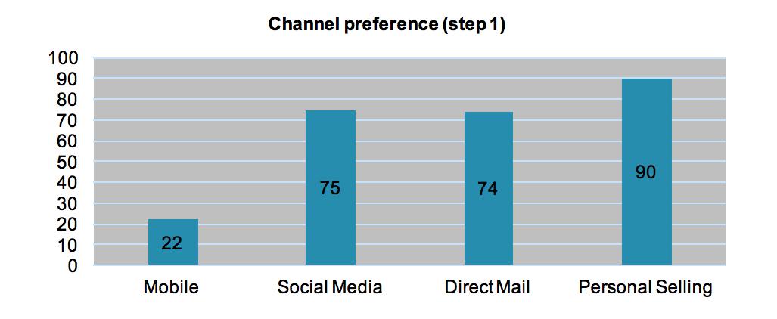
Next, step 2 is tested via a χ²-test for independence. The results of the analysis indicate that there is no significant difference in preference for the 4 channels, between the 2 CLC stages. The minimum expected cell frequency is bigger than 1 (10,70) and the minimum expected count less than 5 is smaller than 20% (0,0%). Figure 10, that represents the percentage of respondents per channel and per CLC stage, indicates that each channel has an equal chance to be chosen in each stage of the CLC. The channel preference percentages do not differ much between the 2 CLC stages. The results of this analysis are not in line with the results reported in section 5.2.5, where there was a significant interaction effect for both social media and direct mail pointing in the direction of a higher WTA in the maturity stage. Regarding the other channels, the results of both tests match, as in section 5.2.5 there was also no significant difference in the WTA over the 2 CLC stages for the other channels. One possible explanation for this different outcome might be omitted variables. In section 5.2.5, gender and highest level of education were added to the regression equation. Besides, regarding the preference question, respondents had the choice between 4 channels, while in section 5.2.5 there was only 1 channel present. Also, after analysing the results of the comment section it appeared that respondents did not know whether they had to keep in mind the received scenarios to answer the question regarding the channel preference. This forms another limitation of the research as it was not mentioned in the questionnaire question itself that respondents should keep in mind the received scenarios.
Figure 10 Channel preference per CLC stage (step 2)
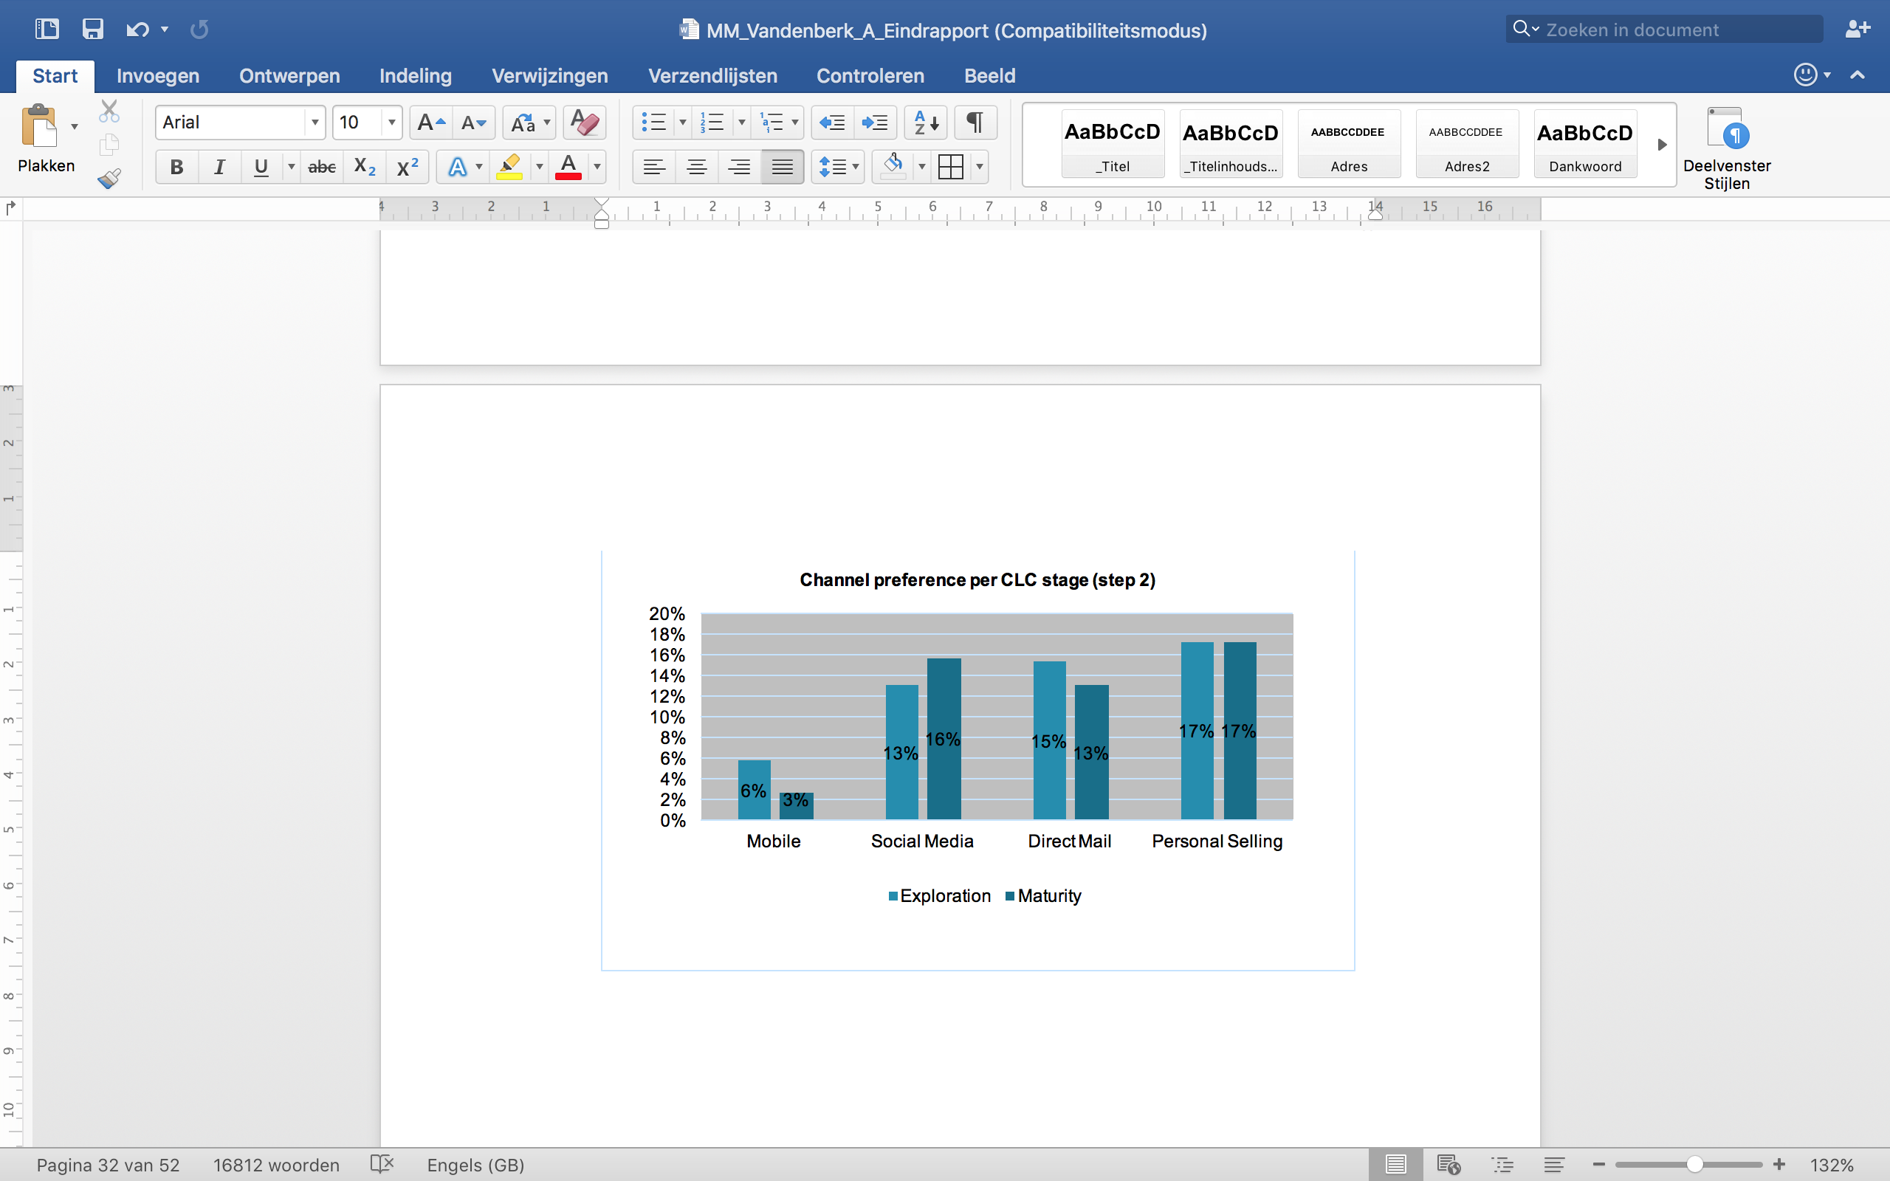

Conclusion and implications for managers
In this part of the research the results that are found in the results section are summarized and related to the existing theories and the concepts from the literature overview. We will formulate an answer to the central problem statement of this research. First a general conclusion is given. Next, we discuss what implications this research entails for retailers.

Conclusion
The introduction of this research indicates that the retail landscape is moving from a multi-channel environment to an omni-channel environment. As a result, retailers can nowadays communicate with their customers simultaneously and interchangeably through multiple channels. With this study we want to provide a starting point for the omni-channel challenge by implementing channels in this research that are a result of the ongoing digitalization (e.g. mobile), although we still focus rather on the sequential use of channels than on their simultaneous. The goal of this research is to indicate which channels retailers should use to communicate with customers at which stage of the CLC. Although multiple channels and CLC stages exist, we limited the research to 4 channels (mobile, social media, direct mail and personal selling) and 2 CLC stages (exploration and maturity).
The research in this master thesis suggests that consumers are more likely to accept a promotional invitation when they receive this invitation via personal selling, followed by direct mail and social media. Their intention to accept the invitation is lowest when the message is received via mobile. Important to remark here is that after analysing the channel preference of consumers, in which the respondents received all 4 channels instead of 1, we found the same results. The results indicate that personal selling is preferred more by consumers than the mobile channel, due to the former’s high level of personalization and low level of intrusiveness. This finding is in line with the research of Venkatesan and Kumar (2004), who state that rich modes of communication (e.g. personal selling) have a bigger influence on the response of consumers than standardized modes of communication (e.g. telephone, direct mail). Mobile on the contrary is seen as the most intrusive channel. On the one hand, this might be due to the fact that mobile is the most recent channel that is used in this research. This might imply that respondents are not yet very familiar with the channel. On the other hand, the LBA mechanism might have caused that respondents perceived the mobile channel scenario as more intrusive than any of the 3 other channel scenarios. Although mobile scores second highest on the level of personalization, the lowest WTA for this channel indicates that the level of intrusiveness weighs heavier for the mobile channel than its level of personalization. The other channels appear to have both a high level of personalization and a low level of intrusiveness, but respectively slightly lower and higher than personal selling. As a result, both channels have an intermediate effect on the WTA. Another possible explanation for the the results is that the scenarios regarding the channel manipulation are not similar enough. That is, mobile, direct mail and social media all 3 have an explicit no opt-in, while personal selling has an implicit no opt-in.
Next, from the research we found support that the 2 channel characteristics, personalization and intrusiveness, cover 2 orthogonal concepts that are not related to one another. As a result, both concepts could be used to test their explanatory power for the effect of the channels on the intention to accept the invitation. In line with our expectations, personalization appears to influence the WTA in a positive way, while intrusiveness seems to have a negative influence. The research further indicates that personalization acts as a full mediator for direct mail, while intrusiveness acts as a full mediator for social media & direct mail and as a partial mediator for the mobile channel. In addition, the difference in the level of personalization and intrusiveness among the 4 channels is examined. Regarding the level of personalization, it appears that direct mail is seen as the least personalized channel. Personal selling is seen as the most personalized, followed by mobile and social media. This can be explained by their level of interaction and their ability to personalize the conversation. Personal selling can be seen as most interactive (bi-directional oral conversation in physical presence), followed by mobile (bi-directional oral conversation), social media (bi-directional written conversation) and lastly direct mail (one-directional written conversation). Concerning the level of intrusiveness then, mobile seems to be the most intrusive channel. This might again be due to LBA mechanism or the fact that mobile is the most recent channel that is used in this research. Next, personal selling is seen as the least intrusive channel, possibly thanks to the personalized conversation.
Further, although 2 opposing effects were expected, the results of this research show that respondents are more likely to accept a promotional invitation in the maturity stage of the CLC than in the exploration stage of the CLC. The results are in line with the theory of the Elaboration Likelihood Model, that states that consumers are expected to be more likely to process promotional information about a brand they are very familiar with in terms of usage (Cacioppo & Petty, 1985 as cited by Bridges et al., 2006). A similar conclusion followed from the research of Oskamp (1977; as as cited by Gázquez-Abad et al., 2011), who found that positive past experiences with a brand or retailer lead to favourable attitudes and thus to a higher response likelihood of the consumer to promotional activities.
Lastly, the research indicates that in comparison to personal selling, the WTA differs among the exploration and maturity stage for social media and direct mail. For both channels, consumers are more willing to accept the invitation in the maturity stage than in the exploration stage of the CLC. The descriptive statistics suggest that the level of personalization explains the difference in effect of social media on the WTA, over the 2 CLC stages. The level of personalization of social media appears to be higher in the maturity stage than in the exploration stage of the CLC. This might propose that social media is seen as a more interactive and personal relevant channel when the customer is more familiar with the brand. In the maturity stage of the CLC for example, a message from a brand might be more personal relevant for a consumer than in the exploration stage. Next, concerning the level of interaction, a message sent via social media to a consumer in the exploration stage might be seen as pushed (one-directional) and thus offering little interaction. In contrast, a message received from a brand in the maturity stage might seem as more two-directional, since you are interested in the brand and the social media channel enables you to interact (via comments or likes) with the brand. Regarding the direct mail, personalization and intrusiveness do not appear to operate as a mediator and thus do not explain the interaction effect. A possible explanation for the interaction effect for direct mail might not lie in the difference in interaction between the 2 CLC stages, but possibly in the perceived relevance of the message itself. Consumers might see the message they receive via direct mail as less obtrusive and more personalized since the direct mail is personally addressed and the content is more in line with the receiver’s interests when they are loyal customers (Dolnicar et al., 2013). Regarding the other channels, the mobile manipulation can be seen as very obtrusive and not very personalized or interactive, due to the LBA mechanism, resulting in a low WTA no matter if a consumer is a loyal client or not. Personal selling on the other hand is most personalized and interactive as a result of the personal conversation, regardless of the CLC stage (Venkatesan and Kumar, 2004). Therefore, the WTA of mobile and personal selling remains the same over the 2 CLC stages as their general level of personalization and intrusiveness does not change over time.

Implications for managers
The results of this research bring along some important implications for retailers and show that the CLC stages and the channels through which they intend to communicate with their customers do play an important role when communicating with customers.
To begin with, consumers are more willing to accept a promotional invitation via personal selling than via the mobile channel, regardless of the CLC stage they are in. Personal selling is preferred the most, followed by social media, direct mail and lastly mobile. Since personal selling is the most personalized and interactive channel in comparison to the other channels, this suggests personal contact and interaction influence a consumer’s willingness to accept a promotional message from a brand. This is not surprising as Deighton and Kornfeld (2009) already indicated the retail landscape is moving from one-way marketer driven communication to more interactive communication that is controlled by the consumer. From the research of Kornfeld and Deighton (2009) also appears that interactive communication is more appreciated by consumers. The same conclusions follow from the research of Venkatesan and Kumar (2004). We can thus conclude that in general, retailers should strive for interactivity and personalization. Since personal selling is very expensive and not always possible, this suggests retailers should make their communication outside the store more personal and interactive. Since social media scores second highest on the WTA, retailers should use these social media platforms to communicate with their customers, engage them to share experiences, start conversations about new products or pitch ideas for new products or events. Retailers should also monitor what is said about them on social media and react upon it when customers have questions or frustrations in order to show that they are listening. This way they can turn negative reactions into positive experiences. Social media however, does appear to be perceived by consumers as more interactive and personalized in the maturity stage, than in the exploration stage of the CLC. In addition, the WTA a promotional message via this channel seems to be higher in the maturity stage of the CLC. This suggests, social media is a more effective medium in the maturity stage of the CLC than in the exploration stage. Other ways to improve interactivity outside the store is via an online help desk in the form of life chat application on the website of the retailer of brand. Via this chat application, consumers can ask questions and express frustrations, while the firm can directly react upon this and provide a higher added value to consumers.
Next, in line with the results of the Elaboration Likelihood Model, this research indicates that consumers are more likely to process promotional information in the maturity stage of the CLC. As a result, a promotional invitation works better for consumers if it comes from a brand they are very familiar with in terms of usage (Cacioppo & Petty, 1985 as cited by Bridges et al., 2006). This implies that loyal customers are easier to convince, while consumers in the exploration stage of the CLC are more difficult to reach and require more convincing arguments, such as via personal selling. This can also be achieved via an online chat application or a FAQ section on the website of the retailer, which can provide an answer to the major questions of the new customers and reassure them. This way retailers can eliminate the doubts of consumers and convince them to try out their brands or products. Since new customers might probably not always actively approach a brand or search for information of brands, it might be worthwhile for retailers to encourage word-of-mouth recommendations from loyal customers (face to face or online via sharing and liking on social media) by offering them advantages or special promotions. Another way to reach these new customers is by using local events to distribute free samples.
Lastly, retailers should be careful with the implementation of the mobile channel in their marketing communication. The mobile channel appears to be the least effective channel, due to its high level of intrusiveness and low level of personal relevance. In order to improve this, it is better for retailers to first ask consumers for permission to send them messages via the mobile channel. A possible way to achieve this is by offering a reduction or special offer if consumers subscribe for mobile messages. A higher personal relevance then, could be stimulated via more personalized and relevant messages (in terms of name and personal interests), based on available data about the consumer.

Limitations and suggestions for further research
First of all, the sample of this research should be evaluated based on data concerning the population of this research. Unfortunately, this was not possible in this research since there are no data available about the users and owners of Facebook and mobile phones. That is why the characteristics of the sample were evaluated based on data of the Flemish population. As a result, no conclusions could be made about the actual representativeness of the population. Besides, students and respondents younger than 25 appear to be overly represented in this research. This might imply that certain effects or relationships that appeared to be significant or not significant in this research, might show other results if the same tests are applied to another sample. For example, if more respondents aged above 35 were included, the interaction effects might show different results. Students are namely more familiar with the recent channels such as social media, while people above 35 are more familiar with the traditional channels such as direct mail. That is why it is recommended for future research to test a fully representative sample on the same variables that were used in this research. One possible solution could be to formally request the actual user statistics of Facebook. Regarding smartphone usage, consumer information of mobile phone manufacturers could be formally requested and used to test the representativeness of the sample. Although these statistics might be highly confidential and therefore difficult to get hold of.
Further, the data of this research are gathered via an online questionnaire that was sent to respondents via judgement and snowball sampling procedures. Both techniques cover non-probability sampling procedures and could therefore be a possible explanation for the misrepresentation of the population of this research. Besides, the correction for the wrongly answered manipulation check questions, resulted in a drop-out percentage of 35%. However, the results of this research show that the results of the dataset without the respondents that wrongly answered the MCQ does not differ from the results of the complete dataset. A possible explanation is the ambiguous formulation of the manipulation check questions. Besides, due to the online questionnaire, respondents might have been exposed to several environmental factors that influenced their concentration and attention. As a result, the reliability of the results can not be fully guaranteed. Another consequence of the online questionnaire is that it measured intentional behaviour based on a hypothetical situation, rather than actual behaviour. As there might exist a difference between both types of behaviour, it could be interesting for future research to duplicate this research and focus on actual behaviour.
Next, this research is limited to 4 channels, namely 2 traditional ones and 2 channels that are the result of the current digitalization. The mobile channel is the most recent channel in this research and is shown to be preferred the least. Therefore, it is also recommended to use channels that consumers are equally familiar with in future research, as this might also influence the results. Besides, the objective of this research was to gain insights into the omni-channel phenomenon. The definition of omni-channel indicates channels can be used simultaneously and interchangeably. In this research however, the channels are rather used sequentially than simultaneously. As a result, more research is necessary on the simultaneous use of channels.
Lastly, another limitation is the message that was used in this research. The goal of the research was to indicate the difference in the response of consumers to a message received via different channels, among the 2 chosen CLC stages. The CLC focuses on the relational aspect of a relationship, rather than the transactional aspect. Since promotional messages are primarily used to influence the response of consumers on short term, the promotional message might also be responsible for possible discrepancies between the expectations and the actual results. However, since the research period was limited in time, this appeared to be the most reasonable solution. As a result, future research could duplicate the research while using a more relational oriented message.

Bibliography
Anderson, N. H., 1971. Integration theory and attitude change. Psychological Review, 78(3): 171 – 206
Anderson, E., Robertson, T., 1995. Inducing Multi-Line Salespeople to Adopt House Brands. Journal of Marketing, 59(2): 16 – 31
Anderson, J. C., Narus, J. A., 1996. Rethinking Distribution: Adaptive Channels. Harvard Business Review, 74(4): 112 – 134
Anderson, E. W., Mittal, V. 2010. Strengthening the satisfaction-profit chain. Journal of service research, 3(2): 107 – 120
Arndt, J., 1979. Toward a Concept of Domesticated Markets. Journal of Marketing, 43(4): 69 – 75
Assael, H., 1998. Consumer Behavior and Marketing Action. Cincinnati, OH: South-Western College Publishing
Ball, D., Coelho, P. S., Machás, A., 2004. The role of communication and trust in explaining customer loyalty. European Journal of Marketing, 38(9/10): 1272 – 1293
Bagozzi, R. P., Dholakia, U. M., 2006. Antecedents and Purchase Consequences of Customer Participation in Small Group Brand Communities. International Journal of Research in Marketing, 23(1): 45 – 61
Barwise, P., Strong, C., 2002. Permission-Based Mobile Advertising. Journal of Interactive Marketing, 16(1): 14 – 24
Bauer, H. H., Reichardt, T., Barnes, S. J., Neumann, M. M., 2005. Driving consumer acceptance of mobile marketing: A theoretical framework and empirical study. Journal of Electronic Commerce Research, 6(3): 181 – 192
Baxter, L. A., 1979. Self-Disclosure as a Relationship Disengagement Strategy. Human Communication Research, 5(3): 215 – 222
Beer, D., Burrows, R., 2007. Sociology and, of and in Web 2.0: Some initial considerations. Sociological Research Online, 12(5): 17
België Federale Overheidsdienst Economie, 2013. Structuur van de bevolking.
http://economie.fgov.be/nl/statistieken/cijfers/bevolking/structuur/. (23/03/2016)
Bernoff, J., Li, C. 2008. Harnessing the power of the oh-so-social web. MIT Sloan Management Review, 49(3): 36 – 42
Berry, L. L., Bolton, R. N., Bridges, C. H., Meyer, J., Parasuraman, A., Seiders, K., 2010. Opportunities for Innovation in the Delivery of Interactive Retail Services. Journal of Interactive Marketing, 24(2): 155 – 167
Biong, H., Selnes, F., 1996. The Strategic Role of the Salesperson in Established Buyer-Seller Relationships. Marketing Science Institute, Cambridge, 96 – 118
Bleier, A., Eisenbeiss, M., 2015. The Importance of Trust for Personalized Online Advertising. Journal of Retailing, 91(3): 390 – 409
Breugelmans, E., 2015. Marketing Engineering. KU Leuven: Campus Carolus Antwerp
Bridges, E., Briesch, R. A., Yim, C. K., 2006. Effects of prior brand usage and promotion on consumer promotional response. Journal of Retailing, 82(4): 295 – 307
Brodie, R. J., Ilic, A., Juric, B., Hollebeek, L., 2013. Consumer engagement in a virtual community: An exploratory analysis. Journal of Business Research, 66(1): 105 – 114
Bruner, G. C., Kumar, A., 2007. Attitude toward Location-based Advertising. Journal of Interactive Advertising, 7(2): 3 – 15
Bucklin, L. P., Sengupta, S., 1993. Organizing Successful Co-Marketing Alliances. Journal of Marketing, 57(2): 32 – 46
Burgess, R. L., Huston, T. L, 1979. Social Exchange in Developing Relationships. New York: Academic Press Inc.
Cleeren, K., 2015. Onderzoeksmethodologie MM. KU Leuven: Campus Carolus Antwerp
Deighton, J., Kornfeld, L., 2009. Interactivity’s Unanticipated Consequences for Marketers and Marketing. Journal of Interactive Marketing, 23(1): 4 – 10
De Pelsmacker, P., Geuens, M., Van Den Bergh, J., 2008. Marketing communicatie. Amsterdam: Pearson Education Benelux BV
Dholakia, U. M., Durham, E., 2010. Harvard Business Review, 88(3): 26
Dictionary.com, 2015. Intrusive.
http://dictionary.reference.com/browse/intrusiveness. (05/12/2015)
Dodds, W. B., Monroe, K. B., Grewal, D., 1991. Effects of Price, Brand and Store Information on Buyer’s Product Evaluations. Journal of Marketing Research, 28(3): 307 – 319
Dolnicar, S., Jordaan, Y., 2013. A Market-Oriented Approach to Responsibly Managing Information Privacy Concerns in Direct Marketing. Journal of Advertising, 36(2): 123 – 149
Dwyer, F. R., Schurr, P. H., Oh, S. 1987. Developing Buyer-Seller Relationships. Journal of Marketing, 51(2): 11 – 17
eMarketer, 2012. Social Media Marketing Can Get Out of Sync with Consumers.
http://www.emarketer.com/Article.aspx?R=1009515 . (21/11/2015)
Gao, T. T., Rohm, A. J., Sultan, F., Pagani, M., 2013. Consumers un-tethered: A three-market empirical study of consumer’s mobile marketing acceptance. Journal of Business Research, 66(12): 2536 – 2544
Gázquez-Abad, J.C., De Canniére, M.H., Martínez-López, F.J. 2011. Dynamics of Customer Response to Promotional and Relational Direct Mailings from an Apparel Retailer: The Moderating Role of Relationship Strength. Journal of Retailing, 87(2): 166 – 181
Godes, D., Silva, J. C., 2012. Sequential and temporal dynamics of online opinion. Marketing Science, 31(3): 448 – 473
Hennig-Thurau, T., Malthouse, E. C., Friege, C., Gensler, S., Lobschat, L., Rangaswamy, A., Skiera, B., 2010. The Impact of New Media on Customer Relationships. Journal of Service Research, 13(3): 311 – 330
Ho, S. Y., 2012. The effects of location personalization on individuals' intention to use mobile services. Decision Support Systems, 53(4): 802 – 812
Holger, E., Hoyer, W.D., Kraft, M., Krieger, K., 2011. Customer relationship management and company performance – the mediating role of new product performance. Academy of Marketing Science Journal, 39(2): 290 – 306
Jap, S. D., Anderson, E., 2007. Testing a Life-Cycle Theory of Cooperative Interorganizational Relationships: Movement Across Stages and Performance. Management Science, 53(2): 260 – 275
Jinyoung, M., Byoungsoo, K., 2015. How are people enticed to disclose personal information despite privacy concerns in social network sites? The calculus between benefit and cost. Journal of the Association for Information Science and Technology, 66(4): 839 – 857
Kaplan, A. M., Haenlein, M., 2009. The fairyland of second life: Virtual social worlds and how to use them. Business Horizons, 52(6): 563 – 572
Keller, K. L., 1993. Conceptualizing, Measuring, and Managing Customer-Based Brand Equity. Journal of Marketing, 57(1): 1 – 22
Kopalle, P. K., Lehmann, D. R., 1995. The Effects of Advertised and Observed Quality on Expectations about New Product Quality. Journal of Marketing Research, 32(3): 280 – 289
Kotler, P., Armstrong, G., Saunders, J., Wong, V., 2009. Principes van marketing. Amsterdam: Pearson Education Benelux
Laerd Dissertation, 2012. Sampling strategy.
http://dissertation.laerd.com/sampling-strategy.php. (22/03/2016)
Leeflang, P.S.H., Verhoef, P.C., Dahlström, P., Freundt, T., 2014. Challenges and solutions for marketing in a digital era. European Management Journal, 32(1): 1 – 12
Li, H., Edwards, S. M., & Lee, J.-H., 2002. Measuring the intrusiveness of advertisements: scale development and validation. Journal of Advertising, 31(2): 37–47
Neslin, S. A., Grewal, D., Leghorn, R., Shankar, V., Teerling, M. L., Thomas, J. S., Verhoef, P. C., 2006. Challenges and opportunities in multichannel customer management. Journal of Service Research, 9(2): 95 – 112
Neslin, S. A., Shankar, V., 2009. Key Issues in Multichannel Customer Management: Current Knowledge and Future Directions. Journal of Interactive Marketing, 23(1): 70 – 81
Macneil, I.R., 1978. Contracts: Adjustment of Long-Term Economic Relations Under Classical, Neoclassical and Relational Contract Law. Northwestern University Law Review, 72: 854 – 902
McAlexander, J. H., Schouten, J. W., Koenig, H. F., 2002. Building Brand Community. Journal of Marketing, 66(1): 38 – 54
McCall, G.J., Simmons, J.L., 1966. Identities and Interactions. New York: The Free Press
Micheaux, A. L., 2011. Managing e-mail Advertising Frequency from the Consumer Perspective. Journal of Advertising, 40(4): 45 – 66
Miles, R. E., Creed, W. E. D., 1995. Organizational forms and managerial philosophies: A descriptive and analytical review. Research in organizational behavior, 17: 333 – 372
Milne, G. R., Boza, M. E., 1999. Trust and Concern in Consumers’ Perceptions of Marketing Information Management Practices. Journal of Interactive Marketing, 18(3): 15 – 29
Mobile Marketing Association, 2009. MMA Updates Definition of Mobile Marketing.
http://mmaglobal.com/news/mma-updates-definition-mobile-marketing. (07/11/2015)
Muñiz, A. M., O’Guinn, T. C., 2001. Brand Community. Journal of Consumer Research, 27(4): 412 – 432
Paavilainen, J., 2002. Mobile Business Strategies. Boston: Addison-Wesley Longman Publishing Co., Inc.
Pradhan, S., 2009. Retailing Management. New Delhi: Tata McGraw Hill Education Private Limited
Pura, M., 2005. Linking perceived value and loyalty in location-based mobile services. Managing Service Quality, 15(6): 509 – 538
Reinartz, W., Krafft, M., Hoyer, W. D. 2004. The Customer Relationship Management Process: Its Measurement and Impact on Performance. Journal of Marketing Research, 41(3): 293 – 305
Rigby, D., 2011. The future of shopping: successful companies will engage customers through "omnichannel" retailing: a mashup of digital and physical experiences. Harvard Business Review, 89(12): 64
Rouse, M., 2007. Multimedia Messaging Service (MMS) definition.
http://searchmobilecomputing.techtarget.com/definition/Multimedia-Messaging-Service. (05/12/2015)
Rousseau, D. M., Sitkin, S. B., Burt, R. S., Camerer, C., 1998. Not so different after all: A cross-discipline view of trust. Academy of Management, 23(3): 393 – 404
SAS HBR, 2010. The New Conversation: Taking Social Media from Talk to Action. Harvard Business Review Analtytic Services, 1 – 24
Sevenedge, 2014a. De Samsung Visual Style.
http://readyforthedevils.sevenedge.be/case-study/samsungvisualstyle. (07/11/2015)
Shanker, V., Carpenter, G., 2012. Handbook of Marketing Strategy. Cheltenham: Edward Elgar Publishing Limited
Smits, T., 28th of September 2015. Lecture Informatieverzameling – Experiment. KU Leuven: Campus Carolus Antwerp
Spekman, R.E., Strauss, D., Smitch, R.B. 1985. Antecedents of Collaborative Relations Between Buyers and Sellers: An Exploratory Investigation from the Buyer’s Perspective. Mimeo, University of Maryland
Srivastava, R.K., Shervani, T., Fahey, L. 1998. Marketing-Based Assets and Shareholder Value: A Framework for Analysis. Journal of Marketing, 62 (1): 2 – 18
Techopedia, 2015. Mobile Device.
https://www.techopedia.com/definition/235 86/mobile-device. (05/12/2015)
Unni, R., Harmon, R., 2007. Perceived Effectiveness of Push vs. Pull Mobile Location Based Advertising. Journal of Interactive Advertising, 7(2): 28 – 40
van der Veen, G., van Ossenbruggen, R., 2015. Mapping Out the Customer’s Journey: Customer Search Strategy as a Basis for Channel. Journal of Marketing Channels, 22(3): 202 – 213
van Doorn, J., Hoekstra, J. C., 2013. Customization of online advertising: The role of intrusiveness. Marketing Letters, 24(4):339 – 351
Van Doorn, J., Lemon, K. N., Mittal, V., Nass, S., Pick, D., Pirner, P., Verhoef, P. C., 2010. Customer engagement behaviour: theoretical foundations and research directions. Journal of Service Research, 13(3): 253 – 266
Van Rompuy G., 2014. Lecture Onderzoeksmethoden voor economen – Multicollineariteit. KU Leuven: Campus Carolus Antwerp
Venkatesan, R., Kumar, V., 2004. A Customer Lifetime Value Framework for Customer Selection and Resource Allocation Strategy. Journal of Marketing, 68(4): 106 – 125
Venkatesh, S., Carpenter, G. S., 2012. Handbook of Marketing Strategy. Cheltenham, Northampton: Edward Elgar.
Verhoef, P. C., Kannan, P. K., Inman, J. J., 2015. From Multi-Channel Retailing to Omni-Channel Retailing: Introduction to the Special Issue on Multi-Channel Retailing. Journal of retailing, 91(2): 174 – 181
Verhoef, P. C., Neslin, S. A., Vroomen, B. 2006. Multichannel customer management: Understanding the research-shopper phenomenon. International Journal of Research in Marketing, 24(2): 129 – 148
Weitz, B. A., Bradford, K. D., 1999. Personal Selling and Sales Management: A Relationship Marketing Perspective. Journal of the Academy of Marketing Science, 27(2): 241 – 254
White, T. B., Zahay, D. L., Thorbjørnsen, H., & Shavitt, S., 2008. Getting too personal: reactance to highly personalized email solicitations. Marketing Letters, 19(1): 39 – 50
Attachment 1: Questionnaire
Dear respondent,
Thank you for participating in this questionnaire. I am Anne Vandenberk, a student at KULeuven Campus Antwerp and as part of my Master thesis I carry out an experiment in order to find valuable results for a new research topic. It is very important that you read everything carefully before moving on to the next step. The information that is given to you, is the only information available. Therefore, try to base your choices on this information only. There are no right or wrong answers, only your own opinion matters. The completion of the questionnaire will only take about 5 minutes. The data will be processed strictly anonymous and will not be used for any other purposes.
Thank you in advance for your participation!
First a few questions to get started
Where do you live?
- In Flanders
- Other:__________________
  - If other: Thank you for your participation. Unfortunately, you do not belong to our target group as we are looking for respondents that live in Flanders to fill in this questionnaire.
Do you own a smartphone?
- Yes
- No
  - If no: Thank you for your participation. Unfortunately, you do not belong to our target group as we are looking for respondents that own a smartphone to fill in this questionnaire.
Do you have a Facebook account?
- Yes
- No
  - If no: Thank you for your participation. Unfortunately, you do not belong to our target group as we are looking for respondents that own a Facebook account to fill in this questionnaire.
From now on it is very important that you project yourself into the hypothetical described scenario as good as possible.
Condition: Exploration stage
An American apparel brand named American Fashion has just entered the Belgian market and is starting to open new selling points in Flanders. They sell clothing that corresponds well to your personal style and taste. You already heard about the brand and are starting to get familiar with the offer and the values of the brand. You find yourself now in the position in which you would like to try the clothing line of American Fashion for the first time in order to evaluate whether you will become a loyal customer or the shopping trip to American Fashion will stay a one-time experience only.
Condition: Maturity stage
You are a loyal customer of the American apparel brand American Fashion that owns several shops in Flanders. You regularly purchase your clothing in the shops of American Fashion and whenever you want to buy a new item for your wardrobe, American Fashion is the first brand you think of and go to. This does not mean you do not look at the offer of other clothing brands, but if the collection of American Fashion corresponds well to the clothing items you were looking for, this is the first place you will spend your money.
Condition: Mobile channel
You are shopping for new clothes in a shopping mall, not close to your hometown. At a certain moment in time, while you pass by an American Fashion shop, you receive a promotional invitation for the opening of a new American Fashion shop in the city you live, through a MMS on your smartphone. You did not explicitly give the permission to receive advertisements for American Fashion via your smartphone. Below you will find a visual example of the invitation. Please answer the following questions while taking into account the hypothetical scenario that was described earlier.
Visual example
Figure A.1 Smartphone invitation
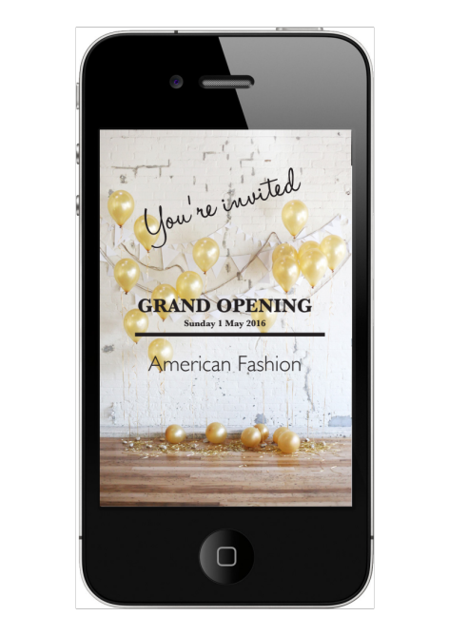
Please indicate for the following statement to what extent you agree with it (totally disagree, disagree, rather disagree, neutral, rather agree, agree, totally agree).
- I am willing to accept the invitation
Condition: Social media
You are browsing through the posts on your Facebook wall via your laptop or computer at home. You see that one of your friends liked or commented (or both) on the promotional invitation for the opening of a new American Fashion shop in the city you live. You did not explicitly give the permission to receive advertisements for American Fashion via Facebook. You look at the invitation. Below you will find a visual example of the invitation. Please answer the following questions while taking into account the hypothetical scenario that was described earlier.
Visual example
Figure A.2 Social media invitation
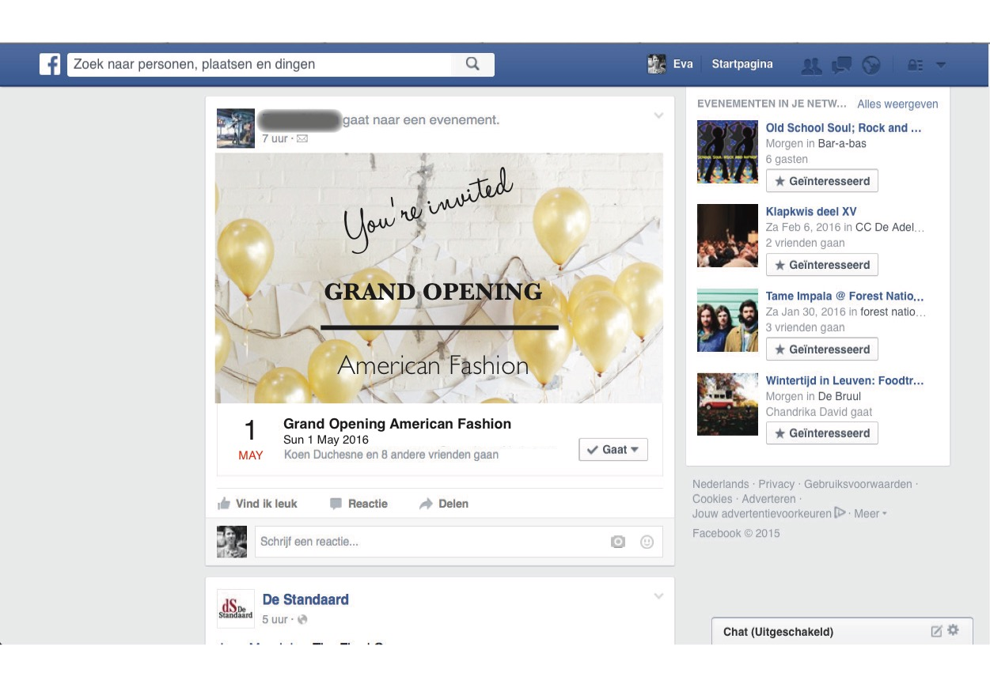
Please indicate for the following statement to what extent you agree with it (totally disagree, disagree, rather disagree, neutral, rather agree, agree, totally agree).
- I am willing to accept the invitation
Condition: Direct mail
You are browsing through the mail you just received via post and you notice the promotional invitation for the opening of a new American Fashion shop in the city you live. You did not explicitly give your personal information to American Fashion. Below you will find a visual example of the invitation. Please answer the following questions while taking into account the hypothetical scenario that was described earlier.
Visual example
Figure A.3 Direct mail invitation
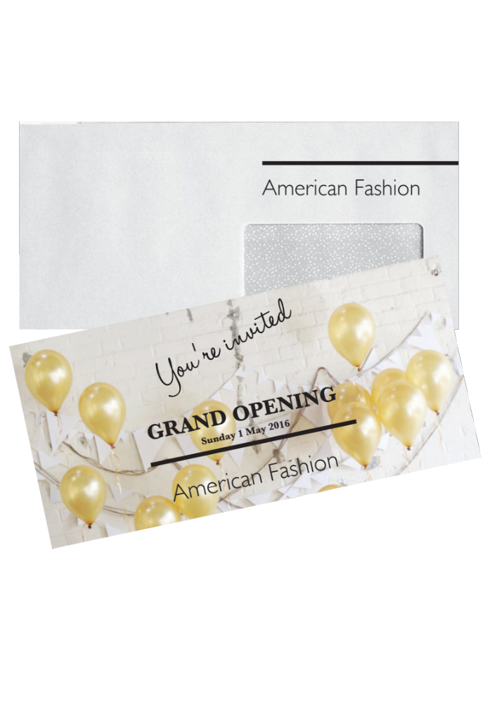
Please indicate for the following statement to what extent you agree with it (totally disagree, disagree, rather disagree, neutral, rather agree, agree, totally agree).
- I am willing to accept the invitation
Condition: Personal selling in the store
You are shopping for new clothes in an American Fashion shop in another city. At a certain moment in time, a saleswoman walks over to you to help you find and fit clothes. The saleswoman starts talking with you about the new collection, your vision about it, the weather, your shopping trip and so on. When the saleswoman hears you are from another city in which American Fashion is about to open a new shop, she invites you to come to the opening of the new American Fashion shop in the city you live. The saleswoman gives you the invitation for the opening in the form of a flyer. Below you will find a visual example of the invitation. Please answer the following questions while taking into account the hypothetical scenario that was described earlier.
Visual example
Figure A.4 Personal selling invitation

Please indicate for the following statement to what extent you agree with it (totally disagree, disagree, rather disagree, neutral, rather agree, agree, totally agree).
- I am willing to accept the invitation
Some questions concerning your opinion towards the described scenario
Please indicate on a scale from 1 to 7, with 1 being very low and 7 very high, the level of personalization, taking into account the hypothetical scenario and the situation in which you received the promotional invitation that were described earlier. With personalization is meant the degree to which the channel through which you received the invitation is relevant to you and makes it possible to react on events and have conversations with others.
Please indicate on a scale from 1 to 7, with 1 being very low and 7 very high, the level of intrusiveness, taking into account the hypothetical scenario and the situation in which you received the promotional invitation that were described earlier. With intrusiveness is meant “coming without invitation or welcome” (Dictionary.com, 2015).
Some questions to check your awareness of the described scenario
In which stage of the customer lifecycle do you find yourself?
- You already heard about American Fashion and are starting to get familiar with the offer and the values of the brand
- You are a loyal customer of American Fashion and regularly purchase your clothing in the shops of the brand
- Don’t know
Via which channel did you receive the invitation?
- Via MMS
- Via Facebook
- Via direct mail
- Via a salesperson
- Don’t know
A question concerning your preference towards the channel through which you would like to receive the invitation
Below you see the visual example of the invitation, for 4different channels. Indicate for which channel your intention to accept the invitation would be highest.
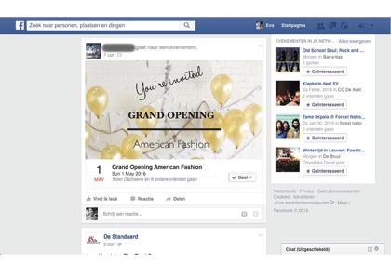
(1) (2) (3) (4)
- The invitation in MMS-format via my smartphone (visual 1):
You are shopping for new clothes in a shopping mall, not close to your hometown. At a certain moment in time, while you pass by an American Fashion shop, you receive a promotional invitation for the opening of a new American Fashion shop in the city you live, through a MMS on your smartphone. You did not explicitly give the permission to receive advertisements for American Fashion via your smartphone.
- The invitation that appears on my wall via a friend on Facebook (visual 2):
You are browsing through the posts on your Facebook wall, when at a certain moment in time, you see that one of your friends liked and/or commented on the promotional invitation for the opening of a new American Fashion shop in the city you live. You did not explicitly give the permission to receive advertisements from American Fashion via Facebook. You look at the invitation.
- The invitation in paper-format via direct mail (visual 3):
You are browsing through the mail you just received via post and you notice the promotional invitation for the opening of a new American Fashion shop in the city you live. You did not explicitly give your personal information to American Fashion.
- The invitation in flyer-format via a salesperson (visual 4):
You are shopping for new clothes in an American Fashion shop in another city. At a certain moment in time, a saleswoman walks over to you to help you find and fit clothes. The saleswoman starts talking with you about the new collection, your vision about it, the weather, your shopping trip and so on. When the saleswoman hears you are from another city in which American Fashion is about to open a new shop, she invites you to come to the opening of the new American Fashion shop in the city you live. The saleswoman gives you the invitation for the opening in the form of a flyer.

Some questions to end the questionnaire
What is your gender?
- Male
- Female
What is your age? (Please only use numbers) ____
What is your highest level of education?
- Primary school
- Secondary school
- Professional bachelor
- Academical bachelor
- Master
- Phd
- Adult education
- Other: ________________________
What is your professional status?
- Student
- Worker
- Servant
- Unemployed
- Searching for work
- Self-employed
- Civil servant
- Liberal profession
- Retired
- Other: _________________________
You have reached the end of the questionnaire. Continue to make sure your answers will be registered. In case you have any questions or remarks, please feel free to indicate them below. Thank you very much for your cooperation!

Attachment 2: Operationalization of the variables
Table A.1 Operationalization of the variables
Variable | Source | Question | Operationalization
Selection question residence | Own question | Where do you live? | 1: Flanders  2: Other
Selection question smartphone usage | Own question | Do you own a smartphone? | 1: Yes  2: No
Selection question Facebook usage | Own question | Do you have a Facebook account? | 1: Yes  2: No
Intention to accept the invitation | Dodds et al. (1991) | Please indicate for each of the following statements to what extent you agree with them (totally disagree, disagree, rather disagree, neutral, rather agree, agree, totally agree).  - I will probably accept the invitation  - There is a chance I will accept the invitation  - I am willing to accept the invitation  - If I would be inclined to attend a promotional event, there is a chance I would attend this event  - I would accept the invitation | 1: Totally disagree  2: Disagree  3: Rather disagree  4: Neutral  5: Rather agree  6: Agree  7: Totally agree
Level of personalization | Own question | Please indicate on a scale from 1 to 7, with 1 being very low and 7 very high, the level of personalization, taking into account the hypothetical scenario and the situation in which you received the promotional invitation that were described earlier. | 1-7
Level of intrusiveness | Own question | Please indicate on a scale from 1 to 7, with 1 being very low and 7 very high, the level of intrusiveness, taking into account the hypothetical scenario and the situation in which you received the promotional invitation that were described earlier. | 1-7
Manipulation check CLC stage | Own question | In which stage of the customer lifecycle do you find yourself?  - Exploration stage  - Maturity stage  - Don’t know | 1: Exploration stage  2: Maturity stage  3: Don’t know
Manipulation check channel | Own question | Via which channel did you receive the invitation?  - Via my smartphone  - Via Facebook  - Via direct mail  - Via a salesperson  - Don’t know | 1: Via my smartphone  2: Via Facebook  3: Via direct mail  4: Via a salesperson  5: Don’t know
Preference check | Own question | Below you see the visual example of the invitation, for 4different channels. Indicate for which channel your intention to accept the invitation would be highest, taking into account the hypothetical situation that was described earlier.  - The invitation in MMS-format via my smartphone  - The invitation that appeared on my wall via a friend on Facebook  - The invitation in paper-format via direct mail  - The invitation in flyer-format via a salesperson | 1: Via smartphone  2: Via Facebook  3: Via direct mail  4: Via a salesperson
Gender | Own question | What is your gender? | 1: Male  2: Female
Age | Own question | What is your age? | Continuous
Level of education | Own question | What is your highest level of education?  - Primary school  - Secondary school  - Professional bachelor  - Academical bachelor  - Master  - PhD  - Adult education  - Other: | 1: Primary school  2: Secondary school  3: Professional bachelor  4: Academical bachelor  5: Master  6: PhD  7: Adult education  8: Other
Professional status | Own question | What is your professional status?  - Student  - Worker  - Servant  - Unemployed  - Searching for work  - Liberal profession  - Civil servant  - Self-employed  - Retired  - Other: | 1: Student  2: Worker  3: Servant  4: Unemployed  5: Searching for work  6: Liberal profession  7: Civil servant  8: Self-employed  9: Retired  10: Other
Source: based on Dodds et al. (1991)

Attachment 3: Frequency tables demographical data
Table A.1 Frequency table gender
Gender | Frequency | Percentage | Cumulative percentage | Population
Female | 91 | 34,7% | 34,7% | 50,6%
Male | 171 | 65,3% | 100,0% | 49,4%
Total | 262 | 100% |  | 100,0%

Table A.2 Frequency table age
Age | Frequency | Percentage | Cumulative percentage | Population
<25 | 150 | 57,3% | 57,3% | 27,9%
25 – 34 | 82 | 31,3% | 88,6% | 12,4%
35 – 44 | 12 | 4,6% | 93,2% | 14,6%
45 – 54 | 14 | 5,3% | 98,5% | 14,8%
55 + | 4 | 1,5% | 100,0% | 30,3%
Total | 262 | 100,0% |  | 100,0%

Table A.4 Frequency table highest level of education
Highest level of education | Frequency | Percentage | Cumulative percentage
Primary school | 6 | 2,3% | 2,3%
Secondary school | 38 | 14,6 % | 16,9%
Professional bachelor | 93 | 35,6% | 52,5%
Academical bachelor | 36 | 13,8% | 66,3%
Master | 75 | 28,7% | 95,0%
PhD | 4 | 1,5% | 96,6%
Adult education | 7 | 2,7% | 99,2%
Other | 2 | 0,8% | 100%
Total | 261 | 100,0%

Table A.5 Frequency table profession
Profession | Frequency | Percentage | Cumulative percentage
Student | 114 | 43,7% | 43,7%
Worker | 13 | 5,0% | 48,7%
Servant | 99 | 37,9% | 86,6%
Searching for work | 4 | 1,5% | 88,1%
Self-employed | 11 | 4,2% | 92,3%
Civil servant | 10 | 3,8% | 96,2%
Liberal profession | 2 | 0,8% | 96,9%
Other | 8 | 3,1% | 100,0%
Total | 261 | 100,0%

Attachment 4: Assumptions univariate tests main analyses
Table A.6 Assumptions ANOVA analysis
Assumptions | Satisfied / Not satisfied
Causality | Satisfied
Metric dependent variable | Satisfied
Normally distributed residuals | Not satisfied
Equal variances in different groups | Satisfied
Enough observations per cell (≥30) | Satisfied
Independent observations | Satisfied
No extreme observations | Satisfied
Source: Cleeren (2015), Breugelmans (2015)
Table A.7 Assumptions linear regressions R1 - R3
Assumptions | R1 | R2 | R3
Causality | Satisfied | Satisfied | Satisfied
All relevant variables included | Not satisfied | Satisfied | Satisfied
Metric DV | Satisfied | Satisfied | Satisfied
Additive relationship between DV and IV | Satisfied | Satisfied | Satisfied
Linear relationship between DV and IV | Satisfied | Satisfied | Satisfied
Independent residuals | Satisfied | Satisfied | Satisfied
Normally distributed residuals | Not satisfied | Not satisfied | Not satisfied
Homoskedastic residuals | Satisfied | Satisfied | Satisfied
No autocorrelated residuals | Satisfied | Satisfied | Satisfied
Enough observations | Satisfied | Satisfied | Satisfied
No multicollinearity | Satisfied | Satisfied | Satisfied
No extreme observations | Satisfied | Satisfied | Satisfied
Source: Cleeren (2015), Breugelmans (2015)
Table A.8 Assumptions linear regressions R4-R7
Assumptions | R4 | R5 | R6 | R7
Causality | Satisfied | Satisfied | Satisfied | Satisfied
All relevant variables included | Not satisfied | Not satisfied | Not satisfied | Not satisfied
Metric DV | Satisfied | Satisfied | Satisfied | Satisfied
Additive relationship between DV and IV | Satisfied | Satisfied | Satisfied | Satisfied
Linear relationship between DV and IV | Satisfied | Satisfied | Satisfied | Satisfied
Independent residuals | Satisfied | Satisfied | Satisfied | Satisfied
Normally distributed residuals | Not satisfied | Not satisfied | Not satisfied | Not satisfied
Homoskedastic residuals | Satisfied | Satisfied | Satisfied | Satisfied
No autocorrelated residuals | Satisfied | Satisfied | Satisfied | Satisfied
Enough observations | Satisfied | Satisfied | Satisfied | Satisfied
No multicollinearity | Satisfied | Satisfied | Satisfied | Satisfied
No extreme observations | Satisfied | Satisfied | Satisfied | Satisfied
Source: Cleeren (2015)
Attachment 5: Results
Table A.9 Comparison expected and actual level of intrusiveness per channel
Intrusiveness
 | Exploration | Maturity | Average | Actual | Expected
Mobile | 4,68 | 4,64 | 4,66 | - - | - -
Social media | 3,67 | 3,73 | 3,70 | - | -
Direct mail | 3,38 | 3,88 | 3,63 | - | +
Personal selling | 3,15 | 3,22 | 3,19 | + | - -

Table A.10 Comparison actual and expected level of personalization per channel
Personalization
 | Exploration | Maturity | Average | Actual | Expected
Mobile | 4,46 | 4,62 | 4,54 | + + | + +
Social media | 3,87 | 4,60 | 4,24 | + | + +
Direct mail | 4,13 | 3,84 | 3,99 | - | -
Personal selling | 4,67 | 4,66 | 4,67 | + + | + +


Press article

Campus Carolus Antwerp
Korte Nieuwstraat 33 | 2000 Antwerp
Tel.: +32 3 201 18 40
Email: feb.antwerpen@kuleuven.be

PRESS RELEASE
Antwerp, 17th of May
For immediate release
Personalization and interaction: a retailer’s road to success
Antwerp – A recent study indicates that consumers are more inclined to respond to a promotional message from a retailer, if they receive it via a personalized and interactive channel. As the brand becomes more established, other forms of communication gain in effectiveness.
In today’s digital revolution, retailers are overwhelmed with alternatives to communicate with consumers. They are continuously searching for ways to reach and communicate effectively with consumers. Effective communication is vital for retailers in building valuable relationships with their customers. A recent study conducted by a master student at KU Leuven indicates that personal relevance and interactivity are the key characteristics of a commercial communication channel.
Mobile channel to be avoided
The research is effectuated among 513 respondents and surveyed via which channels consumers would be more inclined to respond to a promotional message, taking into account the strength of their buyer-seller relationship. From the research it appeared that in general, in-store communication and personal selling are preferred the most. In contrast, retailers should be careful with the mobile channel, as consumers appear to dislike promotional messages via mobile the most, because of its obtrusive and impersonalized characteristics. Since personal selling is not always present or achievable, it is beneficial for retailers to improve the interactivity and personal relevance of their communication. The ongoing digitalization offers numerous alternatives and techniques to achieve this.
The impact of loyalty
As consumers become more familiar with brands, other forms of communication gain in effectiveness. Consumers that are more familiar with a brand are easier to convince than those who are still getting to know the brand. This implies that it is important for retailers to tailor their communication strategy to the relationship status with their customers. For consumers who are still getting to know the brand, personal selling is most appropriate because of its persuasive strengths and high personal relevance. Social media does the job for loyal customers thanks to its interactive capabilities and its high personal relevance. Also direct mail that touches upon the personal interest spheres of the receivers is appreciated by loyal customers.
Personal relevance, interactivity and relational strength are thus very important elements retailers should take into account when developing their communication strategy. A highly relevant and interactive communication that is adapted to the commercial relational status of the customer, can result in a high added value and satisfied customers for retailers.
------------------------------------------- END OF THE MESSAGE ----------------------------------------

Note to editors
Contact person:
Anne Vandenberk | Student Master of Business Administration – Marketing Management anne.vandenberk@student.kuleuven.be
faculteit economie en bedrijfswetenschappen
Campus Carolus Antwerpen
Korte Nieuwstraat 33
2000 Antwerpen
tel. + 32 3 201 18 40
FEB.antwerpen@kuleuven.be

Although Dwyer et al. (1987) refer to the maturity stage as the ‘commitment stage’, we will now continue to use the word maturity to refer to this particular stage in the customer lifecycle as it is easier to understand and resembles to the maturity stage of the product lifecycle.
The product lifecycle (PLC) evolves through the same 5 stages as the customer lifecycle (CLC), called development, introduction, growth, maturity and decline. Both concepts are closely linked to each other regarding their characteristics and communication goals. Where CLC concerns the different stages a relationship moves through, PLC determines the development of the turnover and profit of a product through the different stages in the product lifecycle (Kotler, 2009).
Personalization is seen as a positive channel characteristic that might influence the response of consumers in a positive way, while intrusiveness is expected to have a negative effect. As a result, the pluses and minuses for each channel on personalization indicate whether the channel has a respectively high or low level of personalization and thus a positive or negative effect on the response of consumers. The contrary applies to intrusiveness: the pluses and minuses indicate whether the channel has respectively a low or high level of intrusiveness which is expected to influence the response of consumers respectively in a positive or negative way. Direct mail for example scores low on both personalization (-) and intrusiveness (+) which suggests 2 opposing effects regarding its influence on the response of consumers.
Although one of the assumptions for the ANOVA-analysis are that there should be 30 respondents per condition, we continue with 28 respondents for this single condition as its number is very close to 30.

