FACULTEIT GENEESKUNDE EN FARMACIE

Faculty of Medicine and Pharmacy
Department of Endocrinology, Medical Oncology & Nuclear Medicine

Incidence of Thyroid Immune-Related Adverse Events in Melanoma Patients Treated with Pembrolizumab in an Expanded Access Program
Thesis submitted in fulfillment of the requirements for the degree of Master of Medicine
Jeroen de Filette


Academic Year 2015 - 2016

Promotor: Prof. Dr. Bert Bravenboer
Co-promotor: Prof. Dr. Bart Neyns

Table of Contents

List of Tables & Figures 3
Abbreviations 4
Abstract 5
Introduction 6
Pembrolizumab: revolution in melanoma 7
Mechanism of immune checkpoint blockade 8
Novel immune-related adverse events affecting the thyroid gland 9
Patients and Methods 11
Patients 11
Pembrolizumab immunotherapy 11
Thyroid function tests & thyroid-related adverse events 12
Thyroid autoantibody subanalysis 12
¹⁸FDG-PET/CT subanalysis 13
Statistical analysis 13
Results 15
Patient characteristics 15
Thyroid-related adverse events 16
Prior medical therapy associated with thyroid dysfunction 19
Thyroid autoantibody subanalysis 20
¹⁸FDG uptake in subgroup with suspected inflammatory thyroiditis 20
Discussion 22
Conclusion 26
References 27
Acknowledgements - Dankwoord 33

List of Tables & Figures

Table 1. Overview of FDA-approved agents in advanced melanoma .………………………………... 7
Table 2. Overview of patient characteristics …………………………………………………...……… 15
Table 3. Overview of prior ipilimumab immunotherapy ……………………………………….…….. 19
Table 4. Overview of ¹⁸FDG-PET/CT imaging in inflammatory thyroiditis …...…………………….. 21
Figure 1. PD-1/PD-L1 signaling in malignancy ………………………………………………………... 9
Figure 2. Overview of the investigated cohort of pembrolizumab-treated melanoma patients .……….. 11
Figure 3. Overview of thyroid-related adverse events in pembrolizumab-treated melanoma patients ... 17
Figure 4. Graphic representation of free thyroxine values in pembrolizumab-associated thyroiditis….. 18

Abbreviations

AE | adverse events |  | IFN-α-2b | interferon alpha-2b
AITD | autoimmune thyroid disease |  | IL-2 | interleukin 2
AJCC | American Joint Committee on Cancer |  | irAE  IrRC | immune-related adverse events  Immune-related Response Criteria
APC | antigen-presenting cells |  | LDH | lactate dehydrogenase
BRAF | Proto-Oncogene B-Raf |  | mAb | monoclonal antibody
CTCAE | Common Terminology Criteria for Adverse Events |  | MAPK  MBq | mitogen-activated protein kinase  megabecquerel
CTLA-4 | cytotoxic T-lymphocyte-associated protein 4, cytotoxic T lymphocyte antigen 4 |  | MEK  OS  PD | mitogen-activated protein kinase kinase  overall survival  progressive disease
EAP  ECOG | expanded access program  Eastern Cooperative |  | PD-1 | programmed cell death protein 1  receptor
FDA | Oncology Group  United States |  | peakSUV  bw | peak standardized uptake value  corrected for body weight
¹⁸FDG - PET / CT | Food and Drug Administration  ¹⁸F-fluorodeoxyglucose  positron emission tomography / |  | PFS  TCR | progression-free survival  T-cell receptor
fT3 | computed tomography  free 3,5,3′-triiodothyronine, |  | Tc-99m  TFT | technetium-99m  thyroid function tests
 | free T3 |  | TPOAb | anti-thyroid peroxidase antibodies
fT4 | free thyroxine, free T4 |  | TRAb | TSH receptor antibodies
IFN-α | interferon alpha |  | TSH | thyroid-stimulating hormone

Abstract
Context: Immune checkpoint blockade is associated with endocrine-related adverse events. Thyroid dysfunction during pembrolizumab therapy, an anti-programmed cell death 1 receptor (PD-1) monoclonal antibody (mAb), remains to be fully characterized.
Objective: To assess the incidence and characteristics of pembrolizumab-associated thyroid dysfunction.
Design and setting: Thyroid function was monitored prospectively in melanoma patients who initiated pembrolizumab within an expanded access program at a referral oncology center. ¹⁸Fluorodeoxyglucose uptake on positron emission tomography/computed tomography (¹⁸FDG-PET/CT) was reviewed in cases compatible with inflammatory thyroiditis.
Patients: 99 patients with advanced melanoma (aged 26.3-93.6 years; 63.6% females) who received at least 1 administration of pembrolizumab.
Main Outcome Measures: Patient characteristics, thyroid function (TSH, fT4), thyroid autoantibodies and ¹⁸FDG-PET/CT.
Results: 18 adverse events of thyroid dysfunction were observed in 17 patients. Thyrotoxicosis occurred in 12 patients of which 9 evolved to hypothyroidism. Isolated hypothyroidism was present in 6 patients. Levothyroxine therapy was required in 10 of 15 hypothyroid patients. Thyroid autoantibodies were elevated during thyroid dysfunction in 4 of 10 cases. Diffuse increased ¹⁸FDG uptake by the thyroid gland was observed in all 7 thyrotoxic patients who progressed to hypothyroidism.
Conclusions: Thyroid dysfunction is common in melanoma patients treated with pembrolizumab. Hypothyroidism and thyrotoxicosis related to inflammatory thyroiditis are the most frequent presentations. Serial measurements of thyroid function tests are indicated during anti-PD-1 mAb therapy. Thyrotoxicosis compatible with inflammatory thyroiditis was associated with diffuse increased ¹⁸FDG uptake by the thyroid gland. The prospective role of thyroid autoantibodies should be further investigated together with the histopathological correlates.

Introduction
Melanoma is the most aggressive type of skin cancer, estimated to cause 75% of all skin cancer-related mortality, yet only accounting for 2% of all skin cancers (1). The prognosis is greatly dependent of tumor staging: early stage melanoma has a favorable 5-year overall survival (OS) of 98%; regional spread with involved lymph nodes declines the 5-year OS to 63%; distant metastasis has the worst prognosis with a 5-year OS of only 16% (1). Metastatic melanoma is notoriously treatment-resistant. For decades, cytotoxic chemotherapy with dacarbazine has been ‘de facto’ standard treatment, despite response rates being limited (15-25%) and complete responses occurring seldom (5%) (2,3). Numerous alternative drug regimens have been explored, including nitrosoureas, platinum drugs and vinca alkaloids as well as biochemotherapy, adding non-specific immunotherapy with interleukin 2 (IL-2) and/or interferon-α (IFN-α). Improved response rates have been observed, yet no single of these combinations convincingly improved the prognosis when compared to dacarbazine alone (2-5). Interestingly, long-lasting responses have been observed in a small subset of IL-2-treated patients (2), providing insight into the potential of future immunotherapies. Indeed, the treatment of advanced melanoma has seen enormous progress in recent years. Continuous effort led to the development of two novel classes of therapeutic agents, namely immune checkpoint blockade by monoclonal antibodies (mAb) and small molecule inhibitors which target the mitogen-activated protein kinase (MAPK) pathway. In 2011, the first of these agents (ipilimumab and vemurafenib) were approved for clinical use by the United States Food and Drug Administration (FDA) (6). Table 1 provides an overview of current FDA-approved agents in advanced melanoma. In this report, we focus on the immune checkpoint inhibiting mAb class of therapeutic agents.
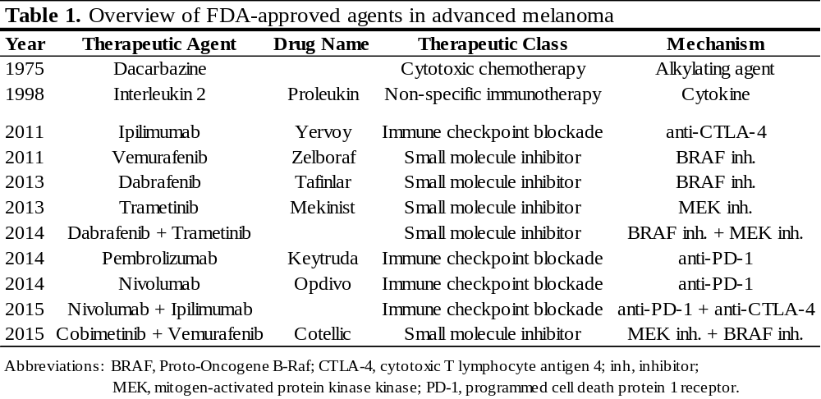
Pembrolizumab: revolution in melanoma
Pembrolizumab, a humanized IgG4 mAb, is an immune checkpoint inhibitor that blocks the programmed cell death 1 receptor (PD-1) (7). It acquired FDA-approval in 2014 for the treatment of patients with unresectable and/or advanced melanoma and for metastatic non-small cell lung cancer (8,9). In the KEYNOTE-002 trial, 540 patients with ipilimumab-refractory melanoma were randomly assigned to receive either investigator-choice chemotherapy (paclitaxel plus carboplatin, paclitaxel, carboplatin, dacarbazine or oral temozolomide) or pembrolizumab (2mg/kg or 10mg/kg). The chemotherapy group showed a 6-month progression-free survival (PFS) of 16% versus 34% and 38% in the respective pembrolizumab groups. Response to treatment was 21% and 25% for pembrolizumab compared to 4% for chemotherapy and lasted more often in the pembrolizumab groups (92% and 87% versus 63%) (10). In a subsequent phase III study, the KEYNOTE-006 trial, PD-1 blockade with pembrolizumab (10mg/kg every 2 or 3 weeks) was compared to ipilimumab (3mg/kg every 3 weeks), a different immune checkpoint inhibiting IgG1 mAb against cytotoxic T-lymphocyte antigen 4 (CTLA-4). Estimated 6-month PFS was 47.3% and 46.4% for the respective pembrolizumab groups versus 26% in the ipilimumab group. Response rates were also higher for pembrolizumab with an observed response in nearly one-third of patients versus 11.9% for ipilimumab (11).
Mechanism of immune checkpoint blockade
Understanding the mechanism of T-cell activation is essential for the understanding of the mechanism of immune checkpoint blockade. The activation of T-cells consists of a twofold-signaling process. The first signal is the presentation of antigens by antigen-presenting cells (APC) to T-cells through interaction with the T-cell receptor (TCR). To reinforce this interaction, a second co-stimulatory signal is required via the interaction of CD28/B7. CD28 is a glycoprotein receptor on the surface of T-cells; B7 is its corresponding ligand on APC. Immune checkpoints are crucial for the negative regulation of the T-cell response, important in preventing collateral damage by the induction of auto-immunity. Both cytotoxic T-lymphocyte antigen 4 (CTLA-4) and programmed cell death 1 receptor (PD-1) are immune checkpoint molecules by their function as co-inhibitory receptors of T-cells. CTLA-4 is a molecule expressed on the surface of T-cells, binding with high affinity to B7, thus negatively regulating the activation of a T-cell response (7). PD-1 is a different molecule of the CD28 family and, like CTLA-4, also is a negative T-cell regulator expressed on the surface of T-cells, able to interact with its corresponding ligand (PD-L1 or PD-L2) on APC. Differently to CTLA-4, PD-1 signaling rather inhibits the effector phase of the immune response in peripheral tissues. Malignancies such as melanoma are able to express PD-L1 to avert an anti-tumor immune response (12,13). Immune checkpoint inhibiting mAb are developed to target these co-inhibitory receptors, release the brakes of the immune system and provoke therapeutic anti-tumor cytotoxic T-cell immune responses. The PD-1/PD-L1 signaling in malignancy is illustrated in Figure 1 (14).
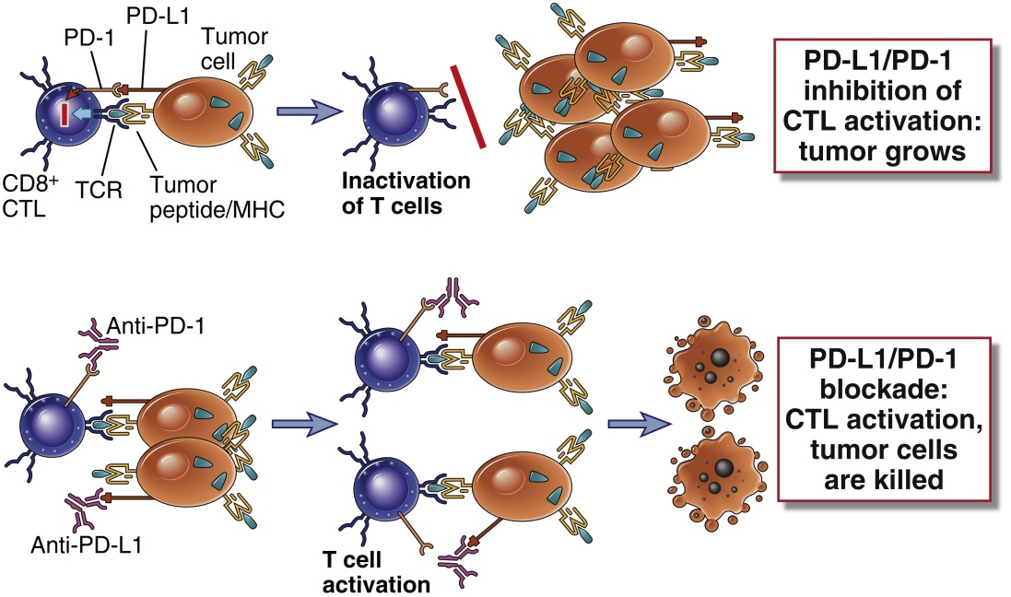
Figure 1. PD-1/PD-L1 signaling in malignancy (14). Tumor cells evade T-cell immune responses by upregulation of inhibitory receptors. Blocking antibodies such as pembrolizumab (anti-PD-1), therapeutically stimulate anti-tumor T-cell immune responses.
Novel immune-related adverse events affecting the thyroid gland
Immune checkpoint blockade is associated with a risk for immune-related adverse events (irAE) by virtue of this unique mechanism of action (15). Endocrine organs are often affected, apart from the skin and the gastrointestinal tract (16,17). While ipilimumab, an anti-CTLA-4 mAb, is known to be mainly associated with hypophysitis (16-18), pembrolizumab is more prone to provoke thyroid dysfunction (10,11,17).
Pembrolizumab therapy has been associated with a 57-79.5% incidence of any irAE, among which are hypothyroidism (5-10.1%) and hyperthyroidism (<2-6.5%) (10,11,19,20). In KEYNOTE 002 & 006, two phase III pembrolizumab trials in melanoma, hypo- and hyperthyroidism occurred in 5-10.1% and 3.2-6.5% of patients respectively (10,11). In a retrospective analysis of 92 pembrolizumab-treated cancer patients at the Mayo clinic, abnormal thyroid function tests (TFT) were detected in 14% of patients, mainly involving cases of hypothyroidism and thyroiditis (21). Anti-thyroid peroxidase antibodies (TPOAb) were elevated in 50% of evaluable patient cases. A case series of 10 patients with painless thyroiditis syndrome on anti-PD-1 mAb therapy were all diagnosed with hypothyroidism, preceded by transient thyrotoxicosis in 6 patients. TPOAb were detected in 66% of available patient cases (22).
A systematic prospective analysis of thyroid function and thyroid autoantibodies in pembrolizumab-treated melanoma patients has yet to be reported. It remains unknown which patients are at risk for developing thyroid-related adverse events (AE). It is unclear how the thyroid function evolves over time during pembrolizumab treatment and what the role is of thyroid autoantibodies. Finally, additional insight into the toxicity mechanisms and the specific role of PD-1 and its ligand in thyroid irAE could enable a better understanding of the pathophysiology of autoimmune thyroid disease. The aim of the present study is to investigate the incidence and characteristics of thyroid-related AE in a “real life” cohort of melanoma patients treated with pembrolizumab at the Oncology Center of the University Hospital of Brussels.

Patients and Methods
Patients
Patients with advanced/unresectable (AJCC stage III/IV) melanoma who initiated pembrolizumab treatment between September 3rd, 2014 and January 4th, 2016, in an expanded access program (EAP) were recruited in a therapeutically non-interventional academia sponsored clinical trial (23,24). This study was approved by the Ethical Committee of the University Hospital of Brussels; written informed consent was obtained from all patients. The ClinicalTrials.gov identifier is NCT02673970. Patient characteristics (age, gender, history of thyroid disorder, prior immunotherapy, melanoma staging), thyroid function tests and thyroid autoantibodies were retrieved from the medical records along with the washout period between the last dosing of prior immunotherapy and the first pembrolizumab dosing.
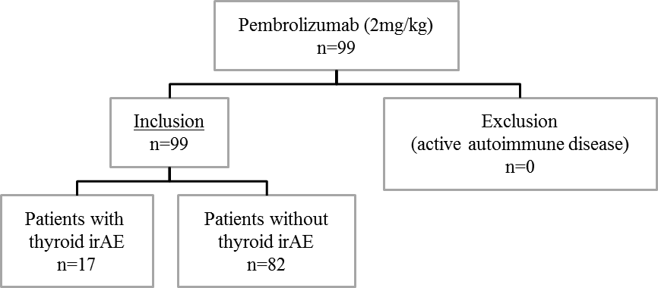
Figure 2. Overview of the investigated cohort of pembrolizumab-treated melanoma patients, displaying inclusion criteria and overall thyroid dysfunction. Abbreviation: irAE, immune-related adverse event.

Pembrolizumab immunotherapy
Pembrolizumab (Keytruda®, Merck Sharp & Dohme Corp.) was administered in accordance with manufacturer-approved guidelines for the use of pembrolizumab in the EAP (2 mg/kg every 3 weeks). All patients received at least 1 administration of pembrolizumab. No patient had to be excluded for active autoimmune disease, which was our main eligibility criterion for initiating pembrolizumab treatment in the EAP. Baseline tumor staging was according to the American Joint Committee on Cancer (AJCC) Staging Manual, 7th edition (25). Performance status was classified using the Eastern Cooperative Oncology Group (ECOG) score (26). Response to immunotherapy was assessed by Immune-related Response Criteria (IrRC) (27). Patients received 3 cycles of pembrolizumab followed by radiological assessment. On progressive disease (PD), a consecutive radiological assessment at least 4 weeks apart (acc. IrRC) was performed. If PD persisted, pembrolizumab was discontinued. Pembrolizumab was further discontinued based on manufacturer-approved guidelines (28) or the investigator’s clinical judgment.
Thyroid function tests & thyroid-related adverse events
TSH and free T4 (fT4) were prospectively assessed at baseline and prior to each pembrolizumab administration. Thyrotoxicosis was defined as a suppressed TSH with an elevated fT4 and/or fT3 level. Hypothyroidism was defined as an elevated TSH with a decreased fT4 level. Subclinical hypothyroidism or thyrotoxicosis was defined as an elevated or suppressed TSH, respectively, with normal fT4 and fT3 levels. Thyroid irAE were graded according to Common Terminology Criteria for Adverse Events (CTCAE), version 4.03 (29). This classification uses the term hyperthyroidism; in this manuscript we preferred the term thyrotoxicosis in order to be unambiguous for the endocrinologist. Our institutional laboratory department for Hormonology & Tumor Markers measured the serum TSH, fT4, fT3, TPOAb and TSH Receptor Antibodies (TRAb) using the Elecsys electrochemiluminescence immunoassays on a Cobas 6000 immunoanalyzer (Roche Diagnostics, Mannheim, Germany). The within-run and between-run coefficients of variation were <2% and <6.5% for TSH, ≤2% and <5% for fT4, ≤1.6% and 2.15% for fT3, <5% and ≤7% for TPOAb, ≤6.6 and 10.1% for TRAb. Reference laboratory values were: TSH (0.27-4.20 mIU/L), fT4 (11.6-22.0 pmol/L), fT3 (4.0-6.8 pmol/L), TPOAb (<34 kIU/L) and TRAb (<1.75 U/L).
Thyroid autoantibody subanalysis
The measurement of thyroid autoantibodies was performed at the time of onset of thyroid dysfunction. In addition, evaluable plasma samples obtained before the introduction of pembrolizumab were analyzed for baseline TPOAb status in patients whose TPOAb status during thyroid-related AE was identified. These plasma samples were prospectively collected after obtaining written informed consent. Blood samples were collected in 10 mL EDTA tubes and immediately centrifuged at a relative centrifugal force of 1410.63×g during 15 min at room temperature. Plasma was separated and stored in 1 mL aliquots at −80°C (30).
¹⁸FDG-PET/CT subanalysis
In patients with thyrotoxicosis compatible with inflammatory thyroiditis due to rapid onset and spontaneous progression to hypothyroidism, ¹⁸fluorodeoxyglucose positron emission tomography/computed tomography (¹⁸FDG-PET/CT) studies were retrieved from the medical records and investigated post-hoc for increased ¹⁸FDG uptake in the thyroid gland. When evaluable, ¹⁸FDG-PET/CT studies obtained before the first pembrolizumab dosing were compared to imaging results obtained closest after the onset of thyrotoxicosis. ¹⁸FDG uptake in the thyroid was assessed both visually and semi-quantitatively by measuring the peak standardized uptake value corrected for body weight (peakSUVbw) in a three-dimensional region of interest placed over the thyroid. Prior to ¹⁸FDG administration, patients were instructed to fast for at least 6 hours to minimize glucose-related competition of ¹⁸FDG uptake and to reduce serum insulin to near basal levels. Blood glucose levels were checked prior to the imaging procedures. None of the patients presented with glucose levels exceeding 200 mg/dL. Whole-body ¹⁸FDG-PET/CT images were acquired 60 minutes after IV tracer administration (¹⁸FDG activities ranging 255-355 MBq, average 311 MBq) using a high-end PET/CT scanner (Philips Gemini TF64 PET/CT). PET images were reconstructed (using the vendor’s standard BLOB-OS-TF algorithm) corrected for attenuation, scatter and random coincidences.
Statistical analysis
All statistical analyses were performed with IBM SPSS Statistics 23 (IBM Corp.). Patient, tumor and treatment variables were compared using the Fisher’s exact (gender, history of thyroid disorder, prior immunotherapy), the Mann-Whitney-Wilcoxon (age, melanoma staging, baseline LDH, time between last ipilimumab and first pembrolizumab dosing), the Kruskal-Wallis (ECOG performance status, metastasis stage) and the unpaired two-sample t-test (baseline mean TSH/fT4). Significance was defined as a P-value of <0.05.

Results
Patient characteristics
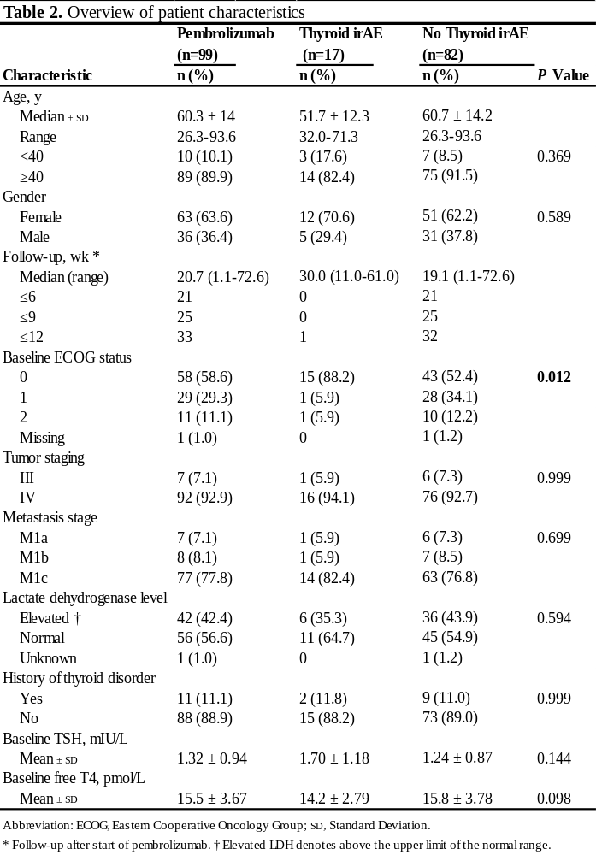
A total of 99 patients with advanced/unresectable (AJCC stage III/IV) melanoma initiated pembrolizumab treatment between September 3rd, 2014 and January 4th, 2016. Table 2 illustrates the baseline characteristics of the study population. The median age was 60.3 years (range 26.3-93.6); 63 patients (63.6%) were female. Of the 99 included patients, 92 (92.9%) presented with metastatic disease of which 42 (42.4%) had an elevated LDH at baseline. Median follow-up was 20.7 weeks (range 1.1-72.6) after pembrolizumab introduction. Total duration of follow-up was limited: 21, 25 and 33 patients were followed for less than 6, 9 and 12 weeks respectively. Prior history of a thyroid disorder not requiring active therapy was present in 11 patients (11.1%) and consisted of 3 patients with a multinodular goiter, 1 patient with an unspecified goiter, 1 patient with a thyroid nodule, 1 patient with amiodarone-induced thyrotoxicosis and 5 patients with a thyroid-related AE on prior ipilimumab (transient thyrotoxicosis, n=4; Graves’ disease, n=1). The mean baseline value ± SD for TSH/fT4 was 1.32 ± 0.94 mIU/L and 15.5 ± 3.67 pmol/L respectively. There was no significant difference between groups with/without thyroid-related AE for age, gender, tumor stage, metastasis stage, baseline LDH, history of thyroid disorder, prior ipilimumab, time between last ipilimumab and first pembrolizumab dosing or baseline mean TSH/fT4. Baseline ECOG performance status was significantly better in the 17 patients who later developed a thyroid-related AE.
Thyroid-related adverse events
A total of 18 adverse events related to abnormal TFT were observed in 17 patients. Figure 3 summarizes all thyroid-related AE during pembrolizumab therapy. One patient developed both transient thyrotoxicosis and isolated hypothyroidism, which were counted as two separate events due to a euthyroid interval of 7 months in between. Thyrotoxicosis and hypothyroidism were observed in 12% and 15% of patients respectively. Thyrotoxicosis was observed in 12 patients (n=3 of grade 1; n=8 of grade 2; n=1 of grade 3). In 9 of these, initial thyrotoxicosis spontaneously progressed to hypothyroidism. There was no correlation between the severity of thyrotoxicosis and the development of subsequent hypothyroidism. Isolated thyrotoxicosis occurred in 3 patients (including 2 cases of transient and 1 of subclinical thyrotoxicosis). Maximum fT4 values ranged between 21.6 and 100 pmol/L. One notable patient presented with severe thyrotoxicosis (grade 3) and had an unmeasurable high fT4 value. Complementary technetium-99m (Tc99m) thyroid scintigraphy showed a diffuse low uptake suggesting a destructive or subacute thyroiditis. Treatment with symptomatic β-blocker (propranolol 60 mg/day) was initiated; thionamide was initially started but discontinued after scintigraphy results were obtained. Hypothyroidism developed in 15 patients (n=3 of grade 1; n=12 of grade 2). Isolated hypothyroidism was observed in 6 patients of whom 3 had subclinical hypothyroidism. Thyroid hormone replacement therapy was required in 10 of 15 hypothyroid patients. The median time-of-onset after the initiation of pembrolizumab therapy for all cases of thyroid dysfunction was 6 weeks (range 3-40); for all cases of hypothyroidism was 5.7 weeks (range 3-40); for cases of thyrotoxicosis progressing to hypothyroidism was 3.1 weeks (range 3-21) and for isolated thyrotoxicosis was 8.6 weeks (range 6-11.1). The time course of fT4 levels in thyrotoxic patients progressing to hypothyroidism is shown in Figure 4.
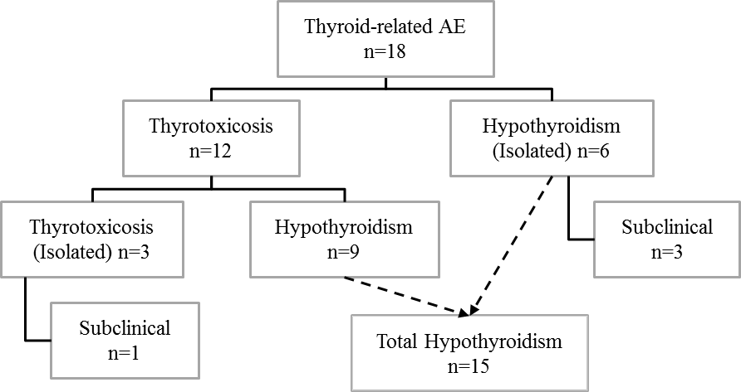
Figure 3. Overview of thyroid-related adverse events (AE) in pembrolizumab-treated melanoma patients. A total of 18 events of abnormal thyroid function tests were observed in 17 patients. Hypothyroidism and thyrotoxicosis due to suspected inflammatory thyroiditis (spontaneous evolution of thyrotoxicosis to hypothyroidism) were the most frequent types of thyroid dysfunction.

Isolated hypothyroidism was observed in 1 patient with multinodular goiter while thyrotoxicosis developed in 1 patient with a history of isolated thyrotoxicosis on prior ipilimumab. Baseline TSH/fT4 levels were normal in both these patients.
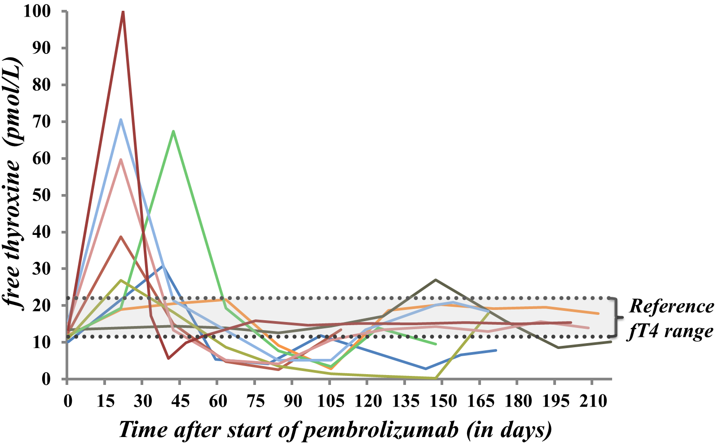
Figure 4. Graphic representation of free thyroxine (fT4) values in patients with suspected inflammatory thyroiditis on pembrolizumab. The evolution of fT4 levels is plotted against the time (in days) after the introduction of pembrolizumab. Early transient thyrotoxicosis develops followed by spontaneous progression to hypothyroidism.

Pembrolizumab immunotherapy was temporarily interrupted for 1 case of grade 3 thyrotoxicosis. Pembrolizumab was not interrupted nor discontinued (n=13) in all other thyroid-related AE, but was discontinued nonetheless for PD in 3 patients and interrupted for a non-endocrine irAE in 1 patient.

Prior medical therapy associated with thyroid dysfunction
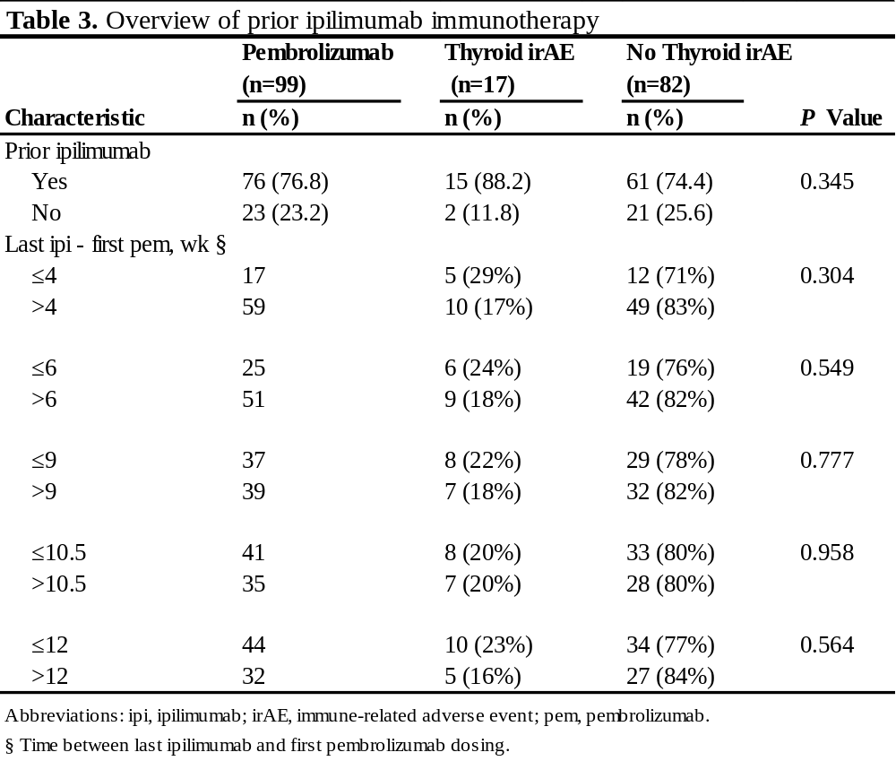
In total, 76 patients (76.8%) were pretreated with ipilimumab mAb therapy; 23 patients (23.2%) were ipilimumab-naïve. Ipilimumab and pembrolizumab were always administered sequentially. Table 3 provides an overview of prior ipilimumab immunotherapy. The duration of washout after last ipilimumab dosing was ≤4 weeks in 17 patients; ≤6, 9 and 12 weeks in respectively 25, 37 and 44 patients. Thyroid-related AE developed in 5 of 17 patients (29%) with an ipilimumab washout ≤4 weeks versus 10 of 59 patients (17%) with a washout period >4 weeks. In patients with a washout ≤6, 9 and 12 weeks, the incidence of thyroid-related AE was 24%, 22% and 23% respectively. In cases of thyrotoxicosis progressing to hypothyroidism, 5 of 9 patients (56%) had a washout >4 weeks versus ≤4 weeks in 3 of 9 patients (33%) while the 1 remaining patient (11%) was ipilimumab-naïve. The half-life of ipilimumab is 14.7 days (31). Its plasma concentration would be negligible after 5 times the half-life, which equals to 10.5 weeks. Of 15 ipilimumab-pretreated patients with a thyroid-related AE, 7 had an ipilimumab washout of >10.5 weeks. Of note, 2 patients were on amiodarone before and during pembrolizumab therapy; 1 of which had developed amiodarone-induced thyrotoxicosis 8 years before melanoma diagnosis. None developed thyroid dysfunction on pembrolizumab.
Thyroid autoantibody subanalysis
Thyroid autoantibodies (TPOAb and/or TRAb) could be assessed in 10 of 17 patients with a thyroid-related AE and were elevated in 4 of 10 patients (40%) during thyroid dysfunction. TPOAb serology was available in all 10 patients and was elevated in 3 patients. TRAb was tested in 5 patients and was elevated in 1 patient at the time of thyrotoxicosis. Positive antithyroid antibodies were exclusively observed in cases of thyrotoxicosis progressing to hypothyroidism. In the 1 case of positive TRAb, thyrotoxicosis swiftly evolved into hypothyroidism without antithyroid therapy. This patient might have had Graves’ disease rapidly shifting to hypothyroidism due to a switch in her antibody subpopulation. Additional serological analyses (on plasma samples obtained before the introduction of pembrolizumab) identified the baseline TPOAb status in 4 of 10 patients whose TPOAb status during thyroid dysfunction had been analyzed. Baseline TPOAb was elevated in 2 patients with an elevated TPOAb level during thyroid dysfunction, while baseline TPOAb remained unchanged in 2 patients in whom a normal TPOAb level was identified during thyroid dysfunction.
¹⁸FDG uptake in subgroup with suspected inflammatory thyroiditis
The uptake of ¹⁸FDG in the thyroid gland could be analyzed in 7 out of 9 thyrotoxic patients who progressed to hypothyroidism and in whom comparable ¹⁸FDG-PET/CT results were available. Diffuse increase of ¹⁸FDG uptake (visually and/or semi-quantitatively) after the onset of thyrotoxicosis was observed in all 7 evaluated patients. Interestingly, there was no increased ¹⁸FDG uptake in 6 of these patients before the introduction of pembrolizumab, while the 1 remaining patient also had an increased tracer uptake at baseline. Table 4 summarizes the visual and semi-quantitative ¹⁸FDG uptake in the thyroid gland.
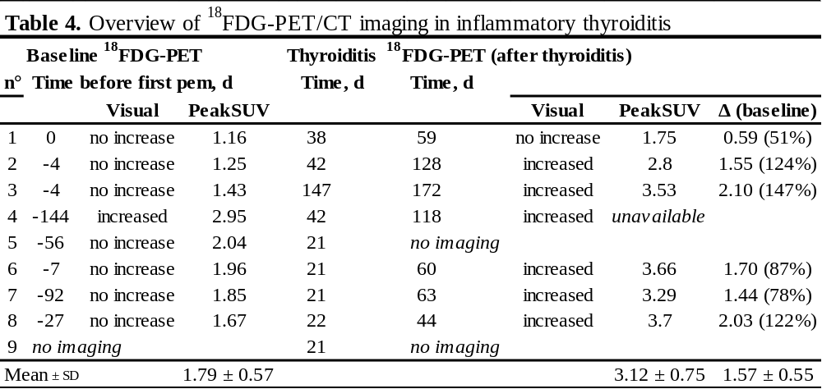
Table 4. Overview of ¹⁸FDG-PET/CT imaging in thyrotoxic patients with compatible inflammatory thyroiditis. Time is denoted in days (d) before/after first pembrolizumab dosing. Delta sign (Δ) signifies the difference in peakSUV (corrected for body weight) after onset of thyroiditis/before first pembrolizumab dosing; followed by the difference compared to the tracer uptake at baseline (%).
A diffuse increased ¹⁸FDG uptake (visually and/or semi-quantitatively) was observed in all 7 evaluable patients after the onset of thyrotoxicosis. Interestingly, there was no increased ¹⁸FDG uptake in 6 of these patients before the introduction of pembrolizumab. Abbreviations: ¹⁸FDG-PET/CT, ¹⁸fluorodeoxyglucose positron emission tomography/computed tomography; pem, pembrolizumab; peakSUV, peak standardized uptake value (corrected for body weight); SD, standard deviation; Δ, delta.

Discussion
Thyroid dysfunction is a common adverse event in the present cohort of pembrolizumab-treated melanoma patients. Hypothyroidism and thyrotoxicosis due to suspected inflammatory thyroiditis were the most frequent clinical presentations. Thyroid dysfunction was mostly observed within the first weeks following the initiation of pembrolizumab. The time interval for the development of thyrotoxicosis progressing to hypothyroidism was particularly short; often following the first pembrolizumab dosing. Thyrotoxicosis was rarely severe and hypothyroidism was manageable with thyroid hormone replacement therapy. Therefore, pembrolizumab was not interrupted despite the thyroid-related AE in all but 1 patient. The underlying mechanisms of thyroid dysfunction were further unraveled by the measurement of thyroid autoantibodies and by reviewing ¹⁸FDG-PET/CT imaging studies. Thyroid autoantibodies were detected in nearly half of patients with thyrotoxicosis progressing to hypothyroidism. Interestingly, we discovered that these positive TPOAb during thyroid dysfunction were already present at baseline in 2 evaluable patient cases. The usefulness of ¹⁸FDG-PET/CT imaging was demonstrated in a subanalysis of patients with thyrotoxicosis progressing to hypothyroidism. Diffuse increase of ¹⁸FDG uptake in the thyroid gland was found in all patients who were clinically suspected to have a more severe form of pembrolizumab-associated inflammatory thyroiditis.
One of the strengths of this study is the large number of evaluated melanoma patients. Thyroid dysfunction was clearly defined and all patients were systematically surveyed. This likely contributed to the higher than previously reported incidence of thyroid disorder in pembrolizumab-treated patients. In the KEYNOTE-002 trial, in which melanoma patients received a similar pembrolizumab regime (2 mg/kg every 3 weeks), hypothyroidism was only observed in 5% of patients (10). Thyroid dysfunction has also been reported at a lower rate in non-small cell lung cancer (NSCLC) patients. Hypothyroidism developed in 6.9% of NSCLC patients (2 or 10 mg/kg, every 2 or 3 weeks) in a phase I pembrolizumab trial (19). In a subsequent phase II/III study, hypothyroidism was observed in 8% (2 or 10 mg/kg) and hyperthyroidism in 4-6% (2 or 10 mg/kg) of patients (20). Our findings highlight the importance of a systematic follow-up of thyroid function tests in this population. Thyrotoxicosis due to suspected inflammatory thyroiditis developed rapidly after the first pembrolizumab dosing. The vigorous onset and the short lag time for evolution towards hypothyroidism are compatible with inflammatory destruction rather than stimulation of the thyroid related to stimulatory autoantibodies. Results of ¹⁸FDG-PET/CT imaging analysis were also in favor of an inflammatory thyroiditis since diffuse increased ¹⁸FDG uptake in the thyroid gland was observed. This finding has also been reported in other forms of inflammatory thyroiditis including Graves’ disease, incidental chronic lymphocytic thyroiditis (32-34) and in a case report on 2 transiently thyrotoxic patients receiving nivolumab (anti-PD-1) immunotherapy (35). When reporting ¹⁸FDG-PET/CT in patients treated with pembrolizumab, clinicians should be aware that this finding might indicate inflammatory thyroiditis. Further systematic assessment needs to confirm our findings and explore the usefulness of ¹⁸FDG uptake in all patients with thyroid dysfunction on pembrolizumab. In thyrotoxic patients on pembrolizumab, we suggest the use of radioiodine/Tc99m scintigraphy for the evaluation of pembrolizumab-associated inflammatory thyroiditis in future studies. Thyroid scintigraphy would demonstrate a decreased tracer uptake during the thyrotoxic period, such as the 1 patient case evaluated by Tc99m thyroid scan in this cohort. On the subject of pembrolizumab-associated hypothyroidism, it is unclear whether discontinuation of levothyroxine is achievable on the long-term. In Hashimoto's thyroiditis, cessation of thyroid replacement therapy is often not possible (36). Further evaluation is needed whether this also holds true for pembrolizumab-associated hypothyroidism.
One of the shortcomings of our study is the limited total duration of follow-up after the first pembrolizumab dosing, mainly in patients without a thyroid-related AE. The overall incidence of thyroid dysfunction may be underestimated. Nevertheless, we describe a higher than previously reported incidence of thyroid-related AE, which could be biased by prior ipilimumab immunotherapy. After all, most patients were not immunotherapy-naïve when pembrolizumab was initiated, although checkpoint blockade therapy was always administered sequentially and never combined. This is very important since the combination of anti-PD-1 and anti-CTLA-4 mAb therapy is associated with an increased risk of thyroid irAE. For instance, in a phase III melanoma study, hypothyroidism was observed in 8.6% of patients treated with nivolumab (anti-PD-1) alone which almost doubled to 15% when combined with ipilimumab (anti-CTLA-4) immunotherapy (37). A washout period of at least 4 weeks between the last dosing of the most recent therapy (ipilimumab, BRAF or MEK inhibitor) and the first pembrolizumab dosing was implemented in the KEYNOTE-002 trial, to account for the possible increased risk of irAE if pembrolizumab was initiated shortly after the last ipilimumab dosing (10). In our study, a relative increase in the incidence of thyroid-related AE was observed in patients with an ipilimumab washout period ≤4 weeks. Most of the observed thyroid-related AE are likely induced by pembrolizumab. Many patients were either ipilimumab-naïve or had a washout period of prior ipilimumab therapy >5 times its half-life. The latter is in agreement with a phase II trial in which ipilimumab did not induce objective responses nor endocrine-related AE of any grade when administered at a low dose of 0.3 mg/kg (38). However, it is impossible to exclude that the effect of prior ipilimumab mAb therapy carries over, even without therapeutic plasma levels. Another consideration is the presence of confounding factors not related to checkpoint blockade therapy. For example, the use of radiographic contrast media is associated with thyroid dysfunction (39) and iodine-induced hyperthyroidism has been described in patients without a history of thyroid disorder (40-42). Severe melanoma progression associated with a predominantly low fT3, suggestive of euthyroid sick syndrome, cannot be definitively excluded as fT3 was not routinely analyzed. Curiously, neither a history of preexisting thyroid disease nor thyroid dysfunction related to prior ipilimumab immunotherapy were identified as major risk factors for thyroid dysfunction on pembrolizumab therapy in this cohort.
Future studies should focus on the underlying mechanisms of thyroid dysfunction. Pembrolizumab mAb therapy activates peripheral anti-tumor effector T-cells by blocking the PD-1 receptor which, together with its ligand, is an important negative immune regulatory signal (7,15,43). We hypothesize a destructive thyroiditis mediated by autoreactive T-cells against the thyroid gland given the nature of the immune-stimulating mechanism of immune checkpoint blockade. However, histopathological correlates are not yet available. We suggest a bystander role for thyroid autoantibodies since these were not detectable in all patients; both in our cohort and in other reports. In a retrospective analysis of pembrolizumab-treated cancer patients at the Mayo Clinic, TPOAb were observed in 50% of analyzed patients. However, TPOAb were not elevated in their reported cases of thyroiditis (21). In the case series on painless thyroiditis syndrome following anti-PD-1 mAb therapy, Orlov et al. detected TPOAb in 67% of patients (22). The predictive role of thyroid autoantibodies remains unsettled. It would be of interest to prospectively evaluate thyroid autoantibodies at baseline and during follow-up since their presence could be a risk factor for inflammatory thyroiditis on pembrolizumab. In autoimmune thyroid disease, the presence of antithyroid antibodies correlates well with a T-cell infiltration in the thyroid gland (44) and patients with subclinical hypothyroidism and positive TPOAb are at increased risk of developing overt hypothyroidism (45). Pembrolizumab is an IgG4 mAb; an immunoglobulin subclass not associated with antibody-dependent cellular cytotoxicity or complement-dependent cytotoxicity (46). Therefore, it is unlikely that pembrolizumab directly triggers an immune reaction via the interaction with the PD-1 receptor expressed by the thyroid gland.
Patients receiving novel immune checkpoint inhibitors should be surveyed closely for the induction of autoimmune adverse events as illustrated in the present cohort study. Pathophysiological mechanisms underlying the clinical observation of thyroid dysfunction need further investigation to underpin the processes involved.

Conclusion
Thyroid dysfunction is common in pembrolizumab-treated melanoma patients; hypothyroidism and thyrotoxicosis due to inflammatory thyroiditis are the most frequent presentations. Thyroid hormone replacement therapy is often required for pembrolizumab-associated hypothyroidism. Serial measurements of thyroid function tests are indicated, especially during the first weeks of pembrolizumab therapy. Diffuse increase of ¹⁸FDG uptake in the thyroid gland of pembrolizumab-treated patients can further point to the diagnosis of an inflammatory thyroiditis. The predictive role of thyroid autoantibodies should be further investigated as well as the histopathological correlates.

References
1. American Cancer Society. Cancer Facts & Figures 2014. Atlanta: American Cancer Society; 2014.
2. Petrella T, Quirt I, Verma S, Haynes AE, Charette M, Bak K, Melanoma Disease Site Group of Cancer Care Ontario's Program in Evidence-based C. Single-agent interleukin-2 in the treatment of metastatic melanoma: a systematic review. Cancer Treat Rev 2007; 33:484-496
3. Mouawad R, Sebert M, Michels J, Bloch J, Spano JP, Khayat D. Treatment for metastatic malignant melanoma: old drugs and new strategies. Crit Rev Oncol Hematol 2010; 74:27-39
4. Eggermont AM, Kirkwood JM. Re-evaluating the role of dacarbazine in metastatic melanoma: what have we learned in 30 years? Eur J Cancer 2004; 40:1825-1836
5. Atkins MB, Hsu J, Lee S, Cohen GI, Flaherty LE, Sosman JA, Sondak VK, Kirkwood JM, Eastern Cooperative Oncology G. Phase III trial comparing concurrent biochemotherapy with cisplatin, vinblastine, dacarbazine, interleukin-2, and interferon alfa-2b with cisplatin, vinblastine, and dacarbazine alone in patients with metastatic malignant melanoma (E3695): a trial coordinated by the Eastern Cooperative Oncology Group. J Clin Oncol 2008; 26:5748-5754
6. Olszanski AJ. Current and future roles of targeted therapy and immunotherapy in advanced melanoma. J Manag Care Spec Pharm 2014; 20:346-356
7. Abbas AK, Lichtman AH, Pillai S. Cellular and Molecular Immunology, Eighth Edition. Philadelphia, PA: Elsevier Saunders; 2015.
8. U.S. Food and Drug Administration. Approved Drugs - Pembrolizumab. http://www.fda.gov/drugs/informationondrugs/approveddrugs/ucm412861.htm. Updated January 9, 2015. Accessed December 12, 2015.
9. U.S. Food and Drug Administration. Approved Drugs - Pembrolizumab injection. http://www.fda.gov/drugs/informationondrugs/approveddrugs/ucm465650.htm. Updated May 10, 2015. Accessed February 9, 2016.
10. Ribas A, Puzanov I, Dummer R, Schadendorf D, Hamid O, Robert C, Hodi FS, Schachter J, Pavlick AC, Lewis KD, Cranmer LD, Blank CU, O'Day SJ, Ascierto PA, Salama AK, Margolin KA, Loquai C, Eigentler TK, Gangadhar TC, Carlino MS, Agarwala SS, Moschos SJ, Sosman JA, Goldinger SM, Shapira-Frommer R, Gonzalez R, Kirkwood JM, Wolchok JD, Eggermont A, Li XN, Zhou W, Zernhelt AM, Lis J, Ebbinghaus S, Kang SP, Daud A. Pembrolizumab versus investigator-choice chemotherapy for ipilimumab-refractory melanoma (KEYNOTE-002): a randomised, controlled, phase 2 trial. Lancet Oncol 2015; 16:908-918
11. Robert C, Schachter J, Long GV, Arance A, Grob JJ, Mortier L, Daud A, Carlino MS, McNeil C, Lotem M, Larkin J, Lorigan P, Neyns B, Blank CU, Hamid O, Mateus C, Shapira-Frommer R, Kosh M, Zhou H, Ibrahim N, Ebbinghaus S, Ribas A, investigators K-. Pembrolizumab versus Ipilimumab in Advanced Melanoma. N Engl J Med 2015; 372:2521-2532
12. Gajewski TF. Identifying and overcoming immune resistance mechanisms in the melanoma tumor microenvironment. Clin Cancer Res 2006; 12:2326s-2330s
13. Dong H, Strome SE, Salomao DR, Tamura H, Hirano F, Flies DB, Roche PC, Lu J, Zhu G, Tamada K, Lennon VA, Celis E, Chen L. Tumor-associated B7-H1 promotes T-cell apoptosis: a potential mechanism of immune evasion. Nat Med 2002; 8:793-800
14. Abbas AK, Lichtman AH, Pillai S. Cellular and Molecular Immunology, Eighth Edition. Figure 18-5 T cell inhibitor blockade; p393. Philadelphia, PA: Elsevier Saunders; 2015.
15. Pardoll DM. The blockade of immune checkpoints in cancer immunotherapy. Nat Rev Cancer 2012; 12:252-264
16. Ryder M, Callahan M, Postow MA, Wolchok J, Fagin JA. Endocrine-related adverse events following ipilimumab in patients with advanced melanoma: a comprehensive retrospective review from a single institution. Endocr Relat Cancer 2014; 21:371-381
17. Corsello SM, Barnabei A, Marchetti P, De Vecchis L, Salvatori R, Torino F. Endocrine side effects induced by immune checkpoint inhibitors. J Clin Endocrinol Metab 2013; 98:1361-1375
18. Maker AV, Yang JC, Sherry RM, Topalian SL, Kammula US, Royal RE, Hughes M, Yellin MJ, Haworth LR, Levy C, Allen T, Mavroukakis SA, Attia P, Rosenberg SA. Intrapatient dose escalation of anti-CTLA-4 antibody in patients with metastatic melanoma. J Immunother 2006; 29:455-463
19. Garon EB, Rizvi NA, Hui R, Leighl N, Balmanoukian AS, Eder JP, Patnaik A, Aggarwal C, Gubens M, Horn L, Carcereny E, Ahn MJ, Felip E, Lee JS, Hellmann MD, Hamid O, Goldman JW, Soria JC, Dolled-Filhart M, Rutledge RZ, Zhang J, Lunceford JK, Rangwala R, Lubiniecki GM, Roach C, Emancipator K, Gandhi L, Investigators K-. Pembrolizumab for the treatment of non-small-cell lung cancer. N Engl J Med 2015; 372:2018-2028
20. Herbst RS, Baas P, Kim DW, Felip E, Perez-Gracia JL, Han JY, Molina J, Kim JH, Arvis CD, Ahn MJ, Majem M, Fidler MJ, de Castro G, Jr., Garrido M, Lubiniecki GM, Shentu Y, Im E, Dolled-Filhart M, Garon EB. Pembrolizumab versus docetaxel for previously treated, PD-L1-positive, advanced non-small-cell lung cancer (KEYNOTE-010): a randomised controlled trial. Lancet 2015;
21. Delivanis D, Merten MM, Kottschade L, Ryder M. Immune therapies targeting the thyroid: new insights from a comprehensive review of pembrolizumab-induced thyroiditis cases at Mayo Clinic. Presented at the 85th Annual Meeting of the American Thyroid Association: Lake Buena Vista, Florida; October 20, 2015 Abstract #88
22. Orlov S, Salari F, Kashat L, Walfish PG. Induction of painless thyroiditis in patients receiving programmed death 1 receptor immunotherapy for metastatic malignancies. J Clin Endocrinol Metab 2015; 100:1738-1741
23. Jansen Y SM, Seremet T, Awada G, Wilgenhof S, Neyns B. Single-center experience with pembrolizumab in patients with ipilimumab pretreated advanced melanoma. Abstract presented at: EADO2015; October 29, 2015; Marseille, France.
24. Jansen Y CJ, Wilgenhof S, Schreuer M, Heirman C, Thielemans K, Neyns B. A randomized controlled phase II clinical trial on autologous monocyte-derived mrna electroporated dendritic cells for stage III/IV melanoma patients who are disease-free following the local treatment of macrometastases. Abstract presented at: SMR2015; November 18-21, 2015; San Francisco, California.
25. American Joint Committee on Cancer. AJCC Cancer Staging Manual, Seventh Edition. New York Dordrecht Heidelberg London: Springer; 2010.
26. Oken MM, Creech RH, Tormey DC, Horton J, Davis TE, McFadden ET, Carbone PP. Toxicity and response criteria of the Eastern Cooperative Oncology Group. Am J Clin Oncol 1982; 5:649-655
27. Wolchok JD, Hoos A, O'Day S, Weber JS, Hamid O, Lebbe C, Maio M, Binder M, Bohnsack O, Nichol G, Humphrey R, Hodi FS. Guidelines for the evaluation of immune therapy activity in solid tumors: immune-related response criteria. Clin Cancer Res 2009; 15:7412-7420
28. U.S. Food and Drug Administration. Keytruda (pembrolizumab) Risk Evaluation and Mitigation Strategy (REMS) Review.; July 25, 2014. Available at: http://www.accessdata.fda.gov/drugsatfda_docs/nda/2014/125514Orig1s000RiskR.pdf. Accessed February 11, 2016.
29. National Cancer Institute. Common Terminology Criteria for Adverse Events (CTCAE). Version 4.03. Quick Reference.; June 14, 2010. Available at: http://evs.nci.nih.gov/ftp1/CTCAE/CTCAE_4.03_2010-06-14_QuickReference_8.5x11.pdf. Accessed December 16, 2015.
30. Schreuer M, Meersseman G, Van Den Herrewegen S, Jansen Y, Chevolet I, Bott A, Wilgenhof S, Seremet T, Jacobs B, Buyl R, Maertens G, Neyns B. Quantitative assessment of BRAF V600 mutant circulating cell-free tumor DNA as a tool for therapeutic monitoring in metastatic melanoma patients treated with BRAF/MEK inhibitors. J Transl Med 2016; 14:95
31. Fellner C. Ipilimumab (yervoy) prolongs survival in advanced melanoma: serious side effects and a hefty price tag may limit its use. P & T : a peer-reviewed journal for formulary management 2012; 37:503-530
32. Chen W, Parsons M, Torigian DA, Zhuang H, Alavi A. Evaluation of thyroid FDG uptake incidentally identified on FDG-PET/CT imaging. Nucl Med Commun 2009; 30:240-244
33. Karantanis D, Bogsrud TV, Wiseman GA, Mullan BP, Subramaniam RM, Nathan MA, Peller PJ, Bahn RS, Lowe VJ. Clinical significance of diffusely increased 18F-FDG uptake in the thyroid gland. J Nucl Med 2007; 48:896-901
34. Chen YK, Chen YL, Liao AC, Shen YY, Kao CH. Elevated 18F-FDG uptake in skeletal muscles and thymus: a clue for the diagnosis of Graves' disease. Nucl Med Commun 2004; 25:115-121
35. van Kooten M, van den Berg G, Glaudemans AWJM, Hiltermann TJN, Groen HJM, Links TP. Transient Thyrotoxicosis during Nivolumab Treatment. Poster presented at: ENDO2016; April 3, 2016; Boston, MA. Available from: https://endo.confex.com/endo/2016endo/webprogram/Paper25877.html. Accessed April 6, 2016.
36. Caturegli P, De Remigis A, Rose NR. Hashimoto thyroiditis: clinical and diagnostic criteria. Autoimmun Rev 2014; 13:391-397
37. Larkin J, Chiarion-Sileni V, Gonzalez R, Grob JJ, Cowey CL, Lao CD, Schadendorf D, Dummer R, Smylie M, Rutkowski P, Ferrucci PF, Hill A, Wagstaff J, Carlino MS, Haanen JB, Maio M, Marquez-Rodas I, McArthur GA, Ascierto PA, Long GV, Callahan MK, Postow MA, Grossmann K, Sznol M, Dreno B, Bastholt L, Yang A, Rollin LM, Horak C, Hodi FS, Wolchok JD. Combined Nivolumab and Ipilimumab or Monotherapy in Untreated Melanoma. N Engl J Med 2015; 373:23-34
38. Wolchok JD, Neyns B, Linette G, Negrier S, Lutzky J, Thomas L, Waterfield W, Schadendorf D, Smylie M, Guthrie T, Jr., Grob JJ, Chesney J, Chin K, Chen K, Hoos A, O'Day SJ, Lebbe C. Ipilimumab monotherapy in patients with pretreated advanced melanoma: a randomised, double-blind, multicentre, phase 2, dose-ranging study. Lancet Oncol 2010; 11:155-164
39. Rhee CM, Bhan I, Alexander EK, Brunelli SM. Association between iodinated contrast media exposure and incident hyperthyroidism and hypothyroidism. Arch Intern Med 2012; 172:153-159
40. Leger AF, Massin JP, Laurent MF, Vincens M, Auriol M, Helal OB, Chomette G, Savoie JC. Iodine-induced thyrotoxicosis: analysis of eighty-five consecutive cases. Eur J Clin Invest 1984; 14:449-455
41. Skare S, Frey HM. Iodine induced thyrotoxicosis in apparently normal thyroid glands. Acta Endocrinol (Copenh) 1980; 94:332-336
42. Fradkin JE, Wolff J. Iodide-induced thyrotoxicosis. Medicine (Baltimore) 1983; 62:1-20
43. Okazaki T, Honjo T. PD-1 and PD-1 ligands: from discovery to clinical application. Int Immunol 2007; 19:813-824
44. Yoshida H, Amino N, Yagawa K, Uemura K, Satoh M, Miyai K, Kumahara Y. Association of serum antithyroid antibodies with lymphocytic infiltration of the thyroid gland: studies of seventy autopsied cases. J Clin Endocrinol Metab 1978; 46:859-862
45. Huber G, Staub JJ, Meier C, Mitrache C, Guglielmetti M, Huber P, Braverman LE. Prospective study of the spontaneous course of subclinical hypothyroidism: prognostic value of thyrotropin, thyroid reserve, and thyroid antibodies. J Clin Endocrinol Metab 2002; 87:3221-3226
46. Davies AM, Sutton BJ. Human IgG4: a structural perspective. Immunol Rev 2015; 268:139-159

Acknowledgements - Dankwoord
Graag wil ik mijn promotor Prof. Dr. Bert Bravenboer en co-promotor Prof. Dr. Bart Neyns van harte bedanken voor hun ongelooflijke begeleiding tijdens de totstandkoming van deze thesis. Altijd heb ik beroep kunnen doen op hun aanmoedigend en deskundig advies. De voorbije maanden waren een geweldig leermoment.
Ik wil Dr. Yanina Jansen en Dr. Max Schreuer bedanken voor hun zeer geapprecieerde hulp en advies. Zonder hun was deze thesis evenmin mogelijk.
Ik wil Prof. Dr. Hendrik Everaert bedanken voor zijn zeer gewillige en deskundige hulp in de interpretatie van de FDG-PET beeldvorming. Ook wil ik Prof. Dr. Ronald Buyl en Dr. Jose Parra bedanken voor hun statistisch advies, Prof. Dr. Ellen Anckaert voor haar hulp in de beschrijving van de schildkliertesten en software engineer Yves Thorrez voor zijn belangrijke assistentie in het verzamelen van de schildklierwaarden. Dr. Isabelle Nubourgh heeft me aanmoedigend advies gegeven over een eerdere versie van de introductie en methoden. Ook dit heb ik ten zeerste gewaardeerd.
Tenslotte wil ik alle patienten en families bedanken voor hun toestemming en medewerking.

